Table of Contents

SECURITIES AND EXCHANGE COMMISSION

WASHINGTON, D.C. 20549

SCHEDULE 14A

(Rule 14a-101)

INFORMATION REQUIRED IN PROXY STATEMENT

SCHEDULE 14A INFORMATION

Proxy Statement Pursuant to Section 14(a) of the

Securities Exchange Act of 1934

Filed by the Registrant ☒ Filed by a Party other than the Registrant ☐

Check the appropriate box:

- Preliminary Proxy Statement

- Confidential, for Use of the Commission Only (as permitted by Rule 14a-6(e)(2))

- Definitive Proxy Statement

- Definitive Additional Materials

- Soliciting Material Pursuant to §240.14a-12

AGNC Investment Corp.

(Name of Registrant as Specified in its Charter)

Payment of Filing Fee (Check the appropriate box):

- No fee required

  - Fee paid previously with preliminary materials

  - Fee computed on table in exhibit required by Item 25(b) per Exchange Act Rules 14a-6(i)(1) and 0-11

Table of Contents

AGNC INVESTMENT CORP.
NOTICE OF 2023 ANNUAL MEETING OF

STOCKHOLDERS TO BE HELD ON APRIL 20, 2023

DATE AND TIME:

Thursday, April 20, 2023, at 9:00 a.m., Eastern Time

WHERE:

The Annual Meeting will be held in a virtual format. The virtual meeting site is www.virtualshareholdermeeting.com/AGNC2023.

ITEMS OF BUSINESS:

1) To elect the Board of Directors, with each director serving a one-year term and until his or her successor is elected and qualified;

2) To approve an advisory resolution on executive compensation;

3) To conduct an advisory vote on the frequency of future advisory votes on executive compensation;

4) To consider and vote upon the ratification of the appointment of Ernst & Young LLP to serve as our independent public accountant for the year ending December 31, 2023;

5) To consider and vote upon amendments to our Amended and Restated Certificate of Incorporation (the “Certificate of Incorporation”) eliminating supermajority voting requirements for stockholders to:

A. amend certain provisions of our Certificate of Incorporation;

B. amend our Fourth Amended and Restated Bylaws (“Bylaws”); and

C. remove directors; and

6) To transact such other business as may properly come before the meeting or any postponement or adjournment thereof.

Stockholders will have an opportunity to submit questions in advance of and during the meeting.

WHO CAN VOTE:

You are entitled to notice of, and to vote at, the Annual Meeting and any postponement or adjournment of the Annual Meeting if you were a common stockholder of record at the close of business on February 24, 2023.

MEETING DETAILS:

Attendance at the meeting is limited to holders of common stock as of the close of business on February 24, 2023. For details regarding our virtual annual meeting, including how to attend and how to submit questions, see Questions 14

and 15 of “Questions and Answers About the 2023 Annual Meeting and Voting” in this proxy statement.

DATE OF DISTRIBUTION:

This notice, the proxy statement, the accompanying proxy card, and our annual report to stockholders, which includes

our annual report on Form 10-K with audited financial statements for the year ended December 31, 2022, are first being sent to our common stockholders on or about March , 2023.

BY ORDER OF THE BOARD OF
DIRECTORS,
Kenneth L. Pollack

Executive Vice President and Secretary

IMPORTANT NOTICE REGARDING THE AVAILABILITY OF PROXY MATERIALS FOR THE
ANNUAL MEETING OF STOCKHOLDERS TO BE HELD ON APRIL 20, 2023

This proxy statement and our annual report to stockholders, which includes our annual report on Form 10-K for the fiscal year ended December 31, 2022, are available free of charge on the internet at www.AGNC.com/2023proxymaterials.

Table of Contents

AGNC INVESTMENT CORP. AT A GLANCE

PROXY SUMMARY

Items to Be Voted

Proposal | Board | Page
 | Recommendation
Proposal 1: Election of Directors | FOR | 11
Proposal 2: Advisory Resolution to Approve Executive Compensation | FOR | 16
Proposal 3: Advisory Vote on the Frequency of Future Advisory Votes on Executive | EVERY YEAR | 17
Compensation
Proposal 4: Ratification of Appointment of Independent Public Accountant | FOR | 18
Proposal 5: Amendments to our Certificate of Incorporation eliminating supermajority
voting requirements | FOR
A. Amendments to certain provisions of our Certificate of Incorporation |  | 21
B. Amendments to our Bylaws | FOR | 21
C. Removal of directors | FOR | 22

How to Vote Your Shares
Your vote is important, and we urge you to cast your vote as soon as possible. You may vote through the internet, by telephone, by mailing your completed proxy card (or voting instruction form, if you hold your shares through a broker, bank, or other nominee), or online during the virtual 2023 Annual Meeting

(the “Annual Meeting”). See “Questions and Answers About the 2023 Annual Meeting and Voting” on page 59 of this proxy statement for additional information regarding voting.

How to Participate in the Meeting

Our Annual Meeting will be held in a virtual format. There will be no physical location for the Annual Meeting, and you will not be able to attend in person. As described in additional detail in this proxy summary and in the “Questions and Answers About the 2023 Annual Meeting and Voting” section beginning on page 59, we believe we are taking meaningful steps to facilitate the attendance and participation of our stockholders at the Annual Meeting,

including by providing support for technical assistance during the meeting, allowing stockholders to submit questions in advance of and during the meeting, and addressing as many stockholder questions at the meeting as time allows. If you are an eligible stockholder, you may attend the meeting virtually by visiting www.virtualshareholdermeeting.com/AGNC2023 and logging in using the 16-digit control number printed on your notice, proxy card,

voting instruction form, or in the email sending you the proxy statement.

AGNC INVESTMENT CORP. - Proxy Statement i

Table of Contents

AGNC INVESTMENT CORP. AT A GLANCE

AGNC INVESTMENT CORP. AT A GLANCE

AGNC Investment Corp. (“AGNC,” the “Company,” “we,” “our,” and “us”) is a leading provider of private capital to the U.S. housing market, enhancing liquidity in the residential real estate mortgage markets and, in turn, facilitating home ownership in the U.S.
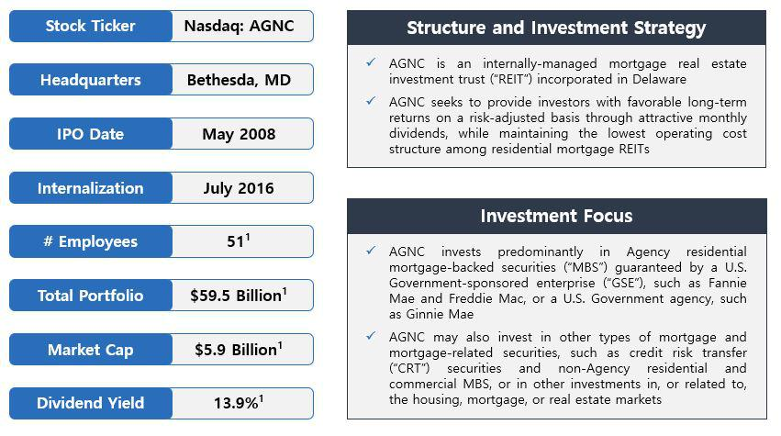

1. Data as of December 31, 2022.

From our May 2008 IPO through December 31, 2022, AGNC has declared $12 billion in common stock dividends, or $45.76 per common share,

and has generated an annualized total stock return of 10.1%, compared to 3.5% for the Bloomberg Mortgage REIT Index, 5.4% for the S&P 500 Financials Index, and 4.2% for the S&P 500 Real Estate Index.

ii AGNC INVESTMENT CORP. - Proxy Statement

Table of Contents

AGNC INVESTMENT CORP. AT A GLANCE
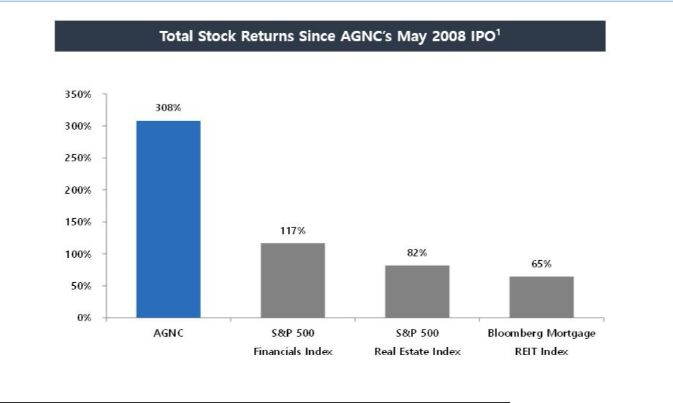

- Total stock return is measured from AGNC's IPO through December 31, 2022. Total stock return over a period includes price appreciation and dividend reinvestment; dividends are assumed to be reinvested at the closing price of the security on the ex-dividend date. Source: Bloomberg.

Qualified Leadership

Management Team

The AGNC management team is led by Peter Federico, our President and Chief Executive Officer, and Christopher Kuehl, our Executive Vice President and Chief Investment Officer. Following our successful leadership transition in July 2021, Gary Kain, previously our Chief Executive Officer and
Chief Investment Officer, now serves as Executive Chair of our Board of Directors (the “Board”). Messrs. Federico, Kuehl, and Kain collectively have over 90 years of experience investing in MBS and have worked together at AGNC for the last 12 years. Messrs. Federico, Kuehl, and Kain, together with the other members of our management team, possess a broad mix of mortgage investment expertise and experience.

Board of Directors

AGNC’s Board is currently comprised of nine members, including seven independent directors, whose diverse range of experience and
backgrounds makes them highly qualified to oversee our strategy, operations, and risk management. As part of its annual process, the Compensation and
Corporate Governance Committee of the Board (the “Compensation Committee”) evaluates our Board’s backgrounds, skill sets, experience, and diversity

to ensure they align with the Company’s go-forward strategy. Prue Larocca serves as the Lead Independent Director and the Board’s Vice Chair. Further discussion of the responsibilities of Ms. Larocca and Mr. Kain are on page 1 under “Board Leadership Structure.”

AGNC INVESTMENT CORP. - Proxy Statement iii

Table of Contents

AGNC INVESTMENT CORP. AT A GLANCE

Director Nominees

 |  |  |  | Committee
Name |  |  |  |  | Compensation &
 | Director Since | Independent | Executive | Audit | Corporate Governance
Donna J. Blank | 2018 | ✓ | ✓ | Chair
Morris A. Davis | 2008 | ✓ |  |  | Chair
Peter J. Federico (Chief Executive Officer) | 2021
John D. Fisk | 2019 | ✓ |  |  | ✓
Andrew A. Johnson, Jr. | 2021 | ✓ |  | ✓
Gary D. Kain (Executive Chair) | 2016 |  | ✓
Prue B. Larocca (Lead Independent Director and Vice Chair) | 2013 | ✓ | Chair | ✓ | ✓
Paul E. Mullings | 2016 | ✓ |  |  | ✓
Frances R. Spark | 2019 | ✓ |  | ✓
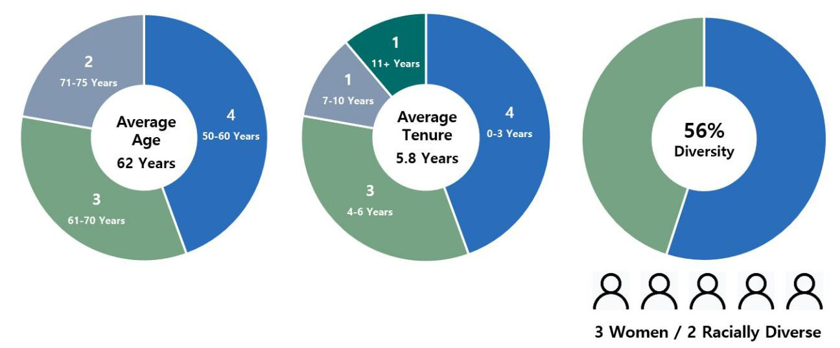

1. Metrics as of February 24, 2023.

iv AGNC INVESTMENT CORP. - Proxy Statement

Table of Contents

AGNC INVESTMENT CORP. AT A GLANCE
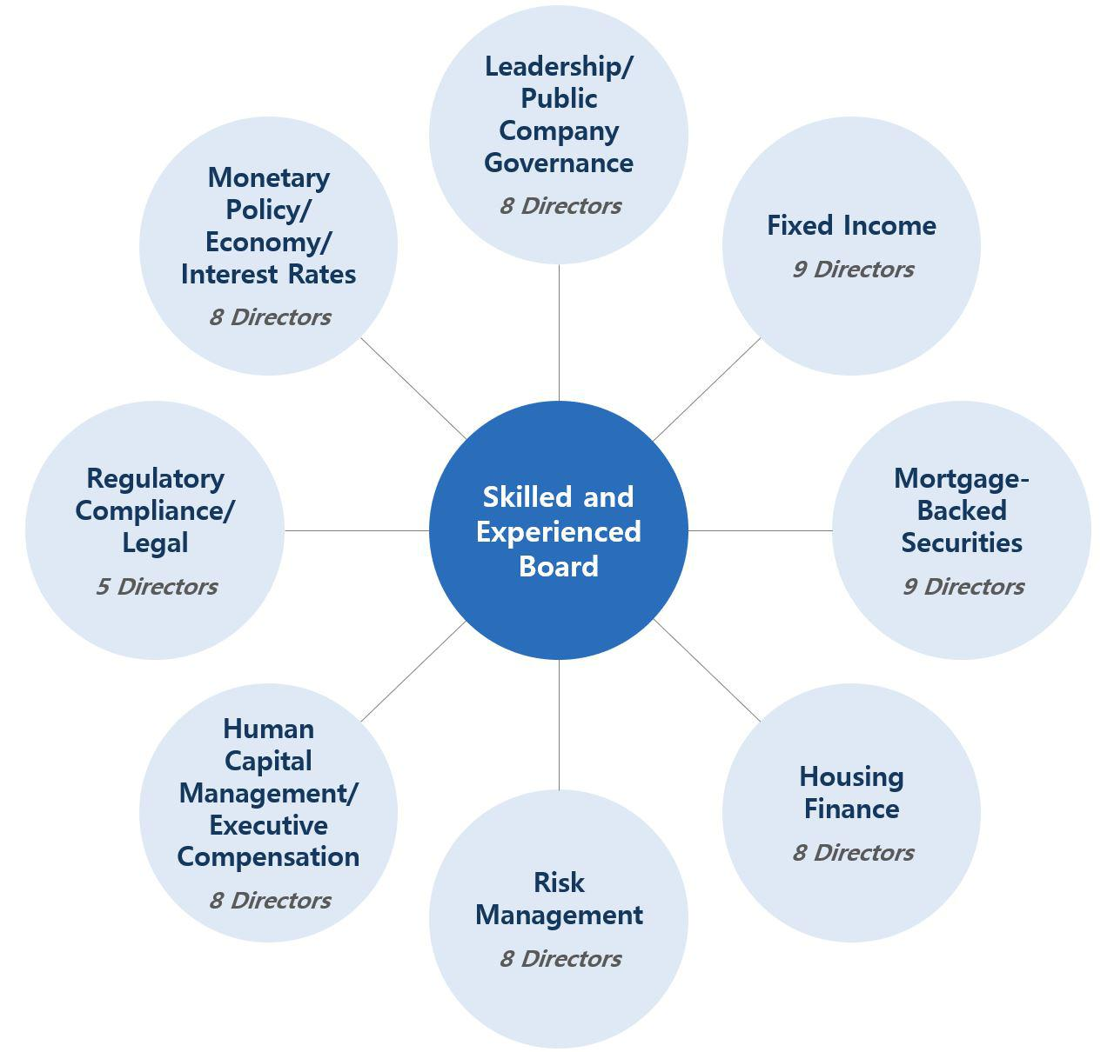

Stockholder Engagement

We actively engage with and value the opinions of our stockholders, which have influenced the evolution of our compensation program, corporate governance practices, and sustainability and human capital management efforts. We value regular engagement with our stockholders, including through our
quarterly earnings calls, investor conferences, Fall and Spring engagement campaigns, and outreach through our Investor Relations department. We engaged in a robust outreach program in 2022, contacting each of our top 50 institutional stockholders (which represent 81% of our common stock owned by institutions) and the two largest proxy advisory firms for the opportunity to engage on any aspect of our business of interest to them, including corporate

governance and sustainability practices. Most investors we contacted declined our meeting request, noting that there was no need to engage this

AGNC INVESTMENT CORP. - Proxy Statement v

Table of Contents

AGNC INVESTMENT CORP. AT A GLANCE

year and expressing general support for our governance and compensation practices. We participated in 11 investor conferences, including retail network calls hosted by research analysts, held over 125 meetings and calls with institutional investors, and responded to over 360 letters, emails, and calls from retail investors. In both 2020 and 2021, we were awarded the Gold Investor CARE Award by Nareit, honoring our excellence in communicating effectively

and efficiently with our investors.

At our 2022 Annual Meeting, we proposed amendments to our Certificate of Incorporation to eliminate supermajority voting requirements in order to afford greater accountability to the will of a majority of our stockholders. While these proposals received overwhelming support from stockholders
voting at the meeting, the necessary vote required in our Certificate of Incorporation to approve them was not reached, and the proposals were not approved. We are re-proposing these amendments this year and will again, directly and through our agent, seek to engage with stockholders and solicit sufficient voter turnout to approve these amendments.

Feedback from investors and other stakeholders was an important consideration in the expansion of our ESG efforts in 2022. In September, we published our second annual ESG report, which again included disclosures consistent with the recommendations of the Sustainability Accounting Standards Board (“SASB”). In addition, we expanded our report to include the Task Force on Climate-related Financial Disclosures (“TCFD”) framework

and also disclosed Scope 1 and Scope 2 greenhouse gas emissions (“GHG”) and energy consumption data. In 2022, we purchased carbon offsets and renewable energy certificates to offset the entirety of our 2021 Scope 1 and Scope 2 emissions, respectively.

Executive Compensation Program Overview, Philosophy and Structure, and Evolution

Our Compensation Committee has implemented a compensation program that links pay with performance, aligns executive objectives and incentives with our stockholders’ interests, and promotes operating efficiency. In addition, we believe our compensation program is competitive given AGNC’s size, scale, business, and management structure, promotes retention of our employees, and is well governed and transparent. All AGNC employees, including our named executive officers (“NEOs”), receive a combination of base salary, short-term incentives in the form of an annual cash

bonus opportunity, and long-term incentives (“LTI”) in the form of restricted stock units (“RSUs”). The long-term equity incentives awarded to our NEOs and other senior-level employees consist of a combination of performance-based RSUs and time-based RSUs.

As part of its ongoing evaluation of our compensation practices and in response to feedback we heard from stockholders during our prior outreach efforts, the Compensation Committee has made a number of meaningful changes to our compensation program and the corporate scorecard (“Corporate Scorecard”) used to evaluate performance since the compensation program was first implemented in 2016. Those changes included ensuring that a substantial portion of our NEOs’ total target compensation is allocated to long-term equity, simplifying the annual Corporate Scorecard to increase reliance on financial performance and better align to our strategic objectives, and improving disclosure to provide greater context for our compensation programs. In 2022, each of our NEOs received at least 40% of their target compensation in the form of LTI awards, and 67% of the target value of our NEOs’ annual LTI awards granted in 2022 vest based on company performance over a three-year period.

vi AGNC INVESTMENT CORP. - Proxy Statement

Table of Contents

 |  |  |  |  |  |  |  |  |  |  |  |  |  |  |  |  |  |  |  |  |  |  |  |  |  |  | TABLE OF CONTENTS
 | Proxy Summary |  |  |  |  |  |  |  |  |  |  |  |  |  |  |  |  |  |  |  |  |  |  |  |  |  |  |  |  |  |  |  |  |  |  |  | i
 | Board and Governance Matters |  |  |  |  |  |  |  |  |  |  |  |  |  |  |  |  |  |  |  |  |  |  |  |  |  |  |  |  |  |  |  |  |  |  |  | 1
 |  |  |  | Board Leadership Structure |  |  |  |  |  |  |  |  |  |  |  |  |  |  |  |  |  |  |  |  |  |  |  |  |  |  |  |  |  |  |  |  | 1
 |  |  |  | Corporate Governance |  |  |  |  |  |  |  |  |  |  |  |  |  |  |  |  |  |  |  |  |  |  |  |  |  |  |  |  |  |  |  |  | 2
 |  |  |  | Committees of the Board of Directors |  |  |  |  |  |  |  |  |  |  |  |  |  |  |  |  |  |  |  |  |  |  |  |  |  |  |  |  |  |  |  |  | 3
 |  |  |  | Board and Committee Meetings |  |  |  |  |  |  |  |  |  |  |  |  |  |  |  |  |  |  |  |  |  |  |  |  |  |  |  |  |  |  |  |  | 4
 |  |  |  | Director Nomination Process |  |  |  |  |  |  |  |  |  |  |  |  |  |  |  |  |  |  |  |  |  |  |  |  |  |  |  |  |  |  |  |  | 4
 |  |  |  | Board Membership Criteria |  |  |  |  |  |  |  |  |  |  |  |  |  |  |  |  |  |  |  |  |  |  |  |  |  |  |  |  |  |  |  |  | 4
 |  |  |  | Oversight of Strategy and Key Risks |  |  |  |  |  |  |  |  |  |  |  |  |  |  |  |  |  |  |  |  |  |  |  |  |  |  |  |  |  |  |  |  | 5
 |  |  |  | ESG and Corporate Responsibility |  |  |  |  |  |  |  |  |  |  |  |  |  |  |  |  |  |  |  |  |  |  |  |  |  |  |  |  |  |  |  |  | 7
 |  |  |  | Director Compensation |  |  |  |  |  |  |  |  |  |  |  |  |  |  |  |  |  |  |  |  |  |  |  |  |  |  |  |  |  |  |  |  | 7
 |  |  |  | Stock Ownership Guidelines |  |  |  |  |  |  |  |  |  |  |  |  |  |  |  |  |  |  |  |  |  |  |  |  |  |  |  |  |  |  |  |  | 8
 |  |  |  | Director Resignation Policy |  |  |  |  |  |  |  |  |  |  |  |  |  |  |  |  |  |  |  |  |  |  |  |  |  |  |  |  |  |  |  |  | 9
 |  |  |  | Certain Transactions with Related Persons |  |  |  |  |  |  |  |  |  |  |  |  |  |  |  |  |  |  |  |  |  |  |  |  |  |  |  |  |  |  |  |  | 9
 |  |  |  | Compensation Committee Interlocks and Insider Participation |  |  |  |  |  |  |  |  |  |  |  |  |  |  |  |  |  |  |  |  |  |  |  |  |  |  |  |  |  |  |  |  | 10
 | Proposal 1: Election of Directors |  |  |  |  |  |  |  |  |  |  |  |  |  |  |  |  |  |  |  |  |  |  |  |  |  |  |  |  |  |  |  |  |  |  |  | 11
 |  |  |  | Summary of our Board’s Industry and Functional Expertise |  |  |  |  |  |  |  |  |  |  |  |  |  |  |  |  |  |  |  |  |  |  |  |  |  |  |  |  |  |  |  |  | 11
 |  |  |  | Director Nominee Biographies and Qualifications |  |  |  |  |  |  |  |  |  |  |  |  |  |  |  |  |  |  |  |  |  |  |  |  |  |  |  |  |  |  |  |  | 11
 |  |  |  | Conclusion and Recommendation; Vote Required |  |  |  |  |  |  |  |  |  |  |  |  |  |  |  |  |  |  |  |  |  |  |  |  |  |  |  |  |  |  |  |  | 15
 | Proposal 2: Advisory Resolution to Approve Executive Compensation |  |  |  |  |  |  |  |  |  |  |  |  |  |  |  |  |  |  |  |  |  |  |  |  |  |  |  |  |  |  |  |  |  |  |  | 16
 |  |  |  | General Information |  |  |  |  |  |  |  |  |  |  |  |  |  |  |  |  |  |  |  |  |  |  |  |  |  |  |  |  |  |  |  |  | 16
 |  |  |  | Conclusion and Recommendation; Vote Required |  |  |  |  |  |  |  |  |  |  |  |  |  |  |  |  |  |  |  |  |  |  |  |  |  |  |  |  |  |  |  |  | 16
 | Proposal 3: Advisory Vote on the Frequency of Future Advisory Votes on Executive Compensation |  |  |  |  |  |  |  |  |  |  |  |  |  |  |  |  |  |  |  |  |  |  |  |  |  |  |  |  |  |  |  |  |  |  |  | 17
 |  |  |  | General Information |  |  |  |  |  |  |  |  |  |  |  |  |  |  |  |  |  |  |  |  |  |  |  |  |  |  |  |  |  |  |  |  | 17
 |  |  |  | Conclusion and Recommendation; Vote Required |  |  |  |  |  |  |  |  |  |  |  |  |  |  |  |  |  |  |  |  |  |  |  |  |  |  |  |  |  |  |  |  | 17
 | Proposal 4: Ratification of Appointment of Independent Public Accountant |  |  |  |  |  |  |  |  |  |  |  |  |  |  |  |  |  |  |  |  |  |  |  |  |  |  |  |  |  |  |  |  |  |  |  | 18
 |  |  |  | Independent Public Accountant’s Fees |  |  |  |  |  |  |  |  |  |  |  |  |  |  |  |  |  |  |  |  |  |  |  |  |  |  |  |  |  |  |  |  | 18
 |  |  |  | Pre-Approval Policy |  |  |  |  |  |  |  |  |  |  |  |  |  |  |  |  |  |  |  |  |  |  |  |  |  |  |  |  |  |  |  |  | 18
 |  |  |  | Conclusion and Recommendation; Vote Required |  |  |  |  |  |  |  |  |  |  |  |  |  |  |  |  |  |  |  |  |  |  |  |  |  |  |  |  |  |  |  |  | 19
 | Report of the Audit Committee |  |  |  |  |  |  |  |  |  |  |  |  |  |  |  |  |  |  |  |  |  |  |  |  |  |  |  |  |  |  |  |  |  |  |  | 20
 | Proposal 5: Approval of Amendments to Our Amended and Restated Certificate of Incorporation Eliminating Supermajority Voting |  |  |  |  |  |  |  |  |  |  |  |  |  |  |  |  |  |  |  |  |  |  |  |  |  |  |  |  |  |  |  |  |  |  |  | 21
 |  | Requirements
 |  | General Information |  |  |  |  |  |  |  |  |  |  |  |  |  |  |  |  |  |  |  |  |  |  |  |  |  |  |  |  |  |  |  |  |  |  | 21
 |  |  |  | Proposal 5A: Amendment to Eliminate the Supermajority Voting Standard for Certain Amendments to Our Certificate of |  |  |  |  |  |  |  |  |  |  |  |  |  |  |  |  |  |  |  |  |  |  |  |  |  |  |  |  |  |  |  |  | 21
 |  |  |  | Incorporation
 |  |  |  | Proposal 5B: Amendment to Eliminate the Supermajority Voting Standard for Amendments to Our Bylaws |  |  |  |  |  |  |  |  |  |  |  |  |  |  |  |  |  |  |  |  |  |  |  |  |  |  |  |  |  |  |  |  | 21
 |  |  |  | Proposal 5C: Amendment to Eliminate the Supermajority Voting Standard for Removal of Directors |  |  |  |  |  |  |  |  |  |  |  |  |  |  |  |  |  |  |  |  |  |  |  |  |  |  |  |  |  |  |  |  | 22
 |  |  |  | Conclusion and Recommendation; Vote Required |  |  |  |  |  |  |  |  |  |  |  |  |  |  |  |  |  |  |  |  |  |  |  |  |  |  |  |  |  |  |  |  | 22
 |  |  |  |  |  |  |  |  |  |  |  |  |  |  |  |  |  |  |  |  |  |  |  |  |  |  |  |  |  |  |  | AGNC INVESTMENT CORP. - Proxy Statement |  |  |  |  | vii

Table of Contents

Executive Officers of Registrant |  |  |  |  |  |  |  |  |  |  |  |  |  |  |  |  |  |  |  |  |  |  |  |  |  |  |  |  |  |  |  |  |  | 23
 | Executive Officer Biographies |  |  |  |  |  |  |  |  |  |  |  |  |  |  |  |  |  |  |  |  |  |  |  |  |  |  |  |  |  |  |  |  | 23
Executive Compensation |  |  |  |  |  |  |  |  |  |  |  |  |  |  |  |  |  |  |  |  |  |  |  |  |  |  |  |  |  |  |  |  |  | 25
 | Compensation Discussion and Analysis |  |  |  |  |  |  |  |  |  |  |  |  |  |  |  |  |  |  |  |  |  |  |  |  |  |  |  |  |  |  |  |  | 25
 |  | 2022 Named Executive Officers |  |  |  |  |  |  |  |  |  |  |  |  |  |  |  |  |  |  |  |  |  |  |  |  |  |  |  |  |  |  |  | 25
 |  | Executive Summary |  |  |  |  |  |  |  |  |  |  |  |  |  |  |  |  |  |  |  |  |  |  |  |  |  |  |  |  |  |  |  | 25
 |  |  | Business Overview |  |  |  |  |  |  |  |  |  |  |  |  |  |  |  |  |  |  |  |  |  |  |  |  |  |  |  |  |  |  | 25
 |  |  | Our Business in the Context of Our Broader Industry |  |  |  |  |  |  |  |  |  |  |  |  |  |  |  |  |  |  |  |  |  |  |  |  |  |  |  |  |  |  | 25
 |  |  | 2022 Year in Review |  |  |  |  |  |  |  |  |  |  |  |  |  |  |  |  |  |  |  |  |  |  |  |  |  |  |  |  |  |  | 27
 |  |  | Compensation Philosophy and Objectives |  |  |  |  |  |  |  |  |  |  |  |  |  |  |  |  |  |  |  |  |  |  |  |  |  |  |  |  |  |  | 28
 |  |  | Stockholder Engagement |  |  |  |  |  |  |  |  |  |  |  |  |  |  |  |  |  |  |  |  |  |  |  |  |  |  |  |  |  |  | 29
 |  |  | Compensation Governance Practices |  |  |  |  |  |  |  |  |  |  |  |  |  |  |  |  |  |  |  |  |  |  |  |  |  |  |  |  |  |  | 31
 |  | Compensation Program In Detail |  |  |  |  |  |  |  |  |  |  |  |  |  |  |  |  |  |  |  |  |  |  |  |  |  |  |  |  |  |  |  | 32
 |  |  | Compensation Program Elements |  |  |  |  |  |  |  |  |  |  |  |  |  |  |  |  |  |  |  |  |  |  |  |  |  |  |  |  |  |  | 32
 |  |  | Corporate Scorecard for Calculating Annual Bonus |  |  |  |  |  |  |  |  |  |  |  |  |  |  |  |  |  |  |  |  |  |  |  |  |  |  |  |  |  |  | 33
 |  |  | Equity Incentive Compensation |  |  |  |  |  |  |  |  |  |  |  |  |  |  |  |  |  |  |  |  |  |  |  |  |  |  |  |  |  |  | 37
 |  |  | Compensation Decision Process |  |  |  |  |  |  |  |  |  |  |  |  |  |  |  |  |  |  |  |  |  |  |  |  |  |  |  |  |  |  | 39
 |  |  | Other Compensation Policies and Practices |  |  |  |  |  |  |  |  |  |  |  |  |  |  |  |  |  |  |  |  |  |  |  |  |  |  |  |  |  |  | 42
 | Report of the Compensation and Corporate Governance Committee |  |  |  |  |  |  |  |  |  |  |  |  |  |  |  |  |  |  |  |  |  |  |  |  |  |  |  |  |  |  |  |  | 44
 | 2022 Summary Compensation Table |  |  |  |  |  |  |  |  |  |  |  |  |  |  |  |  |  |  |  |  |  |  |  |  |  |  |  |  |  |  |  |  | 44
 | Grants of Plan-Based Awards in Fiscal Year 2022 |  |  |  |  |  |  |  |  |  |  |  |  |  |  |  |  |  |  |  |  |  |  |  |  |  |  |  |  |  |  |  |  | 46
 | Outstanding Equity Awards at 2022 Fiscal Year-End |  |  |  |  |  |  |  |  |  |  |  |  |  |  |  |  |  |  |  |  |  |  |  |  |  |  |  |  |  |  |  |  | 47
 | Option Exercises and Stock Vested for Fiscal Year 2022 |  |  |  |  |  |  |  |  |  |  |  |  |  |  |  |  |  |  |  |  |  |  |  |  |  |  |  |  |  |  |  |  | 48
 | Severance and Change of Control Payments |  |  |  |  |  |  |  |  |  |  |  |  |  |  |  |  |  |  |  |  |  |  |  |  |  |  |  |  |  |  |  |  | 48
 | Pay Versus Performance |  |  |  |  |  |  |  |  |  |  |  |  |  |  |  |  |  |  |  |  |  |  |  |  |  |  |  |  |  |  |  |  | 51
 | CEO Compensation Pay Ratio |  |  |  |  |  |  |  |  |  |  |  |  |  |  |  |  |  |  |  |  |  |  |  |  |  |  |  |  |  |  |  |  | 55
Information Regarding Company Voting Securities |  |  |  |  |  |  |  |  |  |  |  |  |  |  |  |  |  |  |  |  |  |  |  |  |  |  |  |  |  |  |  |  |  | 56
 | Security Ownership of Management and Certain Beneficial Owners |  |  |  |  |  |  |  |  |  |  |  |  |  |  |  |  |  |  |  |  |  |  |  |  |  |  |  |  |  |  |  |  | 56
 | Delinquent Section 16(a) Report |  |  |  |  |  |  |  |  |  |  |  |  |  |  |  |  |  |  |  |  |  |  |  |  |  |  |  |  |  |  |  |  | 57
Questions and Answers About Stockholder Communications and Proposals |  |  |  |  |  |  |  |  |  |  |  |  |  |  |  |  |  |  |  |  |  |  |  |  |  |  |  |  |  |  |  |  |  | 58
Questions and Answers About the 2023 Annual Meeting and Voting |  |  |  |  |  |  |  |  |  |  |  |  |  |  |  |  |  |  |  |  |  |  |  |  |  |  |  |  |  |  |  |  |  | 59
Appendix I: Proposed Amended Provisions of Our Certificate of Incorporation |  |  |  |  |  |  |  |  |  |  |  |  |  |  |  |  |  |  |  |  |  |  |  |  |  |  |  |  |  |  |  |  |  | A1-1

viii AGNC INVESTMENT CORP. - Proxy Statement

Table of Contents

BOARD AND GOVERNANCE MATTERS

BOARD AND GOVERNANCE MATTERS

Our Board is currently comprised of seven independent directors, our Executive Chair, and our CEO. The following table sets forth the current members of our Board and their committee membership:

Name |  |  |  | Compensation &
 | Director Since | Executive | Audit 1 | Corporate Governance 2
Donna J. Blank* | 2018 | ✓ | Chair
Morris A. Davis* | 2008 |  |  | Chair
Peter J. Federico (Chief Executive Officer) | 2021
John D. Fisk* | 2019 |  |  | ✓
Andrew A. Johnson, Jr.* | 2021 |  | ✓
Gary D. Kain (Executive Chair) | 2016 | ✓
Prue B. Larocca* (Lead Independent Director and Vice Chair) | 2013 | Chair | ✓ | ✓
Paul E. Mullings* | 2016 |  |  | ✓
Frances R. Spark* | 2019 |  | ✓

* Director is “independent” as defined in Rule 5605(a)(2) of The Nasdaq Listing Rules (the “Nasdaq rules”).
- Each member of the Audit Committee is “independent” as defined in Rules 5605(a)(2) and 5605(c)(2) of the Nasdaq rules and Rule 10A-3 of the Securities Exchange Act of 1934 (the “Exchange Act”). The Board has determined that Mss. Blank and Spark are each an “audit committee financial expert” as defined in Item 407 of Regulation S-K under the Securities Act of 1933 (the “Securities Act”).

- Each member of the Compensation and Corporate Governance Committee is “independent” as defined in Rules 5605(a)(2) and 5605(d)(2) of the Nasdaq rules.

Board Leadership Structure

We believe that objective, independent oversight of management is central to our corporate governance, as well as execution upon our strategic objectives and alignment with the long-term interests of our stockholders. The Board believes that the optimal leadership structure for AGNC may evolve over time as a result of a number of factors, including changes in our strategy, market conditions, and the composition of our Board and management personnel. Accordingly, the Board regularly evaluates the most effective leadership structure for the Company. The Board believes that separating the positions of Chair and Chief Executive Officer is the best corporate governance leadership structure for us at this time and that independent directors should play a significant role in Board leadership. Following the transition of our executive leadership in July 2021, Mr. Federico serves as our Chief Executive Officer; Mr. Kain serves as Executive Chair of the Board, and Ms. Larocca serves as Vice Chair and Lead Independent Director.

Ms. Larocca, in her role as Vice Chair and Lead Independent Director, is empowered with robust, well-defined duties and actively collaborates with our Chief Executive Officer and Executive Chair on a wide variety of issues. In his role as Executive Chair, Mr. Kain serves as a resource to our Chief Executive Officer and Chief Investment Officer and consults with the Company’s senior management on significant strategic decisions and business plan execution, including investment strategies and portfolio risk management. He and Ms. Larocca collaborate closely to shape and implement the Board’s agenda and to facilitate the oversight of AGNC's operations and strategy. The chart below highlights the principal responsibilities of our Executive Chair and Lead Independent Director and their collaboration with other members of the Board and AGNC’s management team.

AGNC INVESTMENT CORP. - Proxy Statement | 1

Table of Contents

BOARD AND GOVERNANCE MATTERS

Responsibilities and Collaboration Among our Lead Independent Director and Executive Chair

Lead Independent Director and Vice Chair

- elected by and acts as leader of independent directors

- chairs meetings of the independent directors and the Executive Committee and chairs meetings of the Board of Directors when the Executive Chair is not present or is recused

Executive Chair

- elected by all directors

- chairs all regular and special meetings of the Board

- serves on the Executive Committee

- serves on all Board committees to facilitate support of committee chairs and coordination of committee work

- able to call meetings of the independent directors and special meetings of the Board of Directors

- collaborates with the Executive Chair, the CEO, the Secretary, and committee chairs to approve scheduling of meetings, development of agendas, and review the content and distribution of materials

- serves as a liaison between management and the independent directors and ensures that the information needs of independent directors are satisfied

- together with the chair of the Compensation Committee, leads the performance evaluation of the Executive Chair and the Chief Executive Officer

- together with the Executive Chair, facilitates identification and resolution of potential conflicts of interest and establishes expectations regarding culture of compliance throughout the Company

- serves as an additional management resource in the event of a crisis or interruption in business continuity

- together with the Vice Chair, facilitates identification and resolution of potential conflicts of interest and establishes expectations regarding culture of compliance throughout the Company

- collaborates with the Lead Independent Director, CEO, Secretary, and committee chairs to call and schedule Board meetings, develop agendas, and review the content and distribution of materials

- as necessary, represents the Company to stockholders, other stakeholders, and government officials in conjunction with the Chief Executive Officer

- provides support and guidance to the Chief Executive Officer and Chief Investment Officer, including consultation on significant strategic decisions

- evaluates and reports to the independent directors as requested regarding the Chief Executive Officer's performance

- communicates on behalf of the independent directors with stockholders, proxy advisory firms, and other stakeholders, as necessary

AGNC is committed to maintaining strong, independent leadership on the Board. Our Board has a policy, consistent with the Nasdaq rules and good corporate governance, to have our independent directors meet regularly without members of management or employee directors present to facilitate the Board’s independent oversight of management. Presently, our independent directors meet during our Board’s regular quarterly meetings and may hold additional meetings at the request of the Lead Independent Director or a majority of the directors.

Each of our Board’s Audit Committee and Compensation Committee is composed entirely of independent directors. These independent committees of our Board also have the authority under their respective charters to hire independent advisors and consultants, at the Company’s expense, to assist them in performing their duties. The chairs of the Audit and Compensation Committees set meeting agendas in consultation with our Secretary. A majority of our Board’s Executive Committee also consists of independent directors. Our Board has determined that all of the current directors, except Messrs. Federico and Kain, are “independent” as defined in the Nasdaq rules.

Corporate Governance

Our Board maintains strong corporate governance practices, which are memorialized in our Corporate Governance Guidelines, to support its oversight responsibilities. These guidelines, together with our Amended and Restated Certificate of Incorporation (our “Certificate of Incorporation”),
Fourth Amended and Restated Bylaws (our “Bylaws”), and committee charters of the Audit Committee and the Compensation Committee, form the basis for performance of our governance activities. All of these documents are available in the Investors section of our website at www.AGNC.com.

- AGNC INVESTMENT CORP. - Proxy Statement

Table of Contents

BOARD AND GOVERNANCE MATTERS

CORPORATE GOVERNANCE HIGHLIGHTS

- Annual election of directors

- Directors elected by majority voting, with a resignation policy for directors who do not receive a majority support

- Five of nine directors are gender or racially diverse

- Chair is separate from the CEO

- Robust independent Board leadership, with Lead Independent Director also serving as Vice Chair

- All directors serve on the boards of two or fewer public companies or mutual fund complexes

- Four new independent directors added since 2018 and average Board tenure of 5.8 years

- Regular meetings of independent directors without members of management

- Stock ownership guidelines for directors and executive officers

- Robust stockholder engagement program, including annual outreach campaign to institutional investors

- Anti-hedging and pledging policy for directors and executive officers

- Clawback policy for incentive compensation

- No stockholder rights plan or “poison pill”

- Comprehensive Code of Ethics and Conduct and Corporate Governance Guidelines

- Annual board and committee self-evaluations

- 100% attendance at 96% of our Board and committee meetings in 2022

- Membership in the National Association of Corporate Directors (the “NACD”), a leading authority on corporate boardroom and governance practices

Committees of the Board of Directors

Our Board’s principal standing committees and their primary functions are described below.

Audit Committee

This committee assists the Board in overseeing:

- our accounting and financial reporting processes;
- the integrity and audits of our financial statements;
- the adequacy of our internal control over financial reporting, including controls relating to the preparation of our financial statements;
- our internal audit department and its annual scope of work;
- cybersecurity and other risks to information technology systems;
- our compliance with legal and regulatory requirements;
- compliance with our Code of Ethics and Conduct (“Code of Ethics”);
- the qualifications and independence of our independent registered public accounting firm; and
- the performance of our independent registered public accounting firm and our internal audit department.

The Audit Committee is also responsible for engaging an independent registered public accounting firm, reviewing the plans and results of the

audit engagement with the independent registered public accounting firm, approving professional services provided by the independent registered public accounting firm, considering the range of audit and non-audit fees, and preparing a report on the review of the Company's audited financial statements as required to be included in our proxy statement. The committee’s meetings include, whenever appropriate, executive sessions with our independent external

auditors, without the presence of management.

Compensation and Corporate Governance Committee

This committee’s principal functions are to:

- oversee and review our compensation practices with respect to our executive officers, employees, and members of the Board and make recommendations to the Board on these matters;

- set the terms of employment of our executive officers and recommend CEO and Executive Chair compensation decisions for approval by all of the independent directors of our Board;
- administer our equity and incentive plans to the extent delegated authority by the Board;
- provide general oversight of our compensation structure, including any compensation plans;
- review and make recommendations to the Board on executive succession plans and leadership development;
- oversee matters relating to human capital management, including the hiring, development, retention, and satisfaction of our employees and our policies and practices for diversity, equity, and inclusion;
- make recommendations to the Board regarding Board and committee oversight of AGNC’s corporate social responsibility and sustainability strategies and practices;
- monitor and facilitate our governance, including membership of the Board and operations pursuant to our Corporate Governance Guidelines;
- review and evaluate the sufficiency of our Code of Ethics;
- oversee evaluation of our CEO, Executive Chair, and other executive officers; and

AGNC INVESTMENT CORP. - Proxy Statement 3

Table of Contents

BOARD AND GOVERNANCE MATTERS

- review and approve the disclosure regarding the Company’s compensation and benefits matters and prepare a report on executive compensation, each as required to be included in our proxy statement for our annual meetings.

The Compensation Committee also serves as the Board’s standing nominating committee and as such performs the following functions:

- identifying, recruiting, and recommending to the Board qualified candidates for election as directors and recommending a slate of nominees for election as directors by our common stockholders at the annual meeting of stockholders;

- developing and recommending to the Board Corporate Governance Guidelines, including the committee’s selection criteria for director nominees;
- recommending to the Board nominees for each committee of the Board;
- overseeing the orientation process for new directors and continuing education of all directors; and
- annually facilitating an assessment of the Board, Board committee, and individual director performance and making reports thereon to the Board.

Under its charter, the Compensation Committee has the authority to select, retain, and terminate compensation consultants. The Compensation Committee retained Frederic W. Cook & Co., Inc. (“FW Cook”) to assist the Compensation Committee in designing and establishing a compensation structure in 2016 and has continued to engage FW Cook to advise on and assist with the review and evaluation of executive compensation and

compensation of our non-employee directors.

Executive Committee

This committee has the authority to exercise all powers of the Board except for actions that must be taken by the full Board under Delaware law, our Certificate of Incorporation, or Bylaws.

Board and Committee Meetings

The Board generally holds regular quarterly meetings and meets on other occasions, as necessary. The Board held 12 regular and special meetings during 2022. In addition, the independent directors met separately in executive sessions to discuss various matters, including our performance and the
performance of our Executive Chair, Chief Executive Officer, and other executive officers.

Each of the Audit Committee and the Compensation Committee schedules regular meetings to coincide with the quarterly meetings of the Board and also meets at the request of senior management or at such other times as its Chair determines. The Chair of each Committee, in consultation with our
Secretary, sets the agendas for the meetings. Each committee reports to the Board on its activities at the next regularly scheduled Board meeting following its committee meetings and when appropriate. During 2022, the Audit Committee held six meetings, and the Compensation Committee held nine meetings. The Board typically conducts an annual multi-day meeting devoted to reviewing the Company’s strategy, macro trends impacting our business, and other

topics of interest to our directors, including relevant continuing education sessions. Following a pause in 2021 due to health risks and logistical constraints resulting from the Covid-19 pandemic (the “Pandemic”), the Board resumed this practice in the second quarter of 2022.

Each of our independent directors attended all of the meetings of the Board and committees on which he or she served in 2022 with the exception

of one independent director who was unable to attend one special meeting of the Board. Although we do not have a policy on director attendance at the Annual Meeting, directors are encouraged to attend, and each of our directors attended the 2022 Annual Meeting.

Director Nomination Process

Nominations for election to the Board may be made by the Compensation Committee or by any common stockholder entitled to vote for the election of directors in accordance with the procedures set forth in our Bylaws and as provided by applicable law. Candidates recommended by common stockholders will be evaluated by the Compensation Committee under the same criteria that are applied to other candidates.

Board Membership Criteria

The Compensation Committee endeavors to identify, recruit, and nominate candidates based on the following eligibility and experience criteria: a candidate’s integrity and business ethics, strength of character, judgment, experience, and independence, as well as factors relating to the composition of
the Board, including its size and structure, the relative strengths and experience of current directors, and principles of diversity, including diversity of experience, personal and professional backgrounds, race, gender, ethnicity, and age.

The Compensation Committee recognizes the importance of diverse viewpoints, experience, and backgrounds to a well- functioning Board. Although the committee does not have formal objective criteria for diversity on our Board, it is a significant consideration, and since 2017, 60% of new director nominations have been women or minority candidates. Furthering our commitment to diversity, we revised our Corporate Governance Guidelines

in 2021 to reflect the Board’s undertaking to instruct any third-party search firm engaged in a director search on our behalf to include in the initial list of candidates individuals reflecting diverse backgrounds, including diversity of gender, race, or ethnicity. In nominating candidates to the Board, the committee determines whether the incumbent director is willing to stand for re-election. If so, the committee evaluates individual contributions to

determine suitability for continued service, taking into consideration the Board’s criteria for candidates, the Board evaluation process, and other perceived needs of the Board. The Company maintains a corporate membership in the NACD, which provides each director

- AGNC INVESTMENT CORP. - Proxy Statement

Table of Contents

BOARD AND GOVERNANCE MATTERS

with access to continuing education, research materials, and publications relating to corporate governance, board leadership, and other topical information. The Company also reimburses directors for participation in professional development opportunities. In 2022, a number of our directors participated in continuing education and certification programs, including in the areas of cybersecurity, corporate governance, and climate change oversight.
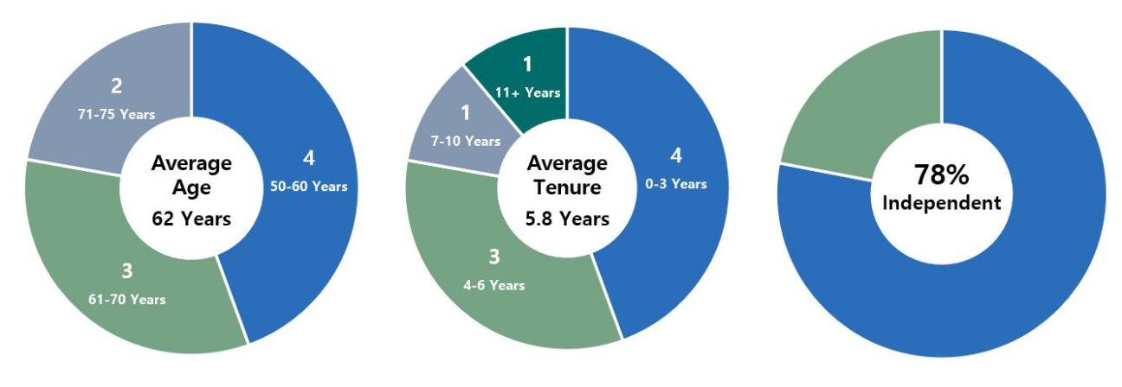

1. Metrics as of February 24, 2023.

The following table provides characteristics of our directors according to the categories required under Nasdaq listing standards.

Board Diversity Matrix (As of February 24, 2023)

 |  |  |  |  | Did Not Disclose
 | Female | Male |  | Non-Binary | Gender
Part I: Gender Identity
Directors | 3 | 6 |  | 0 | 0
Part II: Demographic Background
African American or Black | 0 | 2 |  | 0 | 0
Alaskan Native or Native American | 0 | 0 |  | 0 | 0
Asian | 0 | 0 |  | 0 | 0
Hispanic or Latinx | 0 | 0 |  | 0 | 0
Native Hawaiian or Pacific Islander | 0 | 0 |  | 0 | 0
White | 3 | 4 |  | 0 | 0
Two or More Races or Ethnicities | 0 | 0 |  | 0 | 0
LGBTQ+ | 0 | 0 |  | 0 | 0
Did Not Disclose Demographic Background |  |  | 0

Oversight of Strategy and Key Risks

Our Board is responsible for the general oversight of the Company, including our strategic direction, the performance of our executive officers,

environmental and social initiatives, and the Company’s risk management processes, to assure that the long-term interests of our stockholders are being served. In performing this oversight function, the Board, directly or through its standing committees, regularly reviews and discusses our corporate strategy and our material strategic, operational, financial, compensation, and compliance risks with senior management.

The Board receives updates from management at each regular meeting on the Company’s performance, market conditions, and other recent developments, including, among other things, risks and opportunities facing us, as well as the strategies used to hedge the Company’s exposure to market risks, including interest rate, spread, prepayment, and extension risks. The Board periodically reviews and discusses our broader business strategy with management and in executive session. The Board also regularly reviews our compliance with policies, procedures, risk limits, and processes addressing

other operational risks.

AGNC INVESTMENT CORP. - Proxy Statement 5

Table of Contents

BOARD AND GOVERNANCE MATTERS

The Board considers the Company’s cybersecurity posture and risk exposure with management taking into consideration our operations and the types of data retained on our systems as part of its periodic review of enterprise-wide risk management. Our primary business involves investments in mortgages and mortgage-related instruments. We do not currently perform mortgage servicing, maintain customer accounts, or provide any direct mortgage

lending, and thus we do not receive personal information on individual mortgage borrowers as part of our regular operations. The Company has implemented a comprehensive cybersecurity program aligned with the NIST Cybersecurity Framework and routinely engages with third parties to test its effectiveness. The Board recognizes that the cornerstone of an effective information security program is security awareness at every level of the

organization, and the Company regularly tests and trains employees on cybersecurity best practices.

The Board has delegated oversight of AGNC’s cybersecurity risk to the Audit Committee, which is also responsible for oversight of information technology and data security controls related to our financial reporting. The Audit Committee reviews the Company’s cybersecurity program and risk
exposure with the Company’s Senior Vice President for Information Technology on at least an annual basis, and it receives reports from him on these matters at least quarterly. The Audit Committee may also conduct additional cybersecurity reviews or receive additional updates or reports as it deems necessary.

The Board recognizes the importance of effective executive leadership and the promotion of an ethical and professional culture throughout our organization. The Board and the Compensation Committee are actively engaged in overseeing succession planning, including a routine review of staffing for critical roles, considering the operational needs of the Company and the potential leadership, industry knowledge, and investment skills of existing

employees. The completed transition of Mr. Kain to Executive Chair of the Board and the promotion of Messrs. Federico and Kuehl that took effect in July 2021 were consistent with our Board’s long-term commitment to sound succession planning and effective development of employees. Executives and other key employees in the Company are given exposure to the Board during meetings and other events to assist with their development and the Board’s

evaluation. In addition, the Board receives updates on management’s strategies for recruiting, developing, and retaining outstanding personnel and minimizing employee turnover, as applicable. At least annually, the Audit Committee reviews employee compliance with our Code of Ethics, and the Compensation Committee annually reviews the sufficiency of the Code of Ethics.
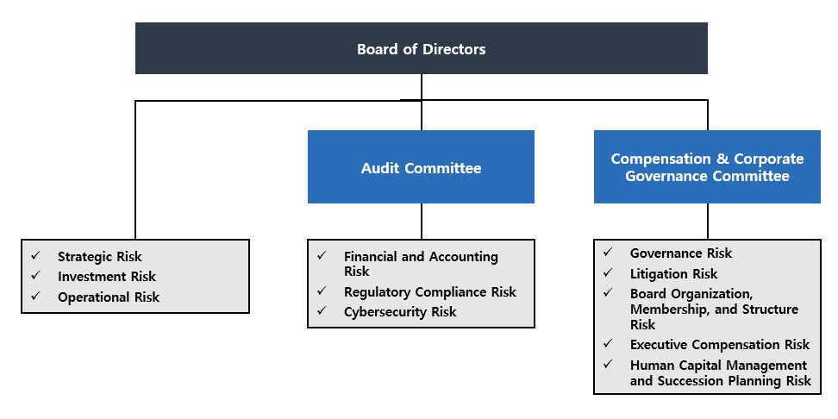

The Board has delegated certain risk management oversight responsibility to its committees as follows:

- Regulatory Compliance Risk: The Board, both directly and through the Audit Committee, receives regular reports from the Company’s legal, accounting, tax, and internal audit representatives on regulatory compliance matters, including the Company’s compliance with its REIT qualification and exemption from the Investment Company Act of 1940 and compliance with our Code of Ethics.

- Financial and Accounting Risk: The Audit Committee oversees the Company’s management of its financial and accounting systems, its internal control over financial reporting, and disclosure controls and procedures through regular meetings with our Chief Financial Officer, senior representatives of the Company’s accounting, internal audit, and legal departments, and representatives of the Company’s independent public accountant.

- Litigation Risk: The Compensation Committee monitors the Company’s litigation, if any.

- Governance Risk: The Compensation Committee also oversees risks related to Board organization, membership, structure, and corporate governance.

- AGNC INVESTMENT CORP. - Proxy Statement

Table of Contents

BOARD AND GOVERNANCE MATTERS

- Succession Planning and Human Capital Risk: The Compensation Committee is responsible for ensuring that a succession plan is in place for our executive officers and other key employees and overseeing the Company’s management and development of its human capital.

ESG and Corporate Responsibility

We understand the importance of incorporating environmental, social, and governance considerations into our business and day-to-day operations, and we appreciate the increased interest of our stockholders in these matters. We consider the interests of all our stakeholders—our stockholders, employees, lenders, other counterparties, vendors, and community—in pursuing the long-term success of our business. Our review and evaluation of

corporate social responsibility is focused on two areas: our business operations and our investment activity.

Our primary operational focus from a social perspective is our human capital. AGNC is committed to providing our employees an engaging, supportive, and inclusive atmosphere in which to grow professionally and contribute to our corporate objectives. We pride ourselves on providing a wide selection of resources to protect and promote our employees’ professional development, health, well-being, financial security, safety, and work-life balance. We offer our employees comprehensive benefits and participation in our long-term equity incentive program, and we have implemented programs that promote cross training, collaboration, and professional growth. We have also approached the workplace disruptions of the Pandemic with flexibility and ensured that the health and safety of our workforce is protected, while our business operations continue uninterrupted. In 2022, we continued our hybrid work model which allows for meaningful collaboration among employees while also promoting flexibility in individual employee schedules. As a 51 person organization engaged in managing a portfolio primarily consisting of Agency mortgage-backed securities, our business operations have a limited environmental impact, but we continuously evaluate opportunities to minimize our direct environmental effects.

From an investment perspective, our business supports home ownership in the United States, which has long been viewed as an important vehicle of individual wealth creation and aids in the development of strong communities. Our investments in residential mortgage-backed securities and other mortgage related instruments play a meaningful role in helping Americans become homeowners. As an investor predominantly in Agency mortgage-backed securities, we have limited insight into the location, age, or other characteristics of individual homes or the identity of the mortgage borrowers included in these investments.

Our Board has elected to allocate oversight of ESG matters amongst the Board and our Compensation and Audit Committees rather than delegating responsibility for oversight of all ESG matters to a single committee. By separating areas of focus and attention encompassed within ESG considerations, each of these Committees and the Board govern and oversee areas of corporate responsibility within their respective areas of focus.

Our Compensation Committee oversees our approach to human capital management and development, the governance and operations of our Board (including its governance and oversight of corporate social responsibility and sustainability), and the composition and diversity of our Board. As part of its oversight of human capital management and corporate responsibility, the Compensation Committee receives reports on the results of employee surveys and updates from management regarding actions taken to promote development and engagement of our workforce. Our Audit Committee oversees our management’s governance of our business conduct in the areas of financial reporting, information security, legal and regulatory compliance, and compliance with our Code of Ethics. Our full Board oversees our investment guidelines, portfolio and risk management framework, and overall strategic direction, which incorporates our responsibility to the people and communities we serve.

In September 2022, we issued our second annual ESG Report, which provides disclosures consistent with the recommendations of the SASB and the TCFD, including Scope 1 and 2 greenhouse gas emissions data. The report provides disclosure on ESG issues and topics most material to our business and operations and further details our ongoing efforts to enhance our corporate responsibility and sustainability practices. Our ESG Report is available in the Corporate Responsibility section of our website at www.AGNC.com/corporate-responsibility.

Director Compensation

As described in more detail below, we compensate our independent directors with cash retainers and equity-based awards. Directors who are employees of the Company or our subsidiaries do not receive any compensation for service as a member of the Board, although we reimburse all directors for travel expenses incurred in connection with Board and committee meetings and Board-related functions. The Compensation Committee periodically

reviews the form and amount of compensation paid to our independent directors to ensure it remains consistent with quality corporate governance practices. In these reviews, the Compensation Committee regularly consults with FW Cook for advice on the design and structure of the program, information on recent trends and developments in non-employee director compensation, general industry data, and analyses of the competitiveness of our non-employee

director compensation levels relative to comparable companies.

In 2022, independent directors received a cash retainer for service on the Board at the annual rate of $112,500, payable quarterly in advance. The cash retainer level was established in 2019 in consultation with FW Cook following the Compensation Committee’s review of market practices at a group
of comparable companies and taking into consideration the level of work required of our directors. In 2022, the Chairs of our Audit Committee and Compensation Committee each received an additional retainer at an annual rate of $25,000, each payable quarterly in advance, and our Vice Chair and Lead Independent Director received an annual

AGNC INVESTMENT CORP. - Proxy Statement | 7

Table of Contents

BOARD AND GOVERNANCE MATTERS

retainer of $100,000, also payable quarterly in advance. The Compensation Committee, in consultation with FW Cook, concluded that the cash retainers for

independent directors, committee chair positions, and Vice Chair and Lead Independent Director remained reasonable for 2022 in light of the work expected in each role.

The Board believes that a substantial portion of director compensation should consist of equity-based compensation to assist in aligning the long-

term interests of our directors with those of our stockholders. On April 21, 2022, each of our independent directors serving on the Board at that time received 12,426 RSUs under the Amended and Restated AGNC Investment Corp. 2016 Equity and Incentive Compensation Plan (the “2016 Equity Plan”), which is described in more detail below. The RSUs vest on the earlier of April 21, 2023 or the date of the 2023 Annual Meeting of Stockholders, subject to

the director’s continued service on our Board through the vesting date. Each RSU represents the right to receive an equivalent number of shares of our common stock, plus dividend equivalents, subject to the terms of the 2016 Equity Plan. The Compensation Committee recommended the amount of annual equity awards in consultation with FW Cook as part of its review of our director compensation relative to our compensation philosophy and objectives,

comparable market practices for independent director compensation, and the work required of our directors.

The following table sets forth the compensation received by each independent director during 2022:

 | Fees Earned | Stock
 | or Paid in |  | Total
Name | Cash | Awards
 | ($) | ($) 1 | ($)
Donna J. Blank | 137,500 | 147,500 | 285,000
Morris A. Davis | 137,500 | 147,500 | 285,000
John D. Fisk | 112,500 | 147,500 | 260,000
Andrew A. Johnson, Jr. | 112,500 | 147,500 | 260,000
Prue B. Larocca | 212,500 | 147,500 | 360,000
Paul E. Mullings | 112,500 | 147,500 | 260,000
Frances R. Spark | 112,500 | 147,500 | 260,000

- The amounts reported in the “Stock Awards” column represent the grant date fair value of each award granted calculated in accordance with Financial Accounting Standards Board ASC Topic 718, Compensation-Stock Compensation (“ASC 718”), as required by Securities and Exchange Commission (“SEC”) regulations. Each award represents the right to receive 12,426 shares of common stock (calculated by dividing the value of the award by the closing price of a share of common stock on the grant date, which was $11.87 on April 21, 2022). As of December 31, 2022, in connection with these awards, each independent director had unvested RSUs relating to 13,751 shares of common stock, including dividend equivalents on the RSUs.

The 2016 Equity Plan

The Company maintains the 2016 Equity Plan to provide our directors, executive officers, and other employees with equity incentive
compensation. Stockholders initially approved the Company’s equity plan in December 2016 and subsequently approved an amendment and restatement with 91.7% of the shares voted in support at the 2021 Annual Meeting. Subject to adjustment as described in the 2016 Equity Plan, total awards under the 2016 Equity Plan are currently limited to 40,000,000 shares, inclusive of dividend equivalents paid on such awards. These shares may be shares of original

issuance or treasury shares or a combination of the two, and awards may be time-vested or performance-vested.

The 2016 Equity Plan authorizes the Compensation Committee to provide equity-based compensation in the form of stock options, appreciation rights, restricted shares, restricted stock units, performance shares, performance units, dividend equivalents, and certain other awards denominated or
payable in, or otherwise based on, shares of common stock, plus cash incentive awards, for the purpose of providing our non-employee directors, officers, and other employees, and those of our subsidiaries, incentives and rewards for service or performance. The 2016 Equity Plan places a limit on the dollar value of awards and other compensation that may be made to a director in any year. Members of our Board may elect to defer distribution of their awards

under the 2016 Equity Plan for a period of up to ten years; deferred awards are non-forfeitable following the vesting date.

Independent Director Plan

The American Capital Agency Corp. Equity Incentive Plan for Independent Directors (the “Independent Director Plan”), created at the time of our

IPO, provided for the issuance of equity-based awards to our independent directors and was terminated when our stockholders approved the 2016 Equity Plan, except with respect to then outstanding awards. Restricted stock units awarded under the Independent Director Plan conferred to the participant the right to receive common stock having a value equal to the number of shares of our common stock that were subject to the award. The holders of awards of

restricted stock units were also entitled to receive dividend equivalents and could elect to defer distribution of their equity-based awards for a period of up to ten years. Deferred awards are non-forfeitable after the vesting date.

Stock Ownership Guidelines

Our Board believes that directors more effectively represent the best interests of the Company if they are stockholders themselves. Thus, each independent director is encouraged to own shares of our common stock equal in value to at least 5x the annual cash retainer paid to independent directors (which was $112,500 in 2022). Shares of deferred or restricted stock or stock units (both

- AGNC INVESTMENT CORP. - Proxy Statement

Table of Contents

BOARD AND GOVERNANCE MATTERS

vested and unvested and including shares for which a deferral election was made) granted to directors under the Independent Director Plan and the 2016 Equity Plan are included in determining the number of shares held for this purpose. Until the stated minimum is met, each independent director must retain at least 50% of the shares of common stock received upon vesting, net of any shares withheld or sold to pay or reimburse taxes on such income. As of

February 24, 2023, all of our directors were in compliance with their obligations under our stock ownership guidelines.

In addition, our Board has adopted a policy prohibiting our executive officers and directors from any hedging, pledging, or entering into margin loans with respect to any shares of our common stock (regardless of whether such stock is owned directly or indirectly, as such terms are used in the SEC
rules promulgated under the Exchange Act) or from engaging in short sales of our common stock or entering into any other transaction or derivative agreement where he or she would earn a profit or offset losses due to a decline of our stock price.

The following table sets forth the total stock ownership of our independent directors, including beneficially owned, unvested, and deferred shares, as calculated pursuant to our stock ownership guidelines as of February 24, 2023:

 | Beneficially | Unvested | Vested/Deferred | Total
Name | Owned | Shares | Shares⁽¹⁾
 | Shares (#) | (#) | (#) | (#)

Donna J. Blank

Morris A. Davis

John D. Fisk

Andrew A. Johnson, Jr.

Prue B. Larocca

Paul E. Mullings

Frances R. Spark

- Reflects shares that are fully vested but distribution has been deferred. Pursuant to the terms of the 2016 Equity Plan and the Independent Director Plan, directors may elect to defer distribution of their awards for a period of up to ten years. Deferral does not alter the vesting schedule, and vested and deferred shares are non-forfeitable.

Director Resignation Policy

Our Bylaws require a candidate in an uncontested election for director to receive a majority of the votes cast in order to be elected as a director.

Under this provision, each vote is specifically counted “for” or “against” the director’s election, unless a common stockholder abstains from voting with respect to the matter. A director nominee is required to receive more votes “for” than “against” to be elected. Pursuant to Delaware law, a director shall remain in office until his or her successor is elected and qualified even if the director has not received a vote sufficient for re-election. Thus, a corporation

could have a “holdover” director. However, pursuant to our Board-approved director resignation policy, an incumbent director must tender his or her resignation to the Board if the director is nominated but not re-elected. The policy also requires the Compensation Committee to make a recommendation to the full Board on whether to accept or reject the resignation within 90 days of receipt of the tendered resignation and the full Board to make that determination. The Board would publicly disclose its decision by filing a Current Report on Form 8-K with the SEC within four days of making its

determination.

Any director who tenders his or her resignation pursuant to this policy may not participate in the Compensation Committee recommendation or Board action regarding whether to accept the resignation offer. If each member of the Compensation Committee does not receive a vote sufficient for re-
election, then the independent directors who did receive a sufficient vote shall appoint a committee amongst themselves to consider the resignation offers and recommend to the Board whether to accept them. If only three or fewer directors receive a sufficient vote for re-election, all directors (other than the director who tendered the resignation under review) may participate in the action regarding whether to accept the resignation offers.

Certain Transactions with Related Persons

Related Person Transaction Policies

Our Board has adopted a policy regarding the approval of any “related person transaction,” which is any transaction or series of transactions in

which we or any of our subsidiaries is or are to be a participant, the amount involved exceeds $120,000, and a “related person” (as defined under SEC rules) has a direct or indirect material interest. Under the policy, a related person would need to promptly disclose to our Secretary any related person transaction and all material facts about the transaction. Our Secretary would then promptly assess and communicate that information to the Audit

Committee. Based on its consideration of all of the relevant facts and circumstances, the Audit Committee will decide whether or not to approve such transaction and will generally approve only those transactions that do not create a conflict of interest. If we become aware of an existing related person transaction that has not been pre-approved under this policy, the transaction will be referred to the Audit Committee, which will evaluate all options

available, including ratification, revision, or termination of such transaction. Our policy requires any director who may be interested in a related person transaction to recuse himself or herself from any consideration of such related person transaction.

AGNC INVESTMENT CORP. - Proxy Statement 9

Table of Contents

BOARD AND GOVERNANCE MATTERS

Our Code of Ethics, which is reviewed annually by our Board and provided to all of our directors, officers, and employees, requires that all such persons avoid any situations or relationships that involve actual or potential conflicts of interest, or perceived conflicts of interest, between an individual’s personal interests and the interests of AGNC. Pursuant to our Code of Ethics, each of these persons must disclose any conflicts of interest, or actions or

relationships that might give rise to a conflict, to their supervisor or our chief compliance officer. If a conflict is determined to exist, the person must disengage from the conflict situation or terminate his or her provision of services to us. Our president and chief executive officer, chief financial officer and principal accounting officer, controller, directors and certain other persons who may be designated by our Board or its Audit Committee, whom we

collectively refer to as our financial executives, must consult with our chief compliance officer with respect to any proposed actions or arrangements that are not clearly consistent with our Code of Ethics. In the event that a financial executive desires to engage in a proposed action or arrangement that is not consistent with our Code of Ethics, the financial executive must obtain a waiver of the relevant provisions of our Code of Ethics in advance from our Audit

Committee. We intend to post amendments to or waivers from the Code of Ethics (to the extent applicable to our financial executives) on our web site at www.AGNC.com.

Related Person Transactions

We did not enter into any transactions in 2022 in which any related person of ours had any material interest.

Compensation Committee Interlocks and Insider Participation

No member of the Compensation Committee during fiscal year 2022 served as an officer, former officer, or employee of ours or had a relationship

required to be disclosed under “Board and Governance Matters—Certain Transactions with Related Persons.” Further, during 2022, none of our executive officers served as:

- a member of the compensation committee (or equivalent) of any other entity, one of whose executive officers served as one of our directors or was an immediate family member of a director, or served on our Compensation Committee; or

- a director of any other entity, one of whose executive officers or their immediate family member served on our Compensation Committee.

10 AGNC INVESTMENT CORP. - Proxy Statement

Table of Contents

PROPOSAL 1: ELECTION OF DIRECTORS

PROPOSAL 1: ELECTION OF DIRECTORS

Pursuant to our Certificate of Incorporation, our common stockholders elect each of the members of the Board annually. The term of each director will expire at the Annual Meeting. Each director has been nominated by the Compensation Committee of the Board, in accordance with our Bylaws, to stand for re-election at the Annual Meeting and to serve as a director until our Annual Meeting to be held in 2024 and until his or her successor is elected

and qualified. It is expected that each of the nominees will be able to serve, but if any such nominee is unable to serve for any reason, the proxies reserve discretion to vote or refrain from voting for a substitute nominee or nominees. A common stockholder using the enclosed form of proxy can vote for or against any or all of the nominees or may abstain from voting for any or all of the nominees.

We believe that all of our nominees possess the personal and professional qualifications necessary to serve as a member of our Board and collectively represent a balance of industry knowledge, skills, and expertise. Our directors have been evaluated by the Compensation Committee pursuant to the guidelines described above under “Board and Governance Matters—Board Membership Criteria,” and the determination was made that each of them

fulfills and exceeds the qualities that we look for in members of our Board. Mr. Kain is our Executive Chair, and Mr. Federico is our President and Chief Executive Officer. All other nominees are independent as defined in the Nasdaq rules.

Summary of Our Board’s Industry and Functional Expertise

We believe that our directors have a diversity of experience and a wide variety of skills and qualifications that strengthen their ability to provide guidance and oversight to the Company and management on behalf of stockholders.

The information set forth below with respect to each of our directors, each of whom is a nominee for election at the Annual Meeting, is as of February 24, 2023. The business address of each nominee is c/o AGNC Investment Corp., 2 Bethesda Metro Center, 12th Floor, Bethesda, Maryland 20814. We have highlighted specific attributes for each Board member below.

Director Nominee Biographies and Qualifications

DONNA J. BLANK, 61

Professional Experience:
Ms. Blank is a finance executive with over 30 years of financial and operational experience, primarily in financial

services. From 2015 through 2016, she was Chief Financial Officer at ZAIS Group, LLC, an alternative asset manager. While at ZAIS, Ms. Blank also served as the Chief Financial Officer of its externally managed publicly traded residential mortgage REIT and its public holding company. Prior to her role at ZAIS, she served as Chief

Financial Officer and Executive Vice President at NFP Corp., a publicly traded insurance brokerage, from 2008 until 2013. From 2003 to 2008, Ms. Blank was Chief Financial Officer at Financial Guaranty Insurance Company, both before and subsequent to its sale by GE Capital to an investor group in late 2003. She has served as an

independent director and member of the Audit and Risk Committee at American Enterprise Mutual Holding Company since March 2018 and has also served as chair of the Audit and Risk Committee since March 2020. Ms. Blank will also assume the role of Lead Independent Director at American Enterprise in March 2023. Ms. Blank

holds an MBA in Finance and a Master of International Affairs, both from Columbia University. In 2022, she completed the MIT Sloan School of Management Executive Education program in Cybersecurity Leadership. Ms. Blank is an “audit committee financial expert” (as defined in Item 407 of Regulation S-K under the Securities Act).

Director Qualifications:
Ms. Blank’s extensive public company accounting and operational experience in the financial services sector,
including her senior executive role at a publicly traded residential mortgage REIT, strengthens our Board’s collective qualifications, skills, experience, and viewpoints.

AGNC INVESTMENT CORP. - Proxy Statement 11

Table of Contents

PROPOSAL 1: ELECTION OF DIRECTORS

MORRIS A. DAVIS, 51

Professional Experience:
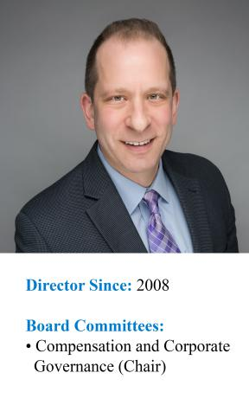
Dr. Davis is the Paul V. Profeta Chair of Real Estate and Academic Director of the Center for Real Estate at Rutgers Business School, where he has worked since September 2014. Dr. Davis is also currently an Adjunct Scholar at the

American Enterprise Institute and is a Senior Scholar of the Opportunity and Inclusive Growth Institute of the Federal Reserve Bank of Minneapolis. Previously, Dr. Davis was the James A. Graaskamp Chair of Real Estate in the Department of Real Estate at the University of Wisconsin-Madison, where he worked from September 2006 through

August 2014. Dr. Davis was also the Academic Director of the James A. Graaskamp Center for Real Estate at the University of Wisconsin-Madison. From July 2002 to August 2006, Dr. Davis was an economist at the Federal Reserve Board working in the Flow of Funds Section. From October 2001 to July 2002, he was Director of Yield

Optimization at Return Buy, Inc. and from August 1998 to October 2001, Dr. Davis was an economist at the Macroeconomics and Quantitative Studies Section of the Federal Reserve Board. Dr. Davis also served on the board of directors of the SkyBridge Opportunity Zone Real Estate Investment Trust, Inc., a private REIT, from November

2018 until September 2019 where he was the chair of the valuation committee. Dr. Davis was also formerly on the Academic Advisory Council of the Federal Reserve Bank of Chicago and served as a Research Associate at the Federal Reserve Bank of Cleveland. Dr. Davis is widely published on issues related to the U.S. housing markets and a

frequent lecturer. He holds a Ph.D. in Economics from the University of Pennsylvania.

Director Qualifications:

Dr. Davis’s extensive expertise in economics, housing policy, and finance matters strengthens our Board’s collective qualifications, skills, experience, and viewpoints.

PETER J. FEDERICO, 56

Professional Experience:

Mr. Federico has served as a Director and our Chief Executive Officer since July 2021 and as our President since March 2018. He previously served as our Chief Operating Officer from March 2018 until July 2021, as Executive Vice President and Chief Financial Officer from July 2016 until March 2018, and as Senior Vice President and Chief Risk Officer from June 2011 until our internalization in July 2016.
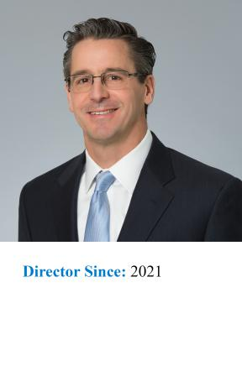

Prior to joining AGNC Investment Corp., Mr. Federico served as Executive Vice President and Treasurer of Freddie Mac from October 2010 through May 2011, where he was primarily responsible for managing the company’s investment activities for its retained portfolio and developing, implementing, and managing risk mitigation strategies. He was also responsible for managing Freddie Mac’s $1.2 trillion interest rate derivative portfolio and short- and long-term debt issuance programs. Mr. Federico also served in a number of other capacities at Freddie Mac, including as Senior Vice President, Asset & Liability Management, during his tenure with the company, which began in 1988. Mr. Federico previously served as President and Chief Operating Officer of MTGE Investment Corp. from March 2018 until May 2018 and as Executive Vice President and Chief Financial Officer of MTGE Investment Corp. from July 2016 until March 2018.

Director Qualifications:
Mr. Federico’s knowledge and understanding of our business as our President and Chief Executive Officer and his expertise in risk mitigation strategies strengthens our Board’s collective qualifications, skills, experience, and viewpoints.

12 AGNC INVESTMENT CORP. - Proxy Statement

Table of Contents

PROPOSAL 1: ELECTION OF DIRECTORS

JOHN D. FISK, 66

Professional Experience:
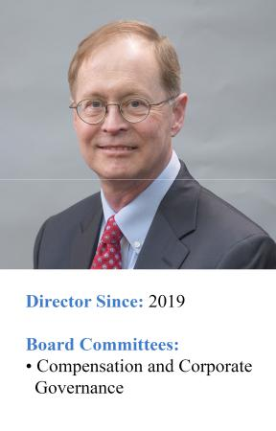
Mr. Fisk retired in March 2019 as the Chief Executive Officer of the FHLBanks Office of Finance, a division of the Federal Home Loan Banks that issues and services all debt securities for the regional Federal Home Loan Banks,

supporting borrowings of $1 trillion. Mr. Fisk had previously served as the Deputy Managing Director and Chief Operating Officer of the FHLBanks Office of Finance from 2004 until 2007 when he became the Chief Executive Officer. Prior to joining the FHLBanks Office of Finance, Mr. Fisk was the Executive Vice President of Strategic

Planning at MGIC Investment Corporation, one of the nation’s largest providers of mortgage insurance, from 2002 until 2004. Mr. Fisk also serves on the Board of Directors of Enact Holdings, Inc., where he chairs the Risk Committee and is a member of the Independent Capital Committee. Mr. Fisk holds an MBA in Finance and Public

Management from The Wharton School at the University of Pennsylvania and a BA from Yale University.

Director Qualifications:

Mr. Fisk’s expertise in the US housing sector, including debt issuance and mortgage insurance, and his senior executive officer experience overseeing human capital management strengthens our Board’s collective qualifications, skills, experience, and viewpoints.

ANDREW A. JOHNSON, JR., 60

Professional Experience:

Mr. Johnson is an investment professional with over 20 years’ experience leading teams focused on fixed income investments. Mr. Johnson served as Managing Director, Head of Global Investment Grade Fixed Income and Chief Investment Officer for Neuberger Berman Investment Advisers, LLC and Neuberger Berman Fixed Income LLC from 2009 to 2019. He retired from his role as Managing Director and Chief Investment Officer in 2019 and transitioned to the role of Senior Diversity and Inclusion Leader at Neuberger Berman Services. In his current position, Mr. Johnson leads the firm’s efforts to improve diversity and inclusion in the workforce across Neuberger Berman entities. Prior to his roles at Neuberger Berman, from 2003 to 2009 Mr. Johnson was a Managing Director, Co-Head Investment Grade Fixed Income and Chief Investment Officer at Lehman Brothers Asset Management, LLC. He currently serves as a Non-Interested Trustee on the Board of Trustees of certain mutual funds advised by Hartford Mutual Funds, Inc. Mr. Johnson holds an MBA in Finance from the University of Chicago and a MSEE and BSEE from Illinois Institute of Technology.

Director Qualifications:
Mr. Johnson’s extensive background in fixed income investments and his experience working to improve diversity and inclusion in the workforce strengthens our Board’s collective qualifications, skills, experience, and viewpoints.

AGNC INVESTMENT CORP. - Proxy Statement 13

Table of Contents

PROPOSAL 1: ELECTION OF DIRECTORS

GARY D. KAIN, 58

Professional Experience:
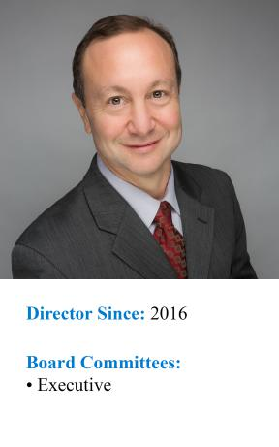
Mr. Kain has served as the Executive Chair of our Board of Directors since July 2021 and has been a Director since March 2016. Previously, he was our Chief Executive Officer from March 2016 until July 2021, Chief Investment

Officer from January 2009 until July 2021, and President from April 2011 until March 2018.

Prior to joining AGNC Investment Corp., Mr. Kain was Senior Vice President of Investments and Capital Markets of Freddie Mac from May 2008 to January 2009. He also served as Senior Vice President of Mortgage
Investments & Structuring of Freddie Mac from February 2005 to April 2008, during which time he was responsible for managing all of Freddie Mac’s mortgage investment activities for the company’s $700 billion retained portfolio. From 2001 to 2005, Mr. Kain served as Vice President of Mortgage Portfolio Strategy at Freddie

Mac. From 1995 to 2001, he was the head trader in Freddie Mac’s Securities Sales & Trading Group, where he was responsible for managing all trading decisions including REMIC structuring and underwriting, hedging all mortgage positions, income generation, and risk management. Prior to that, he served as a senior trader, responsible

for managing the adjustable-rate mortgage and REMIC sectors. Mr. Kain previously served as a Director and Chief Executive Officer of MTGE Investment Corp. (from March 2016 until May 2018 and as Chief Investment Officer from March 2011 until May 2018. In addition, he served as President of MTGE from March 2011 until March 2018.

Director Qualifications:
Mr. Kain’s extensive and lengthy expertise in the Agency mortgage sector and his deep knowledge of our business as our former Chief Executive Officer and Chief Investment Officer strengthens our Board’s collective

qualifications, skills, experience, and viewpoints.

PRUE B. LAROCCA, 71

Professional Experience:

Ms. Larocca has served as our Lead Independent Director since May 2016 and has served as our Vice Chair since July 2021. She previously served as our Chair from May 2016 until July 2021. She is a retired investment banking executive and a widely recognized expert in the areas of housing finance and securitization. Ms. Larocca previously

served as a member of the board of the Housing Preservation Foundation, the Washington School for Girls, and the American Securitization Trade Association. Ms. Larocca was a Managing Director of Royal Bank of Scotland (“RBS”) in the Mortgage Backed and Asset Backed Finance Group from 1997 until her retirement from RBS in 2011.

Prior to joining RBS, Ms. Larocca was a Senior Vice President at Lehman Brothers in the mortgage finance business, managed the consumer and single-family securitization business for the Resolution Trust Corporation, and practiced law with the firms of Milbank, Tweed, Hadley and McCloy and Kutak Rock. She is a graduate of the Georgetown

University Law Center and Indiana University.

Director Qualifications:

Ms. Larocca’s extensive and lengthy expertise in mortgage finance and asset securitization strengthens our Board’s collective qualifications, skills, experience, and viewpoints.

14 AGNC INVESTMENT CORP. - Proxy Statement

Table of Contents

PROPOSAL 1: ELECTION OF DIRECTORS

PAUL E. MULLINGS, 72

Professional Experience:
Mr. Mullings has over 40 years’ experience in the mortgage banking sector. Mr. Mullings served from 2015 until his retirement in 2020 as a Managing Director of The Collingwood Group, a SitusAMC company, a business advisory

and risk management firm focused on the financial services industry. From 2005 to 2015, Mr. Mullings served as a Senior Vice President of Freddie Mac in the Single-Family Business division. While at Freddie Mac, he also served on the Operating, Management and Credit Risk Committees. Prior to joining Freddie Mac, Mr. Mullings was a Senior

Vice President at J.P. Morgan Chase & Co. from 1997 to 2005 in the home finance area. Previously, Mr. Mullings was the President and Chief Executive Officer of the Mortgage Electronic Registration Systems, Inc. (MERS) and the President and Chief Executive Officer of the Residential Mortgage Division of the First Interstate Bank in Los
Angeles. Mr. Mullings received his Overseas Certificate in Business Studies from the College of Arts, Science and Technology in Kingston, Jamaica, following which he became a Member of The Institute of Accounting Staff in conjunction with the Association of Certified Accountants in London, England.

Director Qualifications:
Mr. Mullings’ extensive senior executive officer experience in the mortgage banking sector and the secondary mortgage market strengthens our Board’s collective qualifications, skills, experience, and viewpoints.

FRANCES R. SPARK, 64

Professional Experience:
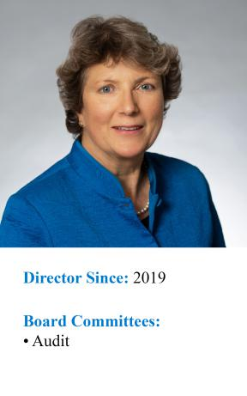
Ms. Spark is an experienced finance professional with broad expertise in mortgage finance and financial reporting for publicly traded companies, including mortgage REITs. Ms. Spark served as the Chief Financial Officer and Treasurer for CYS Investments, Inc., a publicly traded mortgage REIT that invested predominantly in Agency MBS, from 2009

through 2016. Prior to the internalization of CYS’s management in 2011, Ms. Spark also served as the Chief Financial Officer and Treasurer of CYS’s external manager, Sharpridge Capital Management, LP. She had served as a director and Audit Committee chair of CYS from its initial capitalization in 2006 until shortly after its initial public offering.

Prior to CYS, Ms. Spark was the Chief Financial Officer for MVC Capital, Inc., a business development company, from 2003 until 2005. Ms. Spark’s career has included managing Spark Consulting, a privately owned strategic advisory and business consulting firm, and executive positions with financial services firms in the United States and

the United Kingdom. She also served as an independent director and a member of the Audit and Risk Committees of Reverse Mortgage Investment Trust, a private finance company operating in the reverse mortgage industry, from 2015 to 2020. Ms. Spark is a Chartered Accountant and previously worked as an auditor with KPMG in the United

Kingdom. She holds a BS from the University of Southampton in the United Kingdom. Ms. Spark is an “audit committee financial expert” (as defined in Item 407 of Regulation S-K under the Securities Act).

Director Qualifications:
Ms. Spark’s public company accounting, finance, and risk management expertise in the mortgage REIT sector, including her role as a senior executive officer at a publicly traded residential mortgage REIT, strengthens our

Board’s collective qualifications, skills, experience, and viewpoints.

Conclusion and Recommendation; Vote Required

The election of directors nominated in Proposal 1 requires the affirmative vote of a majority of the votes cast by holders of our common stock at

the Annual Meeting. The affirmative vote of a “majority” of the votes cast means that the number of votes cast “for” a director nominee must exceed the votes cast “against” that nominee. In the context of the election of nine directors at the Annual Meeting, it will mean that each of the nine candidates will be required to receive more votes “for” than “against” to be elected. Abstentions and broker non-votes will have no effect on the outcome of the proposal.

THE BOARD OF DIRECTORS RECOMMENDS A VOTE FOR THE ELECTION OF ALL THE NOMINEES NAMED ABOVE.

AGNC INVESTMENT CORP. - Proxy Statement 15

Table of Contents

PROPOSAL 2: ADVISORY RESOLUTION TO APPROVE EXECUTIVE COMPENSATION

PROPOSAL 2:
ADVISORY RESOLUTION TO APPROVE EXECUTIVE COMPENSATION

General Information

As required by Section 14A of the Exchange Act, we are asking for your advisory vote to approve the compensation paid to our named executive officers as disclosed in this proxy statement. Our Board has determined to hold this “say-on-pay” vote every year.

We urge you to review carefully our compensation policies and decisions regarding our named executive officers as presented in the “Compensation Discussion and Analysis,” the accompanying compensation tables, and the related narrative disclosures section appearing on pages 25 to

- As described in detail in this proxy statement, we believe that our executive compensation program applies a pay-for-performance philosophy that effectively aligns the interests of our NEOs with those of our stockholders and allows us to attract, retain, and appropriately incent executives with the skills and experience necessary to achieve our key business objectives.

While the vote on this proposal is advisory in nature and not binding, the Board and the Compensation Committee will take the results of the vote into account in making future compensation decisions.

We are requesting our stockholders to approve, in a non-binding, advisory vote, the following resolution:

“RESOLVED, that the stockholders of the Company hereby approve the compensation paid to our named executive officers, as disclosed in

the proxy statement for the 2023 Annual Meeting of Stockholders pursuant to the disclosure rules of the Securities and Exchange Commission, including the Compensation Discussion and Analysis, compensation tables, and related material disclosed in the proxy statement.”

Conclusion and Recommendation; Vote Required

The affirmative vote of a majority of all shares of common stock cast on the proposal is required for advisory approval of this proposal. Abstentions and broker non-votes will have no effect on the outcome of the proposal. THE BOARD OF DIRECTORS RECOMMENDS A VOTE FOR
APPROVAL OF THE ADVISORY RESOLUTION ON EXECUTIVE COMPENSATION.

16 AGNC INVESTMENT CORP. - Proxy Statement

PROPOSAL 3: ADVISORY VOTE ON THE FREQUENCY OF FUTURE ADVISORY VOTES ON EXECUTIVE COMPENSATION

PROPOSAL 3:
ADVISORY VOTE ON THE FREQUENCY OF

FUTURE ADVISORY VOTES ON EXECUTIVE COMPENSATION

General Information

As required by Section 14A of the Exchange Act and SEC rules, we are asking stockholders to recommend, on a non-binding, advisory basis,

whether the required say-on-pay vote in proposal 2 should occur every one, two or three years. SEC rules require us to submit this vote, commonly referred to as a “say-on-frequency” vote, to stockholders at least once every six years. We previously held a say-on-frequency vote at our 2017 Annual Meeting, where stockholders voted overwhelmingly in favor of conducting the vote every year.

You have the option to vote for any one of the three options: every year, every other year or every third year. The Board has determined that an annual advisory vote on executive compensation is the best approach for the Company at this time based on a number of considerations, including the following:

- While our compensation strategies are intended to align our executives’ pay with the interests of stockholders and compensation decisions relate to both our near-term and longer-term performance, the Board makes compensation decisions annually;
- An annual vote provides stockholders the opportunity to evaluate our performance and executive compensation program more frequently; and
- An annual advisory vote provides us with more frequent feedback on our compensation disclosures and the compensation of our named executive officers. Although the vote on executive compensation is non-binding, our Board takes into account the outcome of the vote when making future decisions about the Company’s executive compensation policies and procedures.

Accordingly, we are recommending that our stockholders vote to conduct an advisory vote on executive compensation every year. Our Board of Directors will carefully consider the outcome of this vote when making future decisions regarding the frequency of advisory votes on executive
compensation. However, because this vote is advisory and not binding, our Board of Directors may decide that it is in the best interests of us and our stockholders to hold an advisory vote on executive compensation more or less frequently than the alternative selected by our stockholders.

Conclusion and Recommendation; Vote Required

The affirmative vote of a majority of all shares of common stock cast on the proposal is required for advisory approval of this proposal. Abstentions and broker non-votes will have no effect on the outcome of the proposal. THE BOARD OF DIRECTORS RECOMMENDS A VOTE FOR
“EVERY YEAR” TO CONDUCT AN ADVISORY VOTE ON EXECUTIVE COMPENSATION.

AGNC INVESTMENT CORP. - Proxy Statement 17

Table of Contents

PROPOSAL 4: RATIFICATION OF APPOINTMENT OF INDEPENDENT PUBLIC ACCOUNTANT

PROPOSAL 4:
RATIFICATION OF APPOINTMENT OF INDEPENDENT PUBLIC ACCOUNTANT

Ernst & Young LLP (“EY”) has served as our independent public accountant since our IPO. The Audit Committee evaluates EY’s performance on an annual basis and makes a determination as to whether the Company should re-engage EY or consider the engagement of another audit firm. At a meeting on February 17, 2023, the Audit Committee approved the appointment of EY to audit our financial statements for 2023. In making this

determination, the Audit Committee carefully considered a number of factors including:

- EY’s independence, objectivity, and professional skepticism;
- EY’s significant knowledge of the Company’s operations, personnel, accounting policies and practices, internal control over financial reporting, and the impact of such knowledge on audit quality;
- EY’s significant industry and sector specific experience, including the number of other mortgage REITs audited by EY;
- the quality and efficiency of services provided by EY based on feedback from Audit Committee members and management;
- EY’s resources, capabilities, technical expertise, including sharing industry insights, trends, and latest practices with the Audit Committee and management;
- EY’s efforts to use technology to increase efficiencies and improve audit quality;
- the quality and candor of EY’s communications;
- recent Public Company Accounting Oversight Board (PCAOB) reports and other publicly available information on the firm;
- the appropriateness of fees charged for audit and non-audit services;
- EY’s compliance with, and practices regarding, the SEC’s rules requiring lead engagement partner rotation every five years; and
- the length of time EY has served as our independent public accountant, the benefits of longer tenure, and the impact of changing auditors.

Based on this evaluation, the Audit Committee determined that it was in the best interests of the Company and our stockholders to continue to engage EY as our independent public accountant. This appointment is subject to ratification or rejection by our common stockholders. A representative of Ernst & Young LLP is expected to be present at the Annual Meeting. The representative will have an opportunity to make a statement if he or she so desires

and is expected to be available to respond to appropriate questions.

Independent Public Accountant’s Fees

EY performed various audit and other services for us during 2022 and 2021. Fees for professional services provided by EY in 2022 and 2021 in each of the following categories were:

 | 2022 | 2021
Audit Fees | $1,875,500 | $1,756,000
Audit-Related Fees | — | —
Tax Fees | 201,316 | 82,680
All Other Fees | — | —
Total Fees | $2,076,816 | $1,838,680

Audit Fees

“Audit Fees” relate to fees and expenses billed by EY for the annual audit, including the audit of our financial statements, services required by statute and regulation, audit of internal control over financial reporting, review of our quarterly financial statements, and for comfort letters and consents
related to stock issuances.

Tax Fees

“Tax Fees” relate to fees billed for professional services for tax compliance and consulting on tax-related matters.

Pre-Approval Policy

All services rendered by EY were permissible under applicable laws and regulations and were pre-approved by the Audit Committee for 2022 in

accordance with its pre-approval policy. The Audit Committee has established a policy regarding the pre-approval of all audit and permissible non-audit services provided by our independent public accountant. The policy requires the Audit Committee to approve each audit or non-audit engagement or accounting project involving the independent public accountant, and the related fees, prior to commencement of the engagement or project to make certain

that the provision of such services does not impair the firm’s independence. The committee may delegate its pre-approval authority to one or more of its members, and such member(s) are required to report any pre-approval decisions to the Audit Committee at its next meeting. The Audit Committee has delegated authority to its Chair to pre-approve the engagement and related fees of the independent public accountant for any additional audit or permissible

non-audit services. In addition, pursuant to the policy, pre-approval is not required for additional non-audit services if such services result in a de minimus amount of less than 5% of the total annual fees paid by us to the independent public accountant during

18 AGNC INVESTMENT CORP. - Proxy Statement

Table of Contents

PROPOSAL 4: RATIFICATION OF APPOINTMENT OF INDEPENDENT PUBLIC ACCOUNTANT

the fiscal year in which the non-audit services are provided, were not recognized by us at the time of engagement to be non-audit services, and are reported to the Audit Committee promptly thereafter and approved prior to the completion of the annual audit.

Conclusion and Recommendation; Vote Required

The affirmative vote of the holders of a majority of all shares of our common stock cast on the proposal is required to ratify the appointment of our independent public accountant. Abstentions will have no effect on the outcome of the proposal. THE BOARD OF DIRECTORS RECOMMENDS A VOTE FOR RATIFICATION OF THE APPOINTMENT OF ERNST & YOUNG LLP AS OUR INDEPENDENT PUBLIC ACCOUNTANT FOR 2023.

AGNC INVESTMENT CORP. - Proxy Statement 19

REPORT OF THE AUDIT COMMITTEE

REPORT OF THE AUDIT COMMITTEE

The Board of Directors has appointed an Audit Committee presently composed of four directors, Mss. Blank, Larocca, and Spark and
Mr. Johnson. Each of the directors is independent as defined in the Nasdaq rules. The Board of Directors has determined that Mss. Blank and Spark are each an “audit committee financial expert” (as defined in Item 407 of Regulation S-K under the Securities Act).

The Audit Committee’s responsibility is one of oversight as set forth in its charter, which is available in the Investors section of our website at ir.agnc.com/corporate-governance-documents. It is not the duty of the Audit Committee to prepare our financial statements, to plan or conduct audits, or to determine that our financial statements are complete and accurate and are in accordance with U.S. generally accepted accounting principles. Our

management is responsible for preparing our financial statements and for maintaining internal controls. The independent auditors are responsible for auditing the financial statements and for expressing an opinion as to whether those audited financial statements fairly present our financial position, results of operations, and cash flows in conformity with U.S. generally accepted accounting principles.

The Audit Committee has reviewed and discussed our audited consolidated financial statements with management and with Ernst & Young LLP, our independent auditors for 2022.

The Audit Committee has discussed with Ernst & Young LLP the matters required to be discussed by the applicable requirements of the Public Company Accounting Oversight Board and the Securities and Exchange Commission.

The Audit Committee has received from Ernst & Young LLP the written statements required by Public Company Accounting Oversight Board Rule No. 3526, “Communications with Audit Committees Concerning Independence,” and has discussed Ernst & Young LLP’s independence with Ernst &
Young LLP, and has considered the compatibility of non-audit services with the auditor’s independence.

Based on the review and discussions referred to above, the Audit Committee recommended to the Board of Directors that the audited consolidated financial statements for the year ended December 31, 2022 be included in our annual report on Form 10-K for the year ended December 31, 2022, for filing
with the Securities and Exchange Commission.

The Audit Committee has approved the appointment of Ernst & Young LLP to serve as our independent public accountants for the year ending December 31, 2023 and has directed that the appointment of Ernst & Young LLP be submitted to our stockholders for ratification.

By the Audit Committee:
Donna J. Blank, Chair
Andrew A. Johnson, Jr.
Prue B. Larocca
Frances R. Spark

20 AGNC INVESTMENT CORP. - Proxy Statement

Table of Contents

PROPOSAL 5: APPROVAL OF AMENDMENTS TO OUR AMENDED AND RESTATED CERTIFICATE OF INCORPORATION ELIMINATING SUPERMAJORITY VOTING REQUIREMENTS

PROPOSAL 5:
APPROVAL OF AMENDMENTS TO OUR AMENDED AND RESTATED CERTIFICATE OF INCORPORATION ELIMINATING SUPERMAJORITY VOTING REQUIREMENTS

General Information

As part of our ongoing review and evaluation of our corporate governance practices, in 2022 the Board considered the advantages and disadvantages of the supermajority voting provisions in our Certificate of Incorporation. At that time, the Board considered that supermajority voting provisions can facilitate corporate governance stability by requiring broad stockholder support in order to effect fundamental changes. However, many investors and others believe that supermajority voting provisions conflict with principles of good corporate governance because the provisions may limit a board’s responsiveness and accountability to stockholders and restrict stockholder participation in corporate governance matters. After considering the advantages and disadvantages of the supermajority voting provisions and evaluating stockholder positions on the issue, the Board recommended that stockholders adopt certain amendments to our Certificate of Incorporation to replace the supermajority voting requirements with a majority voting standard at our 2022 Annual Meeting. While the proposal received overwhelming support from stockholders casting a ballot at the 2022 Annual Meeting, the necessary vote to approve the amendments was not reached, and the proposals were not approved.

At a meeting held on January 26, 2023, our Board again considered the Company’s corporate governance practices and the interests of stockholders in relation to the supermajority voting provisions included in our Certificate of Incorporation. The Board also reviewed the vote results from the 2022 Annual Meeting, and following this review, the Board is again recommending that stockholders at our 2023 Annual Meeting adopt certain amendments to our Certificate of Incorporation to replace the supermajority voting requirements with a majority voting standard. The Company will again engage D.F. King to assist in the solicitation of proxies in an effort to reach the required vote for approval of this Proposal 5.

Our Certificate of Incorporation currently includes supermajority voting requirements for amendments to certain provisions of our Certificate of Incorporation, amendments to our Bylaws, and removal of directors with or without cause. The Board is again this year submitting the proposed amendments as three proposals for approval at the Annual Meeting, as described below. Stockholders will vote on Proposals 5A, 5B, and 5C separately, and the approval of each proposal is not conditioned on the approval of the other proposals. The proposed amendments to our Certificate of Incorporation would become effective upon the filing of a Certificate of Amendment with the Secretary of State of Delaware, which we would file promptly following the Annual Meeting if our stockholders approve the amendments.

Proposal 5A: Amendment to Eliminate the Supermajority Voting Standard for Certain Amendments to our Certificate of Incorporation

Article XII of our Certificate of Incorporation currently provides that the affirmative vote of the holders of at least 66% of the shares of all classes of capital stock then entitled to vote shall be required to amend, repeal, or adopt any provision inconsistent with Article V of the Certificate of Incorporation. Article V relates to the Company’s Board of Directors and includes provisions regarding the number, election, term, removal, and vacancies of directors and general powers of the Board. Proposal 5A requests that stockholders approve an amendment to delete the final sentence of Article XII requiring a supermajority vote. As a result of this amendment, the voting standard for amending any provision inconsistent with Article V would be the same standard as for amendments to other provisions of our Certificate of Incorporation and would require the affirmative vote of the holders of a majority of all the shares of the Company’s capital stock then entitled to vote generally in the election of directors. This majority vote requirement reflects the default voting standard under the Delaware General Corporation Law (the “DGCL”) for certificate of incorporation amendments.

The proposed amendment to Article XII also conforms certain language describing the voting standard in that Article to Section 5.5 to ensure identical language is used to describe the same voting standard throughout our Certificate of Incorporation.

The full text of the proposed amendment, marked to show the proposed deletion and insertion, is set forth in Appendix A of this proxy statement. The general description above of the amended provision on certain amendments to the Certificate of Incorporation is a summary and should be read in conjunction with, and is qualified in its entirety by reference to, the full text of the proposed amendment attached as Appendix A.

Proposal 5B: Amendment to Eliminate the Supermajority Voting Standard for Amendments to Our Bylaws

Article XI of our Certificate of Incorporation currently provides that stockholders may only adopt, amend, alter, change, or repeal the Bylaws of the Company by the affirmative vote of the holders of at least 66% of all classes of the Company’s capital stock entitled to vote generally in the election of directors. Proposal 5B requests that stockholders approve an amendment to Article XI to provide that stockholders may adopt, amend, alter, change, or repeal the Bylaws of the Company by the affirmative vote of the holders of a majority of all the shares of the Company’s capital stock then entitled to vote generally in the election of directors.

AGNC INVESTMENT CORP. - Proxy Statement 21

PROPOSAL 5: APPROVAL OF AMENDMENTS TO OUR AMENDED AND RESTATED CERTIFICATE OF INCORPORATION ELIMINATING SUPERMAJORITY VOTING REQUIREMENTS

The proposed amendment to Article XI also conforms certain language describing the voting standard in that Article to Section 5.5 to ensure identical language is used to describe the same voting standard throughout our Certificate of Incorporation.

The full text of the proposed amendment, marked to show the proposed deletions and insertions, is set forth in Appendix B of this proxy statement. The general description above of the amended provision on amendment of the Company’s Bylaws is a summary and should be read in conjunction with, and is qualified in its entirety by reference to, the full text of the proposed amendment attached as Appendix B.

Proposal 5C: Amendment to Eliminate the Supermajority Voting Standard for Removal of Directors

Currently, Section 5.5 of our Certificate of Incorporation provides that stockholders may remove any director or the entire Board from office at any time with or without cause only by the affirmative vote of the holders of at least 66% of all shares of the capital stock of the Company entitled to vote generally in the election of directors. Proposal 5C requests that stockholders approve an amendment to this standard to provide that stockholders may remove directors with or without cause by the affirmative vote of the holders of a majority of all the shares of the Company’s capital stock then entitled to vote generally in the election of directors. This majority vote requirement reflects the default voting standard under the DGCL.

The full text of the proposed amendment, marked to show the proposed deletions and insertions, is set forth in Appendix C of this proxy statement. The general description above of the amended provision on removal of directors is a summary and should be read in conjunction with, and is qualified in its entirety by reference to, the full text of the proposed amendment attached as Appendix C.

As previously determined by the Board and announced by the Company, if Proposal 5C is not approved by the stockholders, the Company would continue not to enforce the supermajority voting requirement for the removal of directors reflected in Section 5.5 and will instead, to the extent permitted by law, allow such action, if any, to be determined under a majority voting standard.

Conclusion and Recommendation; Vote Required

The Board is submitting and recommending the amendments to the Certificate of Incorporation to replace supermajority voting provisions with a majority voting standard. The approval of Proposals 5A, 5B, and 5C each requires the affirmative vote by the holders of 66% of all shares of our common stock entitled to vote at the Annual Meeting. Abstentions and broker non-votes have the same effect as voting against Proposals 5A, 5B, or 5C. The Board believes that Proposals 5A, 5B, and 5C are each in our best interests and in the best interests of the stockholders and has unanimously approved the proposed amendments to the Certificate of Incorporation. THE BOARD RECOMMENDS A VOTE FOR THE APPROVAL OF PROPOSALS 5A, 5B, AND 5C TO AMEND THE CERTIFICATE OF INCORPORATION TO REPLACE SUPERMAJORITY VOTING REQUIREMENTS WITH A MAJORITY VOTING STANDARD.

22 AGNC INVESTMENT CORP. - Proxy Statement

Table of Contents

EXECUTIVE OFFICERS

EXECUTIVE OFFICERS OF REGISTRANT

Executive Officer Biographies

The Board generally elects officers annually following our annual meeting of stockholders to serve until the meeting of the Board following the next annual meeting. Set forth below is certain information about each executive officer as of February 24, 2023. The business address of each executive
officer is c/o AGNC Investment Corp., 2 Bethesda Metro Center, 12th Floor, Bethesda, Maryland 20814.

PETER J. FEDERICO, 56
Director, President and Chief Executive Officer

Mr. Federico has served as a Director and as our Chief Executive Officer since July 2021 and as our President since March 2018. He previously served as our Chief Operating Officer from March 2018 until July 2021, Executive Vice President and Chief Financial Officer from July 2016 until March 2018, and
Senior Vice President and Chief Risk Officer from June 2011 until July 2016. Further information about Mr. Federico may be found under “Proposal 1:
Election of Directors-Director Nominee Biographies and Qualifications” of this proxy statement.

GARY D. KAIN, 58
Director, Executive Chair

Mr. Kain has served as a Director since 2016 and as our Executive Chair since July 2021. He previously served as our Chief Executive Officer from March

2016 through July 2021, Chief Investment Officer from January 2009 through July 2021, and President from April 2011 until March 2018. Further information about Mr. Kain may be found under “Proposal 1: Election of Directors-Director Nominee Biographies and Qualifications” of this proxy statement.

CHRISTOPHER J. KUEHL, 49
Executive Vice President, Agency Portfolio Investments and Chief Investment Officer

Mr. Kuehl has served as our Chief Investment Officer since July 2021 and as an Executive Vice President since November 2016. He was previously a Senior Vice President from March 2012 through October 2016.

Prior to joining AGNC Investment Corp., Mr. Kuehl served as Vice President of Mortgage Investments & Structuring of Freddie Mac. In this capacity, Mr. Kuehl was responsible for directing Freddie Mac’s purchases, sales, and structuring activities for all MBS products, including fixed-rate mortgages,
ARMs, and CMOs. Prior to joining Freddie Mac in 2000, Mr. Kuehl was a Portfolio Manager with TeleBank/Etrade Bank.

BERNICE E. BELL, 51
Executive Vice President and Chief Financial Officer

Ms. Bell has served as our Executive Vice President since January 2022 and Chief Financial Officer since March 2018. Ms. Bell previously served as

Senior Vice President from January 2016 to January 2022, Chief Accounting Officer from January 2016 to March 2018, Vice President from April 2011 to January 2016, and as our Controller from 2008 through December 2015.

Prior to joining AGNC Investment Corp., Ms. Bell served as the Vice President and Controller of American Capital, Ltd. from July 2003 to December

2009. Prior to joining American Capital, Ms. Bell was the Vice President and Controller of certain privately-held companies engaged in the business of telecommunications and software development from July 1998 to June 2003 and was with the accounting firm Price Waterhouse, LLP from July 1994 to June 1998.

KENNETH L. POLLACK, 55

Executive Vice President, General Counsel, Chief Compliance Officer, and Secretary

Mr. Pollack has served as our Executive Vice President since January 2022 and our General Counsel, Chief Compliance Officer, and Secretary since July 2016. Mr. Pollack previously served as Senior Vice President from July 2016 until January 2022.

Prior to joining AGNC Investment Corp., Mr. Pollack was Senior Vice President and Deputy General Counsel of American Capital, Ltd. At American

Capital, Mr. Pollack served as lead counsel for American Capital’s portfolio investment activities in the areas of Real Estate, U.S. Sponsor Finance, U.S.
Buyouts, International Power, Special Situations, Operations, and Financial Restructuring.

AGNC INVESTMENT CORP. - Proxy Statement 23

Table of Contents

EXECUTIVE OFFICERS

Mr. Pollack joined American Capital in 2004. Prior to American Capital, Mr. Pollack was an Associate in the Corporate and Securities and Real Estate Practice Groups of Arnold & Porter.

SEAN P. REID, 47
Executive Vice President, Strategy and Corporate Development

Mr. Reid has served as our Executive Vice President, Strategy and Corporate Development since January 2022. He previously served as Senior Vice

President from July 2016 until January 2022 and as Senior Vice President, Corporate and Business Development for our former manager from August 2013 to July 2016.

Mr. Reid was previously a Vice President in the Washington, D.C. Buyouts group of American Capital, Ltd. and, prior to that, an Assistant General Counsel

with American Capital’s in-house legal team. Prior to joining American Capital, Mr. Reid was an Associate in the Corporate & Securities practice group of Covington & Burling in Washington, D.C.

24 AGNC INVESTMENT CORP. - Proxy Statement

Table of Contents

EXECUTIVE COMPENSATION

 | EXECUTIVE COMPENSATION
 | Compensation Discussion and Analysis
2022 NEOs
Our NEOs for 2022 are:
Name | Title
Peter J. Federico | President and Chief Executive Officer
Gary D. Kain | Executive Chair
Christopher J. Kuehl | Executive Vice President and Chief Investment Officer
Bernice E. Bell | Executive Vice President and Chief Financial Officer
Kenneth L. Pollack | Executive Vice President, General Counsel, Chief Compliance Officer, and Secretary

Executive Summary

This Compensation Discussion and Analysis provides information on our executive compensation philosophy, objectives, structure, and our process for setting compensation for our named executive officers, or NEOs.

Business Overview

AGNC is a leading provider of private capital to the U.S. housing market, enhancing liquidity in the residential real estate mortgage markets and, in turn, facilitating home ownership in the U.S. AGNC is an internally managed REIT that invests predominantly in Agency residential mortgage-backed securities funded through a combination of equity capital and collateralized borrowings structured as repurchase agreements. We seek to provide investors

with favorable long-term returns on a risk-adjusted basis through attractive monthly dividends, while maintaining the lowest operating cost structure among residential mortgage REITs. We generate income from the interest earned on our investment assets, net of associated borrowing and hedging costs, and net realized gains and losses on our investments and hedging activities. As such, our business operations are similar to investment managers that focus on fixed

income investments, although we exclusively invest AGNC’s capital rather than third-party client funds.

Our Business in the Context of our Broader Industry

We are the second largest residential mortgage REIT overall by market capitalization, total assets, and total equity when compared to the 18 other

residential-focused mortgage REITs included in The Bloomberg Mortgage REIT Index (BBREMTG) as of December 31, 2022, and we refer to these other 18 REITs collectively as the “Resi mREIT Universe.”¹ Some of these 18 REITs have an investment focus similar to AGNC, but most of these REITs have strategies that place a greater emphasis on credit-sensitive assets than our portfolio. Moreover, many of the mortgage REITs in the Resi mREIT Universe

are externally managed by a third party and pay the third party a management fee as a set percentage of equity (plus, in some cases, a performance incentive fee) in lieu of compensating employees directly. In an external management structure, the third-party manager, rather than the REIT, is responsible for the compensation and benefits of its executives and other employees, which are paid out of the management fee. As an internally managed

REIT, AGNC is directly responsible for determining executive compensation and providing disclosure regarding its compensation philosophy and programs. We believe our internal management structure allows us to closely align our compensation programs to our and our stockholders’ long-term interests.

- The residential mREIT universe is unweighted and includes AG Mortgage Investment Trust, Inc. (“MITT”), Annaly Capital Management, Inc. (“NLY”), ARMOUR Residential REIT, Inc. (“ARR”), Chimera Investment Corporation (“CIM”), Dynex Capital, Inc. (“DX”), Cherry Hill Mortgage Investment Corporation (“CHMI”), Ellington Financial, Inc. (“EFC”), Ellington Residential Mortgage REIT (“EARN”), Great Ajax Corp. (“AJX”), Invesco Mortgage Capital Inc. (“IVR”), MFA Financial, Inc. (“MFA”), New York Mortgage Trust, Inc. (“NYMT”), Orchid Island Capital, Inc. ("ORC"), PennyMac Mortgage Investment Trust (“PMT”), Redwood Trust, Inc. (“RWT”), Rithm Capital Corp. (“RITM”), Two Harbors Investment Corp. (“TWO”), and Western Asset Mortgage Capital Corporation (“WMC”, and collectively, the “Resi mREIT Universe”).

AGNC INVESTMENT CORP. - Proxy Statement 25

Table of Contents

EXECUTIVE COMPENSATION

AGNC seeks to generate attractive risk-adjusted returns for our stockholders and offers a track-record of industry leading financial performance and the lowest cost operating structure in the residential mortgage REIT industry. Our value proposition to stockholders includes five key aspects of our business:
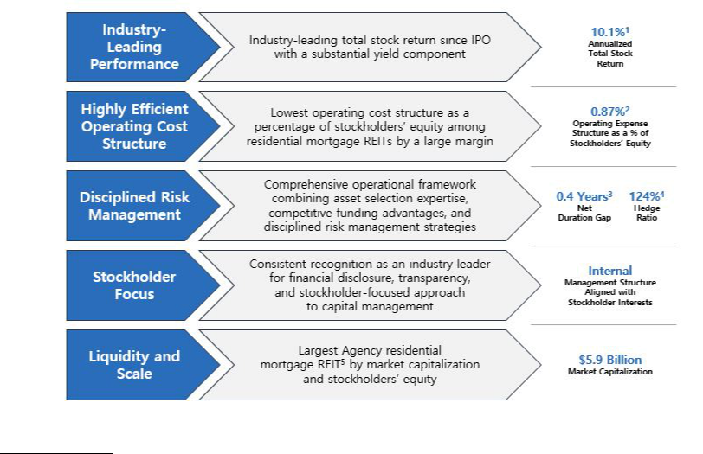

- Annualized total stock return is measured from AGNC’s IPO in 2008 through December 31, 2022. Total stock return over a period includes price appreciation and dividend reinvestment; dividends are assumed to be reinvested at the closing price of the security on the ex-dividend date. Source: Bloomberg.
- AGNC’s operating cost structure is based on average stockholders’ equity for the twelve-month period ended December 31, 2022; it includes compensation and benefits and general and administrative expenses.
- Duration is shown as of December 31, 2022; it is a model estimate of interest rate sensitivity measured in years as of a single point in time. AGNC’s Net Duration Gap is a measure of the difference between the interest rate sensitivity of our assets and our liabilities, inclusive of interest rate hedges.
- Hedge Ratio is shown as of December 31, 2022; it is measured as the ratio of interest rate swaps, swaptions, and net U.S. Treasury position to Agency repo, other debt, net TBA, and forward settling securities positions (at cost).
- “Agency residential mortgage REIT” includes issuers with greater than 90% of capital invested in Agency MBS.

26 AGNC INVESTMENT CORP. - Proxy Statement

Table of Contents

EXECUTIVE COMPENSATION

2022 Year in Review

In 2022, financial markets endured a difficult transition resulting from the Federal Reserve (the “Fed”) policy pivot from an extremely accommodative policy following the Pandemic and the associated economic impact to an aggressive tightening cycle to combat significant inflationary pressures. Interest rates across the yield curve rose materially as the Fed raised the Federal Funds rate by 4.25% in just nine months. The yield on ten-year U.S. Treasury securities rose by nearly 2.5%, generating a total return for these bonds of -15% in 2022, the worst annual performance in decades. In sharp market downturns, Agency MBS tend to initially underperform other fixed income asset classes, and 2022 was no exception. Agency MBS yield spreads to benchmark interest rates across all coupons reached historically wide levels, and the unlevered Bloomberg U.S. MBS Index total return for the year was -12%, its worst annual performance since the Index's inception in 1976.

Against this challenging macroeconomic backdrop, AGNC posted an economic return of -28.4%, comprised of $1.44 of dividends per common share and a $5.91 decrease in tangible net book value per common share. The Company maintained its dividend of $0.12 per common share per month without change despite these economic headwinds. Although AGNC modestly underperformed our Agency REIT Peer Group¹ on an economic return basis in 2022 (-28.4 % for AGNC vs. - % for our Agency REIT Peer Group), AGNC’s total stock return for the year materially exceeded the total stock return of the Agency REIT Peer Group (-22% for AGNC vs. -30% average for Agency REIT Peer Group members). AGNC's outperformance on a total stock return basis is even more notable over the three- and five-year horizons, in which it posted annualized total stock returns of -7% (versus -21% for the Agency REIT Peer Group average) and -2% (versus -14% for the Agency REIT Peer Group average), respectively. In addition, AGNC maintained the lowest operating expense ratio as a percentage of stockholders’ equity among residential mortgage REITs for the sixth consecutive year, comprising every full calendar year since AGNC’s internalization on July 1, 2016.²

In addition, bolstering our primary focus on generating favorable risk-adjusted returns for our stockholders, AGNC executed upon a number of strategic and operational initiatives in 2022 to enhance our franchise value, including numerous operational measures implemented to improve operating efficiency and risk management processes, capital activities including accretive common and preferred equity issuances and common stock repurchases, continued improvement of our ESG and sustainability disclosure and practices, and enhancements of our corporate communications and investor outreach initiatives. These activities are described in greater detail in our Strategic and Operational Review on page 35.

- Our Agency REIT Peer Group is unweighted and includes Annaly Capital Management, Inc. (“NLY”), ARMOUR Residential REIT, Inc. (“ARR”), Dynex Capital, Inc. (“DX”), Invesco Mortgage Capital Inc. (“IVR”), Orchid Island Capital, Inc. ("ORC"), and Two Harbors Investment Corp. (“TWO” and collectively, the “Agency REIT Peer Group”).
- For mortgage REITs other than AGNC, cost structures are based on operating expenses and average stockholders’ equity (excluding noncontrolling interests, as applicable) over the applicable year as publicly reported by such REITs. Operating costs include expenses for compensation and benefits, management fees, incentive fees (if applicable), and G&A and may include one-time or nonrecurring expenses. Operating costs exclude direct costs associated with operating activities, such as loan acquisition costs, securitization costs, servicing expenses, etc. to the extent publicly disclosed by such REITs. AGNC’s cost structure is based on operating expenses for the applicable year and average stockholders’ equity. AGNC’s net operating expense ratio includes compensation and benefits and G&A, excludes non-cash amortization charges and nonrecurring cash expenses associated with the Company’s internalization in 2016, and was net of management fee income from MTGE Investment Corp. during the period of AGNC’s management of MTGE Investment Corp.

Despite the challenges faced in 2022, AGNC’s annualized total stock return since our IPO remains very favorable on an absolute basis at 10.1% and significantly exceeds the Bloomberg Mortgage REIT Index and relevant S&P 500 industry groups (Financials and Real Estate).

AGNC INVESTMENT CORP. - Proxy Statement 27

Table of Contents

EXECUTIVE COMPENSATION
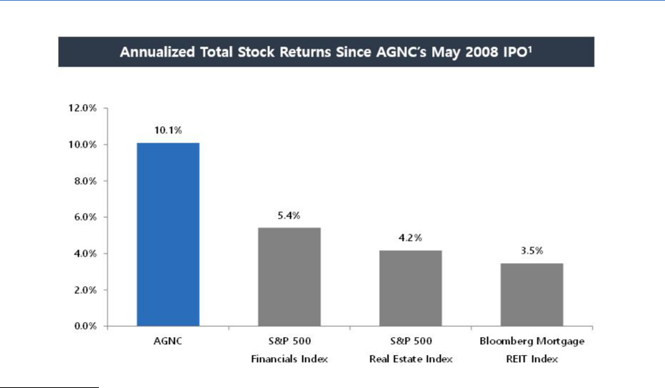

- Total stock return is measured from AGNC’s IPO through December 31, 2022. Total stock return over a period includes price appreciation and dividend reinvestment; dividends are assumed to be reinvested at the closing price of the security on the ex-dividend date. Source: Bloomberg.

Compensation Philosophy and Objectives

Compensation Program Objectives

The compensation programs for all of our employees, including our NEOs, are designed to focus on key strategic and financial objectives including:

Pay-for-Performance |  | Link compensation to achievement of short- and long-term financial and strategic goals
Attraction and Retention |  | Attract and retain a high-quality team with skills necessary to outperform industry peers and achieve AGNC’s
 |  | strategic objectives
Alignment with Stockholders |  | Align the interests of executive officers, employees, and stockholders by tying elements of realized compensation to
 |  | stockholder value
Financial Efficiency |  | Maintain a low-cost operating structure that maximizes financial efficiency from a tax, accounting, and cash flow
 |  | perspective
Strong Compensation |  | Employ high quality practices in governance of executive compensation
Governance
28 | AGNC INVESTMENT CORP. - Proxy Statement

Table of Contents

EXECUTIVE COMPENSATION

In support of these objectives, AGNC provides all of its employees total compensation in the form of base salary, annual performance-based incentives, and long-term incentive awards. The following describes the components of our NEO compensation program:
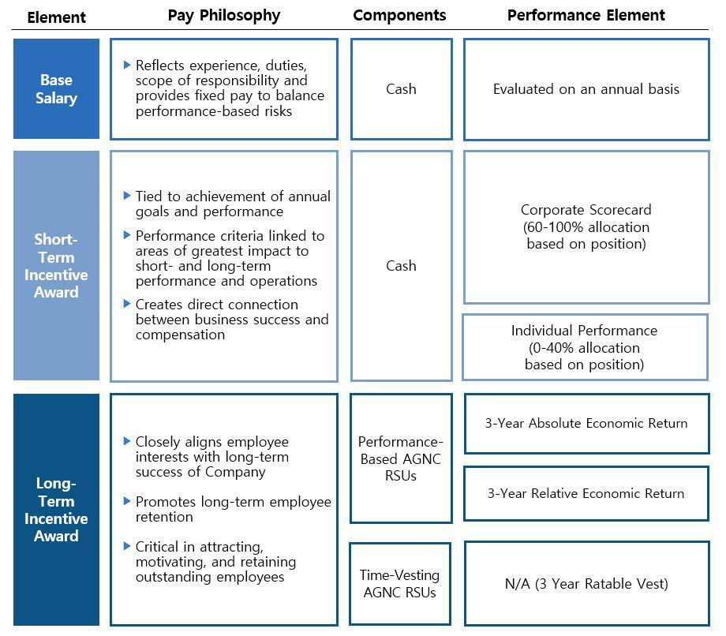

Stockholder Engagement

In 2022, 89% of our stockholders present or represented at the annual meeting and entitled to vote on the matter supported our advisory resolution

on executive compensation, which we believe reflects the positive support for the construction of our executive compensation program after taking into account stockholder feedback.

We value regular engagement with our stockholders, including through our quarterly earnings calls, investor conferences, fall and spring

engagement campaigns, and outreach through our Investor Relations department. We continued our robust program in 2022. Throughout the year, we participated in 11 investor conferences, including retail network calls hosted by research analysts, held over 125 meetings and calls with institutional investors, and responded to over 360 letters, emails, and calls from retail investors. We engaged with our retail investors through our Investor Relations

Department and as facilitated through collaboration with our proxy solicitor. In the Fall of 2022, we sought meetings with our top 50 institutional stockholders, who collectively hold 81% of our institutionally held common stock, and the two largest proxy advisory firms to engage on governance related topics, including executive compensation. Most of our institutional investors and the two proxy advisory firms declined our request, noting that

there

AGNC INVESTMENT CORP. - Proxy Statement 29

Table of Contents

EXECUTIVE COMPENSATION

was no need to engage this year. Stockholders with whom we met expressed support for our governance initiatives and our approach to ESG disclosure and did not voice concerns about our executive compensation program.

We continuously work to improve our stockholder engagement efforts and value the feedback provided to us during this process. Engagement with our stockholders regarding our compensation policies and practices has played a significant role in the evolution of our compensation program.
Summary of Compensation Changes in 2022

The Compensation Committee continually evaluates our compensation program and considers stockholder feedback, industry trends, and
comparative pay analysis. In 2021, the compensation packages for Messrs. Kain, Federico, and Kuehl were adjusted as a result of the promotion of Messrs.

Federico and Kuehl to the roles of Chief Executive Officer and Chief Investment Officer, respectively, and Mr. Kain’s transition to the role of Executive Chair. Messrs. Federico and Kuehl each received increases in their target bonus levels and their target LTI in 2021 commensurate with their mid-year promotions. Although no changes were made to the target compensation of Messrs. Kain, Federico, and Kuehl in 2022, their annual target compensation

changed relative to 2021 as 2022 compensation levels reflected a full-year of service in their new roles and with corresponding pay adjustments. Consequently, Mr. Federico’s target total direct compensation for 2021 was $7,000,000, and his target total direct compensation for 2022 was $9,000,000. Mr. Kain’s base salary, target bonus, and target LTI were reduced as a result of his transition to the role of Executive Chair of our Board and corresponding

adjustment in his day-to-day responsibilities to the Company, though 67% of his LTI continues to be allocated to performance-based RSUs. Mr. Pollack and Ms. Bell were each promoted to Executive Vice President, and, after examining compensation practices at comparable companies and considering their roles and functions performed, the Compensation Committee also increased target annual compensation for them to the levels reflected in this

Compensation Discussion and Analysis.

Composition of NEO Compensation

The Compensation Committee believes that incentive compensation should be a substantial component of each executive’s total compensation package. In 2022 all executives received at least 40% of their total compensation in the form of LTI, with 67% of LTI awards at target being performance vesting. The charts demonstrate the pay mix for our NEOs in 2022:
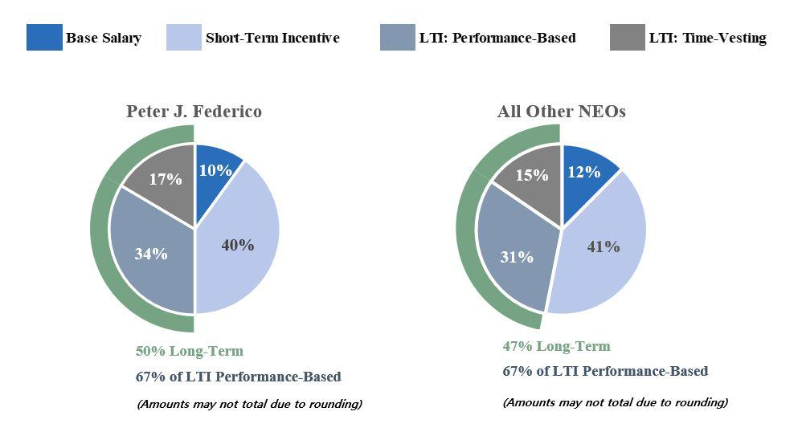

30 AGNC INVESTMENT CORP. - Proxy Statement

Table of Contents

EXECUTIVE COMPENSATION

Compensation Governance Practices

To support our compensation philosophy and objectives, we are committed to the following compensation governance practices:

What we do:

- Focus on retention of high-performing employees
- Pay for performance
- Align executive and stockholder interests
- Impose stock ownership guidelines for our executive officers
- Prohibit our directors and executive officers from hedging, pledging, and short selling Company stock
- Engage an independent compensation consultant
- Maintain a clawback policy
- Provide long-term equity incentive compensation to all of our employees
- Conduct an annual review of our compensation program based on market conditions, performance, and stockholder feedback

What we don’t do:

- Pay based on a percentage of assets under management
- Provide tax gross-ups
- Provide special perquisites for executives
- Maintain supplemental retirement benefit plans
- Make option grants below fair market value
- Reprice stock options
- Provide for “single-trigger” severance or vesting acceleration

AGNC INVESTMENT CORP. - Proxy Statement 31

Table of Contents

EXECUTIVE COMPENSATION

Compensation Program in Detail

Compensation Program Elements

The Compensation Committee believes it is important to pay our NEOs in a manner that balances short- and long-term compensation and cash and

equity-based compensation. Our NEOs’ compensation program includes three primary elements: base salary, short-term incentives in the form of an annual cash bonus, and long-term equity incentives, with a significant portion subject to multi-year performance-based vesting.

The Compensation Committee’s philosophy on pay mix applies throughout the entire organization, with all AGNC employees receiving a portion

of their compensation in the form of short-term and long-term incentives. The proportion of an individual’s target total direct compensation opportunity in the form of variable incentive-based elements relative to fixed elements is directly correlated to the individual’s level of responsibility and role in the organization. Employees with greater seniority and greater responsibility have higher proportions of incentive-based compensation in their target mix.

Similarly, within the incentive-based elements, the proportion of LTI generally corresponds with the individual’s level of responsibility in the organization.

Base Salary

Base salary provides a baseline level of cash compensation to our NEOs and is a fixed expense for the Company. The Compensation Committee established base salaries for our NEOs considering a variety of factors, including:

- the competitive market for executive officers
- the scope of each executive officer’s responsibilities
- the highly complex and unique services provided by our NEOs
- the desire to retain our NEOs
- the duties and responsibilities of the NEOs
- internal and external pay equity

The Compensation Committee reviews the base salaries for our NEOs annually and at the time of a promotion or other change in responsibilities, and salaries may be adjusted after considering the above factors. The annual base salaries set forth in the table below are the minimum levels required in
each executive’s respective employment agreement. The base salary level for each of our NEOs was unchanged from 2021, with the exception of Mr. Kain, whose base salary in 2022 decreased as a result of his transition to the role of Executive Chair.

NEO | 2022 Base Salary
Peter J. Federico | $900,000
Gary D. Kain | $500,000
Christopher J. Kuehl | $900,000
Bernice E. Bell | $500,000
Kenneth L. Pollack | $500,000

Annual Bonus

The Compensation Committee has established performance criteria for short-term incentives that directly correspond to the areas of greatest impact to our short- and long-term performance and operations, creating a direct connection between business success and our NEOs’ compensation. Each NEO’s target for short-term incentive compensation, set forth in the table below, is determined based on an evaluation of the same factors used in setting

base salaries.

NEO | 2021 Target Annual Bonus | 2022 Target Annual Bonus
Peter J. Federico | $2,700,000 ¹ | $3,600,000
Gary D. Kain | $4,500,000 ² | $3,600,000
Christopher J. Kuehl | $1,800,000 ³ | $2,000,000
Bernice E. Bell | $1,000,000 | $1,250,000
Kenneth L. Pollack | $850,000 | $1,000,000

- Reflects a prorated amount based on a target annual bonus of $1,800,000 for the period from January 1, 2021 through June 30, 2021 and $3,600,000 for the period from July 1, 2021 through December 31, 2021 corresponding to his promotion to Chief Executive Officer.
- Reflects a prorated amount based on a target annual bonus of $5,400,000 for the period from January 1, 2021 through June 30, 2021 and $3,600,000 for the period from July 1, 2021 through December 31, 2021 corresponding to his transition to Executive Chair.
- Reflects a prorated amount based on a target annual bonus of $1,600,000 for the period from January 1, 2021 through June 30, 2021 and $2,000,000 for the period from July 1, 2021 through December 31, 2021 corresponding to his promotion to Chief Investment Officer.

The target bonuses for Messrs. Kain, Federico, and Kuehl in 2022 reflect the first full-year at their target levels following Mr. Kain’s transition to the role of Executive Chair and the promotion of Messrs. Federico and Kuehl to the roles of Chief Executive

32 AGNC INVESTMENT CORP. - Proxy Statement

Table of Contents

EXECUTIVE COMPENSATION

Officer and Chief Investment Officer, respectively, in July 2021. Compensation for each of Messrs. Kain, Federico, and Kuehl were pro-rated in 2021 to reflect their changed roles during the year. In 2022, the Compensation Committee also evaluated the compensation package provided to our other NEOs in consultation with FW Cook. As part of this review, the Compensation Committee examined compensation practices at comparable companies and

considered the scope of each NEO’s responsibilities. After considering these factors, the Compensation Committee determined it was appropriate to increase Ms. Bell’s bonus target to 250% of her base salary and increase Mr. Pollack's bonus target to 200% of his base salary for 2022.

Corporate Scorecard for Calculating Annual Bonus

The Compensation Committee uses a Corporate Scorecard to assist in its evaluation of NEO performance and awarding annual cash bonuses. The Corporate Scorecard establishes a framework that incentivizes and rewards behavior over a broad range of circumstances, and as described in greater detail below, the 2022 Corporate Scorecard was based on a mix of financial and strategic measures that corresponded to the core elements of our value

proposition for stockholders. We believe the goals and measures included in the Corporate Scorecard effectively align NEO short-term incentives with financial, strategic, and operational performance of greatest importance to our business. Under the 2022 Corporate Scorecard, actual payouts can range from 0% to 150% of target for each metric, with category and metric weights as assigned by the Compensation Committee, and payouts for performance

between the threshold and maximum level of each measure are determined through linear interpolation. The cash bonuses for Messrs. Kain and Federico were based solely on achievement of the Corporate Scorecard measures. The other NEOs’ short-term cash incentives were based predominantly on the Corporate Scorecard measures and to a lesser extent on personal performance.

2022 Corporate Scorecard

The Compensation Committee annually reviews the appropriateness of the Corporate Scorecard and considers feedback from stockholders as part of their deliberations. In response to feedback received during investor outreach in prior years, we revised the Corporate Scorecard in 2019 to increase the
weighting of financial performance and realign the strategic and operational objectives more directly with the Company’s value proposition to stockholders. In 2020, we increased the rigor of the relative annual economic return measure by raising the base target to 1% (above peer group average) from 0% (equal to peer group average), with the threshold and outperformance bounds each also increased by 1% to reflect appropriate ranges based upon the historical

distribution of results and other factors.

In conducting its annual review in January 2022, the Compensation Committee determined that it was appropriate to reallocate the weightings of the financial performance metrics. Prior to 2022, the financial performance metrics were weighted equally (25% each) among three components: (i)
absolute annual economic return, (ii) relative annual economic return and (iii) relative price-to-tangible book ratio. For the 2022 Corporate Scorecard, the Compensation Committee adjusted the weightings to reduce relative price-to-tangible book ratio from 25% to 15% and increase relative annual economic return from 25% to 35%. The Compensation Committee concluded that revising the allocation among the relative measures to increase relative annual

economic return better aligns the scorecard with the performance metrics prioritized by investors. In addition, the Compensation Committee determined that market conditions and stock price volatility among the Agency REIT Peer Group made the relative price-to-tangible book ratio a less reliable indicator of performance. The Compensation Committee also revised the strategic and operational metrics to include ESG factors as a standalone element, reflecting
our increased focus on sustainability and human capital as discussed further on page 7. With these changes, the Compensation Committee determined that
the other Corporate Scorecard measures and performance levels adopted in January 2020 and applied in 2021 remained appropriate for 2022 when taking
into consideration numerous factors, including continued alignment of the Corporate Scorecard with the Compensation Committee’s overall compensation

philosophy, the level of rigor of the goals and objectives in light of market conditions, and relevant feedback from stockholders. As in prior years, the Compensation Committee set the financial measures for the Corporate Scorecard in January 2022 following an evaluation of historic performance over a five-year period, back-testing financial measures over this period to evaluate hypothetical payout levels when applying the Corporate Scorecard to those

periods, and our high-level forecast. Although the outlook for financial markets remained uncertain at the outset of 2022, the Compensation Committee also weighed the value of maintaining consistency in measures. Following this review, the Compensation Committee concluded that the threshold, target, and outperformance levels for the Corporate Scorecard financial measures, weighted at 75% of the overall Corporate Scorecard, remained challenging for

2022 in a market environment marked by ongoing recovery from the Pandemic’s economic shocks, rapidly changing monetary policy, and continued economic uncertainty. The Compensation Committee also determined that it remained appropriate to continue including non-financial strategic and operational objectives weighted at 25% of the overall Corporate Scorecard.

Our Corporate Scorecard was designed to incentivize and reward results over a broad range of circumstances through balanced weightings of absolute and relative financial performance and strategic and operational objectives.

AGNC INVESTMENT CORP. - Proxy Statement 33

Table of Contents

EXECUTIVE COMPENSATION

Financial Metrics (75% of Total Corporate Scorecard)

Performance Continuum

Category | Performance | Metric | Below |  |  | Out-
Weight | Metric | Weight | Threshold | Threshold | Target | performance
 | Absolute Economic Return 1 | 25.0% | < 0.0% | 0.0% | 10.0% | ≥ 17.0%
75% | Economic Return vs. Peer Index 1,2 | 35.0% | < (5.0%) | (5.0%) | 1.0% | ≥ 5.5%
 | Price-to-Tangible Book Ratio vs. Peer Index 2 | 15.0% | < (6.5%) | (6.5%) | 3.5% | ≥ 11.0%
 |  |  | Payout Continuum (% of Metric Weight)
 |  |  | 0% | 50% | 100% | 150%

- Economic return is calculated on tangible common equity per share.
- Reflects AGNC’s relative performance to the unweighted, simple average of the Agency REIT Peer Group. Our relative economic return measure is calculated on an October 1 – September 30 year basis due to the availability of comparative data.

The financial measures emphasized our focus on generating strong absolute and relative economic returns and maintaining a strong common stock trading price to tangible book value relative to our peers.

Our economic return reflects the overall return we generate on our common equity capital and is comprised of our dividends declared and the change in the tangible net book value per share of common stock over the relevant period. As such, it incorporates all aspects of our investment activity,
including interest received on our investments, net of borrowing costs, and realized and unrealized gains and losses on our investments, hedging instruments, and other assets and liabilities. We believe this measure best reflects a composite view of AGNC’s financial performance over any time period. Most investors and research analysts active in the residential mortgage REIT sector utilize this metric as a primary factor in analyzing residential mortgage

REIT performance.

Our Compensation Committee has included both absolute and relative economic return as separate financial performance measures. Our inclusion of absolute economic return is reflective of our focus on generating positive economic returns for our stockholders and supporting our dividend, regardless
of overall macroeconomic conditions. Relative economic return has been included to provide a comparison of our performance against our peers and to reward our management team and employees for outperformance. While a favorable macroeconomic climate may drive a strong absolute economic return, relative economic return requires out-performance relative to peers, all of which are subject to the same prevailing macroeconomic conditions. For 2022,

our Compensation Committee retained our target goal of absolute economic return at 10% and set the target goal for relative economic return at 1% above the Agency REIT Peer Group average. These goals reflect the Compensation Committee’s view that an absolute economic return target of 10% would be appropriately challenging and that outperformance of the peer average by 1% should be the base target for relative economic return.

Our third financial measure is our stock price to tangible net book value per share, or “price-to-book ratio,” relative to peers. Our Compensation Committee has set our target relative price-to-book ratio at a significant premium of 3.5% to the Agency REIT Peer Group average. Price-to-book ratio is a valuation metric utilized by many investors and research analysts and reflects the premium (or discount) to tangible net book value of a company implied

by the company’s stock price. As such, the price-to-book ratio for AGNC relative to peers may in certain market environments imply the relative perception by the market of, or outlook for, AGNC as compared to its peer group. We believe that our track record of favorable long-term financial performance, low -cost operating structure, disciplined risk management, stockholder focus, and significant scale and liquidity should position AGNC for a

premium valuation relative to our peer group in most market environments.

Collectively, our three financial measures incentivize our management team to drive favorable returns – on both an absolute and relative basis – for our stockholders. Our success in generating economic returns at or above target levels while maintaining targeted premium valuation levels on a price-to-book basis should translate into favorable total stock returns for our stockholders. As such, we believe these metrics appropriately align our short-term

incentive plan with our stockholders.

Strategic and Operational Metrics (25% of Total Corporate Scorecard)

As noted above, our Compensation Committee believes our value proposition should position AGNC for a premium valuation. Our Compensation Committee seeks to drive management performance in these areas and focuses our strategic and operational efforts on the following components:

- Operating Efficiency: maintain low operating cost structure relative to peers and continually identify opportunities to improve operations across functional groups where practicable

- Disciplined Risk Management: mitigate business and operational risk based on the Company’s comprehensive risk management framework
- Stockholder Focus and Capital Management: provide detailed and transparent financial disclosure, actively engage with stockholders, and maintain an active stockholder-friendly approach to capital management consistent with broader market considerations

- ESG Framework: incorporate material ESG and sustainability factors into our strategy, business, and operations and provide disclosure regarding ESG and corporate sustainability philosophy and practices

34 AGNC INVESTMENT CORP. - Proxy Statement

Table of Contents

EXECUTIVE COMPENSATION

Annual 2022 Corporate Scorecard Incentive Compensation Determination

Following a review of each of the components of the 2022 Corporate Scorecard, the Compensation Committee calculated a total scorecard payout for 2022 of 61.9% of target. This below-target and significantly reduced payout ratio relative to prior years was reflective of the Company’s financial performance in 2022. A more detailed discussion regarding each of the elements included in the Corporate Scorecard is provided below.

Index | Index | Index | Weighted
 | Weight | Payout | Payout
Financial Metrics | 75% | 49.2% | 36.9%
Strategic / Operational Metrics | 25% | 100.0% | 25.0%
Corporate Scorecard Payout |  |  | 61.9%

2022 Financial Metric Results

Based on our 2022 Corporate Scorecard, a review of our 2022 financial performance indicated a 49.2% payout for the financial metric portion. AGNC generated a negative absolute economic return for the year, below the threshold, primarily as a result of macroeconomic conditions that drove historically poor returns for fixed income markets broadly and the Agency MBS market specifically. After years of relative economic return outperformance compared to the Agency REIT Peer Group, in 2022 AGNC moderately underperformed the Agency REIT Peer Group by 3.2% on the relative economic return metric, as AGNC’s predominant investment focus on Agency MBS led to relative underperformance against more diversified peers. For the relative price-to-tangible book ratio measure, AGNC outperformed the Agency REIT Peer Group by 2.3%, which was below the +3.5% target.
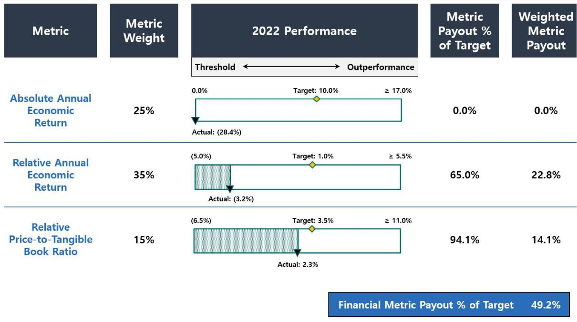

2022 Strategic and Operational Review

In evaluating our performance under the operational and strategic objective portion of the Corporate Scorecard, the Compensation Committee noted the following accomplishments, among others, in determining that the Company met target expectations and achieved 100% performance on the
operational and strategic objectives.

AGNC INVESTMENT CORP. - Proxy Statement 35

Table of Contents

EXECUTIVE COMPENSATION

Component of Value | Objective / Focus | Highlights
Proposition

Operating Efficiency ✔ Maintain low operating cost structure relative
to the residential mortgage REIT and
broader asset management industries

Disciplined Risk Management ✔ Utilize comprehensive risk management framework predicated on careful asset selection, disciplined hedging and

diversified funding to preserve tangible net book value across a wide range of market scenarios

- Maintain business continuity through operations and cybersecurity risk management

Stockholder Focus and ✔ Provide detailed and transparent public

Capital Management financial disclosure, actively engage with
investors, and provide clear and effective stockholder communications

✔ Maintain an active, stockholder-friendly
capital management approach that is
consistent with broader market
considerations

ESG Framework and ✔ Expand and improve high-quality ESG and

Practices corporate sustainability practices, and
incorporate material ESG and sustainability
factors into AGNC’s strategy, business, and
operations

- Continued to outperform mREIT industry on an operating cost basis by a wide margin
- Completed transition of custody clearing / settlement services to our wholly-owned broker dealer subsidiary Bethesda Securities, LLC, generating substantial cost savings and reducing exposure to third-party custodian operations

- Enhanced operational efficiencies through development of new tools and processes in Agency MBS valuation and treasury and middle office operations

- Operated in compliance with investment risk reporting framework throughout 2022, mitigating exposure to market volatility and diminished liquidity in a rising interest rate environment

- Maintained funding diversification with ample availability and capacity
- Continued to optimize funding, custody, and TBA clearing through Bethesda Securities and further integrated Bethesda Securities and AGNC back and middle office operations
- Maintained compliance with all reporting, listing, and REIT regulatory requirements
- Continued improvement and testing of IT infrastructure to strengthen information security posture and resiliency
- Maintained and enhanced corporate culture focused on compliance and risk management, including training on code of ethics and insider trading requirements, as evidenced by employee survey results

- Implemented new and more efficient processes, including valuation process for Agency MBS
- Mobilized to greater in office work expectations in March without disruption

- Enhanced corporate communications and investor outreach initiatives

- Participated in 11 sell-side hosted events, including retail network calls hosted by research analysts, held over 125 meetings and calls with institutional investors, and responded to over 360 letters, emails, and calls from retail investors throughout the year

- Enhanced liquidity and earnings capacity through ATM offerings of over $525 million of common stock and $150 million offering of new Series G Fixed-Rate Reset Cumulative Redeemable Preferred Stock

- Repurchased over $50 million of common stock at a meaningful discount to tangible net book value

- Maintained high quality governance oversight and structure, including compliance with governance requirements
- Filed second annual ESG report and disclosure consistent with SASB and TCFD reporting framework
- Created employee-led committee focused on community engagement and corporate giving
- Employee survey results reflect high levels of satisfaction, including in areas of DEI, engagement, training, and development

- Leased new headquarters office space in LEED Platinum certified building; designed build out with focus on sustainability and wellness

36 AGNC INVESTMENT CORP. - Proxy Statement

Table of Contents

EXECUTIVE COMPENSATION

Individual Bonus Decisions

The 2022 bonus payments for our NEOs are reflected in the following table:

NEO | Short-Term Incentive Award ($) | Percentage of 2022 Target
Peter J. Federico | $2,228,400 | 61.9%
Gary D. Kain | $2,228,400 | 61.9%
Christopher J. Kuehl | $1,512,000 | 75.6%
Bernice E. Bell | $1,001,250 | 80.1%
Kenneth L. Pollack | $801,000 | 80.1%

Short-term incentives for Messrs. Kain and Federico in 2022 were based solely on achievement of the Corporate Scorecard measures. Based on the Compensation Committee’s assessment of the 2022 Corporate Scorecard, this resulted in a payout of 61.9% of target for Messrs. Kain and Federico.
Short-term cash incentives for our NEOs other than Messrs. Federico and Kain were based predominantly on the Corporate Scorecard measures and to a lesser extent on individual performance. After considering the contributions of Messrs. Kuehl and Pollack and Ms. Bell, as discussed below, and management’s collective achievements throughout the year, the Compensation Committee determined that a rating of 107.5% was appropriate for each of

Messrs. Kuehl and Pollack and Ms. Bell for the individual component element of the Corporate Scorecard. In reaching this conclusion, the Compensation Committee also recognized the difficulty in completing these accomplishments during periods of extreme market volatility and the challenging macroeconomic environment present in 2022. The Compensation Committee recognized the efforts of Ms. Bell and Messrs. Kuehl and Pollack in a number

of operational accomplishments throughout the organization that contributed to increased efficiency and resiliency, including the transition of custody, clearing, and settlement services of agency MBS to our wholly owned broker dealer subsidiary and enhanced processes for securities valuations and cash management. Ms. Bell and Messrs. Kuehl and Pollack were also recognized for their efforts to maintain high levels of employee engagement during a

period of market uncertainty and through the mobilization to greater in office work expectations, all with limited workforce attrition.

Mr. Kuehl was awarded a cash bonus at 75.6% of his target based on a relative weighting of the Corporate Scorecard at 70% and his personal performance at 30%. In evaluating his personal performance, the Compensation Committee noted his efforts in repositioning the Company’s investment
portfolio in response to rapidly changing and historically challenging conditions. In addition, the Compensation Committee considered Mr. Kuehl’s focus on risk management throughout a year of substantial market volatility and illiquidity. Ms. Bell and Mr. Pollack each were awarded 80.1% of their target bonus, which reflects a relative weighting of the Corporate Scorecard at 60% and their individual personal performance at 40%. For Ms. Bell, the

Compensation Committee considered, among other things, her continued focus on reviewing internal procedures to improve operational efficiency. In 2022, Ms. Bell led the Company’s review and evaluation of hedge designations, which expanded flexibility and capacity for hedging activities during the volatile market conditions, and improved our internal procedures for investment and derivative valuations. For Mr. Pollack, the Compensation Committee

considered, among other things, his continued leadership in and attention to our corporate governance, compliance, and enterprise-wide risk management and maintaining appropriate communication among management and the Board. In addition, the Compensation Committee noted Mr. Pollack’s work in enhancing the Company’s business continuity and resiliency during market stress and volatility scenarios.

Equity Incentive Compensation

The Compensation Committee believes that equity incentive compensation is an important component of our NEO compensation package and is critical in attracting, motivating, and retaining outstanding employees. Equity incentive compensation is intended to closely align our NEOs’ and other
employees’ interests with our long-term success and promote long-term employee retention. Our long-term incentive program consists of a combination of performance-based RSUs and time-vesting RSUs.

Performance-based RSUs are designed to reward creation of long-term economic returns for our stockholders both on an absolute and relative

basis. To establish challenging economic thresholds and motivate long-term performance, the awards vest at the end of a three-year performance period based 50% on our absolute economic return and 50% on our economic return relative to the unweighted average of economic returns of the Agency REIT Peer Group. In establishing vesting criteria for these awards, the Compensation Committee considers historical returns for us and our peers and our

forecast. Absolute and relative economic returns are calculated on a cumulative basis over the three-year performance period. Achievement of these goals will be determined in the same manner, including the same peer group, as described above with respect to the short-term incentive awards for such year. For performance between the threshold, target, and outperformance measures, the number of shares vested will be determined through linear interpolation.

AGNC INVESTMENT CORP. - Proxy Statement 37

Table of Contents

EXECUTIVE COMPENSATION

2022 Long-Term Incentive Awards

The 2022 long-term incentive awards made by the Compensation Committee in February 2022 were at each NEO’s target levels as specified in their respective employment agreement and are reflected in the following table:

Mix of Long-Term Incentive Awards

NEO | Time-Vested | Performance-Vested | Total Value
 | RSUs ($) 1 | RSUs ($) 2 | of Awards ($) 3
Peter J. Federico | 1,485,000 | 3,015,000 | 4,500,000
Gary D. Kain | 1,386,000 | 2,814,000 | 4,200,000
Christopher J. Kuehl | 858,000 | 1,742,000 | 2,600,000
Bernice E. Bell | 412,500 | 837,500 | 1,250,000
Kenneth L. Pollack | 330,000 | 670,000 | 1,000,000

- Awards vest ratably over a three-year and one-half month period in equal annual installments.

- Represents grant-date fair value assuming performance achievement at 100% of target. Performance payouts may range from 0% to 200% of target shares based on actual performance. Awards are subject to cliff vesting two years and eleven and one-half months after the grant date, subject to a three-year performance period.
- Awards were granted on March 1, 2022 based on a $12.99 stock price.

The fair value of these awards as of their March 1, 2022 grant date is included in the Summary Compensation Table and Grants of Plan-Based Awards Table. The ultimate value of the RSUs will depend on AGNC’s total stockholder return over the vesting period, and in the case of the performance-based RSUs, AGNC’s absolute and relative economic return over the three-year performance period.

In setting the level of awards to our NEOs, the Compensation Committee considered a number of factors, including the compensation practices at comparable companies, and our ongoing commitment to link NEO compensation to our long-term performance. The Compensation Committee also considered the roles and ongoing responsibilities of each of our NEOs and relevant market data. The grant levels for our NEOs in 2022 reflected the first

full-year compensation for Messrs. Federico, Kain, and Kuehl following the promotions of Messrs. Federico and Kuehl and the transition of Mr. Kain to Executive Chair mid-year in 2021.

- The 2022 awards to Messrs. Federico and Kuehl reflected the full-year target LTI award in their new roles as Chief Executive Officer and Chief Investment Officer, respectively. By comparison, the awards they received in 2021 were comprised of a proration between their target LTI award levels for their new roles during the second half of 2021 and their former roles during the first half of 2021. Their 2022 target LTI awards continued to be allocated 67% performance-based and 33% time-based.

- Mr. Kain’s long-term incentive target of $4,200,000 in 2022 reflected the full-year target LTI award in his new role as Executive Chair. His 2021 award was comprised of a proration between his target LTI award level in his role as Chief Executive Officer and Chief Investment Officer during the first half of 2021 and his target LTI award level in his role as Executive Chair during the second half of 2021. His 2022 LTI continued to be allocated 67% performance-based and 33% time-based.

- Ms. Bell’s long-term incentive target was increased from $1,100,000 to $1,250,000 in 2022, with the allocation of 2022 awards, at target, being 67% performance-based and 33% time-based.

- Mr. Pollack’s long-term incentive target was increased from $950,000 to $1,000,000 in 2022, with the allocation of 2022 awards, at target, being 67% performance-based and 33% time-based.

In granting awards in 2022, the Compensation Committee also reviewed the measures used for performance-based RSUs and determined that it was appropriate to retain the measures established in 2021 without adjustment. Although the outlook for financial markets remained uncertain at the outset of 2022, the Compensation Committee considered the value of consistency year-over-year in considering adjustments to the scorecard and concluded that these measures remained challenging in the current market environment for awards made in 2022. The table below sets forth the below threshold, threshold, target, and outperformance levels established by the Compensation Committee for performance-based RSU awards made in 2022.

Performance | Metric | Below |  | Base Performance
Variable | Weight | Threshold | Threshold | Target | Outperformance
Absolute Three-Year Economic Return | 50% | < 0.0% | 0.0% | 30.0% | ≥ 60.0%
Relative Three-Year Economic Return | 50% | < (4.5%) | (4.5%) | 3.0% | ≥ 10.5%
Payout Factor (% of Target Shares) | 100% | 0% | 0% | 100% | 200%

38 AGNC INVESTMENT CORP. - Proxy Statement

Table of Contents

EXECUTIVE COMPENSATION

2020 Performance-Based Restricted Stock Unit Awards

The three-year performance period for the performance-based RSU awards made to our employees in February 2020 was completed on December 31, 2022. The performance calculations included absolute economic return measured from December 31, 2019 through December 31, 2022 and
relative economic return as compared to an Agency mortgage REIT peer group determined at the time of the grant and measured from September 30, 2019 through September 30, 2022. AGNC generated an absolute economic return of -19.1% and relative economic return of +21.9% for the applicable measurement period, resulting in a vesting factor of 100% of the target number of shares for the 2020 performance-based RSUs, as validated by the

Compensation Committee. Unless deferred by the NEO, distribution of shares in settlement of these awards occurred on February 15, 2023, provided that the recipient remained employed by the Company on that date. The diagram below includes the performance targets and details the performance calculations for these awards. Additional details regarding these RSUs are provided in the Outstanding Equity Awards table on page 47 of this proxy

statement. These measures were established in 2020 based on then anticipated ranges of performance deemed to be appropriately challenging based on the Compensation Committee’s analyses, including back-testing.
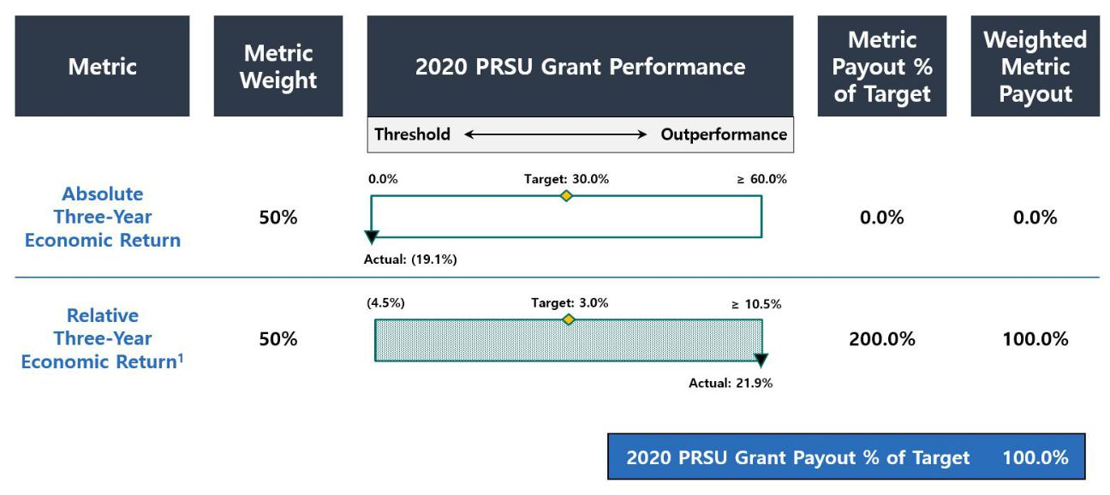

- Peer index reflects an unweighted, simple average of the peer group constituents: NLY, TWO, IVR, ARR, CMO, ANH and DX. Under pre-established peer group criteria, if a peer undergoes a merger or acquisition, its economic return is included through the quarter ended just prior to completion of the transaction. As a result of the acquisition of ANH announced in December 2020 (closed in March 2021) and the acquisition of CMO announced in July 2021 (closed in October 2021), ANH has been included through December 31, 2020, and CMO has been included through September 30, 2021.

Savings and Health and Welfare Benefits

Our executive officers participate in a broad-based 401(k) retirement savings plan generally applicable to all our employees, which includes an

opportunity to receive employer matching contributions. We do not currently provide for pension plans, supplemental retirement plans, or deferred compensation plans for our executive officers. We previously provided our executive officers the option to elect to defer payments of long-term incentive awards. In addition, all of our executive officers also participate in medical, dental, vision, disability, life and long-term care insurance, and qualified

transportation benefits that are provided generally to all our employees.

Perquisites and Other Personal Benefits

We do not believe our executive officers should receive special perquisites and benefits and do not currently provide our executive officers with any perquisites or other personal benefits that are not available on a non-discriminatory basis to all employees.

Compensation Decision Process

Compensation Comparator Group

AGNC’s internal management structure, size, and scale relative to other residential mortgage REITs and our Agency mortgage-backed securities

investment focus are significant differentiators relative to other potential comparative public companies and have made identifying a peer group for AGNC challenging. As a result, the Compensation Committee has not adopted a policy to benchmark compensation levels against comparative companies.

We are the second largest residential mortgage REIT overall by market capitalization, total assets, and total equity when compared with the Resi mREIT Universe. Eight other REITs in the Resi mREIT Universe are internally managed, and the other ten

AGNC INVESTMENT CORP. - Proxy Statement 39

Table of Contents

EXECUTIVE COMPENSATION

mortgage REITs in the Resi mREIT Universe are externally managed by a third party and provide only limited public compensation disclosure. Moreover, only two other internally managed mREITs in the Resi mREIT Universe had a market capitalization above $1.5 billion as of December 31, 2022, and only one of those REITs had an Agency mortgage-backed securities focus comparable to AGNC. Residential mREITs that primarily invest in non-Agency mortgage-backed securities involve different risk and return profiles and will have performance that is not well correlated to ours. The business and operations of commercial mortgage REITs center on commercial real estate finance rather than single-family home mortgages and will have performance linked to credit risk decisions, including geographic and sector weightings, that are less relevant for our business model.

Although we are an internally managed REIT, our business of investing primarily in Agency mortgage-backed securities makes our operations somewhat comparable to asset management firms. However, asset management firms employ a different business model: they primarily generate income from management fees charged to clients based on, among other things, the level of assets under management or financial returns that clients earn on their investments. By comparison, AGNC generates income primarily from its investments in Agency securities. As a result, AGNC’s performance may vary materially from asset management firms given the vastly different asset base and significant leverage and hedging activities inherent in our business model.

Although we have few close peers considering our internal management structure, size, and scale relative to other mortgage REITs and investment focus on Agency mortgage-backed securities, the Compensation Committee, with the assistance of FW Cook, reviews compensation levels and practices at various financial services companies as part of its consideration of our compensation structure, programs, and practices. In 2022, the Compensation Committee reviewed the compensation practices at 18 companies, including seven internally managed publicly traded mortgage REITs and 10 publicly traded asset management companies and non-bank financial services companies. This is the same group considered by the Compensation Committee in 2021, with the exception of one asset management firm which was removed from the group after being acquired in 2021. The Compensation Committee determined the highly specialized and unique skill sets required of executives in these industries are most comparable to those required of AGNC’s NEOs, although very few would be an exact match for our Company. However, in considering this analysis, the Compensation Committee believes that, due to their vastly different business models, capital allocations, and assets, these companies collectively will have performance that is not well correlated to AGNC’s performance, and accordingly they are not a suitable peer set for purposes of evaluating management's relative performance or the alignment of our compensation program to our performance.

Mortgage REITs: | Asset Management and Financial Services Companies:
Annaly Capital Management, Inc. | Affiliated Managers Group, Inc.
Arbor Realty Trust, Inc. | AllianceBernstein Holding L.P.
Chimera Investment Corporation | Ameriprise Financial, Inc.
Ladder Capital Corp. | Apollo Global Management LLC
MFA Financial, Inc. | Ares Management LP
Redwood Trust, Inc. | DigitalBridge Group, Inc.
Two Harbors Investment Corp. | Invesco Ltd.
 | KKR & Co. L.P.
 | The Blackstone Group L.P.
 | The Carlyle Group L.P.

Performance Comparator Group

The Compensation Committee has determined that a subset of the Resi mREIT Universe, which we refer to as the “Agency REIT Peer Group,” provides a better basis for comparison to evaluate our performance and operations under our Corporate Scorecard and performance-based LTI awards. For
purposes of 2022 incentive awards, these REITs were:

- Annaly Capital Management, Inc.

- ARMOUR Residential REIT, Inc.

- Dynex Capital, Inc.

- Invesco Mortgage Capital, Inc.

- Orchid Island Capital, Inc.

- Two Harbors Investment Corp.

The Agency REIT Peer Group companies have portfolios and investment objectives that most closely resemble our own focus on Agency securities. Non-agency REITs in the Resi mREIT Universe have strategies that place a greater emphasis on credit-sensitive assets than our portfolio and
those of our Agency REIT Peer Group. As such, these REITs would be expected to achieve divergent returns from our own Agency securities-focused portfolio through various economic cycles and conditions. The Compensation Committee thus determined that our economic returns and trading price relative to book value are appropriately measured against a simple, unweighted average of the Agency REIT Peer Group for purposes of determining our

relative performance. Only two of the six REITs in the Agency REIT Peer Group were included in the group of companies for which executive

40 AGNC INVESTMENT CORP. - Proxy Statement

Table of Contents

EXECUTIVE COMPENSATION

compensation practices were reviewed by the Compensation Committee, Annaly Capital Management, Inc. and Two Harbors Investment Corp. The other four companies included in the Agency REIT Peer Group were excluded from our compensation comparator group because these four REITs either are significantly smaller than AGNC or are externally managed.

The Compensation Committee continues to evaluate our peer group construction in response to changes in market conditions and the mortgage REIT sector. The Compensation Committee desires to limit the number of year-over-year changes to this peer group in order to provide meaningful ongoing comparative analyses for its work. The Compensation Committee elected to add Orchid Island Capital, Inc. to the Agency REIT Peer Group for

2022 incentive compensation awards based on guiding parameters, including a minimum of $500 million in total stockholders’ equity and approximately 50% or greater allocation of capital to Agency residential mortgage-backed securities at the time of inclusion. Two companies in the 2021 Agency REIT Peer Group, Anworth Mortgage Asset Corporation and Capstead Mortgage Corporation, were acquired in 2021 and were removed from the Agency REIT

Peer Group for purposes of awards made in 2022.

Role of the Compensation and Corporate Governance Committee

Our Compensation Committee, which is comprised solely of independent directors, is responsible for establishing and overseeing our philosophy

regarding executive compensation and for making decisions relating to the compensation of our NEOs. The Compensation Committee is also responsible for ensuring that the total compensation offered to our executive officers is fair and competitive and motivates high performance. The terms of any employment agreements with our NEOs and actions on compensation under the employment agreements are also under the primary direction of the

Compensation Committee. Decisions that set the compensation of our CEO or Executive Chair are subject to the review and approval of the Company’s independent directors based on the Compensation Committee’s evaluation of goals and objectives.

The Compensation Committee periodically reviews the Company’s compensation policies and programs and makes any modifications that the

Committee deems necessary or advisable, subject to the terms of such policies or programs. The Compensation Committee annually reviews and approves the Company’s goals and objectives relevant to the compensation of the NEOs and other employees of the Company.

Role of Management

All compensation decisions related to our executive officers are at the discretion of the Compensation Committee or independent directors of our Board. The Compensation Committee considers the advice and counsel of the CEO when evaluating compensation of the other NEOs given his direct day-to-day working relationship with those executives. Taking this feedback into consideration, the Compensation Committee engages in discussions and either determines the compensation of our NEOs or makes a final recommendation to the Board related to compensation paid to NEOs. Neither our CEO nor our

Executive Chair is present or a participant in the portions of meetings of the Compensation Committee or of the Board at which his performance is evaluated and his compensation is discussed and determined; only independent directors participate in such matters.

Role of the Independent Compensation Consultant

Under its charter, the Compensation Committee has the authority to select, retain, and terminate compensation consultants. The Compensation Committee has retained FW Cook to provide advice and counsel on executive compensation opportunities and program design and structure. Representatives of FW Cook attended certain meetings of the Compensation Committee, including meeting with members of the Compensation Committee

without members of management present. FW Cook assists the Compensation Committee in its analysis and evaluation of our executive compensation program, practices, and communications and provides the Compensation Committee with market data and analysis of certain comparator companies that hire personnel and executives with similar skills and experience as our executive management team. FW Cook also provides advice with respect to our

Corporate Scorecard, our long-term incentive awards, the setting of measures for performance-based incentive compensation, and other work that informs executive compensation decisions. During 2022, the Compensation Committee reviewed the independence of FW Cook using assessment criteria under applicable Nasdaq and SEC rules and concluded FW Cook was independent and had no conflicts of interest.

Risk Assessment and Compensation

The Compensation Committee regularly monitors the risks and rewards associated with our compensation program. The Compensation Committee established our compensation program with the intent to align our interests with stockholders and prevent unnecessary or excessive risk-taking.
We believe that our compensation policies and practices are well balanced and designed to avoid creating incentives that encourage unnecessary or excessive risks that could potentially have a material adverse effect on the Company. We use variable compensation for all of our NEOs, with a focus on performance based compensation. We have designed a compensation program with a mix of short- and long-term incentives to ensure management focuses

on the long-term impact of short-term decisions and that management’s interests are aligned with stockholders. At least 50% and up to 67% of our NEOs’ long-term incentive awards vest based on performance over a three-year period. Compliance with the risk management framework designed to address excessive risk taking and approved by our Board is an integral part of the strategic and operational objectives of the Corporate Scorecard used for short-

term incentive compensation decisions. The Compensation Committee continually assesses our executive compensation programs and has implemented additional policies and practices that we believe have further mitigated compensation driven risk, including the adoption of a clawback policy and executive officer stock ownership guidelines.

AGNC INVESTMENT CORP. - Proxy Statement 41

Table of Contents

EXECUTIVE COMPENSATION

Other Compensation Policies and Practices

Stock Ownership Guidelines

We have adopted stock ownership guidelines for our executive officers establishing share ownership targets based on a multiple of base salary.

The minimum objective is 6x for our Executive Chair and our CEO, 4x for our Chief Investment Officer, and 3x for all other executive officers. Until the foregoing ownership requirements are met, each individual is required to retain at least 50% of the shares of common stock received upon vesting or earn-out of stock-based compensation, net of any shares withheld or sold to pay or reimburse taxes on such income. The retention obligations also apply in the

event ownership levels fall below applicable guideline levels due to a decline in stock price. Shares of time-vested RSUs granted under the 2016 Equity Plan (whether vested, unvested, or subject to a deferral election) are included in determining the number of shares held for this purpose, net of anticipated tax withholdings. Shares of unvested performance-based RSUs are not included for this purpose prior to completion of the applicable performance period.

As of February 24, 2023, all of our NEOs had complied with their obligations under our stock ownership guidelines.

The following table sets forth the total stock ownership of all our NEOs, including beneficially owned, unvested, and deferred shares, as calculated pursuant to our stock ownership guidelines as of February 24, 2023:

Name

Peter J. Federico

Gary D. Kain

Christopher J. Kuehl

Bernice E. Bell

Kenneth L. Pollack

Beneficially | Unvested Shares | Vested/Deferred | Total
Owned
Shares (#) | (#) ² | Shares (#) ^{2,3} | (#)

- Includes 667,920 shares held in a family trust over which shares Mr. Kain has voting and dispositive power.
- Share amounts are net of anticipated tax withholdings.
- Deferred shares are vested and non-forfeitable, subject to AGNC's clawback policy.

Anti-Hedging and Pledging Policy

Our Board has adopted a policy prohibiting our executive officers and directors from any hedging, pledging, or entering into margin loans with respect to any shares of our common stock or from engaging in short sales of our common stock or entering into any other transaction or derivative agreement where he or she would earn a profit or offset losses due to a decline of our stock price. By way of example, transactions prohibited under the

policy may include options, short sales, puts, calls, or derivative actions such as forwards, futures, or swaps. In addition to the restrictions imposed on our executive officers and directors, the AGNC Mortgage Management, LLC Personal Investments Code prohibits all employees from engaging in financial transactions that directly hedge or offset, or are designed to directly hedge or offset, any decrease in the market value of our common stock.

Clawback Policy

We have adopted a clawback policy relating to recovery of certain performance-based compensation in the event of an accounting restatement by the Company due to material noncompliance with any financial reporting requirement under U.S. federal securities laws resulting at least in part from the
willful fraud, dishonesty, or recklessness of one of the Company’s executive officers in the performance of his or her duties to the Company. Under this policy, the Company would be entitled to seek recovery of the portion of performance-based compensation paid to our executive officers that would not have been earned had the Company’s restated financial statements been used in the determination of the amount of performance-based compensation

originally awarded. This policy includes a three-year look back period. The Company anticipates revising its policy in 2023 to comply with anticipated Nasdaq listing standards to implement recent SEC rulemaking on clawback policies.

Employment Agreements

The Company has entered into employment agreements with each of our NEOs. The Compensation Committee has consulted with FW Cook on each of the agreements and believes that they provide appropriate and balanced incentives toward achieving the annual and long-term strategic objectives
set by the Compensation Committee and create a stronger alignment of interests between our executives and our stockholders.

The Compensation Committee reviews the compensation of our executive officers on an annual basis and will make adjustments when warranted by personal performance, internal and external pay equity, and other considerations. The Company entered into restated employment agreements with
Messrs. Kain, Federico, and Kuehl in December 2020 as a result of the announced transition of Mr. Kain to the role of Executive Chair of the Board and the promotions of Messrs. Federico and Kuehl to the positions of Chief Executive Officer and Chief Investment Officer, respectively. The revised employment agreements adjust their respective compensation arrangements in light of their new roles and responsibilities and are described in more detail

herein. The Compensation Committee entered into amended and restated employment agreements dated January 22, 2021 with Ms. Bell and Mr. Pollack to

42 AGNC INVESTMENT CORP. - Proxy Statement

Table of Contents

EXECUTIVE COMPENSATION

increase their target compensation, and in 2022, as part of its annual review of NEO compensation, the Committee further adjusted their compensation levels.

The employment agreements for each NEO include certain severance payments and benefits if a NEO that is party to an employment agreement is

terminated by the Company, including without “cause” or by the NEO for “good reason,” as each term is defined in each respective employment agreement and were the result of arms-length negotiations with these NEOs. The severance provisions included in the employment agreements related to a change of control include a “double trigger” requirement, which we determined was appropriate and in the best interest of our stockholders. See “Severance and

Change of Control Payments” on page 48. The employment agreements with these NEOs also include covenants related to post-employment obligations in areas such as competition with us, solicitation of our employees, and the confidentiality of certain information.

AGNC INVESTMENT CORP. - Proxy Statement 43

Table of Contents

EXECUTIVE COMPENSATION

Report of the Compensation and Corporate Governance Committee

Our Compensation and Corporate Governance Committee reviewed and discussed with our management the “Compensation Discussion and Analysis” contained in this proxy statement. Based on that review and discussions, our Compensation and Corporate Governance Committee recommends
to the Board of Directors that the “Compensation Discussion and Analysis” be included in this proxy statement.

By the Compensation and Corporate
Governance Committee:
Morris A. Davis, Chair
John D. Fisk
Prue B. Larocca
Paul E. Mullings

44 AGNC INVESTMENT CORP. - Proxy Statement

Table of Contents

EXECUTIVE COMPENSATION

2022 Summary Compensation Table

The following table provides information concerning the compensation of our NEOs earned during our fiscal years ended December 31, 2022, 2021, and 2020.

In the column “Salary,” we disclose the amount of base salary paid to the NEO during the fiscal year. See “Base Salary” under “Compensation Program in Detail” above, for a description of the base salaries payable under each NEO’s employment agreement. In the column “Bonus,” we disclose the amount of short-term cash incentive payments earned by the NEO during the fiscal year. See “2022 Corporate Scorecard” for a description of the annual

scorecard for calculating the cash component of our incentive compensation awards for 2022 that were paid in 2023, and which are included in the Summary Compensation Table for 2022. In the column “Stock Awards,” we disclose awards of RSUs under the 2016 Equity Plan, which includes both performance-based vesting and time-based vesting awards. The grant date fair value of the performance-based vesting RSU awards assumes performance
achievement at 100% of the target amount. Performance payouts may range from 0% to 200% of the target amount based on actual performance achieved.
See “Equity Incentive Compensation” under “Compensation Discussion and Analysis,” above.

The amounts in the column “All Other Compensation” represent employer matches for employee contributions to our 401(k) plan. The NEOs did not have any perquisites or other personal benefits in excess of the reporting thresholds during the fiscal year.

 |  | Salary | Bonus | Stock | All Other | Total
Name and Principal Position |  |  |  | Awards ¹ | Compensation
 | Year | ($) | ($) | ($) | ($) | ($)
Peter J. Federico | 2022 | 900,000 | 2,228,400 | 4,500,000 | 18,300 | 7,646,700
President and Chief Executive Officer² | 2021 | 900,000 | 2,632,500 | 3,400,000 | 17,400 | 6,949,900
 | 2020 | 900,000 | 2,269,800 | 2,300,000 | 17,100 | 5,486,900
Gary D. Kain | 2022 | 500,000 | 2,228,400 | 4,200,000 | 18,300 | 6,946,700
Executive Chair³ | 2021 | 700,000 | 4,387,500 | 6,150,000 | 17,400 | 11,254,900
 | 2020 | 900,000 | 6,809,400 | 8,100,000 | 17,100 | 15,826,500
Christopher J. Kuehl | 2022 | 900,000 | 1,512,000 | 2,600,000 | 18,300 | 5,030,300
Executive Vice President and Chief Investment Officer⁴ | 2021 | 900,000 | 1,764,000 | 2,125,000 | 17,400 | 4,806,400
 | 2020 | 900,000 | 1,936,818 | 1,650,000 | 17,100 | 4,503,918
Bernice E. Bell | 2022 | 500,000 | 1,001,250 | 1,250,000 | 18,300 | 2,769,550
Executive Vice President and Chief Financial Officer | 2021 | 500,000 | 985,000 | 1,100,000 | 17,400 | 2,602,400
 | 2020 | 500,000 | 983,450 | 875,000 | 17,100 | 2,375,550
Kenneth L. Pollack | 2022 | 500,000 | 801,000 | 1,000,000 | 18,300 | 2,319,300
Executive Vice President, General Counsel, Chief | 2021 | 500,000 | 837,250 | 950,000 | 17,400 | 2,304,650
Compliance Officer and Secretary | 2020 | 500,000 | 809,900 | 800,000 | 17,100 | 2,127,000

- The amounts reported in the “Stock Awards” column represent the aggregate grant date fair value of each NEO’s awards calculated in accordance with FASB ASC Topic 718, as required by SEC regulations. The fair market value of a stock award is based on the fair market value of our stock on the date of grant with the value of the performance-based RSUs based on the probable outcome of the performance conditions as of the grant date and is set at 100% of the target amount. For fiscal year 2022, the grant date fair value of performance-based RSUs at 100% of the target amount was $3,015,000 for Mr. Federico, $2,814,000 for Mr. Kain, $1,742,000 for Mr. Kuehl, $837,500 for Ms. Bell, and $670,000 for Mr. Pollack, and the grant date fair value of the performance-based RSUs assuming the highest level of performance conditions is met, was $6,030,000 for Mr. Federico, $5,628,000 for Mr. Kain, $3,484,000 for

Mr. Kuehl, $1,675,000 for Ms. Bell, and $1,340,000 for Mr. Pollack. See below in the Grants of Plan Based Awards in Fiscal Year 2022 table for further details regarding the allocation of grants between time-vesting and performance-based RSUs.
- Mr. Federico assumed the role of Chief Executive Officer on July 1, 2021. His 2021 compensation reflects blended compensation for his services for six months as our President and Chief Operating Officer and six months as our President and Chief Executive Officer. His total compensation in 2022 reflects full year compensation as our CEO.
- Mr. Kain transitioned from the role of Chief Executive Officer and Chief Investment Officer to Executive Chair on July 1, 2021.
- Mr. Kuehl assumed the role of Chief Investment Officer on July 1, 2021. His 2021 compensation reflects blended compensation for his services for six months as our Executive Vice President, Agency Portfolio Investments and six months as our Executive Vice President and Chief Investment Officer. His total compensation in 2022 reflects full year compensation as our CIO.

AGNC INVESTMENT CORP. - Proxy Statement 45

Table of Contents

EXECUTIVE COMPENSATION

Grants of Plan-Based Awards in Fiscal Year 2022

In the following table we provide information about each grant of an award made to an NEO during our fiscal year ended December 31, 2022 under the 2016 Equity Plan. See “Equity Incentive Compensation” in “Compensation Discussion and Analysis” above for a description of the plan and
awards. Amounts included in the “Grant date fair value of stock awards” column are valued in accordance with ASC 718 without reduction of any assumed forfeitures.

 |  |  | Estimated Future Payouts Under Equity |  |  | All Other
 |  |  | Incentive Plan Awards ³
 |  |  |  |  |  | Stock
 |  |  |  |  |  | Awards: | Grant date fair
Name | Award Type ¹ | Grant Date ² | Threshold | Target | Maximum | Number | value of stock
 |  |  | (#) | (#) | (#) | of Units | awards ⁴
Peter J. Federico
 | Time-Based Vesting RSUs | 3/1/22 |  |  |  | 114,318 | $1,485,000
 | Performance-Based Vesting RSUs | 3/1/22 | 0 | 232,101 | 464,202 |  | $3,015,000
Gary D. Kain
 | Time-Based Vesting RSUs | 3/1/22 |  |  |  | 106,697 | $1,386,000
 | Performance-Based Vesting RSUs | 3/1/22 | 0 | 216,628 | 433,256 |  | $2,814,000
Christopher J. Kuehl
 | Time-Based Vesting RSUs | 3/1/22 |  |  |  | 66,050 | $858,000
 | Performance-Based Vesting RSUs | 3/1/22 | 0 | 134,103 | 268,206 |  | $1,742,000
Bernice E. Bell
 | Time-Based Vesting RSUs | 3/1/22 |  |  |  | 31,755 | $412,500
 | Performance-Based Vesting RSUs | 3/1/22 | 0 | 64,472 | 128,944 |  | $837,500
Kenneth L. Pollack
 | Time-Based Vesting RSUs | 3/1/22 |  |  |  | 25,404 | $330,000
 | Performance-Based Vesting RSUs | 3/1/22 | 0 | 51,578 | 103,156 |  | $670,000

- AGNC time-based vesting RSU awards vest ratably over a three-year and one-half month period in three equal annual installments. AGNC performance-based vesting RSU awards are subject to cliff vesting two years and eleven and one-half months after the grant date after a three-year performance period and meeting performance conditions. Awards were granted to each NEO pursuant to the terms of his or her respective employment agreement.

- The Compensation Committee approved all grants of plan-based awards in fiscal year 2022 at a meeting held on February 17, 2022.

- Excludes accrued dividend equivalent units.

- AGNC performance-based vesting RSUs’ grant date fair value assumes performance achievement at 100% of target. Performance payouts may range from 0% to 200% of target based on actual performance achieved.

46 AGNC INVESTMENT CORP. - Proxy Statement

Table of Contents

EXECUTIVE COMPENSATION

Outstanding Equity Awards at 2022 Fiscal Year-End

In the table below we provide information about stock awards under the 2016 Equity Plan that have not vested and were outstanding as of December 31, 2022, for each NEO.

 |  |  | Stock awards
 |  |  | Market value of | Equity incentive plan | Equity incentive plan
 |  | Number of shares or |  |  | awards: market or
 |  |  | shares or units of | awards: number of | payout value
 |  | units of stock that | stock that | unearned units that | of unearned
Name | Grant Date | have not vested ¹ | have not vested 2 | have not vested 1 | units ²
 |  | (#) | ($) | (#) | ($)
Peter J. Federico | 2/20/2020 ³ | 17,653 | $182,709
 | 2/20/2020 ⁴ |  |  | 107,578 | $1,113,432
 | 3/1/2021 ⁵ | 57,232 | $592,351
 | 3/1/2021 ⁶ |  |  | 87,163 | $902,137
 | 3/1/2022 ⁵ | 127,699 | $1,321,685
Gary D. Kain | 3/1/2022 ⁶ |  |  | 129,635 | $1,341,722
 | 2/20/2020 ³ | 62,817 | $650,156
 | 2/20/2020 ⁴ |  |  | 376,987 | $3,901,815
 | 3/1/2021 ⁵ | 103,528 | $1,071,515
 | 3/1/2021 ⁶ |  |  | 157,658 | $1,631,760
 | 3/1/2022 ⁵ | 119,187 | $1,233,585
Christopher J. Kuehl | 3/1/2022 ⁶ |  |  | 120,993 | $1,252,278
 | 2/20/2020 ³ | 12,642 | $130,845
 | 2/20/2020 ⁴ |  |  | 77,175 | $798,761
 | 3/1/2021 ⁵ | 35,767 | $370,188
 | 3/1/2021 ⁶ |  |  | 54,475 | $563,816
 | 3/1/2022 ⁵ | 73,782 | $763,644
Bernice E. Bell | 3/1/2022 ⁶ |  |  | 74,900 | $775,215
 | 2/20/2020 ³ | 10,152 | $105,073
 | 2/20/2020 ⁴ |  |  | 30,541 | $316,099
 | 3/1/2021 ⁵ | 28,057 | $290,390
 | 3/1/2021 ⁶ |  |  | 21,045 | $217,816
 | 3/1/2022 ⁵ | 35,473 | $367,146
Kenneth L. Pollack | 3/1/2022 ⁶ |  |  | 36,010 | $372,704
 | 2/20/2020 ³ | 9,278 | $96,027
 | 2/20/2020 ⁴ |  |  | 27,926 | $289,034
 | 3/1/2021 ⁵ | 24,225 | $250,729
 | 3/1/2021 ⁶ |  |  | 18,175 | $188,111
 | 3/1/2022 ⁵ | 28,377 | $293,702
 | 3/1/2022 ⁶ |  |  | 28,809 | $298,173

- Includes accrued dividend equivalent units.

- Market value computed by multiplying the closing market price of our stock on December 30, 2022, or $10.35, by the number of units.

- Time-based vesting RSUs vest ratably over a three-year and three-quarter month period that commenced on the Grant Date with the next vesting date on March 15, 2023.

- Performance-based vesting RSUs which, subject to meeting the performance conditions calculated over a three-year period, cliff vest three years from the Grant Date. Reflects performance achievement of 100% of target.
- Time-based vesting RSUs vest ratably over a three-year and one-half month period that commenced on the Grant Date with the next vesting date on March 15, 2023.

- Performance-based vesting RSUs which, subject to meeting the performance conditions calculated over a three-year period, cliff vest two years and eleven and one-half months from the Grant Date. Assumes performance achievement at 50% of target.

AGNC INVESTMENT CORP. - Proxy Statement 47

Table of Contents

EXECUTIVE COMPENSATION

Option Exercises and Stock Vested for Fiscal Year 2022

The following table provides information about stock awards under the 2016 Equity Plan that vested in 2022 for each NEO:

 |  | Stock Awards
Name | Number of shares | Value realized on vesting ($)
 | acquired on vesting (#)
Peter J. Federico | 162,183 | $2,185,524
Gary D. Kain | 759,697 | $10,360,277
Christopher J. Kuehl | 121,283 | $1,637,167
Bernice E. Bell | 72,318 | $971,797
Kenneth L. Pollack | 69,832 | $939,728

Severance and Change of Control Payments

Employment Agreements

Each of the employment agreements with Ms. Bell and Messrs. Kain, Federico, Kuehl, and Pollack contains provisions for payments upon certain events as set forth below. In the event of a termination by the Company of any of our NEOs for Cause (as defined in their respective employment agreements), our NEOs are not entitled to receive any supplemental payments or incremental benefits.

Termination by the Board Without Cause or Termination by the Executive for Good Reason

If the employment of Ms. Bell or Messrs. Kain, Federico, Kuehl, or Pollack terminates by reason of a Termination Without Cause or Termination For Good Reason, each as defined in their employment agreements, and such termination does not occur during the 21-month period (24 months in the case
of Ms. Bell or Mr. Pollack) following a Change of Control, each such executive would be entitled to the following payments from the Company, as applicable, in addition to the payments listed below under “All Terminations” (a) an amount equal to the product of (i) 1.5 for Messrs. Federico, Kain or Kuehl or 1.0 for Ms. Bell or Mr. Pollack, multiplied by (ii) the sum of (A) the executive’s annual base salary at the time of such termination, plus (B) the

target value of the executive’s annual cash bonus for the year in which such termination occurs (the “Severance Amount”), paid over 18 months for Messrs. Federico, Kain, and Kuehl, and 12 months to Ms. Bell and Mr. Pollack, respectively; (b) a pro rata portion of the annual cash bonus the executive would have been entitled to receive if he or she had remained employed through December 31 of the year in which such termination occurs (as determined
by the Compensation Committee but assuming that all qualitative and subjective performance metrics were achieved at their target level);

- reimbursements under COBRA, or substitute payments, for the executive and his or her eligible dependents for up to 18 months in the case of Messrs. Federico, Kain and Kuehl and 12 months in the case of Ms. Bell and Mr. Pollack; and (d) acceleration of any outstanding unvested equity awards.

Mr. Kain’s Severance Amount (and his eligibility for reimbursements under COBRA or substitute payments) was proportionally reduced for each month that he remained employed between July 1, 2021 and December 31, 2022, and, as of December 31, 2022, the Severance Amount for Mr. Kain is $0.

Termination by the Board Without Cause or Termination by the Executive For Good Reason Following a Change of Control

If the employment of Ms. Bell or Messrs. Kain, Federico, Kuehl, or Pollack terminates by reason of a Termination Without Cause or Termination

For Good Reason, and such termination occurs during the 21-month period following a Change of Control (24 months in the case of Ms. Bell and Mr. Pollack), as defined in their employment agreements, each such executive would be entitled to the following (as applicable), in addition to the payments listed below under “All Terminations”: (a) an amount equal to the product of (i) 2.0 (for Messrs. Federico or Kuehl) or 1.5 (for Ms. Bell and

Messrs. Kain, or Pollack), multiplied by (ii) the sum of (A) the executive’s annual base salary at the time of such termination, plus (B) the target value of the executive’s annual cash bonus for the year in which such termination occurs, paid in a lump sum; (b) a pro rata portion of the target value of his or her annual cash bonus for the year in which such termination occurs; (c) COBRA reimbursements (or substitute payments) for the executive and his or her

eligible dependents for up to 18 months; and (d) acceleration of any outstanding unvested equity awards. The amount payable to Mr. Kain as described in clause (a) of this paragraph (and his eligibility for reimbursements under COBRA or substitute payments) was proportionally reduced for each month that he remained employed between July 1, 2021 and December 31, 2022, and, as of December 31, 2022, this amount is $0.

Death or Disability

If the employment period of Ms. Bell or Messrs. Kain, Federico, Kuehl, or Pollack terminates early by reason of death or disability, each executive (or his or her estate or eligible dependents, if applicable) is entitled to receive, in addition to the payments listed below under “All Terminations”: (i) a pro
rata portion of the annual cash bonus the executive would have been entitled to receive if he or she had remained employed through December 31 of the year in which such termination occurs (as determined by the Compensation Committee but assuming that the executive achieved all qualitative and subjective performance metrics at their target level), payable in a lump sum; (ii) COBRA reimbursements (or substitute payments) for the executive and his

or her eligible dependents for up to 18 months (12 months in the case of Ms. Bell and Mr. Pollack); and (iii) acceleration of any outstanding unvested equity awards. After July 1, 2021, the eligibility of Mr. Kain and his eligible dependents to COBRA reimbursements or substitute payments was proportionately reduced for each month that he remained employed between July 1, 2021 and December 31, 2022, and as of December 31, 2022, Mr. Kain

is no longer eligible for COBRA reimbursements or substitute payments.

48 AGNC INVESTMENT CORP. - Proxy Statement

Table of Contents

EXECUTIVE COMPENSATION

Voluntary Termination

Pursuant to the terms of his amended and restated employment agreement, effective as of July 1, 2021, if Mr. Kain’s employment had terminated by reason of a voluntary termination before December 31, 2022 (with at least 90 days prior notice to the Board), (i) Mr. Kain’s unvested time-based LTI
awards granted to him in 2021 or earlier would have vested in full upon such termination and (ii) his performance-based LTI awards granted in 2021 or earlier would have vested on the same terms as though Mr. Kain had remained employed for the remainder of the applicable vesting period. For a voluntary termination on or after December 31, 2022, Mr. Kain would also receive a pro rata portion of his annual cash bonus for the year in which his employment is

terminated, and any unvested LTI awards granted in 2022 or later will be subject to the same accelerated vesting described above, except that, for such LTI awards granted in the year of the voluntary termination, such terms would only apply to a pro rata portion of the awards based on the number of full calendar months Mr. Kain was employed in such year. The continued vesting of any performance-based vesting described in this section shall only occur if

Mr. Kain continues to comply with certain restrictive covenants contained in the agreement during such time.

All Terminations

If the employment period of Ms. Bell and Messrs. Kain, Federico, Kuehl, or Pollack terminates early for any reason, each executive is entitled to

receive (i) any earned but unpaid base salary; (ii) any annual cash bonus that has been earned for a calendar year prior to termination but is unpaid (but only if not a Termination For Cause or (other than Mr. Kain) a voluntary termination by the executive for any reason other than Good Reason); (iii) any unpaid reimbursable expenses that have been incurred by the executive; (iv) any plan benefits which by their terms extend beyond termination of employment; and

(v) any COBRA benefits generally available to employees.

In addition, each of the employment agreements contains a non-competition provision that prevents the officer from participating as an officer, employee, director, partner, stockholder, consultant or otherwise, in any type of business that engages in the Company’s business for a certain restricted
period. Each of the employment agreements also contains a provision preventing the executive from soliciting any of our employees or interfering in a similar manner with our business during such restricted period.

Equity Plans

The 2016 Equity Plan includes “double-trigger” acceleration provisions with respect to the vesting of awards in connection with a Change of Control of the Company (as defined in the 2016 Equity Plan). Under the 2016 Equity Plan, the vesting of awards may accelerate in connection with a Change of Control where either (1) within a specified period the participant experiences a qualifying termination of employment or service, as applicable, in a manner described in the award agreement or (2) the award is not continued, assumed, or converted into a replacement award in a manner described in

the applicable award agreement.

The following table summarizes the estimated payments to be made under the employment agreement for each NEO at, following, or in connection with any termination of employment, including by the Company without cause or by the executive for good reason, death or disability and upon
a change of control. In accordance with SEC regulations, the following table does not include any amount to be provided to an NEO under any arrangement that does not discriminate in scope, terms or operation in favor of the NEO and that are available generally to all salaried employees. Also, the following table does not duplicate information already provided in the outstanding equity awards at fiscal year-end table, except to the extent that the amount payable

to the NEO would be enhanced by the termination event. The amounts in the following table are hypothetical and based on SEC regulations. Actual payments will depend on the circumstances and timing of any termination.

In accordance with SEC regulations, for purposes of the quantitative disclosure in the following table, we have assumed that the termination took place on December 31, 2022, and that the price per share of our common stock is the closing market price as of December 30, 2022, which was $10.35.

AGNC INVESTMENT CORP. - Proxy Statement 49

Table of Contents

EXECUTIVE COMPENSATION

The information below constitutes forward-looking statements for purposes of the Private Litigation Securities Reform Act of 1995.

Termination by
Company Without
 | Termination by | Cause or
 |  | Termination by |  | Voluntary
 | Company Without | Executive for
 | Cause or Termination | Good Reason, each in |  | Termination by
NEO Benefits and Payments | by Executive for | connection with a | Death or Disability | Executive without
 | Good Reason ¹ | Change in Control ² |  | Good Reason
upon Termination | ($) | ($) | ($) | ($)
Peter J. Federico
Severance Amount | 6,750,000 | 9,000,000 | — | —
Base Salary | — | — | — | —
Cash Bonus ³ | 2,228,400 | 2,228,400 | 2,228,400 | —
Accelerated Equity Awards ⁴ | 5,454,036 | 5,454,036 | 5,454,036 | —
Insurance Benefits ⁵ | 49,422 | 49,422 | 49,422 | —
TOTAL: | 14,481,858 | 16,731,858 | 7,731,858 | —
Gary D. Kain
Severance Amount | — | — | — | —
Base Salary | — | — | — | —
Cash Bonus ³ | 2,228,400 | 2,228,400 | 2,228,400 | 2,228,400
Accelerated Equity Awards ⁴ | 9,741,110 | 9,741,110 | 9,741,110 | 9,741,110
Insurance Benefits ⁵ | — | — | — | —
TOTAL: | 11,969,510 | 11,969,510 | 11,969,510 | 11,969,510
Christopher J. Kuehl
Severance Amount | 4,350,000 | 5,800,000 | — | —
Base Salary | — | — | — | —
Cash Bonus ³ | 1,512,000 | 1,512,000 | 1,512,000 | —
Accelerated Equity Awards ⁴ | 3,402,469 | 3,402,469 | 3,402,469 | —
Insurance Benefits ⁵ | 49,422 | 49,422 | 49,422 | —
TOTAL: | 9,313,891 | 10,763,891 | 4,963,891
Bernice E. Bell
Severance Amount | 1,750,000 | 2,625,000 | — | —
Base Salary | — | — | — | —
Cash Bonus ³ | 1,001,250 | 1,001,250 | 1,001,250 | —
Accelerated Equity Awards ⁴ | 1,669,227 | 1,669,227 | 1,669,227 | —
Insurance Benefits ⁵ | 32,948 | 49,422 | 32,948 | —
TOTAL: | 4,453,425 | 5,344,899 | 2,703,425
Kenneth L. Pollack
Severance Amount | 1,500,000 | 2,250,000 | — | —
Base Salary | — | — | — | —
Cash Bonus ³ | 801,000 | 801,000 | 801,000 | —
Accelerated Equity Awards ⁴ | 1,415,777 | 1,415,777 | 1,415,777 | —
Insurance Benefits ⁵ | 32,948 | 49,422 | 32,948 | —
TOTAL: | 3,749,725 | 4,516,199 | 2,249,725

- Severance amounts are payable over a period of 18 months for Messrs. Federico and Kuehl and over a period of 12 months for each of Messrs. Kain and Pollack and Ms. Bell.
- Severance amounts are payable in a lump sum on the first payroll date 60 days after termination.
- Payable in a lump sum by March 15 of the calendar year following the calendar year in which termination occurs. Reflects cash bonus NEO is entitled to receive for fiscal year 2022 based on achievement of Corporate Scorecard measures and personal performance, as applicable.
- Reflects performance achievement of 100% of target for February 20, 2020 performance-based vesting RSUs award. Assumes performance achievement at 50% of target for March 1, 2021 and March 1, 2022 performance-based vesting RSUs awards.
- Insurance Benefits are based on the December 2022 monthly payment for Health, Dental and Vision coverage for each NEO.

50 AGNC INVESTMENT CORP. - Proxy Statement

Table of Contents

EXECUTIVE COMPENSATION

Pay Versus Performance

As required by Section 953(a) of the Dodd-Frank Wall Street Reform and Consumer Protection Act and Item 402(v) of Regulation S-K, we have

prepared this pay versus performance disclosure, which serves to further demonstrate the alignment of our executive compensation program with stockholder interests.

 |  |  |  |  |  |  | Value of Initial Fixed
 |  |  |  |  |  |  | $100 Investment Based
 |  |  |  |  |  |  |  | on:
 |  |  |  |  | Average | Average
 | Summary | Summary |  |  | Summary |  | Total | Peer Group |  | Relative
 |  |  | Compensation |  | Compensation | Compensation
 | Compensation | Compensation |  | Compensation |  |  | Stock- | Total Stock- | Net Income | Annual
 |  |  | Actually Paid to |  | Table Total for | Actually Paid to
 | Table Total for | Table Total for |  | Actually Paid to |  |  | holder | holder | ($ in | Economic
Year |  |  | Current CEO ($) |  | Non-CEO NEOs | Non-CEO NEOs
 | Current CEO ($) ¹ | Prior CEO ($) ¹ | 1 | Prior CEO ($) ¹ | 2 | 2 | Return ³ | Return ^{3,4} | Millions) ⁵ | Return ⁶
2022 | $7,646,700 | N/A | $3,653,990 | N/A | $4,266,463 | $1,425,320 | $81.01 | $69.20 | $(1,190)
2021 | $6,949,900 | $11,254,900 | $7,745,878 | $15,106,695 | $2,952,885 | $3,317,861 | $103.51 | $91.50 | $749 | 9.9%
2020 | N/A | $15,826,500 | N/A | $13,076,972 | $3,623,342 | $3,153,609 | $98.36 | $77.80 | $(266) | 28.8%

- During 2022, our CEO was Peter Federico (“Current CEO”). During 2021, our CEOs were Peter Federico and Gary Kain (“Prior CEO”). Messrs. Kain and Federico each served as CEO of the Company for a six month period during 2021. Compensation totals during 2021 reflect the full-year compensation received by each of Messrs. Kain and Federico and do not reflect pro-rated payment for the period that each individual served as CEO. During 2020, our CEO was Gary Kain.
- During 2022, our remaining NEOs consisted of Messrs. Kain, Kuehl and Pollack and Ms. Bell. During 2021, our remaining NEOs consisted of Messrs. Kuehl, Pas, and Pollack and Ms. Bell. During 2020, our remaining NEOs consisted of Messrs. Federico, Kuehl, and Pollack and Ms. Bell. For more details regarding how the amounts in this column are calculated, refer to the “Adjustments to Summary Compensation Tables to Determine Compensation Actually Paid" tables immediately below.
- Total Stockholder Return and Peer Group Total Stockholder Return assumes $100 invested at December 31, 2019.
- As permitted by SEC rules, the Peer Group referenced for purpose of the Total Stockholder Return comparison consists of the Bloomberg Mortgage REIT Index.

- Reflects after-tax net income attributable to stockholders prepared in accordance with GAAP for each of the years shown.

- The Company has designated “Relative Annual Economic Return” as its Company Selected Measure, as this is the largest financial component of our 2022 Corporate Scorecard and our most important financial measure (that is not otherwise required to be disclosed in this table) used by us to link compensation actually paid to our NEOs to Company performance. Relative Annual Economic Return compares the economic return of AGNC to that of the average of the Agency REIT Peer Group. For purposes of AGNC's Corporate Scorecard, relative annual economic return is calculated on an October 1 - September 30 year, but consistent with the requirements of Regulation S-K, it is calculated for purposes of this table on a calendar year basis. Additional details regarding the calculation of Relative Annual Economic Return and the companies included in the Agency REIT Peer Group for 2022 are included in the discussion of our 2022 Corporate Scorecard on page 33. For 2020, the peer group consisted of NLY, ANH, ARR, CMO, DX, IVR, and TWO. For 2021, the component companies were NLY, ARR, CMO, DX, IVR, and TWO, although CMO was included only through September 30, 2021 as a result of its acquisition. ANH was not included in 2021 as a result of its acquisition.

Compensation Actually Paid represents the Summary Compensation Table Totals adjusted for the following items:

 |  |  | Year 2022
Adjustments to Summary Compensation Table Totals to Determine Compensation Actually Paid |  | Current CEO | Prior CEO | Average for Non-
 |  |  |  |  | CEO-NEOs
Deduction for amounts reported under the Stock Awards Column in the Summary Compensation Table $ |  | (4,500,000) | N/A | $ | (2,262,500)
Increase for fair value at year-end of awards granted during year that remain unvested as of year-end | $ | 2,663,407 | N/A | $ | 1,339,108
Increase/(Deduction) for change in fair value from prior year-end to current year-end of awards
granted prior to year that were outstanding and unvested as of year-end | $ | (2,009,058) | N/A | $ | (1,669,332)
Increase/(Deduction) for change in fair value from prior year-end to vesting date of awards granted prior to year | $ | (147,059) | N/A | $ | (248,419)
that vested during year
Total adjustments | $ | (3,992,710) | N/A | $ | (2,841,143)
 |  | AGNC INVESTMENT CORP. - Proxy Statement |  |  |  | 51

Table of Contents

EXECUTIVE COMPENSATION

 |  |  |  | Year 2021
Adjustments to Summary Compensation Table Totals to Determine Compensation Actually Paid |  | Current CEO |  | Prior CEO | Average for Non-
 |  |  |  |  |  | CEO-NEOs
Deduction for amounts reported under the Stock Awards Column in the Summary Compensation Table $ |  | (3,400,000) | $ | (6,150,000) | $ | (1,257,500)
Increase for fair value at year-end of awards granted during year that remain unvested as of year-end | $ | 3,443,197 | $ | 6,228,139 | $ | 1,273,459
Increase/(Deduction) for change in fair value from prior year-end to current year-end of awards
granted prior to year that were outstanding and unvested as of year-end | $ | 635,848 | $ | 3,420,757 | $ | 316,660
Increase/(Deduction) for change in fair value from prior year-end to vesting date of awards granted prior to year | $ | 116,933 | $ | 352,899 | $ | 32,357
that vested during year
Total adjustments | $ | 795,978 | $ | 3,851,795 | $ | 364,976
 |  |  |  | Year 2020
Adjustments to Summary Compensation Table Totals to Determine Compensation Actually Paid |  | Current CEO |  | Prior CEO | Average for Non-
 |  |  |  |  |  | CEO-NEOs
Deduction for amounts reported under the Stock Awards Column in the Summary Compensation Table |  | N/A | $ | (8,100,000) | $ | (1,406,250)
Increase for fair value at year-end of awards granted during year that remain unvested as of year-end |  | N/A | $ | 7,117,718 | $ | 1,235,711
Increase/(Deduction) for change in fair value from prior year-end to current year-end of awards
granted prior to year that were outstanding and unvested as of year-end |  | N/A | $ | (14,176) | $ | (19,510)
Increase/(Deduction) for change in fair value from prior year-end to vesting date of awards granted prior to year |  | N/A | $ | (1,753,070) | $ | (279,684)
that vested during year
Total adjustments |  | N/A | $ | (2,749,528) | $ | (469,733)

The following graph illustrates the relationship between compensation actually paid to our NEOs and AGNC’s total stockholder return on a cumulative basis assuming investment of $100 on December 31, 2019:
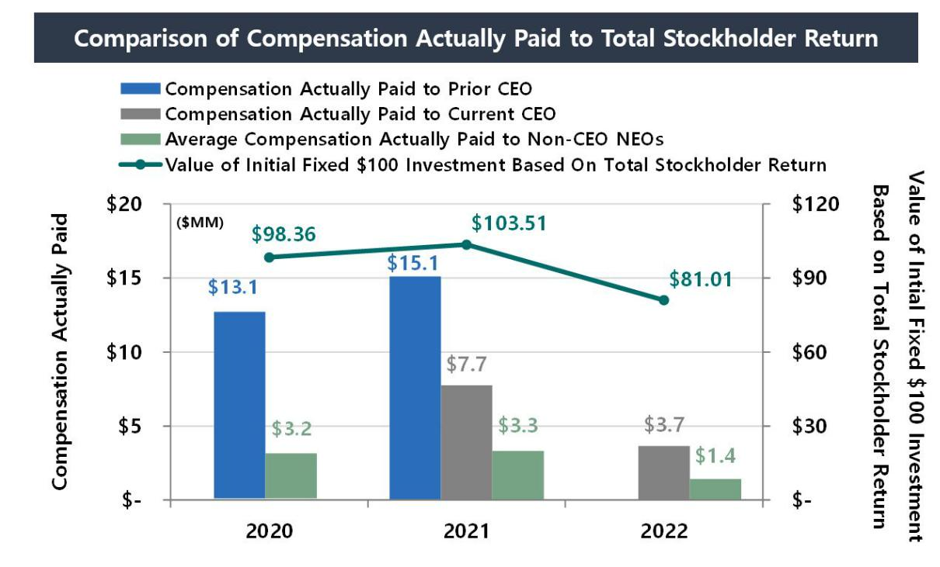

52 AGNC INVESTMENT CORP. - Proxy Statement

Table of Contents

EXECUTIVE COMPENSATION

The following graph illustrates the relationship between compensation actually paid to our NEOs and AGNC’s net income on an annual basis:
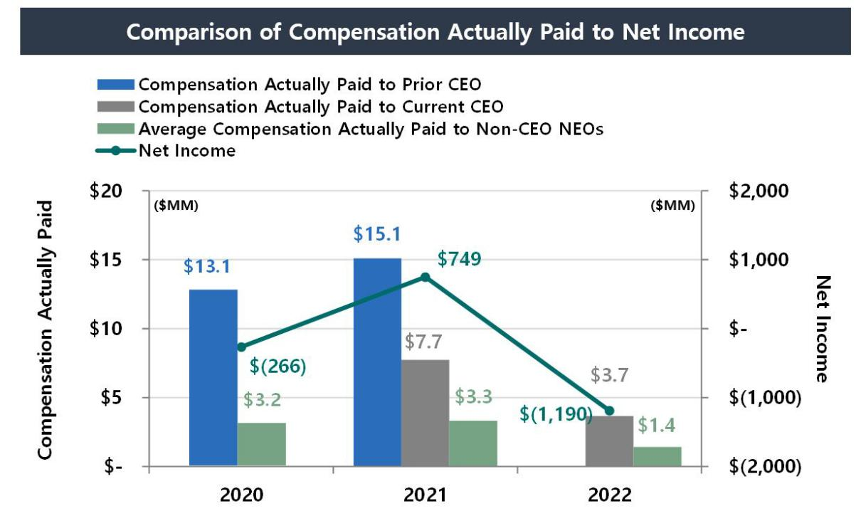

The following graph illustrates the relationship between compensation actually paid to our NEOs and AGNC’s economic return relative to the
AGNC Peer Group on an annual basis:
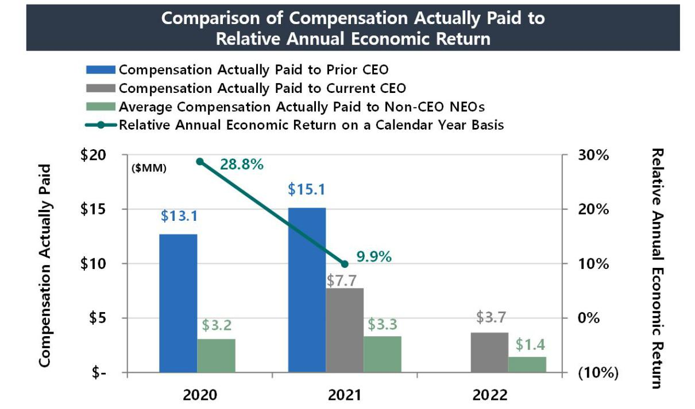

AGNC INVESTMENT CORP. - Proxy Statement 53

Table of Contents

EXECUTIVE COMPENSATION

The relationship between AGNC’s total stockholder return and the total stockholder return of The Bloomberg Mortgage REIT Index on a cumulative basis is shown below:
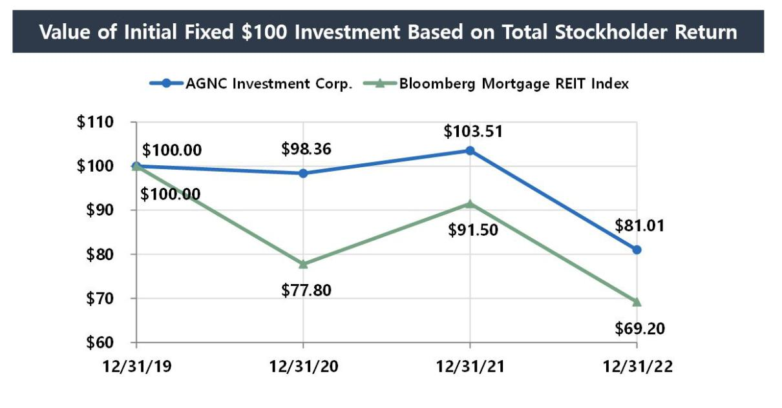

Since its adoption in 2016, our current compensation program has linked the compensation of our NEOs to achievement of short- and long-term financial and strategic goals. Our 2022 Corporate Scorecard consists 75% of financial metrics and 25% of strategic and operational measures. A significant

percentage of our NEOs’ compensation is in the form of equity awards that vest over three years, and in 2022, 67% of these awards to NEOs were performance vesting. In 2022, incentive compensation served as a material element of each NEO’s compensation package and serves to further align compensation to Company performance. The most important financial performance measures utilized by the Compensation Committee to link

compensation paid to our NEOs to AGNC's performance for 2022 were:

- Annual Economic Return Relative to the Agency REIT Peer Group

- Absolute Annual Economic Return

- Ratio of Price-to-Tangible Book Value Relative to the Agency REIT Peer Group

54 AGNC INVESTMENT CORP. - Proxy Statement

Table of Contents

EXECUTIVE COMPENSATION

CEO Compensation Pay Ratio

As required by Section 953(b) of the Dodd-Frank Wall Street Reform and Consumer Protection Act, and Item 402(u) of Regulation S-K, we determined that the 2022 total compensation of Peter Federico, our President and Chief Executive Officer, of $7,646,700 was approximately 25.48 times
the total compensation of a median employee in 2022 of $300,104.

We identified the median employee using the annual base salary and expected bonus, as of December 31, 2022, plus any long-term incentive stock awards granted in 2022 for all individuals, excluding our Chief Executive Officer, who were employed by us on December 31, 2022, the last day of our
payroll year (whether employed on a full-time, part-time, or seasonal basis). After identifying the median employee, we calculated annual total compensation for such employee using the same methodology we used for determining the CEO Compensation shown in the Summary Compensation Table.

AGNC INVESTMENT CORP. - Proxy Statement 55

Table of Contents

INFORMATION REGARDING COMPANY VOTING SECURITIES

INFORMATION REGARDING COMPANY VOTING SECURITIES

Security Ownership of Management and Certain Beneficial Owners

The following table sets forth, as of February 24, 2023 (unless otherwise indicated), the beneficial ownership of common stock of each current director, each nominee for director, each of our named executive officers, our executive officers and directors as a group, and each stockholder known to
management to own beneficially more than 5% of the outstanding shares of our common stock. Unless otherwise indicated, we believe that the beneficial owners set forth in the table below have sole voting and investment power. As of February 24, 2023, there were shares of our common stock outstanding.

Name and Address of Beneficial Owner

Beneficial Owners of more than 5%:

 | Percentage of
Number of Shares of | Common
 | Stock
Common Stock | Beneficially
Beneficially Owned ¹ | Owned

The Vanguard Group 2 | 54,355,072 | 9.5%
100 Vanguard Blvd.
Malvern, PA 19355
BlackRock, Inc.3 | 32,777,157 | 5.7%
55 East 52nd Street
New York, NY 10055
Directors and Named Executive Officers: 4
Peter J. Federico |  | *
Gary D. Kain ⁵ |  | *
Christopher J. Kuehl |  | *
Donna J. Blank |  | *
Bernice E. Bell |  | *
Morris A. Davis |  | *
John D. Fisk |  | *
Andrew A. Johnson, Jr. |  | *
Prue B. Larocca |  | *
Paul E. Mullings |  | *
Kenneth L. Pollack |  | *
Frances R. Spark |  | *
Directors and Executive Officers as a group (13 persons) |  | *

* Less than one percent.
- The amounts shown reflect shares of our common stock. Mr. Kain also owns 10,900 shares of our 6.875% Series D Fixed-to-Floating Rate Cumulative Redeemable Preferred Stock (“Series D Preferred Stock”), representing less than one percent of the shares of Series D Preferred Stock issued and outstanding as of February 24, 2023. Holders of Series D Preferred Stock generally do not have any voting rights. Other than Mr. Kain’s ownership of Series D Preferred Stock, our Directors and executive officers do not own shares of our 7.00% Series C Fixed-to-Floating Rate Cumulative Redeemable Preferred Stock, 6.875%, Series D Fixed-to-Floating Rate Cumulative Redeemable Preferred Stock, 6.50% Series E Fixed-to-Floating Rate Cumulative Redeemable Preferred Stock, 6.125% Series F Fixed-to-Floating Rate Cumulative Redeemable Preferred Stock, or Series G Fixed-Rate-Reset Cumulative Redeemable Preferred Stock.

- This information is based on a Schedule 13G/A filed with the SEC on February 9, 2023 by The Vanguard Group, Inc. (“Vanguard”), as an investment adviser. Vanguard is the beneficial owner of 54,355,072 shares and has the sole power to dispose or direct the disposition of 53,216,704 of such shares, shared power to dispose or direct the disposition of 1,138,368 of such shares, and shared power to vote or direct the vote of 256,477 of such shares.

- This information is based on a Schedule 13G/A filed with the SEC on February 1, 2023 by BlackRock, Inc., as a parent holding company or control person of certain named funds (“BlackRock”). BlackRock is the beneficial owner of 32,777,157 shares and has the sole power to dispose or direct the disposition of 32,777,157 of such shares and sole power to vote or direct the vote of 30,893,478 of such shares.

- The address of each of the executive officers and directors listed above is c/o AGNC Investment Corp., 2 Bethesda Metro Center, 12th Floor, Bethesda, MD 20814.
- Includes 667,920 shares held in a family trust over which shares Mr. Kain has voting and dispositive power.

56 AGNC INVESTMENT CORP. - Proxy Statement

Table of Contents

INFORMATION REGARDING COMPANY VOTING SECURITIES

Delinquent Section 16(a) Report

Section 16(a) of the Exchange Act requires our executive officers and directors, as well as beneficial owners of more than 10% of the outstanding shares of our common stock, to file reports regarding their ownership and subsequent changes to their ownership with the SEC. Based solely on a review of copies of reports filed for 2022 and written representations from reporting persons, we believe that for the fiscal year ended December 31, 2022, all required reports under Section 16(a) were filed on a timely basis with the exception of one Form 4 report related to a single transaction to withhold shares

for taxes that was filed late for Mr. Kain due to an administrative error.

AGNC INVESTMENT CORP. - Proxy Statement 57

Table of Contents

QUESTIONS AND ANSWERS ABOUT STOCKHOLDER COMMUNICATIONS AND PROPOSALS

QUESTIONS AND ANSWERS ABOUT STOCKHOLDER COMMUNICATIONS AND PROPOSALS

1. WHO IS RESPONSIBLE FOR STOCKHOLDER COMMUNICATIONS?

The Board is of the view that management is primarily responsible for all communications on behalf of AGNC with stockholders and the public at large. Thus, in addition to our executive officers, we employ a Vice President, Investor Relations, whose primary responsibilities include investor and stockholder relations.

2. HOW DO I COMMUNICATE WITH THE COMPANY’S BOARD?

Stockholders who wish to communicate with our Board or with a particular director may send a letter to our Secretary at AGNC Investment Corp., 2 Bethesda Metro Center, 12th Floor, Bethesda, MD 20814. Any communication should clearly specify that it is intended to be made to the entire Board or to one or more particular director(s).

Under this process, our Secretary reviews all such correspondence and will forward to the Board a summary of all such correspondence and copies of all correspondence that, in the opinion of the Secretary, deals with the functions of the Board or committees thereof or that he otherwise determines requires their attention. Directors may at any time review a log of all correspondence received by AGNC that is addressed to members of the Board and request

copies of any such correspondence. Concerns relating to accounting, internal controls, or auditing matters are immediately brought to the attention of the Chair of the Audit Committee and handled in accordance with procedures approved by the Board with respect to such matters.

A copy of such procedures for the submission and handling of complaints or concerns regarding accounting, internal accounting controls, or auditing matters is included in our Code of Ethics, which is published in the Investors section of our web site at ir.agnc.com/corporate-governance-documents.

3. HOW CAN A STOCKHOLDER NOMINATE A DIRECTOR OR SUBMIT A PROPOSAL FOR THE 2024 ANNUAL MEETING?

Stockholder proposals or nominees for election to the Board must be made in accordance with the procedures set forth in our Bylaws and described in the following question, and not the procedures set forth in the preceding question.

4. HOW CAN A STOCKHOLDER SUBMIT A PROPOSAL FOR THE 2024 ANNUAL MEETING OF STOCKHOLDERS?

Proposals received from common stockholders in accordance with Rule 14a-8 under the Exchange Act are given careful consideration by our

Compensation Committee and our Board. If a common stockholder intends to present a proposal at the 2024 annual meeting of stockholders pursuant to Rule 14a-8 under the Exchange Act, in order for such stockholder proposal to be included in our proxy statement and proxy card for that meeting, the stockholder proposal must be received by our Secretary at AGNC Investment Corp., 2 Bethesda Metro Center, 12th Floor, Bethesda, Maryland 20814, on

or before November 11, 2023, unless the date of the 2024 annual meeting of stockholders has been changed by more than 30 days from April 20, 2024, in which event the deadline is a reasonable time before we begin to print and send our proxy materials.

If such proposal is in compliance with all of the requirements of Rule 14a-8 under the Exchange Act, the proposal will be included in our proxy statement and proxy card relating to such meeting. Nothing in the response to this question shall be deemed to require us to include any stockholder proposal that does not meet all the requirements for such inclusion established by the SEC in effect at that time.

In order for a proposal by a common stockholder submitted outside of Rule 14a-8, including any nominations for election to the Board made by common stockholders, to be considered at the 2024 annual meeting of stockholders, such proposal must be made by written notice (setting forth the information required by our current Bylaws) and received by our Secretary not less than 90 and not more than 120 days in advance of the 2024 annual meeting.

Such proposals should be submitted by certified mail, return receipt requested.

5. HOW CAN I OBTAIN A COPY OF THE COMPANY’S 2022 ANNUAL REPORT ON FORM 10-K AND OTHER SEC FILINGS?

A copy of our 2022 annual report on Form 10-K containing audited financial statements was delivered or made available with this proxy statement. Additional copies of our 2022 annual report on Form 10-K (without exhibits, unless otherwise requested) are available in print, free of charge, to
stockholders requesting a copy by writing to: AGNC Investment Corp., Investor Relations, 2 Bethesda Metro Center, 12th Floor, Bethesda, Maryland 20814, or by calling (301) 968-9300. You may review our filings with the SEC by visiting the SEC’s home page on the internet at http://www.sec.gov or by visiting the Investors section of our web site at ir.agnc.com/financial-information/sec-filings.

58 AGNC INVESTMENT CORP. - Proxy Statement

Table of Contents

QUESTIONS AND ANSWERS ABOUT THE 2023 ANNUAL MEETING AND VOTING

QUESTIONS AND ANSWERS ABOUT THE 2023 ANNUAL MEETING AND VOTING

1. WHY DID I RECEIVE THESE PROXY MATERIALS?

Our Board is furnishing this proxy statement to you to solicit proxies on its behalf to be voted at the 2023 Annual Meeting on Thursday, April 20, 2023, at 9:00 a.m., Eastern Time. This year’s Annual Meeting will be held in a virtual format only through a live audio webcast. The proxies also may be voted at any postponement or adjournment of the meeting.

All properly executed written proxies, and all properly completed proxies submitted by telephone or by the internet, that are timely delivered pursuant to this solicitation, will be voted at the Annual Meeting in accordance with the directions given in the proxy unless the proxy is revoked before the completion of voting at the meeting.

2. WHAT ITEMS WILL BE CONSIDERED AND VOTED ON AT THE ANNUAL MEETING?

 |  | Board
Proposal |  | Recommendations
1) | Election of nine directors, each to serve a one-year term and until his or | FOR each of the nominees of the Board of
 | her successor is elected and qualified | Directors
2) | Approval of an advisory resolution on executive compensation | FOR the advisory resolution
3) | Approval of an advisory resolution on the frequency of future advisory | FOR “Every Year”
 | votes on executive compensation
4) | Ratification of the appointment of Ernst & Young LLP to serve as our | FOR the ratification of appointment
 | independent public accountant for the year ending December 31, 2023
5) | Approval of amendments to our Amended and Restated Certificate of
 | Incorporation eliminating supermajority voting requirements for
 | stockholders to:
 | A. amend certain provisions of our Certificate of Incorporation | FOR the proposed amendment to the Certificate of
 |  | Incorporation
 | B. amend our Bylaws | FOR the proposed amendment to the Certificate of
 |  | Incorporation
 | C. remove directors | FOR the proposed amendment to the Certificate of
 |  | Incorporation

The Board does not intend to bring other matters before the Annual Meeting except items incidental to the conduct of the meeting. However, on all other

matters properly brought before the meeting, or any postponement or adjournment thereof, by the Board or others, the persons named as proxies in the accompanying proxy card, or their substitutes, will vote in accordance with their discretion.

3. WHAT IS A PROXY?

It is your legal designation of another person to vote the stock you own. That other person is called a proxy. If you designate someone as your proxy in a

written document, that document is also called a proxy or a proxy card. Peter J. Federico and Kenneth L. Pollack have been designated as proxies by the Board for the Annual Meeting.

4. WHAT IS THE RECORD DATE AND WHAT DOES IT MEAN?

The record date for the Annual Meeting is February 24, 2023 (the “record date”). The record date is established by the Board and only common stockholders of record at the close of business on the record date are entitled to:

- receive notice of the meeting; and

- vote at the meeting and any postponement or adjournment of the meeting.

Each common stockholder of record on the record date is entitled to one vote for each share of common stock held. On the record date, there were shares of common stock outstanding.

- WHAT IS THE DIFFERENCE BETWEEN A STOCKHOLDER OF RECORD AND A STOCKHOLDER WHO HOLDS STOCK IN STREET NAME?

If your shares of common stock are registered in your name on the books and records of our transfer agent, you are a common stockholder of record.

If your shares of common stock are held for you through an intermediary in the name of your broker, bank or other nominee, your shares are held in street name. The answer to Question 10 below describes brokers’ discretionary voting authority and when your

AGNC INVESTMENT CORP. - Proxy Statement 59

Table of Contents

QUESTIONS AND ANSWERS ABOUT THE 2022 ANNUAL MEETING AND VOTING

broker, bank, or other nominee is permitted to vote your shares of common stock without instructions from you. For shares held through a benefit or compensation plan or a broker, bank, or other nominee, you may vote by submitting voting instructions to your plan trustee, broker, bank, or nominee. If you attend the virtual Annual Meeting, you may withdraw your proxy and vote online during the meeting using your 16-digit control number included on

your notice, proxy card, or the voting instruction form.

It is important that you vote your shares of common stock if you are a stockholder of record and, if you hold shares in street name, that you provide appropriate voting instructions to your broker, bank, or other nominee as discussed in the answer to Question 10 below.

6. WHAT ARE THE DIFFERENT METHODS THAT I CAN USE TO VOTE MY SHARES OF COMMON STOCK?

You may submit your proxy or vote your shares of our common stock by any of the following methods:

By Telephone or the Internet—Common stockholders can vote their shares via telephone or the internet as instructed in the proxy card or the voting instruction form. The telephone and internet procedures are designed to authenticate a stockholder’s identity, to allow common stockholders to vote their

shares, and to confirm that their instructions have been properly recorded.

By Mail—A common stockholder who receives a paper proxy card or voting instruction form or requests a paper proxy card or voting instruction form by

telephone or internet may elect to vote by mail and should complete, sign, and date the proxy card or voting instruction form and mail it in the pre-addressed envelope that accompanies the delivery of the proxy card or voting instruction form. For common stockholders of record, proxy cards submitted by mail must be received by the date and time of the Annual Meeting. For common stockholders who hold their shares through an intermediary, such as a

broker, bank, or other nominee, the voting instruction form submitted by mail must be mailed by the deadline imposed by your broker, bank, or other nominee for your shares to be voted.

Online during the Meeting—Shares of common stock may be voted online during the Annual Meeting using the 16-digit control number included on your notice, proxy card, or the voting instruction form.

7. WHO COUNTS THE VOTES?

A representative of Broadridge Investor Communication Solutions, Inc. will serve as the inspector of election and will receive and tabulate the proxies and certify the results.

8. WHAT IF A STOCKHOLDER DOES NOT SPECIFY A CHOICE FOR A MATTER WHEN RETURNING A PROXY?

Stockholders should specify their voting choice for each matter on the accompanying proxy. If no specification is made, such shares will be voted “FOR”

the election of the nine director nominees, “FOR” the advisory resolution on executive compensation, for “EVERY YEAR” for the advisory resolution on the frequency of future advisory resolutions on executive compensation,“FOR” the ratification of the appointment of Ernst & Young LLP as our independent public accountant for the year ending December 31, 2023, and “FOR” the approval of amendments to our Certificate of Incorporation
eliminating supermajority voting requirements.

9. WHAT DOES IT MEAN IF I RECEIVE MORE THAN ONE PROXY CARD?

It means that you have multiple accounts with brokers and/or our transfer agent. Please vote all of these shares.

We recommend that you contact your broker and/or our transfer agent to consolidate as many accounts as possible under the same name and address. Our

transfer agent is Computershare Investor Services. Computershare’s address is 150 Royall Street, Suite 101; Canton, MA 02021; you can reach Computershare at 1-800-733-5001 (from within the United States or Canada) or 781-575-3400 (from outside the United States or Canada) or via their Investor Centre™ portal at www.computershare.com/investor.

- WILL MY SHARES BE VOTED IF I DO NOT PROVIDE MY PROXY?

Stockholders of Record—If you are a stockholder of record (see Question 5 above), your shares of common stock will not be voted if you do not provide your proxy unless you vote online during the Annual Meeting. It is important that you vote your shares.

Street Name Holders—If your shares of common stock are held in street name (see Question 5 above) and you do not provide your signed and dated

voting instruction form to your broker, bank, or other nominee, your shares may be voted by your broker, bank, or other nominee but only under certain circumstances. Specifically, under applicable rules, shares held in the name of your broker, bank, or other nominee may be voted by your broker, bank, or other nominee on certain “routine” matters if you do not provide voting instructions.

The only proposals to be voted on at the Annual Meeting that are considered a “routine” matter for which brokers, banks or other nominees may vote uninstructed shares is the ratification of the appointment of Ernst & Young LLP as the Company’s independent public accountant. The other proposals (specifically, the election of director nominees, the approval of the advisory resolution on executive compensation, the advisory vote on the frequency of

future advisory votes on executive compensation, and the amendments to our Certificate of Incorporation to remove supermajority voting provisions) are not considered “routine” under applicable rules, so the broker, bank, or other nominee cannot vote your shares on these proposals unless you provide to the broker, bank, or other nominee voting instructions for these matters. If you do not provide voting instructions on a non-routine matter, your shares of

common stock will not be voted on the matter, which is referred to as a “broker non-vote.” It is, therefore, important that you vote your shares.

60 AGNC INVESTMENT CORP. - Proxy Statement

Table of Contents

QUESTIONS AND ANSWERS ABOUT THE 2023 ANNUAL MEETING AND VOTING

11. ARE ABSTENTIONS AND BROKER NON-VOTES COUNTED?

Abstentions and broker non-votes will not be counted as votes cast and will not affect the outcome of the votes on Proposals 1, 2, 3, and 4 at the Annual Meeting. Approval of Proposal 5, the amendment of our Certificate of Incorporation, requires the affirmative vote of at least 66% of the shares of our common stock outstanding and entitled to vote. Instructions to “Abstain” with respect to any of these amendments will be counted for purposes of
determining the number of share represented and entitled to vote. Accordingly, an abstention will have the effect of a vote “Against” these amendments.
Broker non-votes will also count as a vote “Against” these amendments. See Question 10 above for more information about broker non-votes.

12. HOW CAN I REVOKE A PROXY?

The enclosed proxy is solicited on behalf of the Board and is revocable at any time prior to the voting of the proxy, by the filing of an instrument revoking

it, or a duly executed proxy bearing a later date, with our Secretary, addressed to our principal executive offices at 2 Bethesda Metro Center, 12th Floor, Bethesda, Maryland 20814. In the event that you attend the Annual Meeting, you may revoke your proxy and cast your vote personally online during the meeting.

- WHO WILL PAY THE COST OF THIS PROXY SOLICITATION?

We will bear the cost of soliciting proxies on the accompanying form. In addition to the use of mail, our officers and employees may solicit proxies by telephone or email. Upon request, we will reimburse brokers, dealers, banks and trustees, or their nominees, for reasonable expenses incurred by them in forwarding our proxy materials to beneficial owners of our common stock. The Company has also retained D.F. King & Co., Inc. to assist in the solicitation

of proxies in connection with the Annual Meeting and will pay D.F. King a fee of $10,000 for its services. In addition, the Company may pay D.F. King additional fees depending on the extent of additional services requested by the Company and will reimburse D.F. King for expenses incurred in connection with its engagement by the Company.

- HOW DO I OBTAIN ADMISSION TO THE ANNUAL MEETING?

Attendance at the virtual Annual Meeting will be limited to common stockholders of record as of the close of business on the record date, February 24,

2023. To be admitted to the Annual Meeting at www.virtualshareholdermeeting.com/AGNC2023, you must enter the 16-digit control number which is located on your notice, proxy card, voting instruction form, or in the email sending you the Proxy Statement. If you are a beneficial stockholder, you may contact the bank, broker, or other institution where you hold your account if you have questions about obtaining your control number. Participants will be

able to access the virtual meeting site 15 minutes before the meeting begins on April 20, 2023. Stockholders experiencing technical difficulties when logging into the virtual meeting platform may access technical assistance provided by Broadridge Financial Solutions, Inc., the hosting platform for the Annual Meeting, toll-free in the United States at 1-844-986-0822 or internationally at 303-562-9302 beginning 15 minutes in advance of the meeting.

- WILL STOCKHOLDERS BE ABLE TO ASK QUESTIONS AT THE MEETING?

The Annual Meeting will include a question and answer session and will address questions submitted in writing in advance of and during the virtual meeting. Common stockholders of record on the record date may submit questions at www.proxyvote.com beginning up to 24 hours in advance of the meeting. We will endeavor to answer as many questions submitted by stockholders as time permits. We reserve the right to edit profanity or other

inappropriate language and to exclude questions regarding topics that are not pertinent to meeting matters or Company business in accordance with our rules of conduct for the meeting. If we receive substantially similar questions, we may group such questions together and provide a single response to avoid repetition. Additional information regarding the rules and procedures for participating in the virtual Annual Meeting will be provided in our meeting rules

of conduct, which stockholders can view during the meeting at the virtual meeting website.

- HOW MANY VOTES MUST BE PRESENT TO HOLD THE ANNUAL MEETING?

In order for us to conduct the Annual Meeting, holders representing a majority of our outstanding shares of common stock entitled to vote as of the close of business on the record date must be present online or by proxy at the meeting. This is referred to as a quorum.

Your shares are counted as present at the Annual Meeting if you attend the virtual meeting online and vote in person or if you properly return a proxy by internet, telephone, or mail.

Abstentions and broker non-votes will be considered present for the purpose of determining whether a quorum is present.

OTHER MATTERS

The Board does not intend to bring other matters before the Annual Meeting except items incidental to the conduct of the meeting. However, on all other matters properly brought before the meeting, or any postponement or adjournment thereof, by the Board or others, the persons named as proxies in the accompanying proxy card, or their substitutes, will vote in accordance with their discretion.

AGNC INVESTMENT CORP. - Proxy Statement 61

Table of Contents

PROPOSED AMENDED PROVISIONS OF THE AGNC INVESTMENT CORP. AMENDED AND RESTATED CERTIFICATE OF INCORPORATION

APPENDIX A

The proposed amendment to our Certificate of Incorporation to eliminate the supermajority voting requirement applicable to an amendment of our Certificate of Incorporation (Proposal 4A) is set forth below.

ARTICLE XII
AMENDMENT OF CERTIFICATE OF INCORPORATION

The Corporation hereby reserves the right to amend, alter, change or repeal any provision contained in this Certificate of Incorporation. Except as may be provided in a resolution or resolutions providing for any class of Preferred Stock pursuant to Article IV hereof and which relate to such class of Preferred Stock and except as provided in Article IV hereof, any such amendment, alteration, change or repeal shall require the affirmative vote of both (a)

a majority of the members of the Board of Directors then in office and (b) a majority of the combined voting power of all of the shares of all classes of capital stock of the Corporation then entitled to vote generally in the election of directors, voting together as a single class.

By a vote of the majority of the Board of Directors then in office, the Board of Directors may adopt a resolution providing that at any time prior to the filing of the amendment with the Secretary of State, notwithstanding authorization of the proposed amendment by the stockholders, the Board of Directors may abandon such proposed amendment without further action by the stockholders.

Notwithstanding anything contained in this Certificate of Incorporation to the contrary, the affirmative vote of the holders of at least sixty-six percent (66%) of the combined voting power of all of the shares of all classes of capital stock of the Corporation then entitled to vote shall be required to amend, repeal or adopt any provision inconsistent with Article V herein.

APPENDIX B

The proposed amendment to our Certificate of Incorporation to eliminate the supermajority voting requirement applicable to an amendment of our By-laws (Proposal 4B) is set forth below.

ARTICLE XI

AMENDMENT OF BY-LAWS

The Board of Directors shall have power to adopt, amend, alter, change and repeal any By-laws by a vote of the majority of the Board of Directors then in office. In addition to any requirements of the General Corporation Law (and notwithstanding the fact that a lesser percentage may be specified by the General Corporation Law), any adoption, amendment, alteration, change or repeal of any By-laws by the stockholders of the Corporation shall require the affirmative vote of the holders of at least sixty-six percent (66%)a majority of the combined voting power of all of the shares of all classes of capital stock of the Corporation then entitled to vote generally in the election of directors, voting together as a single class.

APPENDIX C

The proposed amendment to our Certificate of Incorporation to eliminate the supermajority voting requirement to remove directors (Proposal 4C) is set forth below.

Section 5.5 Removal of Directors. Except as may be provided in a resolution or resolutions providing for any class of Preferred Stock pursuant to Article IV hereof, with respect to any directors elected by the holders of such class, any director, or the entire Board of Directors, may be removed from office at any time with or without cause by the affirmative vote of the holders of at least sixty-six percent (66%)a majority of the voting power of all of the shares of capital stock of the Corporation then entitled to vote generally in the election of directors, voting together as a single class.

AI-1

Table of Contents
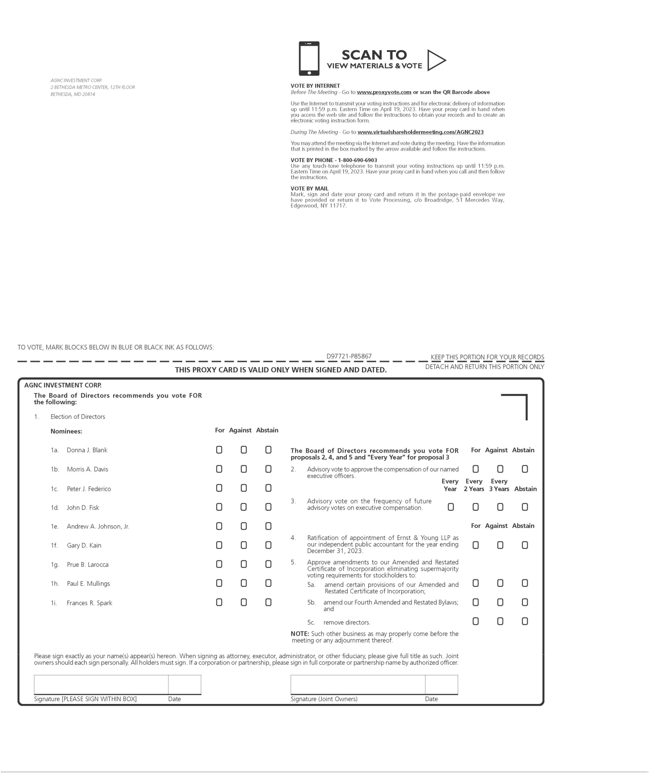

Table of Contents
