SECURITIES AND EXCHANGE COMMISSION

WASHINGTON, D.C. 20549

SCHEDULE 14A

(Rule 14a-101)

INFORMATION REQUIRED IN PROXY STATEMENT

SCHEDULE 14A INFORMATION

Proxy Statement Pursuant to Section 14(a) of the

Securities Exchange Act of 1934

Filed by the Registrant ☒ Filed by a Party other than the Registrant ☐

Check the appropriate box:

- Preliminary Proxy Statement

- Confidential, for Use of the Commission Only (as permitted by Rule 14a-6(e)(2))

- Definitive Proxy Statement

- Definitive Additional Materials

- Soliciting Material Pursuant to §240.14a-12

American Capital Agency Corp.

(Name of Registrant as Specified in its Charter)

Payment of Filing Fee (Check the appropriate box):

- No fee required

- Fee computed on table below per Exchange Act Rules 14a-6(i)(4) and 0-11.

  - Title of each class of securities to which transaction applies:

  - Aggregate number of securities to which transaction applies:

  - Per unit price or other underlying value of transaction computed pursuant to Exchange Act Rule 0-11 (set forth the amount on which the filing fee is calculated and state how it was determined):

  - Proposed maximum aggregate value of transaction:

  - Total fee paid:

- Fee paid previously with preliminary materials

- Check box if any part of the fee is offset as provided by Exchange Act Rule 0-11(a)(2) and identify the filing for which the offsetting fee was paid previously. Identify the previous filing by registration statement number, or the Form or Schedule and the date of its filing.

  - Amount Previously Paid:

  - Form, Schedule or Registration Statement No.:

  - Filing Party:

  - Date Filed:

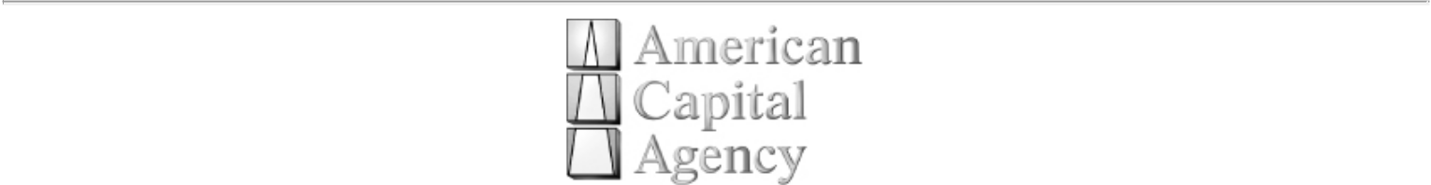

AMERICAN CAPITAL AGENCY CORP.

NOTICE TO STOCKHOLDERS

REGARDING OUR 2011 ANNUAL MEETING OF STOCKHOLDERS

Some of our stockholders may have received a notice regarding our 2011 Annual Meeting of Stockholders (“Annual Meeting”) that stated the Annual Meeting was to be held on April 25, 2011 for stockholders of record as of March 4, 2011. This notice is to advise you that we are setting a new meeting date and record date and you should ignore the prior communication.

In connection with our Annual Meeting, we will be filing a preliminary proxy statement (the “Preliminary Proxy Statement”) with the Securities and Exchange Commission (the “SEC”). We will also be filing a definitive proxy statement (the “Definitive Proxy Statement” and collectively with the Preliminary Proxy Statement, the “Proxy Statement”) that will include the new meeting date and record date. STOCKHOLDERS ARE URGED TO READ THE PROXY STATEMENT CAREFULLY WHEN AVAILABLE BECAUSE IT WILL CONTAIN IMPORTANT INFORMATION. OUR DIRECTORS AND EXECUTIVE OFFICERS ARE PARTICIPANTS IN THE SOLICITATION OF PROXIES IN CONNECTION WITH OUR ANNUAL MEETING AND INFORMATION CONCERNING SUCH PARTICIPANTS AND ANY INTERESTS THEY MAY HAVE IN US WILL BE SET FORTH IN THE PROXY STATEMENT.

The Proxy Statement will be available at no charge on the SEC’s website at http://www.sec.gov. In addition, we will provide copies of the Proxy Statement without charge upon request. Requests for copies should be directed to: American Capital Agency Corp., 2 Bethesda Metro Center, 14th Floor, Bethesda, MD 20814, telephone number (301) 968-9300.

Samuel A. Flax

Executive Vice President and Secretary

March 16, 2011

