Table of Contents

SECURITIES AND EXCHANGE COMMISSION

WASHINGTON, D.C. 20549

SCHEDULE 14A

(Rule 14a-101)

INFORMATION REQUIRED IN PROXY STATEMENT

SCHEDULE 14A INFORMATION

Proxy Statement Pursuant to Section 14(a) of the

Securities Exchange Act of 1934

Filed by the Registrant ☒ Filed by a Party other than the Registrant ☐

Check the appropriate box:

- Preliminary Proxy Statement

- Confidential, for Use of the Commission Only (as permitted by Rule 14a-6(e)(2))

☒ Definitive Proxy Statement

- Definitive Additional Materials

- Soliciting Material Pursuant to §240.14a-12

AGNC Investment Corp.

(Name of Registrant as Specified in its Charter)

Payment of Filing Fee (Check the appropriate box):

- No fee required

  - Fee paid previously with preliminary materials

  - Fee computed on table in exhibit required by Item 25(b) per Exchange Act Rules 14a-6(i)(1) and 0-11

Table of Contents


AGNC INVESTMENT CORP.
NOTICE OF 2024 ANNUAL MEETING OF

STOCKHOLDERS TO BE HELD ON APRIL 18, 2024

DATE AND TIME:

Thursday, April 18, 2024, at 9:00 a.m., Eastern Time

WHERE:

The Annual Meeting will be held in a virtual format. The virtual meeting site is www.virtualshareholdermeeting.com/AGNC2024.

ITEMS OF BUSINESS:

1) To elect the Board of Directors, with each director serving a one-year term and until his or her successor is elected and qualified;

2) To approve an advisory resolution on executive compensation;

3) To consider and vote upon the ratification of the appointment of Ernst & Young LLP to serve as our independent public accountant for the year ending December 31, 2024; and

4) To transact such other business as may properly come before the meeting or any postponement or adjournment thereof.

Stockholders will have an opportunity to submit questions in advance of and during the meeting.

WHO CAN VOTE:

You are entitled to notice of, and to vote at, the Annual Meeting and any postponement or adjournment of the Annual Meeting if you were a common stockholder of record at the close of business on February 23, 2024.

MEETING DETAILS:

Attendance at the meeting is limited to holders of common stock as of the close of business on February 23, 2024. For details regarding our virtual annual meeting, including how to attend and how to submit questions, see Questions 14

and 15 of “Questions and Answers About the 2024 Annual Meeting and Voting” in this proxy statement.

DATE OF DISTRIBUTION:

This notice, the proxy statement, the accompanying proxy card, and our annual report to stockholders, which includes

our annual report on Form 10-K with audited financial statements for the year ended December 31, 2023, are first being sent to our common stockholders on or about March 8, 2024.

BY ORDER OF THE BOARD OF
DIRECTORS,
Kenneth L. Pollack

Executive Vice President and Secretary

IMPORTANT NOTICE REGARDING THE AVAILABILITY OF PROXY MATERIALS FOR THE
ANNUAL MEETING OF STOCKHOLDERS TO BE HELD ON APRIL 18, 2024

This proxy statement and our annual report to stockholders, which includes our annual report on Form 10-K for the fiscal year ended December 31, 2023, are available free of charge on the internet at www.AGNC.com/2024proxymaterials.

Table of Contents

 | AGNC INVESTMENT CORP. AT A GLANCE
PROXY SUMMARY
Items to Be Voted
Proposal | Board | Page
 | Recommendation | Page
Proposal 1: Election of Directors | FOR | 11
Proposal 2: Advisory Resolution to Approve Executive Compensation | FOR | 16
Proposal 3: Ratification of Appointment of Independent Public Accountant | FOR | 17

How to Vote Your Shares
Your vote is important, and we urge you to cast your vote as soon as possible. You may vote through the internet, by telephone, by mailing your completed proxy card (or voting instruction form, if you hold your shares through a broker, bank, or other nominee), or online during the virtual 2024 Annual Meeting

(the “Annual Meeting”). See “Questions and Answers About the 2024 Annual Meeting and Voting” on page 53 of this proxy statement for additional information regarding voting.


How to Participate in the Meeting

Our Annual Meeting will be held in a virtual format. There will be no physical location for the Annual Meeting, and you will not be able to attend in person. As described in additional detail in this proxy summary and in the “Questions and Answers About the 2024 Annual Meeting and Voting” section on page 53, we believe we are taking meaningful steps to facilitate the attendance and participation of our stockholders at the Annual Meeting, including by
providing support for technical assistance during the meeting, allowing stockholders to submit questions in advance of and during the meeting, and addressing as many stockholder questions at the meeting as time allows. If you are an eligible stockholder, you may attend the meeting virtually by visiting www.virtualshareholdermeeting.com/AGNC2024 and logging in using the 16-digit control number printed on your notice, proxy card, voting instruction

form, or in the email sending you the proxy statement.

AGNC INVESTMENT CORP. - Proxy Statement i

Table of Contents

AGNC INVESTMENT CORP. AT A GLANCE

AGNC INVESTMENT CORP. AT A GLANCE

AGNC Investment Corp. (“AGNC,” the “Company,” “we,” “our,” and “us”) is a leading provider of private capital to the U.S. housing market, enhancing liquidity in the residential real estate mortgage markets and, in turn, facilitating home ownership in the U.S.
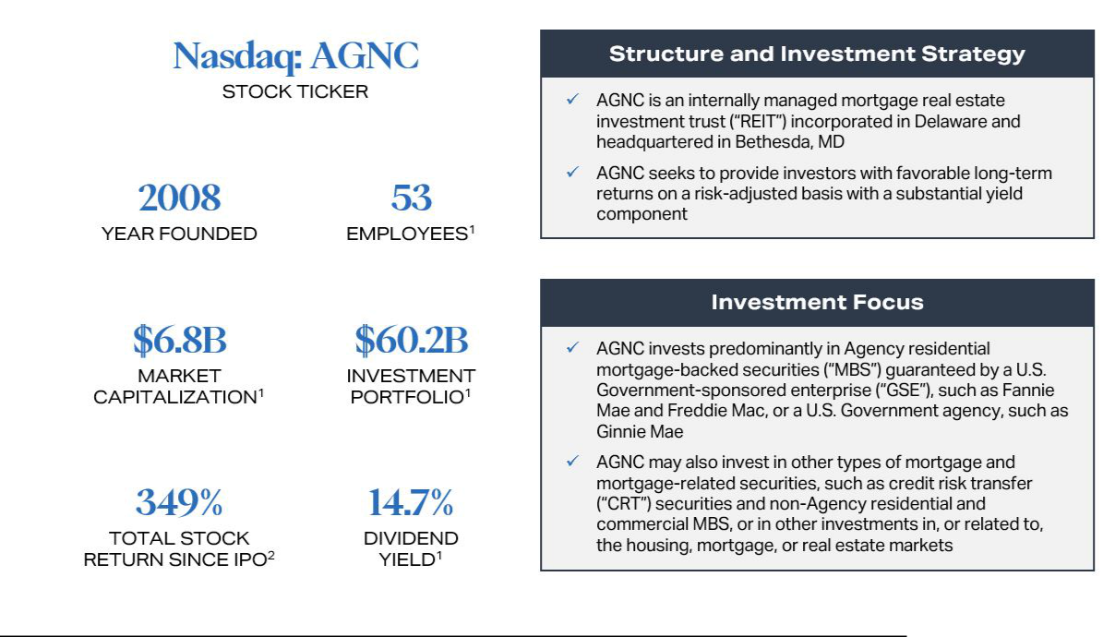

- Data as of December 31, 2023.
- Total stock return is measured from AGNC’s May 2008 IPO through December 31, 2023. Total stock return over a period includes price appreciation and dividend reinvestment; dividends are assumed to be reinvested at the closing price of the security on the ex-dividend date. Source: Bloomberg.

From our May 2008 IPO through December 31, 2023, AGNC has declared $12.9 billion in common stock dividends, or $47.20 per common share, and has generated a total stock return of 349%, compared to 88% for the Bloomberg Mortgage REIT Index, 143% for the S&P 500 Financials Index, and 104% for the S&P 500 Real Estate Index.

ii AGNC INVESTMENT CORP. - Proxy Statement

Table of Contents

AGNC INVESTMENT CORP. AT A GLANCE
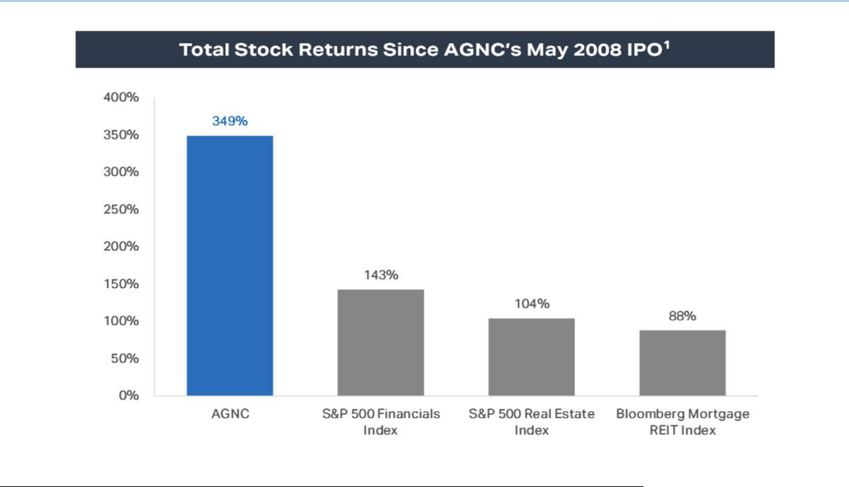

- Total stock return is measured from AGNC’s May 2008 IPO through December 31, 2023. Total stock return over a period includes price appreciation and dividend reinvestment; dividends are assumed to be reinvested at the closing price of the security on the ex-dividend date. Source: Bloomberg.

Qualified Leadership

Management Team

The AGNC management team is led by Peter Federico, our President and Chief Executive Officer, and Christopher Kuehl, our Executive Vice President and Chief Investment Officer. Following our successful leadership transition in July 2021, Gary Kain, previously our Chief Executive Officer and
Chief Investment Officer, now serves as Executive Chair of our Board of Directors (the “Board”). Messrs. Federico, Kuehl, and Kain collectively have over 90 years of experience investing in mortgage-backed securities (“MBS”) and have worked together at AGNC for the last 13 years. Messrs. Federico, Kuehl, and Kain, together with the other members of our management team, possess a broad mix of mortgage investment expertise and experience.

Board of Directors

AGNC’s Board is currently comprised of nine members, including seven independent directors, whose diverse range of experience and
backgrounds makes them highly qualified to oversee our strategy, operations, and risk management. As part of its annual process, the Compensation and
Corporate Governance Committee of the Board (the “Compensation Committee”) evaluates our Board’s backgrounds, skill sets, experience, and diversity
to ensure they align with the Company’s go-forward strategy. Prue Larocca serves as the Lead Independent Director and the Board’s Vice Chair. Further discussion of the responsibilities of Ms. Larocca and Mr. Kain are on page 1 under “Board Leadership Structure.”

AGNC INVESTMENT CORP. - Proxy Statement iii

Table of Contents

AGNC INVESTMENT CORP. AT A GLANCE

Director Nominees

 |  |  |  | Committee
Name |  |  |  |  | Compensation &
Name | Director Since | Independent | Executive | Audit | Corporate Governance
Donna J. Blank | 2018 | ✓ | ✓ | Chair
Morris A. Davis | 2008 | ✓ |  |  | Chair
Peter J. Federico (Chief Executive Officer) | 2021
John D. Fisk | 2019 | ✓ |  |  | ✓
Andrew A. Johnson, Jr. | 2021 | ✓ |  | ✓
Gary D. Kain (Executive Chair) | 2016 |  | ✓
Prue B. Larocca (Lead Independent Director and Vice Chair) | 2013 | ✓ | Chair | ✓ | ✓
Paul E. Mullings | 2016 | ✓ |  |  | ✓
Frances R. Spark | 2019 | ✓ |  | ✓
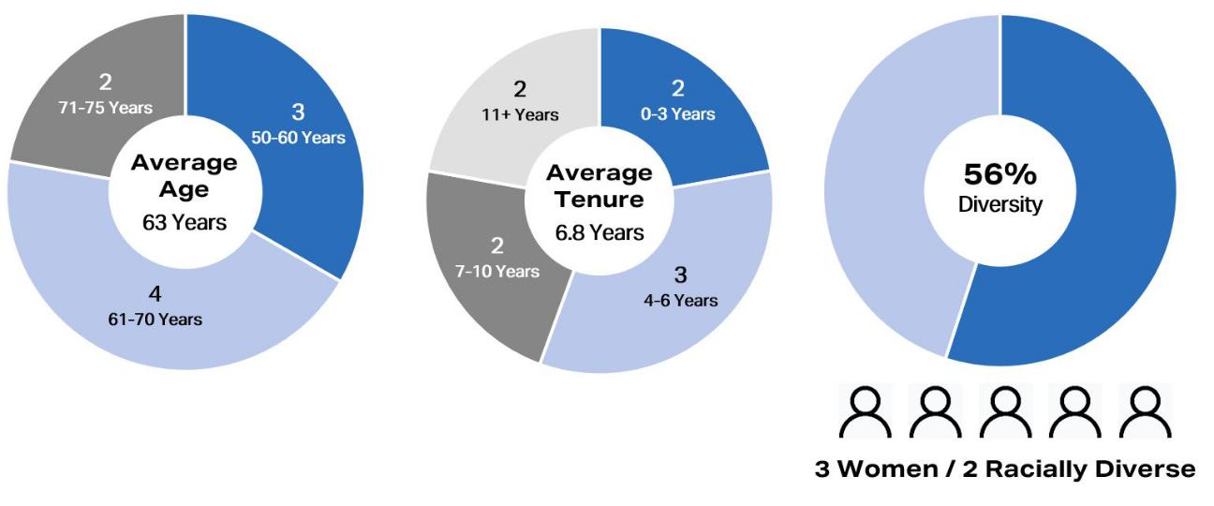

1. Metrics as of February 23, 2024.

iv AGNC INVESTMENT CORP. - Proxy Statement

Table of Contents

AGNC INVESTMENT CORP. AT A GLANCE

Director Skills Matrix

8/9 Leadership

Current or former CEO, CFO, business unit or operations head


9/9 Mortgage-Backed Securities and Housing Finance

Experience with the primary and secondary markets for residential mortgage transactions, including origination, pooling
and securitization, and secondary market investments in such instruments


8/9 Monetary Policy/Interest Rates

Understanding of the implications of changes in interest rates and monetary policy decisions on the economy and fixed income
markets

9/9 Risk Management

Experience in the management of critical business and/or legal risk, understanding of risk management functions, including risk
identification/classification; ability to think strategically about risk and provide oversight and advice relating to risk


8/9 Human Capital Management/Executive Compensation

Experience in leadership continuity, succession planning, human capital development, compensation programs, and management
of compensation and human capital related risks

8/9 Public Company Governance

Service on another public company board or other senior-level experience providing an understanding of corporate governance
practices


9/9 Fixed Income

Experience in the fixed income market, including as an investor, regulator, or capital markets participant


7/9 Capital and Portfolio Management

Experience with capital management and portfolio investment activities of financial services companies, institutional investors,
or investment management businesses 6/9 Capital Markets and M&A
Knowledge of capital markets and experience with raising money from institutional investors as well as public markets; experience
with acquisition, disposition, or consolidation of companies or business units


5/9 Regulatory and Legal Compliance

Experience in regulatory, legal, and public policy matters

Stockholder Engagement

We actively engage with and value the opinions of our stockholders, which have influenced the evolution of our compensation program, corporate governance practices, and sustainability and human capital management efforts. We value regular engagement with our stockholders, including through our quarterly earnings calls, investor conferences, fall and spring engagement campaigns, and outreach through our Investor Relations department. In 2023, we held a successful equity-research-analyst event following the Nasdaq opening bell ringing ceremony celebrating AGNC’s fifteenth anniversary as a public

company, participated in seven investor conferences, held over 160 meetings and calls with institutional investors, and responded to over 500 letters, emails, and calls from retail investors. In the fall of 2023, we engaged in a robust outreach program, contacting our top 50 institutional stockholders by shares of common stock owned, which collectively represented 89% of our common stock owned by institutions, and the two largest proxy advisory firms

for the opportunity to engage on any aspect of our business of interest to them, including corporate governance and sustainability practices. In our calls with institutional investors, we discussed the Company’s proposals at the 2022 and 2023 Annual Meetings to revise the Company’s Amended and Restated Certificate of Incorporation (our “Certificate of Incorporation”) to eliminate certain supermajority voting provisions. We discussed the efforts undertaken

by the Company in two consecutive years to amend these provisions, the challenges faced in obtaining the necessary approval, and the declining support by stockholders voting at each successive meeting. All investors with whom we spoke agreed with the reasonableness of the Company’s determination not to re-propose these amendments again at this year’s Annual Meeting. Additional discussion on the proposed amendments and the Company’s decision not to

include the amendments on the agenda is included in the “Corporate Governance” discussion on page 2.

In addition to our stockholder engagement with respect to our Certificate of Incorporation, stockholders with whom we spoke expressed general

support for our corporate governance, sustainability, and compensation practices. In November, we published our third annual ESG report, which again included disclosures consistent with the recommendations of the Sustainability Accounting Standards Board (“SASB”) and the Task Force on Climate-related Financial Disclosures (“TCFD”) framework and disclosure of AGNC’s Scope 1 and Scope 2 greenhouse gas emissions (“GHG”) and energy

consumption data. In 2023, we purchased carbon offsets and renewable energy certificates to offset the entirety of our 2022 Scope 1 and Scope 2 emissions, respectively.

Executive Compensation Program Overview, Philosophy and Structure, and Evolution

Our Compensation Committee has implemented a compensation program that links pay with performance, aligns executive objectives and incentives with our stockholders’ interests, and promotes operating efficiency. In addition, we believe our

AGNC INVESTMENT CORP. - Proxy Statement v

Table of Contents

AGNC INVESTMENT CORP. AT A GLANCE

compensation program is competitive given AGNC’s size, scale, business, and management structure; promotes retention of our employees; and is well-governed and transparent. All AGNC employees, including our named executive officers (“NEOs”), receive a combination of base salary, short-term incentives in the form of an annual cash bonus opportunity, and long-term incentives (“LTI”) in the form of restricted stock units (“RSUs”). The long-term
equity incentives awarded to our NEOs and other senior-level employees consist of a combination of performance-based RSUs and time-based RSUs.

As part of its ongoing evaluation of our compensation practices and in response to feedback we heard from stockholders during our prior outreach efforts, the Compensation Committee has made a number of meaningful changes to our compensation program and the corporate scorecard (“Corporate Scorecard”) used to evaluate performance since the compensation program was first implemented in 2016. Those changes included ensuring that a substantial portion of our NEOs’ total target compensation is allocated to long-term equity, simplifying the annual Corporate Scorecard to increase reliance on financial performance and better align to our strategic objectives, and improving disclosure to provide greater context for our compensation programs. The Compensation Committee’s continuing review of our pay practices resulted in further adjustments to components of pay among the elements of our compensation package to NEOs in 2023. These adjustments are discussed in greater detail in the “Summary of Recent Compensation Changes” section on page 26. Following these adjustments, our compensation program continues to be heavily weighted towards performance, with a meaningful percentage of each NEO’s compensation in the form of LTI awards based on company performance over a three-year period. At our 2023 Annual Meeting, 94% of our stockholders present or represented at the annual meeting and entitled to vote on the matter supported our advisory resolution on executive compensation.

vi AGNC INVESTMENT CORP. - Proxy Statement

Table of Contents

 |  |  |  |  |  |  |  |  |  |  |  |  |  |  |  |  |  |  |  |  |  |  |  |  |  |  |  |  |  | TABLE OF CONTENTS
 | Proxy Summary |  |  |  |  |  |  |  |  |  |  |  |  |  |  |  |  |  |  |  |  |  |  |  |  |  |  |  |  |  |  |  |  |  |  | i
 | Board and Governance Matters |  |  |  |  |  |  |  |  |  |  |  |  |  |  |  |  |  |  |  |  |  |  |  |  |  |  |  |  |  |  |  |  |  |  | 1
 |  | Board Leadership Structure |  |  |  |  |  |  |  |  |  |  |  |  |  |  |  |  |  |  |  |  |  |  |  |  |  |  |  |  |  |  |  |  |  | 1
 |  | Corporate Governance |  |  |  |  |  |  |  |  |  |  |  |  |  |  |  |  |  |  |  |  |  |  |  |  |  |  |  |  |  |  |  |  |  | 2
 |  | Committees of the Board of Directors |  |  |  |  |  |  |  |  |  |  |  |  |  |  |  |  |  |  |  |  |  |  |  |  |  |  |  |  |  |  |  |  |  | 3
 |  | Board and Committee Meetings |  |  |  |  |  |  |  |  |  |  |  |  |  |  |  |  |  |  |  |  |  |  |  |  |  |  |  |  |  |  |  |  |  | 4
 |  | Director Nomination Process |  |  |  |  |  |  |  |  |  |  |  |  |  |  |  |  |  |  |  |  |  |  |  |  |  |  |  |  |  |  |  |  |  | 4
 |  | Board Membership Criteria |  |  |  |  |  |  |  |  |  |  |  |  |  |  |  |  |  |  |  |  |  |  |  |  |  |  |  |  |  |  |  |  |  | 4
 |  | Oversight of Strategy and Key Risks |  |  |  |  |  |  |  |  |  |  |  |  |  |  |  |  |  |  |  |  |  |  |  |  |  |  |  |  |  |  |  |  |  | 5
 |  | ESG and Corporate Responsibility |  |  |  |  |  |  |  |  |  |  |  |  |  |  |  |  |  |  |  |  |  |  |  |  |  |  |  |  |  |  |  |  |  | 7
 |  | Director Compensation |  |  |  |  |  |  |  |  |  |  |  |  |  |  |  |  |  |  |  |  |  |  |  |  |  |  |  |  |  |  |  |  |  | 7
 |  | Stock Ownership Guidelines |  |  |  |  |  |  |  |  |  |  |  |  |  |  |  |  |  |  |  |  |  |  |  |  |  |  |  |  |  |  |  |  |  | 8
 |  | Director Resignation Policy |  |  |  |  |  |  |  |  |  |  |  |  |  |  |  |  |  |  |  |  |  |  |  |  |  |  |  |  |  |  |  |  |  | 9
 |  | Certain Transactions with Related Persons |  |  |  |  |  |  |  |  |  |  |  |  |  |  |  |  |  |  |  |  |  |  |  |  |  |  |  |  |  |  |  |  |  | 9
 |  | Compensation Committee Interlocks and Insider Participation |  |  |  |  |  |  |  |  |  |  |  |  |  |  |  |  |  |  |  |  |  |  |  |  |  |  |  |  |  |  |  |  |  | 10
 | Proposal 1: Election of Directors |  |  |  |  |  |  |  |  |  |  |  |  |  |  |  |  |  |  |  |  |  |  |  |  |  |  |  |  |  |  |  |  |  |  | 11
 |  | Summary of our Board’s Industry and Functional Expertise |  |  |  |  |  |  |  |  |  |  |  |  |  |  |  |  |  |  |  |  |  |  |  |  |  |  |  |  |  |  |  |  |  | 11
 |  | Director Nominee Biographies and Qualifications |  |  |  |  |  |  |  |  |  |  |  |  |  |  |  |  |  |  |  |  |  |  |  |  |  |  |  |  |  |  |  |  |  | 11
 |  | Conclusion and Recommendation; Vote Required |  |  |  |  |  |  |  |  |  |  |  |  |  |  |  |  |  |  |  |  |  |  |  |  |  |  |  |  |  |  |  |  |  | 15
 | Proposal 2: Advisory Resolution to Approve Executive Compensation |  |  |  |  |  |  |  |  |  |  |  |  |  |  |  |  |  |  |  |  |  |  |  |  |  |  |  |  |  |  |  |  |  |  | 16
 |  | General Information |  |  |  |  |  |  |  |  |  |  |  |  |  |  |  |  |  |  |  |  |  |  |  |  |  |  |  |  |  |  |  |  |  | 16
 |  | Conclusion and Recommendation; Vote Required |  |  |  |  |  |  |  |  |  |  |  |  |  |  |  |  |  |  |  |  |  |  |  |  |  |  |  |  |  |  |  |  |  | 16
 | Proposal 3: Ratification of Appointment of Independent Public Accountant |  |  |  |  |  |  |  |  |  |  |  |  |  |  |  |  |  |  |  |  |  |  |  |  |  |  |  |  |  |  |  |  |  |  | 17
 |  | Independent Public Accountant’s Fees |  |  |  |  |  |  |  |  |  |  |  |  |  |  |  |  |  |  |  |  |  |  |  |  |  |  |  |  |  |  |  |  |  | 17
 |  | Pre-Approval Policy |  |  |  |  |  |  |  |  |  |  |  |  |  |  |  |  |  |  |  |  |  |  |  |  |  |  |  |  |  |  |  |  |  | 17
 |  | Conclusion and Recommendation; Vote Required |  |  |  |  |  |  |  |  |  |  |  |  |  |  |  |  |  |  |  |  |  |  |  |  |  |  |  |  |  |  |  |  |  | 18
 | Report of the Audit Committee |  |  |  |  |  |  |  |  |  |  |  |  |  |  |  |  |  |  |  |  |  |  |  |  |  |  |  |  |  |  |  |  |  |  | 19
 | Executive Officers of Registrant |  |  |  |  |  |  |  |  |  |  |  |  |  |  |  |  |  |  |  |  |  |  |  |  |  |  |  |  |  |  |  |  |  |  | 20
 |  | Executive Officer Biographies |  |  |  |  |  |  |  |  |  |  |  |  |  |  |  |  |  |  |  |  |  |  |  |  |  |  |  |  |  |  |  |  |  | 20
 | Executive Compensation |  |  |  |  |  |  |  |  |  |  |  |  |  |  |  |  |  |  |  |  |  |  |  |  |  |  |  |  |  |  |  |  |  |  | 22
 |  | Compensation Discussion and Analysis |  |  |  |  |  |  |  |  |  |  |  |  |  |  |  |  |  |  |  |  |  |  |  |  |  |  |  |  |  |  |  |  |  | 22
 |  |  | 2023 Named Executive Officers |  |  |  |  |  |  |  |  |  |  |  |  |  |  |  |  |  |  |  |  |  |  |  |  |  |  |  |  |  |  |  |  | 22
 |  |  | Executive Summary |  |  |  |  |  |  |  |  |  |  |  |  |  |  |  |  |  |  |  |  |  |  |  |  |  |  |  |  |  |  |  |  | 22
 |  |  |  |  | Business Overview |  |  |  |  |  |  |  |  |  |  |  |  |  |  |  |  |  |  |  |  |  |  |  |  |  |  |  |  |  |  | 22
 |  |  |  |  | 2023 Performance Highlights |  |  |  |  |  |  |  |  |  |  |  |  |  |  |  |  |  |  |  |  |  |  |  |  |  |  |  |  |  |  | 23
 |  |  |  |  | Compensation Philosophy and Objectives |  |  |  |  |  |  |  |  |  |  |  |  |  |  |  |  |  |  |  |  |  |  |  |  |  |  |  |  |  |  | 24
 |  |  |  |  |  |  |  |  |  |  |  |  |  |  |  |  |  |  |  |  |  |  |  |  |  |  |  |  |  |  |  |  |  |  | AGNC INVESTMENT CORP. - Proxy Statement | vii

Table of Contents

 |  |  | Stockholder Engagement |  |  |  |  |  |  |  |  |  |  |  |  |  |  |  |  |  |  |  | 25
 |  |  | Summary of Recent Compensation Changes |  |  |  |  |  |  |  |  |  |  |  |  |  |  |  |  |  |  |  | 26
 |  |  | Compensation Governance Practices |  |  |  |  |  |  |  |  |  |  |  |  |  |  |  |  |  |  |  | 27
 | Compensation Program In Detail |  |  |  |  |  |  |  |  |  |  |  |  |  |  |  |  |  |  |  |  |  | 27
 |  |  | Compensation Program Elements |  |  |  |  |  |  |  |  |  |  |  |  |  |  |  |  |  |  |  | 28
 |  |  | Corporate Scorecard for Calculating Annual Bonus |  |  |  |  |  |  |  |  |  |  |  |  |  |  |  |  |  |  |  | 29
 |  |  | Equity Incentive Compensation |  |  |  |  |  |  |  |  |  |  |  |  |  |  |  |  |  |  |  | 33
 |  |  | Compensation Decision Process |  |  |  |  |  |  |  |  |  |  |  |  |  |  |  |  |  |  |  | 35
 |  |  | Other Compensation Policies and Practices |  |  |  |  |  |  |  |  |  |  |  |  |  |  |  |  |  |  |  | 38
 | Report of the Compensation and Corporate Governance Committee |  |  |  |  |  |  |  |  |  |  |  |  |  |  |  |  |  |  |  |  |  | 39
 | 2023 Summary Compensation Table |  |  |  |  |  |  |  |  |  |  |  |  |  |  |  |  |  |  |  |  |  | 39
 | Grants of Plan-Based Awards in Fiscal Year 2023 |  |  |  |  |  |  |  |  |  |  |  |  |  |  |  |  |  |  |  |  |  | 41
 | Outstanding Equity Awards at 2023 Fiscal Year-End |  |  |  |  |  |  |  |  |  |  |  |  |  |  |  |  |  |  |  |  |  | 42
 | Option Exercises and Stock Vested for Fiscal Year 2023 |  |  |  |  |  |  |  |  |  |  |  |  |  |  |  |  |  |  |  |  |  | 43
 | Severance and Change of Control Payments |  |  |  |  |  |  |  |  |  |  |  |  |  |  |  |  |  |  |  |  |  | 43
 | Pay Versus Performance |  |  |  |  |  |  |  |  |  |  |  |  |  |  |  |  |  |  |  |  |  | 46
 | CEO Compensation Pay Ratio |  |  |  |  |  |  |  |  |  |  |  |  |  |  |  |  |  |  |  |  |  | 50
Information Regarding Company Voting Securities |  |  |  |  |  |  |  |  |  |  |  |  |  |  |  |  |  |  |  |  |  |  | 51
 | Security Ownership of Management and Certain Beneficial Owners |  |  |  |  |  |  |  |  |  |  |  |  |  |  |  |  |  |  |  |  |  | 51
Questions and Answers About Stockholder Communications and Proposals |  |  |  |  |  |  |  |  |  |  |  |  |  |  |  |  |  |  |  |  |  |  | 52
Questions and Answers About the 2024 Annual Meeting and Voting |  |  |  |  |  |  |  |  |  |  |  |  |  |  |  |  |  |  |  |  |  |  | 53

viii AGNC INVESTMENT CORP. - Proxy Statement

Table of Contents

BOARD AND GOVERNANCE MATTERS

BOARD AND GOVERNANCE MATTERS

Our Board is currently comprised of seven independent directors, our Executive Chair, and our CEO. The following table sets forth the current members of our Board and their committee membership:

Name |  |  |  | Compensation &
Name | Director Since | Executive | Audit 1 | Corporate Governance 2
Donna J. Blank* | 2018 | ✓ | Chair
Morris A. Davis* | 2008 |  |  | Chair
Peter J. Federico (Chief Executive Officer) | 2021
John D. Fisk* | 2019 |  |  | ✓
Andrew A. Johnson, Jr.* | 2021 |  | ✓
Gary D. Kain (Executive Chair) | 2016 | ✓
Prue B. Larocca* (Lead Independent Director and Vice Chair) | 2013 | Chair | ✓ | ✓
Paul E. Mullings* | 2016 |  |  | ✓
Frances R. Spark* | 2019 |  | ✓

* Director is “independent” as defined in Rule 5605(a)(2) of The Nasdaq Listing Rules (the “Nasdaq rules”).

- Each member of the Audit Committee is “independent” as defined in Rules 5605(a)(2) and 5605(c)(2) of the Nasdaq rules and Rule 10A-3 of the Securities Exchange Act of 1934 (the “Exchange Act”). The Board has determined that Mss. Blank and Spark are each an “audit committee financial expert” as defined in Item 407 of Regulation S-K under the Securities Act of 1933 (the “Securities Act”).

- Each member of the Compensation and Corporate Governance Committee is “independent” as defined in Rules 5605(a)(2) and 5605(d)(2) of the Nasdaq rules.

Board Leadership Structure

We believe that objective, independent oversight of management is central to our corporate governance, as well as execution upon our strategic objectives and alignment with the long-term interests of our stockholders. The Board believes that the optimal leadership structure for AGNC may evolve over time as a result of a number of factors, including changes in our strategy, market conditions, and the composition of our Board and management personnel. Accordingly, the Board regularly evaluates the most effective leadership structure for the Company. The Board believes that separating the positions of Chair and Chief Executive Officer is the best corporate governance leadership structure for us at this time and that independent directors should play a significant role in Board leadership. Following the transition of our executive leadership in July 2021: Mr. Kain serves as Executive Chair of the Board; Ms. Larocca serves as Lead Independent Director and Vice Chair and Mr. Federico serves as our Chief Executive Officer.

Ms. Larocca, in her role as Lead Independent Director and Vice Chair, is empowered with robust, well-defined duties and actively collaborates with our Chief Executive Officer and Executive Chair on a wide variety of issues. In his role as Executive Chair, Mr. Kain serves as a resource to our Chief Executive Officer and Chief Investment Officer and consults with the Company’s senior management on significant strategic decisions and business-plan execution, including investment strategies and portfolio risk management. He and Ms. Larocca collaborate closely to shape and implement the Board’s agenda and to facilitate the oversight of AGNC’s operations and strategy. The chart below highlights the principal responsibilities of our Executive Chair and Lead Independent Director and their collaboration with other members of the Board and AGNC’s management team.

AGNC INVESTMENT CORP. - Proxy Statement | 1

Table of Contents

BOARD AND GOVERNANCE MATTERS

Responsibilities and Collaboration Among our Lead Independent Director and Executive Chair

Lead Independent Director and Vice Chair

- elected by and acts as leader of independent directors

- chairs meetings of the independent directors and the Executive Committee and chairs meetings of the Board of Directors when the Executive Chair is not present or is recused

Executive Chair

- elected by all directors

- chairs all regular and special meetings of the Board

- serves on the Executive Committee

- serves on all Board committees to facilitate support of committee chairs and coordination of committee work

- able to call meetings of the independent directors and special meetings of the Board of Directors

- collaborates with the Executive Chair, the CEO, the Secretary, and committee chairs to approve scheduling of meetings, development of agendas, and review the content and distribution of materials

- serves as a liaison between management and the independent directors and ensures that the information needs of independent directors are satisfied

- together with the chair of the Compensation Committee, leads the performance evaluation of the Executive Chair and the Chief Executive Officer

- together with the Executive Chair, facilitates identification and resolution of potential conflicts of interest and establishes expectations regarding culture of compliance throughout the Company

- serves as an additional management resource in the event of a crisis or interruption in business continuity

- together with the Vice Chair, facilitates identification and resolution of potential conflicts of interest and establishes expectations regarding culture of compliance throughout the Company

- collaborates with the Lead Independent Director, CEO, Secretary, and committee chairs to call and schedule Board meetings, develop agendas, and review the content and distribution of materials

- as necessary, represents the Company to stockholders, other stakeholders, and government officials in conjunction with the Chief Executive Officer

- provides support and guidance to the Chief Executive Officer and Chief Investment Officer, including consultation on significant strategic decisions

- evaluates and reports to the independent directors as requested regarding the Chief Executive Officer’s performance

- communicates on behalf of the independent directors with stockholders, proxy advisory firms, and other stakeholders, as necessary

AGNC is committed to maintaining strong, independent leadership on the Board. Our Board has a policy, consistent with the Nasdaq rules and good corporate governance, to have our independent directors meet regularly without members of management or employee directors present to facilitate the Board’s independent oversight of management. Presently, our independent directors meet during our Board’s regular quarterly meetings and may hold additional meetings at the request of the Lead Independent Director or a majority of the directors.

Each of our Board’s Audit Committee and Compensation Committee is composed entirely of independent directors. These independent committees of our Board also have the authority under their respective charters to hire independent advisors and consultants, at the Company’s expense, to assist them in performing their duties. The chairs of the Audit and Compensation Committees set meeting agendas in consultation with our Secretary. A majority of our Board’s Executive Committee also consists of independent directors. Our Board has determined that all of the current directors, except Messrs. Federico and Kain, are “independent” as defined in the Nasdaq rules.

Corporate Governance

Our Board maintains strong corporate governance practices, which are memorialized in our Corporate Governance Guidelines, to support its oversight responsibilities. These guidelines, together with our Amended and Restated Certificate of Incorporation (our “Certificate of Incorporation”),

Amended and Restated Bylaws (our “Bylaws”), and committee charters of the Audit Committee and the Compensation Committee, form the basis for performance of our governance activities. All of these documents are available in the Investors section of our website at www.AGNC.com.

Amendments to AGNC’s Certificate of Incorporation to Eliminate Certain Supermajority Voting Provisions

At the 2022 and 2023 Annual Meetings, we included on the agenda, and the Board recommended that stockholders vote in favor of, amendments to our Certificate of Incorporation eliminating certain supermajority voting provisions. Under the provisions of AGNC’s Certificate of Incorporation, approval of these amendments requires the affirmative vote of at least 66% of all shares of common stock entitled to vote on the matter. Although
stockholders who cast votes at the meetings voted overwhelmingly in favor of the amendments, stockholder participation was well below the threshold required to pass the proposals and declined year over year. Based on information available to the Company, more than 60% of the Company’s shares of common stock are held by investors in individual brokerage accounts who, as a group, have very low vote participation in stockholder meetings and are

very challenging to reach via traditional stockholder outreach efforts. Although the Company incurred the additional costs of engaging a proxy solicitor, support for the proposals was 45% in 2022 and 41% in 2023 of shares entitled to vote on the matter, well-short of the required 66%

- AGNC INVESTMENT CORP. - Proxy Statement

Table of Contents

BOARD AND GOVERNANCE MATTERS

threshold. The inclusion of the proposal on the agenda would require the Company to file a preliminary proxy with the Securities and Exchange Commission, which accelerates the timing of the Company’s proxy statement preparations and places additional burdens on the Company’s resources. In evaluating whether to propose the amendments for a third consecutive year at the 2024 Annual Meeting, the Company considered the additional costs

involved in filing the preliminary proxy, the high percentage of the Company’s common stock held by retail investors in the Company, the limited effectiveness of proxy solicitation efforts, and the declining support from 2022 to 2023. The Company also discussed with its proxy solicitor opportunities to increase voter turnout on these proposals and concluded that it would be highly unlikely to achieve requisite support levels despite outreach efforts given

the current ownership base of our common stock. After evaluating these factors, the Company elected not to include them on the agenda for the 2024 Annual Meeting. The Company will continue to evaluate the factors and considerations outlined herein and will endeavor to include the amendments on a future meeting agenda at such time that the Company concludes the likelihood of approval has increased.


CORPORATE GOVERNANCE HIGHLIGHTS

- Annual election of directors

- Directors elected by majority voting, with a resignation policy for directors who do not receive a majority support

- Five of nine directors are gender or racially diverse

- Chair is separate from the CEO

- Robust independent Board leadership, with Lead Independent Director also serving as Vice Chair

- All directors serve on the boards of two or fewer public companies or mutual fund complexes

- Average Board tenure of 6.8 years, with the majority of the Board having tenure less than six years

- Regular meetings of independent directors without members of management

- Stock ownership guidelines for directors and executive officers

- Robust stockholder engagement program, including annual outreach campaign to institutional investors

- Anti-hedging and pledging policy for directors and executive officers

- Clawback policy for incentive compensation

- No stockholder rights plan or “poison pill”

- Comprehensive Code of Ethics and Conduct and Corporate Governance Guidelines

- Annual board and committee self-evaluations

- 100% attendance at 95% of our Board and committee meetings in 2023

- Membership in the National Association of Corporate Directors (the “NACD”), a leading authority on corporate boardroom and governance practices

Committees of the Board of Directors

Our Board’s principal standing committees and their primary functions are described below.

Audit Committee

This committee assists the Board in overseeing:

- our accounting and financial reporting processes;
- the integrity and audits of our financial statements;
- the adequacy of our internal control over financial reporting, including controls relating to the preparation of our financial statements;
- our internal audit department and its annual scope of work;
- cybersecurity and other risks to information technology systems;
- our compliance with legal and regulatory requirements;
- compliance with our Code of Ethics and Conduct (“Code of Ethics”);
- the qualifications and independence of our independent registered public accounting firm; and
- the performance of our independent registered public accounting firm and our internal audit department.

The Audit Committee is also responsible for engaging an independent registered public accounting firm, reviewing the plans and results of the

audit engagement with the independent registered public accounting firm, approving professional services provided by the independent registered public accounting firm, considering the range of audit and non-audit fees, and preparing a report on the review of the Company’s audited financial statements as required to be included in our proxy statement. The committee’s meetings include, whenever appropriate, executive sessions with our independent external auditors, without the presence of management.

Compensation and Corporate Governance Committee

This committee’s principal functions are to:

- oversee and review our compensation practices with respect to our executive officers, employees, and members of the Board and make recommendations to the Board on these matters;

- set the terms of employment of our executive officers and recommend CEO and Executive Chair compensation decisions for approval by the independent directors of our Board;
- administer our equity and incentive plans to the extent delegated authority by the Board;

AGNC INVESTMENT CORP. - Proxy Statement 3

Table of Contents

BOARD AND GOVERNANCE MATTERS

- provide general oversight of our compensation structure, including any compensation plans;
- review and make recommendations to the Board on executive succession plans and leadership development;
- oversee matters relating to human capital management, including the hiring, development, retention, and satisfaction of our employees and our policies and practices for diversity, equity, and inclusion;
- make recommendations to the Board regarding Board and committee oversight of AGNC’s corporate social responsibility and sustainability strategies and practices;
- monitor and facilitate our governance, including membership of the Board and operations pursuant to our Corporate Governance Guidelines;
- review and evaluate the sufficiency of our Code of Ethics;
- oversee evaluation of our CEO, Executive Chair, and other executive officers; and
- review and approve the disclosure regarding the Company’s compensation and benefits matters and prepare a report on executive compensation, each as required to be included in our proxy statement for our annual meetings.

The Compensation Committee also serves as the Board’s standing nominating committee and as such performs the following functions:

- identifying, recruiting, and recommending to the Board qualified candidates for election as directors and recommending a slate of nominees for election as directors by our common stockholders at the annual meeting of stockholders;

- developing and recommending to the Board Corporate Governance Guidelines, including the committee’s selection criteria for director nominees;
- recommending to the Board nominees for each committee of the Board;
- overseeing the orientation process for new directors and continuing education of all directors; and
- annually facilitating an assessment of the Board, Board committee, and individual director performance and making reports thereon to the Board.

Under its charter, the Compensation Committee has the authority to select, retain, and terminate compensation consultants. The Compensation Committee retained Frederic W. Cook & Co., Inc. (“FW Cook”) to assist the Compensation Committee in designing and establishing a compensation
structure in 2016 and has continued to engage FW Cook to advise on and assist with the review and evaluation of executive compensation and compensation of our non-employee directors.

Executive Committee

This committee has the authority to exercise all powers of the Board except for actions that must be taken by the full Board under Delaware law, our Certificate of Incorporation, or Bylaws.

Board and Committee Meetings

The Board generally holds regular quarterly meetings and meets on other occasions, as necessary. The Board held 10 regular and special meetings during 2023. In addition, the independent directors met separately in executive sessions to discuss various matters, including our performance and the performance of our Executive Chair, Chief Executive Officer, and other executive officers.

Each of the Audit Committee and the Compensation Committee schedules regular meetings to coincide with the quarterly meetings of the Board and also meets at the request of senior management or at such other times as its Chair determines. The Chair of each Committee, in consultation with our Secretary, sets the agendas for the meetings. Each committee reports to the Board on its activities at the next regularly scheduled Board meeting following
its committee meetings and when appropriate. During 2023, the Audit Committee held five meetings, and the Compensation Committee held seven meetings. The Board periodically conducts a multi-day meeting devoted to reviewing the Company’s strategy, macro trends impacting our business, and other topics of interest to our directors, including relevant continuing education sessions, which last occurred in December 2023.

Each of our independent directors attended all of the meetings of the Board and committees on which he or she served in 2023 with the exception of one independent director who was unable to attend one special meeting of the Board. Although we do not have a policy on director attendance at the Annual Meeting, directors are encouraged to attend, and each of our directors attended the 2023 Annual Meeting.

Director Nomination Process

Nominations for election to the Board may be made by the Compensation Committee or by any common stockholder entitled to vote for the election of directors in accordance with the procedures set forth in our Bylaws and as provided by applicable law. Candidates recommended by common stockholders will be evaluated by the Compensation Committee under the same criteria that are applied to other candidates.

Board Membership Criteria

The Compensation Committee endeavors to identify, recruit, and nominate candidates based on the following eligibility and experience criteria: a candidate’s integrity and business ethics, strength of character, judgment, experience, and independence, as well as factors relating to the composition of

the Board, including its size and structure, the relative strengths and experience of current directors, and principles of diversity, including diversity of experience, personal and professional backgrounds, race, gender, ethnicity, and age.

- AGNC INVESTMENT CORP. - Proxy Statement

Table of Contents

BOARD AND GOVERNANCE MATTERS

The Compensation Committee recognizes the importance of diverse viewpoints, experience, and backgrounds to a well- functioning Board. Although the committee does not have formal objective criteria for diversity on our Board, it is a significant consideration, and since 2017, 60% of new director nominations have been women or minority candidates. Furthering our commitment to diversity, we revised our Corporate Governance Guidelines
in 2021 to reflect the Board’s undertaking to instruct any third-party search firm engaged in a director search on our behalf to include in the initial list of candidates individuals reflecting diverse backgrounds, including diversity of gender, race, or ethnicity. In nominating candidates to the Board, the committee determines whether the incumbent director is willing to stand for re-election. If so, the committee evaluates individual contributions to

determine suitability for continued service, taking into consideration the Board’s criteria for candidates, the Board evaluation process, and other perceived needs of the Board. The Company maintains a corporate membership in the NACD, which provides each director with access to continuing education, research materials, and publications relating to corporate governance, board leadership, and other topical information. The Company also reimburses

directors for participation in professional development opportunities. A number of our directors have participated in continuing education and certification programs, including in the areas of cybersecurity, corporate governance, and climate change oversight.
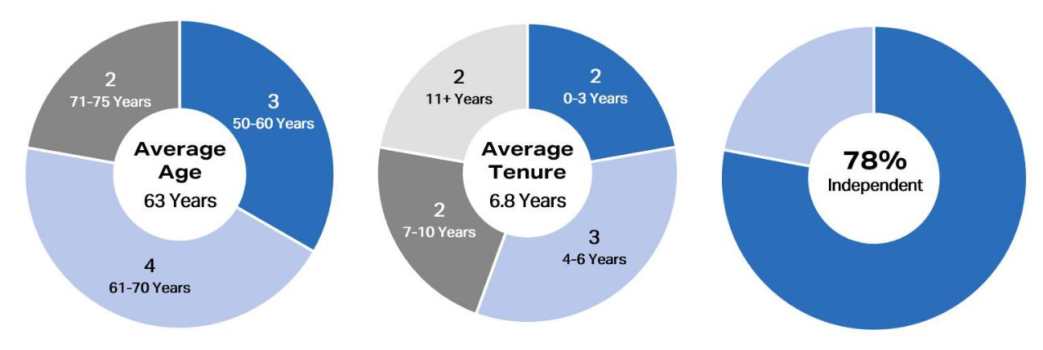

1. Metrics as of February 23, 2024.

The following table provides characteristics of our directors according to the categories required under Nasdaq listing standards.


Board Diversity Matrix (As of February 23, 2024)

 |  |  |  |  | Did Not Disclose
 | Female | Male |  | Non-Binary | Gender
Part I: Gender Identity
Directors | 3 | 6 |  | 0 | 0
Part II: Demographic Background
African American or Black | 0 | 2 |  | 0 | 0
Alaskan Native or Native American | 0 | 0 |  | 0 | 0
Asian | 0 | 0 |  | 0 | 0
Hispanic or Latinx | 0 | 0 |  | 0 | 0
Native Hawaiian or Pacific Islander | 0 | 0 |  | 0 | 0
White | 3 | 4 |  | 0 | 0
Two or More Races or Ethnicities | 0 | 0 |  | 0 | 0
LGBTQ+ | 0 | 0 |  | 0 | 0
Did Not Disclose Demographic Background |  |  | 0

Oversight of Strategy and Key Risks

Our Board is responsible for the general oversight of the Company, including our strategic direction, the performance of our executive officers, environmental and social initiatives, and the Company’s risk management processes, to assure that the long-term interests of our stockholders are being
served. In performing this oversight function, the Board, directly or through its standing

AGNC INVESTMENT CORP. - Proxy Statement 5

Table of Contents

BOARD AND GOVERNANCE MATTERS

committees, regularly reviews and discusses our corporate strategy and our material strategic, operational, financial, compensation, and compliance risks with senior management.

The Board receives updates from management at each regular meeting on the Company’s performance, market conditions, and other recent

developments, including, among other things, risks and opportunities facing us, as well as the strategies used to hedge the Company’s exposure to market risks, including interest rate, prepayment, and extension risks. The Board periodically reviews and discusses our broader business strategy with management and in executive session. The Board also regularly reviews our compliance with policies, procedures, risk limits, and processes addressing

other operational risks.

The Board recognizes the importance of effective executive leadership and the promotion of an ethical and professional culture throughout our organization. The Board and the Compensation Committee are actively engaged in overseeing succession planning, including a routine review of staffing
for critical roles, considering the operational needs of the Company and the potential leadership, industry knowledge, and investment skills of existing employees. Executives and other key employees in the Company are given exposure to the Board during meetings and other events to assist with their development and the Board’s evaluation. In addition, the Board receives updates on management’s strategies for recruiting, developing, and retaining

outstanding personnel and minimizing employee turnover, as applicable. At least annually, the Audit Committee reviews employee compliance with our Code of Ethics, and the Compensation Committee annually reviews the sufficiency of the Code of Ethics.
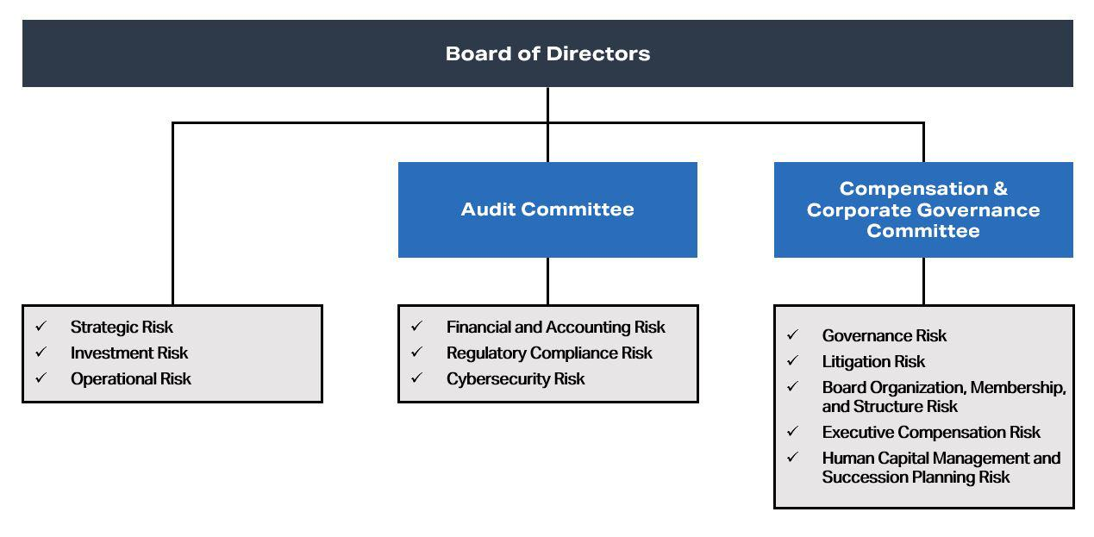

The Board has delegated certain risk management oversight responsibilities to its committees as follows:

- Financial and Accounting Risk: The Audit Committee oversees the Company’s management of its financial and accounting systems, its internal control over financial reporting, and disclosure controls and procedures through regular meetings with our Chief Financial Officer, senior members of the Company’s internal audit and legal departments, and representatives of the Company’s independent public accountant.

- Regulatory Compliance Risk: The Board, both directly and through the Audit Committee, receives regular reports from the Company’s Chief Financial Officer, General Counsel, and Head of Internal Audit on regulatory compliance matters, including the Company’s compliance with its REIT qualification and exemption from the Investment Company Act of 1940 and compliance with our Code of Ethics.

- Cybersecurity Risk: The Audit Committee, which is responsible for oversight of information technology and data security controls related to our financial reporting, oversees our management of cybersecurity risk and receives regular reporting on such matters from the Company’s Chief Technology Officer. In delegating responsibility to the Audit Committee, the Board discussed our risk exposure with management, taking into consideration our operations and the types of data retained on our systems.

- Governance Risk: The Compensation Committee also oversees risks related to Board organization, membership, structure, and corporate governance.

- Litigation Risk: The Compensation Committee monitors the Company’s litigation, if any.

- Succession Planning and Human Capital Risk: The Compensation Committee is responsible for ensuring that a succession plan is in place for our executive officers and other key employees and overseeing the Company’s management and development of its human capital.

- AGNC INVESTMENT CORP. - Proxy Statement

Table of Contents

BOARD AND GOVERNANCE MATTERS

Corporate Responsibility

We understand the importance of incorporating environmental, social, and governance (“ESG”) considerations into our business and day-to-day operations, and we appreciate the increased interest of our stockholders in these matters. We consider the interests of all our stakeholders—our

stockholders, employees, lenders, other counterparties, vendors, and community—in pursuing the long-term success of our business. Our review and evaluation of corporate social responsibility is focused on two areas: our business operations and our investment activity.

Our primary operational focus from a social perspective is our human capital. AGNC is committed to providing our employees an engaging, supportive, and inclusive atmosphere in which to grow professionally and contribute to our corporate objectives. We pride ourselves on providing a wide selection of resources to protect and promote our employees’ professional development, health, well-being, financial security, safety, and work-life balance. We offer our employees comprehensive benefits and participation in our long-term equity incentive program, and we have implemented programs that promote cross training, collaboration, and professional growth. We utilize a hybrid work model that allows for meaningful collaboration among employees while also promoting flexibility in individual employee schedules. As a 53-person organization engaged in managing a portfolio primarily consisting of Agency mortgage-backed securities, our business operations have a limited environmental impact, but we continuously evaluate opportunities to minimize our direct environmental effects.

From an investment perspective, our business supports home ownership in the United States, which has long been viewed as an important vehicle of individual wealth creation and aids in the development of strong communities. Our investments in residential mortgage-backed securities and other mortgage-related instruments play a meaningful role in helping Americans become homeowners. As an investor predominantly in Agency mortgage-backed securities, we have limited insight into the location, age, or other characteristics of individual homes or the identity of the mortgage borrowers included in these investments.

Our Board has elected to allocate oversight of ESG matters among the Board and our Compensation and Audit Committees rather than delegating responsibility for oversight of all ESG matters to a single committee. By separating areas of focus and attention encompassed within ESG considerations, each of these Committees and the Board govern and oversee areas of corporate responsibility within their respective areas of focus.

Our Compensation Committee oversees our approach to human capital management and development, the governance and operations of our Board (including its governance and oversight of corporate social responsibility and sustainability), and the composition and diversity of our Board. As part of its oversight of human capital management and corporate responsibility, the Compensation Committee receives reports on the results of employee surveys and updates from management regarding actions taken to promote development and engagement of our workforce. Our Audit Committee oversees our management’s governance of our business conduct in the areas of financial reporting, information security, legal and regulatory compliance, and compliance with our Code of Ethics. Our full Board oversees our investment guidelines, portfolio and risk management framework, and overall strategic direction, which incorporates our responsibility to the people and communities we serve.

In November 2023, we issued our third annual ESG Report, which provides disclosures consistent with the recommendations of the SASB and the TCFD, including Scope 1 and 2 greenhouse gas emissions data. The report provides disclosure on ESG issues and topics most material to our business and operations and further details our ongoing efforts to enhance our corporate responsibility and sustainability practices. Our ESG Report is available in the Responsibility section of our website at www.AGNC.com/corporate-responsibility.

Director Compensation

As described in more detail below, we compensate our independent directors with cash retainers and equity-based awards. Directors who are employees of the Company or our subsidiaries do not receive any compensation for service as a member of the Board although we reimburse all directors for travel expenses incurred in connection with Board and committee meetings and Board-related functions. The Compensation Committee periodically

reviews the form and amount of compensation paid to our independent directors to ensure it remains consistent with quality corporate governance practices. In these reviews, the Compensation Committee regularly consults with FW Cook for advice on the design and structure of the program, information on recent trends and developments in non-employee director compensation, general industry data, and analyses of the competitiveness of our non-employee

director compensation levels relative to comparable companies.

The Board conducted its annual review of compensation for independent directors in April 2023 and reviewed a compilation of compensation practices for independent directors at a group of comparable companies provided by FW Cook. The Board also considered changes in the level of work

required of the Company’s directors following the Covid-19 pandemic (the “Pandemic”) and market conditions that have prevailed since that time that require a greater level of effort. After completing its review and noting that the annual retainer had been set at $112,500 since 2019, the Board concluded that the annual retainer paid to the independent directors for service on the Board should be increased from $112,500 to $125,000, per year effective as of

July 1, 2023. As part of this review, the Board also determined that the annual RSU awards made to our independent directors should be increased to $165,000 per year, which reflects an increase of $17,500 relative to RSU awards made to each independent director in 2022. After considering the comparative data provided by FW Cook and the increased responsibilities of leaders on our Board, the directors determined that the annual retainer paid to

the Chairs of our Audit Committee and Compensation Committee, which had not changed since 2017, should be increased from an annual rate of $25,000, to $35,000, each payable quarterly in advance, and the annual retainer paid to our Lead Independent Director and Vice Chair should be increased from $100,000 to $140,000, also payable quarterly in advance. Accordingly,

AGNC INVESTMENT CORP. - Proxy Statement | 7

Table of Contents

BOARD AND GOVERNANCE MATTERS

each of our independent directors, the Chairs of our Audit Committee and Compensation Committee, and our Lead Independent Director and Vice Chair received their increased retainer rate for the third and fourth quarterly retainer payments in 2023.

The Board believes that a substantial portion of director compensation should consist of equity-based compensation to assist in aligning the long-

term interests of our directors with those of our stockholders. On April 20, 2023, each of our independent directors serving on the Board at that time received 16,533 RSUs under the Amended and Restated AGNC Investment Corp. 2016 Equity and Incentive Compensation Plan (the “2016 Equity Plan”), which is described in more detail below. The RSUs vest on the earlier of April 20, 2024 or the date of the 2024 Annual Meeting of Stockholders, subject to

the director’s continued service on our Board through the vesting date. Each RSU represents the right to receive an equivalent number of shares of our common stock, plus dividend equivalents, subject to the terms of the 2016 Equity Plan. The Compensation Committee recommended the amount of annual equity awards in consultation with FW Cook as part of its review of our director compensation relative to our compensation philosophy and objectives,

comparable market practices for independent director compensation, and the work required of our directors.

The following table sets forth the compensation received by each independent director during 2023:

 | Fees Earned | Stock
 | or Paid in | Stock | Total
Name | Cash | Awards | Total
Name | ($) | ($) 1 | ($)
Donna J. Blank | 148,750 | 165,000 | 313,750
Morris A. Davis | 148,750 | 165,000 | 313,750
John D. Fisk | 118,750 | 165,000 | 283,750
Andrew A. Johnson, Jr. | 118,750 | 165,000 | 283,750
Prue B. Larocca | 238,750 | 165,000 | 403,750
Paul E. Mullings | 118,750 | 165,000 | 283,750
Frances R. Spark | 118,750 | 165,000 | 283,750

- The amounts reported in the “Stock Awards” column represent the grant date fair value of each award granted calculated in accordance with Financial Accounting Standards Board ASC Topic 718, Compensation-Stock Compensation (“ASC 718”), as required by Securities and Exchange Commission (“SEC”) regulations. Each award represents the right to receive 16,533 shares of common stock (calculated by dividing the value of the award by the closing price of a share of common stock on the grant date, which was $9.98 on April 20, 2023). As of December 31, 2023, in connection with these awards, each independent director had unvested RSUs relating to 18,520 shares of common stock, including dividend equivalents on the RSUs.

The 2016 Equity Plan

The Company maintains the 2016 Equity Plan to provide our directors, executive officers, and other employees with equity incentive

compensation. Stockholders initially approved the Company’s equity plan in December 2016 and subsequently approved an amendment and restatement with 91.7% of the shares voted in support at the 2021 Annual Meeting. Subject to adjustment as described in the 2016 Equity Plan, total awards under the 2016 Equity Plan are currently limited to 40,000,000 shares, inclusive of dividend equivalents paid on such awards. These shares may be shares of original

issuance or treasury shares or a combination of the two, and awards may be time-vested or performance-vested.

The 2016 Equity Plan authorizes the Compensation Committee to provide equity-based compensation in the form of stock options, appreciation rights, restricted shares, restricted stock units, performance shares, performance units, dividend equivalents, and certain other awards denominated or

payable in, or otherwise based on, shares of common stock, plus cash incentive awards, for the purpose of providing our non-employee directors, officers, and other employees, and those of our subsidiaries, incentives and rewards for service or performance. The 2016 Equity Plan places a limit on the dollar value of awards and other compensation that may be made to a director in any year. Members of our Board may elect to defer distribution of their awards

under the 2016 Equity Plan for a period of up to ten years; deferred awards are non-forfeitable following the vesting date.

Independent Director Plan

The American Capital Agency Corp. Equity Incentive Plan for Independent Directors (the “Independent Director Plan”), created at the time of our

IPO, provided for the issuance of equity-based awards to our independent directors and was terminated when our stockholders approved the 2016 Equity Plan, except with respect to then outstanding awards. Restricted stock units awarded under the Independent Director Plan conferred to the participant the right to receive common stock having a value equal to the number of shares of our common stock that were subject to the award. The holders of awards of

restricted stock units were also entitled to receive dividend equivalents and could elect to defer distribution of their equity-based awards for a period of up to ten years. Deferred awards are non-forfeitable after the vesting date.

Stock Ownership Guidelines

Our Board believes that directors more effectively represent the best interests of the Company if they are stockholders themselves. Thus, each independent director is encouraged to own shares of our common stock equal in value to at least 5x the annual cash retainer paid to independent directors (which was $125,000 at the end of 2023). Fully vested RSUs that have been deferred and unvested time-based RSUs are included in determining the
number of shares held for this purpose. Although our independent directors

- AGNC INVESTMENT CORP. - Proxy Statement

Table of Contents

BOARD AND GOVERNANCE MATTERS

do not receive performance-based equity awards, for the avoidance of doubt, unvested performance-based awards, if they were awarded, would not be included in the number of shares held for purposes of our share ownership guidelines. Until the stated minimum is met, each independent director must retain at least 50% of the shares of common stock received upon vesting, net of any shares withheld or sold to pay or reimburse taxes on such income. As

of February 23, 2024, all of our directors were in compliance with their obligations under our stock ownership guidelines.

In addition, our Board has adopted a policy prohibiting our executive officers and directors from any hedging, pledging, or entering into margin loans with respect to any shares of our common stock (regardless of whether such stock is owned directly or indirectly, as such terms are used in the SEC
rules promulgated under the Exchange Act) or from engaging in short sales of our common stock or entering into any other transaction or derivative agreement where he or she would earn a profit or offset losses due to a decline of our stock price.

The following table sets forth the total stock ownership of our independent directors, including beneficially owned, unvested, and deferred shares, as calculated pursuant to our stock ownership guidelines as of February 23, 2024:

 | Beneficially | Unvested | Vested/Deferred | Total
Name | Owned | Shares | Shares ¹ | Total
Name | Shares (#) | (#) | (#) | (#)
Donna J. Blank | 7,223 | 18,756 | 40,161 | 66,140
Morris A. Davis | 12,122 | 18,756 | 28,203 | 59,081
John D. Fisk | 20,773 | 18,756 | 38,042 | 77,571
Andrew A. Johnson, Jr. | — | 18,756 | 16,136 | 34,892
Prue B. Larocca | 69,168 | 18,756 | 9,252 | 97,176
Paul E. Mullings | 8,526 | 18,756 | 69,559 | 96,841
Frances R. Spark | 29,892 | 18,756 | 12,906 | 61,554

- Reflects shares that are fully vested but distribution has been deferred. Pursuant to the terms of the 2016 Equity Plan and the Independent Director Plan, directors may elect to defer distribution of their awards for a period of up to ten years. Deferral does not alter the vesting schedule, and vested and deferred shares are non-forfeitable.

Director Resignation Policy

Our Bylaws require a candidate in an uncontested election for director to receive a majority of the votes cast in order to be elected as a director.

Under this provision, each vote is specifically counted “for” or “against” the director’s election, unless a common stockholder abstains from voting with respect to the matter. A director nominee is required to receive more votes “for” than “against” to be elected. Pursuant to Delaware law, a director shall remain in office until his or her successor is elected and qualified even if the director has not received a vote sufficient for re-election. Thus, a corporation

could have a “holdover” director. However, pursuant to our Board-approved director resignation policy, an incumbent director must tender his or her resignation to the Board if the director is nominated but not re-elected. The policy also requires the Compensation Committee to make a recommendation to the full Board on whether to accept or reject the resignation within 90 days of receipt of the tendered resignation and the full Board to make that determination. The Board would publicly disclose its decision by filing a Current Report on Form 8-K with the SEC within four days of making its

determination.

Any director who tenders his or her resignation pursuant to this policy may not participate in the Compensation Committee recommendation or Board action regarding whether to accept the resignation offer. If each member of the Compensation Committee does not receive a vote sufficient for re-
election, then the independent directors who did receive a sufficient vote shall appoint a committee amongst themselves to consider the resignation offers and recommend to the Board whether to accept them. If only three or fewer directors receive a sufficient vote for re-election, all directors (other than the director who tendered the resignation under review) may participate in the action regarding whether to accept the resignation offers.

Certain Transactions with Related Persons

Related Person Transaction Policies

Our Board has adopted a policy regarding the approval of any “related person transaction,” which is any transaction or series of transactions in

which we or any of our subsidiaries is or are to be a participant, the amount involved exceeds $120,000, and a “related person” (as defined under SEC rules) has a direct or indirect material interest. Under the policy, a related person would need to promptly disclose to our Secretary any related person transaction and all material facts about the transaction. Our Secretary would then promptly assess and communicate that information to the Audit

Committee. Based on its consideration of all of the relevant facts and circumstances, the Audit Committee will decide whether or not to approve such transaction and will generally approve only those transactions that do not create a conflict of interest. If we become aware of an existing related person transaction that has not been pre-approved under this policy, the transaction will be referred to the Audit Committee, which will evaluate all options

available, including ratification, revision, or termination of such transaction. Our policy requires any director who may be interested in a related person transaction to recuse himself or herself from any consideration of such related person transaction.

AGNC INVESTMENT CORP. - Proxy Statement 9

Table of Contents

BOARD AND GOVERNANCE MATTERS

Our Code of Ethics, which is reviewed annually by our Board and provided to all of our directors, officers, and employees, requires that all such persons avoid any situations or relationships that involve actual or potential conflicts of interest, or perceived conflicts of interest, between an individual’s personal interests and the interests of AGNC. Pursuant to our Code of Ethics, each of these persons must disclose any conflicts of interest, or actions or
relationships that might give rise to a conflict, to their supervisor or our chief compliance officer. If a conflict is determined to exist, the person must disengage from the conflict situation or terminate his or her provision of services to us. Our president and chief executive officer, chief financial officer and principal accounting officer, controller, directors and certain other persons who may be designated by our Board or its Audit Committee, whom we

collectively refer to as our financial executives, must consult with our chief compliance officer with respect to any proposed actions or arrangements that are not clearly consistent with our Code of Ethics. In the event that a financial executive desires to engage in a proposed action or arrangement that is not consistent with our Code of Ethics, the financial executive must obtain a waiver of the relevant provisions of our Code of Ethics in advance from our Audit

Committee. We intend to post amendments to or waivers from the Code of Ethics (to the extent applicable to our financial executives) on our web site at www.AGNC.com.

Related Person Transactions

We did not enter into any transactions in 2023 in which any related person of ours had any material interest.

Compensation Committee Interlocks and Insider Participation

No member of the Compensation Committee during fiscal year 2023 served as an officer, former officer, or employee of ours or had a relationship

required to be disclosed under “Board and Governance Matters—Certain Transactions with Related Persons.” Further, during 2023, none of our executive officers served as:

- a member of the compensation committee (or equivalent) of any other entity, one of whose executive officers served as one of our directors or was an immediate family member of a director, or served on our Compensation Committee; or

- a director of any other entity, one of whose executive officers or their immediate family member served on our Compensation Committee.

10 AGNC INVESTMENT CORP. - Proxy Statement

Table of Contents

PROPOSAL 1: ELECTION OF DIRECTORS

PROPOSAL 1: ELECTION OF DIRECTORS

Pursuant to our Certificate of Incorporation, our common stockholders elect each of the members of the Board annually. The term of each director will expire at the Annual Meeting. Each director has been nominated by the Compensation Committee of the Board, in accordance with our Bylaws, to stand for re-election at the Annual Meeting and to serve as a director until our Annual Meeting to be held in 2025 and until his or her successor is elected
and qualified. It is expected that each of the nominees will be able to serve, but if any such nominee is unable to serve for any reason, the proxies reserve discretion to vote or refrain from voting for a substitute nominee or nominees. A common stockholder using the enclosed form of proxy can vote for or against any or all of the nominees or may abstain from voting for any or all of the nominees.

We believe that all of our nominees possess the personal and professional qualifications necessary to serve as a member of our Board and collectively represent a balance of industry knowledge, skills, and expertise. Our directors have been evaluated by the Compensation Committee pursuant to the guidelines described above under “Board and Governance Matters—Board Membership Criteria,” and the determination was made that each of them

fulfills and exceeds the qualities that we look for in members of our Board. Mr. Kain is our Executive Chair, and Mr. Federico is our President and Chief Executive Officer. All other nominees are independent as defined in the Nasdaq rules.

Summary of Our Board’s Industry and Functional Expertise

We believe that our directors have a diversity of experience and a wide variety of skills and qualifications that strengthen their ability to provide guidance and oversight to the Company and management on behalf of stockholders.

The information set forth below with respect to each of our directors, each of whom is a nominee for election at the Annual Meeting, is as of February 23, 2024. The business address of each nominee is c/o AGNC Investment Corp., 7373 Wisconsin Avenue, 22nd Floor, Bethesda, Maryland 20814. We have highlighted specific attributes for each Board member below.

Director Nominee Biographies and Qualifications

DONNA J. BLANK, 62
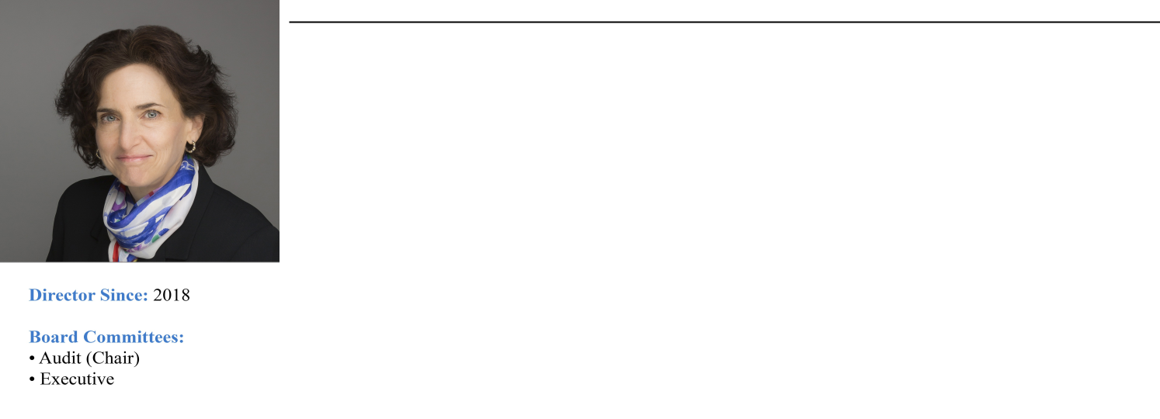

Professional Experience:
Ms. Blank is a finance executive with over 30 years of financial and operational experience, primarily in financial
services. From 2015 through 2016, she was Chief Financial Officer at ZAIS Group, LLC, an alternative asset manager. While at ZAIS, Ms. Blank also served as the Chief Financial Officer of its externally managed publicly traded residential mortgage REIT and its public holding company. Prior to her role at ZAIS, she served as Chief

Financial Officer and Executive Vice President at NFP Corp., a publicly traded insurance brokerage, from 2008 until 2013. From 2003 to 2008, Ms. Blank was Chief Financial Officer at Financial Guaranty Insurance Company, both before and subsequent to its sale by GE Capital to an investor group in late 2003. She currently serves as the

Lead Independent Director and Chair of the Audit and Risk Committee at Wellabe Mutual Holding Company. Ms. Blank holds an MBA in Finance and a Master of International Affairs, both from Columbia University. In 2022, she completed the MIT Sloan School of Management Executive Education program in Cybersecurity Leadership. Ms.

Blank is an “audit committee financial expert” (as defined in Item 407 of Regulation S-K under the Securities Act).

Director Qualifications:

Ms. Blank’s extensive public company accounting and operational experience in the financial services sector, including her senior executive role at a publicly traded residential mortgage REIT, strengthens our Board’s collective qualifications, skills, experience, and viewpoints.

AGNC INVESTMENT CORP. - Proxy Statement 11

Table of Contents

PROPOSAL 1: ELECTION OF DIRECTORS

MORRIS A. DAVIS, 52

Professional Experience:
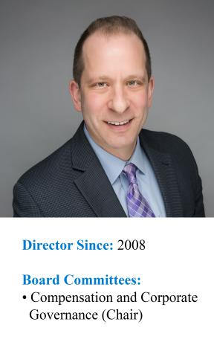
Dr. Davis is the Paul V. Profeta Chair of Real Estate and Academic Director of the Center for Real Estate at Rutgers Business School, where he has worked since September 2014. Dr. Davis is also currently a Visiting Scholar of the

Opportunity and Inclusive Growth Institute of the Federal Reserve Bank of Minneapolis and a Visiting Scholar at the Federal Reserve Bank of Chicago. Previously, Dr. Davis was the James A. Graaskamp Chair of Real Estate in the Department of Real Estate at the University of Wisconsin-Madison, where he worked from September 2006 through

August 2014. Dr. Davis was also the Academic Director of the James A. Graaskamp Center for Real Estate at the University of Wisconsin-Madison. From July 2002 to August 2006, Dr. Davis was an economist at the Federal Reserve Board working in the Flow of Funds Section. From October 2001 to July 2002, he was Director of Yield

Optimization at Return Buy, Inc. and from August 1998 to October 2001, Dr. Davis was an economist at the Macroeconomics and Quantitative Studies Section of the Federal Reserve Board. Dr. Davis also served on the board of directors of the SkyBridge Opportunity Zone Real Estate Investment Trust, Inc., a private REIT, from November

2018 until September 2019 where he was the chair of the valuation committee. Dr. Davis was formerly an Adjunct Scholar at the American Enterprise Institute and also formerly served as a Research Associate at the Federal Reserve Bank of Cleveland. Dr. Davis is widely published on issues related to the U.S. housing markets and a frequent

lecturer. He holds a Ph.D. in Economics from the University of Pennsylvania.

Director Qualifications:

Dr. Davis’s extensive expertise in economics, housing policy, and finance matters strengthens our Board’s collective qualifications, skills, experience, and viewpoints.

PETER J. FEDERICO, 57

Professional Experience:

Mr. Federico has served as a Director and our Chief Executive Officer since July 2021 and as our President since March 2018. He previously served as our Chief Operating Officer from March 2018 until July 2021, as Executive Vice President and Chief Financial Officer from July 2016 until March 2018, and as Senior Vice President and Chief Risk Officer from June 2011 until our internalization in July 2016.
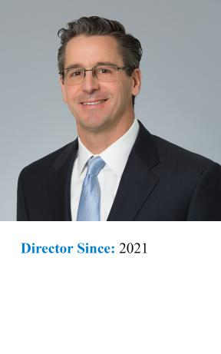

Prior to joining AGNC Investment Corp., Mr. Federico served as Executive Vice President and Treasurer of Freddie Mac from October 2010 through May 2011, where he was primarily responsible for managing the company’s investment activities for its retained portfolio and developing, implementing, and managing risk mitigation strategies. He was also responsible for managing Freddie Mac’s $1.2 trillion interest rate derivative portfolio and short- and long-term debt issuance programs. Mr. Federico also served in a number of other capacities at Freddie Mac, including as Senior Vice President, Asset & Liability Management, during his tenure with the company, which began in 1988.

Director Qualifications:
Mr. Federico’s knowledge and understanding of our business as our President and Chief Executive Officer and his expertise in risk mitigation strategies strengthens our Board’s collective qualifications, skills, experience, and viewpoints.

12 AGNC INVESTMENT CORP. - Proxy Statement

Table of Contents

PROPOSAL 1: ELECTION OF DIRECTORS

JOHN D. FISK, 67

Professional Experience:
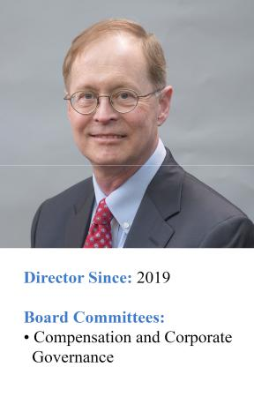
Mr. Fisk retired in March 2019 as the Chief Executive Officer of the FHLBanks Office of Finance, a division of the Federal Home Loan Banks that issues and services all debt securities for the regional Federal Home Loan Banks,

supporting borrowings of $1 trillion. Mr. Fisk had previously served as the Deputy Managing Director and Chief Operating Officer of the FHLBanks Office of Finance from 2004 until 2007 when he became the Chief Executive Officer. Prior to joining the FHLBanks Office of Finance, Mr. Fisk was the Executive Vice President of Strategic

Planning at MGIC Investment Corporation, one of the nation’s largest providers of mortgage insurance, from 2002 until 2004. Mr. Fisk also serves on the Board of Directors of Enact Holdings, Inc., where he chairs the Risk Committee and is a member of the Independent Capital Committee. Mr. Fisk holds an MBA in Finance and Public

Management from The Wharton School at the University of Pennsylvania and a BA from Yale University.

Director Qualifications:

Mr. Fisk’s expertise in the US housing sector, including debt issuance and mortgage insurance, and his senior executive officer experience overseeing human capital management strengthens our Board’s collective qualifications, skills, experience, and viewpoints.

ANDREW A. JOHNSON, JR., 61
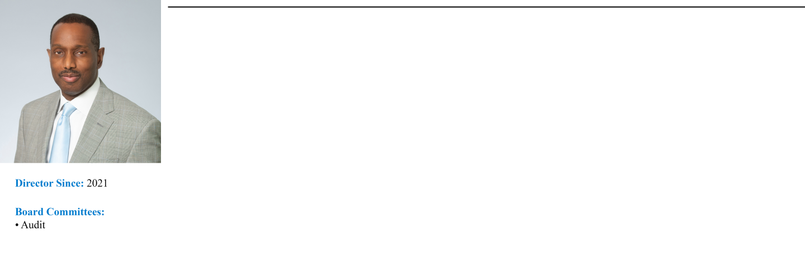

Professional Experience:

Mr. Johnson is an investment professional with over 20 years’ experience leading teams focused on fixed income investments. Mr. Johnson served as Managing Director, Head of Global Investment Grade Fixed Income and Chief Investment Officer for Neuberger Berman Investment Advisers, LLC and Neuberger Berman Fixed Income LLC from 2009 to 2019. He retired from his role as Managing Director and Chief Investment Officer in 2019 and transitioned to the role of Senior Diversity and Inclusion Leader at Neuberger Berman Services. In his current position, Mr. Johnson leads the firm’s efforts to improve diversity and inclusion in the workforce across Neuberger Berman entities. Prior to his roles at Neuberger Berman, from 2003 to 2009 Mr. Johnson was a Managing Director, Co-Head Investment Grade Fixed Income and Chief Investment Officer at Lehman Brothers Asset Management, LLC. He currently serves as a Non-Interested Trustee on the Board of Trustees of certain mutual funds advised by Hartford Mutual Funds, Inc. Mr. Johnson holds an MBA in Finance from the University of Chicago and a MSEE and BSEE from Illinois Institute of Technology.

Director Qualifications:
Mr. Johnson’s extensive background in fixed income investments and his experience working to improve diversity and inclusion in the workforce strengthens our Board’s collective qualifications, skills, experience, and viewpoints.

AGNC INVESTMENT CORP. - Proxy Statement 13

Table of Contents

PROPOSAL 1: ELECTION OF DIRECTORS

GARY D. KAIN, 59
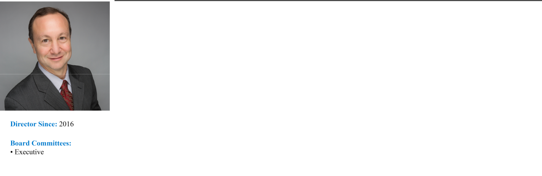

Professional Experience:
Mr. Kain has served as the Executive Chair of our Board of Directors since July 2021 and has been a Director since March 2016. Previously, he was our Chief Executive Officer from March 2016 until July 2021, Chief Investment

Officer from January 2009 until July 2021, and President from April 2011 until March 2018.

Prior to joining AGNC Investment Corp., Mr. Kain was Senior Vice President of Investments and Capital Markets of Freddie Mac from May 2008 to January 2009. He also served as Senior Vice President of Mortgage

Investments & Structuring of Freddie Mac from February 2005 to April 2008, during which time he was responsible for managing all of Freddie Mac’s mortgage investment activities for the company’s $700 billion retained portfolio. From 2001 to 2005, Mr. Kain served as Vice President of Mortgage Portfolio Strategy at Freddie

Mac. From 1995 to 2001, he was the head trader in Freddie Mac’s Securities Sales & Trading Group, where he was responsible for managing all trading decisions including REMIC structuring and underwriting, hedging all mortgage positions, income generation, and risk management. Prior to that, he served as a senior trader, responsible

for managing the adjustable-rate mortgage and REMIC sectors.

Director Qualifications:
Mr. Kain’s extensive and lengthy expertise in the Agency mortgage sector and his deep knowledge of our business
as our former Chief Executive Officer and Chief Investment Officer strengthens our Board’s collective qualifications, skills, experience, and viewpoints.

PRUE B. LAROCCA, 72
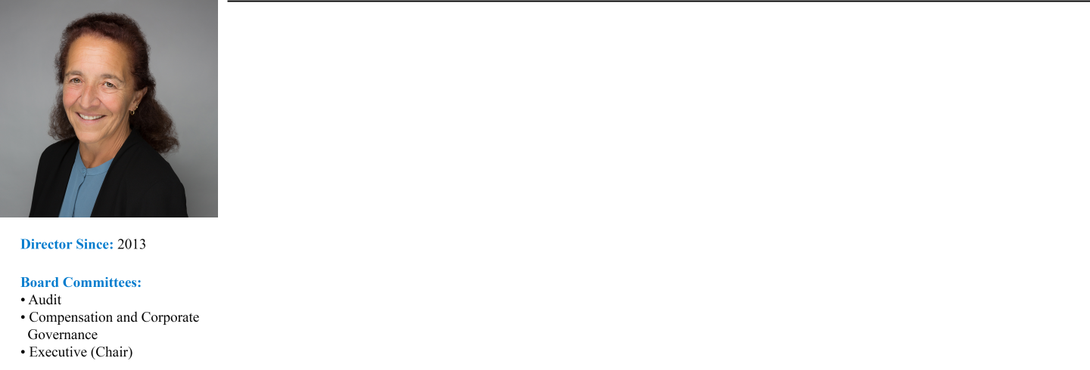

Professional Experience:

Ms. Larocca has served as our Lead Independent Director since May 2016 and has served as our Vice Chair since July 2021. She previously served as our Chair from May 2016 until July 2021. She is a retired investment banking executive and a widely recognized expert in the areas of housing finance and securitization. Ms. Larocca previously

served as a member of the board of the Housing Preservation Foundation, the Washington School for Girls, and the American Securitization Trade Association. Ms. Larocca was a Managing Director of Royal Bank of Scotland (“RBS”) in the Mortgage Backed and Asset Backed Finance Group from 1997 until her retirement from RBS in 2011.

Prior to joining RBS, Ms. Larocca was a Senior Vice President at Lehman Brothers in the mortgage finance business, managed the consumer and single-family securitization business for the Resolution Trust Corporation, and practiced law with the firms of Milbank, Tweed, Hadley and McCloy and Kutak Rock. She is a graduate of the Georgetown

University Law Center and Indiana University.

Director Qualifications:

Ms. Larocca’s extensive expertise in mortgage finance and asset securitization strengthens our Board’s collective qualifications, skills, experience, and viewpoints.

14 AGNC INVESTMENT CORP. - Proxy Statement

Table of Contents

PROPOSAL 1: ELECTION OF DIRECTORS

PAUL E. MULLINGS, 73
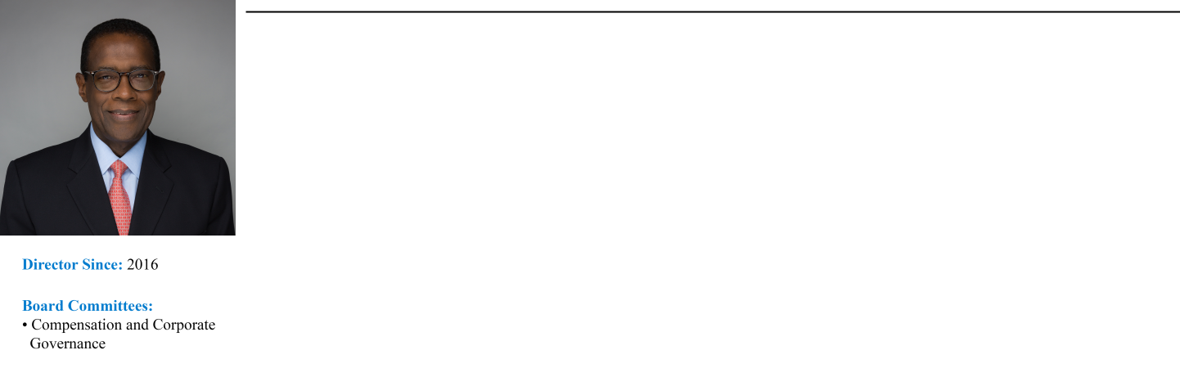

Professional Experience:
Mr. Mullings has over 40 years’ experience in the mortgage banking sector. Mr. Mullings served from 2015 until his retirement in 2020 as a Managing Director of The Collingwood Group, a SitusAMC company, a business advisory

and risk management firm focused on the financial services industry. From 2005 to 2015, Mr. Mullings served as a Senior Vice President of Freddie Mac in the Single-Family Business division. While at Freddie Mac, he also served on the Operating, Management and Credit Risk Committees. Prior to joining Freddie Mac, Mr. Mullings was a Senior

Vice President at J.P. Morgan Chase & Co. from 1997 to 2005 in the home finance area. Previously, Mr. Mullings was the President and Chief Executive Officer of the Mortgage Electronic Registration Systems, Inc. (MERS) and the President and Chief Executive Officer of the Residential Mortgage Division of the First Interstate Bank in Los

Angeles. Mr. Mullings received his Overseas Certificate in Business Studies from the College of Arts, Science and Technology in Kingston, Jamaica, following which he became a Member of The Institute of Accounting Staff in conjunction with the Association of Certified Accountants in London, England.

Director Qualifications:
Mr. Mullings’ extensive senior executive officer experience in the mortgage banking sector and the secondary mortgage market strengthens our Board’s collective qualifications, skills, experience, and viewpoints.

FRANCES R. SPARK, 65

Professional Experience:
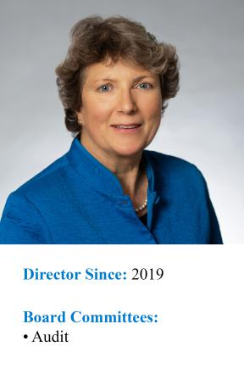
Ms. Spark is an experienced finance professional with broad expertise in mortgage finance and financial reporting for publicly traded companies, including mortgage REITs. Ms. Spark served as the Chief Financial Officer and Treasurer for CYS Investments, Inc., a publicly traded mortgage REIT that invested predominantly in Agency MBS, from 2009

through 2016. Prior to the internalization of CYS’s management in 2011, Ms. Spark also served as the Chief Financial Officer and Treasurer of CYS’s external manager, Sharpridge Capital Management, LP. She had served as a director and Audit Committee chair of CYS from its initial capitalization in 2006 until shortly after its initial public offering.

Prior to CYS, Ms. Spark was the Chief Financial Officer for MVC Capital, Inc., a business development company, from 2003 until 2005. Ms. Spark’s career has included managing Spark Consulting, a privately owned strategic advisory and business consulting firm, and executive positions with financial services firms in the United States and

the United Kingdom. She also served as an independent director and a member of the Audit and Risk Committees of Reverse Mortgage Investment Trust, a private finance company operating in the reverse mortgage industry, from 2015 to 2020. Ms. Spark is a Chartered Accountant and previously worked as an auditor with KPMG in the United

Kingdom. She holds a BS from the University of Southampton in the United Kingdom. Ms. Spark is an “audit committee financial expert” (as defined in Item 407 of Regulation S-K under the Securities Act).

Director Qualifications:
Ms. Spark’s public company accounting, finance, and risk management expertise in the mortgage REIT sector, including her role as a senior executive officer at a publicly traded residential mortgage REIT, strengthens our

Board’s collective qualifications, skills, experience, and viewpoints.

Conclusion and Recommendation; Vote Required

The election of directors nominated in Proposal 1 requires the affirmative vote of a majority of the votes cast by holders of our common stock at

the Annual Meeting. The affirmative vote of a “majority” of the votes cast means that the number of votes cast “for” a director nominee must exceed the votes cast “against” that nominee. In the context of the election of nine directors at the Annual Meeting, it will mean that each of the nine candidates will be required to receive more votes “for” than “against” to be elected. Abstentions and broker non-votes will have no effect on the outcome of the proposal.

THE BOARD OF DIRECTORS RECOMMENDS A VOTE FOR THE ELECTION OF ALL THE NOMINEES NAMED ABOVE.

AGNC INVESTMENT CORP. - Proxy Statement 15

Table of Contents

PROPOSAL 2: ADVISORY RESOLUTION TO APPROVE EXECUTIVE COMPENSATION

PROPOSAL 2:
ADVISORY RESOLUTION TO APPROVE EXECUTIVE COMPENSATION

General Information

As required by Section 14A of the Exchange Act, we are asking for your advisory vote to approve the compensation paid to our named executive officers as disclosed in this proxy statement. Our Board has determined to hold this “say-on-pay” vote every year.

We urge you to review carefully our compensation policies and decisions regarding our named executive officers as presented in the “Compensation Discussion and Analysis,” the accompanying compensation tables, and the related narrative disclosures section appearing on pages 22 to
- As described in detail in this proxy statement, we believe that our executive compensation program applies a pay-for-performance philosophy that effectively aligns the interests of our NEOs with those of our stockholders and allows us to attract, retain, and appropriately incent executives with the skills and experience necessary to achieve our key business objectives.

While the vote on this proposal is advisory in nature and not binding, the Board and the Compensation Committee will take the results of the vote into account in making future compensation decisions.

We are requesting our stockholders to approve, in a non-binding, advisory vote, the following resolution:

“RESOLVED, that the stockholders of the Company hereby approve the compensation paid to our named executive officers, as disclosed in

the proxy statement for the 2024 Annual Meeting of Stockholders pursuant to the disclosure rules of the Securities and Exchange Commission, including the Compensation Discussion and Analysis, compensation tables, and related material disclosed in the proxy statement.”

Conclusion and Recommendation; Vote Required

The affirmative vote of a majority of all shares of common stock cast on the proposal is required for advisory approval of this proposal. Abstentions and broker non-votes will have no effect on the outcome of the proposal. THE BOARD OF DIRECTORS RECOMMENDS A VOTE FOR

APPROVAL OF THE ADVISORY RESOLUTION ON EXECUTIVE COMPENSATION.

16 AGNC INVESTMENT CORP. - Proxy Statement

Table of Contents

PROPOSAL 3: RATIFICATION OF APPOINTMENT OF INDEPENDENT PUBLIC ACCOUNTANT

PROPOSAL 3:
RATIFICATION OF APPOINTMENT OF INDEPENDENT PUBLIC ACCOUNTANT

Ernst & Young LLP (“EY”) has served as our independent public accountant since our IPO. The Audit Committee evaluates EY’s performance on an annual basis and makes a determination as to whether the Company should re-engage EY or consider the engagement of another audit firm. At a meeting on February 16, 2024, the Audit Committee approved the appointment of EY to audit our financial statements for 2024. In making this

determination, the Audit Committee carefully considered a number of factors including:

- EY’s independence, objectivity, and professional skepticism;
- EY’s significant knowledge of the Company’s operations, personnel, accounting policies and practices, internal control over financial reporting, and the impact of such knowledge on audit quality;
- EY’s significant industry and sector specific experience, including the number of other mortgage REITs audited by EY;
- the quality and efficiency of services provided by EY based on feedback from Audit Committee members and management;
- EY’s resources, capabilities, technical expertise, including sharing industry insights, trends, and latest practices with the Audit Committee and management;
- EY’s efforts to use technology to increase efficiencies and improve audit quality;
- the quality and candor of EY’s communications;
- recent Public Company Accounting Oversight Board (PCAOB) reports and other publicly available information on the firm;
- the appropriateness of fees charged for audit and non-audit services;
- EY’s compliance with, and practices regarding, the SEC’s rules requiring lead engagement partner rotation every five years; and
- the length of time EY has served as our independent public accountant, the benefits of longer tenure, and the impact of changing auditors.

Based on this evaluation, the Audit Committee determined that it was in the best interests of the Company and our stockholders to continue to engage EY as our independent public accountant. This appointment is subject to ratification or rejection by our common stockholders. A representative of Ernst & Young LLP is expected to be present at the Annual Meeting. The representative will have an opportunity to make a statement if he or she so desires
and is expected to be available to respond to appropriate questions.

Independent Public Accountant’s Fees

EY performed various audit and other services for us during 2023 and 2022. Fees for professional services provided by EY in 2023 and 2022 in each of the following categories were:

 | 2023 | 2022
Audit Fees | $1,956,000 | $1,875,500
Audit-Related Fees | — | —
Tax Fees | $187,659 | $201,316
All Other Fees | — | —
Total Fees | $2,143,659 | $2,076,816

Audit Fees

“Audit Fees” relate to fees and expenses billed by EY for the annual audit, including the audit of our financial statements, services required by statute and regulation, audit of internal control over financial reporting, review of our quarterly financial statements, and for comfort letters and consents

related to stock issuances.

Tax Fees

“Tax Fees” relate to fees billed for professional services for tax compliance and consulting on tax-related matters.

Pre-Approval Policy

All services rendered by EY were permissible under applicable laws and regulations and were pre-approved by the Audit Committee for 2023 in

accordance with its pre-approval policy. The Audit Committee has established a policy regarding the pre-approval of all audit and permissible non-audit services provided by our independent public accountant. The policy requires the Audit Committee to approve each audit or non-audit engagement or accounting project involving the independent public accountant, and the related fees, prior to commencement of the engagement or project to make certain

that the provision of such services does not impair the firm’s independence. The committee may delegate its pre-approval authority to one or more of its members, and such member(s) are required to report any pre-approval decisions to the Audit Committee at its next meeting. The Audit Committee has delegated authority to its Chair to pre-approve the engagement and related fees of the independent public accountant for any additional audit or permissible

non-audit services. In addition, pursuant to the policy, pre-approval is not required for additional non-audit services if such services result in a de minimus amount of less than 5% of the total annual fees paid by us to the independent public accountant during the fiscal year in which the non-audit services are provided, were not recognized by us at the time of engagement to be non-audit services, and are reported to the Audit Committee promptly thereafter and approved prior to the completion of the annual audit.

AGNC INVESTMENT CORP. - Proxy Statement 17

Table of Contents

PROPOSAL 3: RATIFICATION OF APPOINTMENT OF INDEPENDENT PUBLIC ACCOUNTANT

Conclusion and Recommendation; Vote Required

The affirmative vote of the holders of a majority of all shares of our common stock cast on the proposal is required to ratify the appointment of our independent public accountant. Abstentions will have no effect on the outcome of the proposal. THE BOARD OF DIRECTORS RECOMMENDS A

VOTE FOR RATIFICATION OF THE APPOINTMENT OF ERNST & YOUNG LLP AS OUR INDEPENDENT PUBLIC ACCOUNTANT FOR 2024.

18 AGNC INVESTMENT CORP. - Proxy Statement

Table of Contents

REPORT OF THE AUDIT COMMITTEE

REPORT OF THE AUDIT COMMITTEE

The Board of Directors has appointed an Audit Committee presently composed of four directors, Mss. Blank, Larocca, and Spark and
Mr. Johnson. Each of the directors is independent as defined in the Nasdaq rules. The Board of Directors has determined that Mss. Blank and Spark are each an “audit committee financial expert” (as defined in Item 407 of Regulation S-K under the Securities Act).

The Audit Committee’s responsibility is one of oversight as set forth in its charter, which is available in the Investors section of our website at ir.agnc.com/corporate-governance-documents. It is not the duty of the Audit Committee to prepare our financial statements, to plan or conduct audits, or to determine that our financial statements are complete and accurate and are in accordance with U.S. generally accepted accounting principles. Our

management is responsible for preparing our financial statements and for maintaining internal controls. The independent auditors are responsible for auditing the financial statements and for expressing an opinion as to whether those audited financial statements fairly present our financial position, results of operations, and cash flows in conformity with U.S. generally accepted accounting principles.

The Audit Committee has reviewed and discussed our audited consolidated financial statements with management and with Ernst & Young LLP, our independent auditors for 2023.

The Audit Committee has discussed with Ernst & Young LLP the matters required to be discussed by the applicable requirements of the Public Company Accounting Oversight Board and the Securities and Exchange Commission.

The Audit Committee has received from Ernst & Young LLP the written statements required by Public Company Accounting Oversight Board Rule No. 3526, “Communications with Audit Committees Concerning Independence,” has discussed Ernst & Young LLP’s independence with Ernst &
Young LLP, and has considered the compatibility of non-audit services with the auditor’s independence.

Based on the review and discussions referred to above, the Audit Committee recommended to the Board of Directors that the audited consolidated financial statements for the year ended December 31, 2023 be included in our annual report on Form 10-K for the year ended December 31, 2023, for filing

with the Securities and Exchange Commission.

The Audit Committee has approved the appointment of Ernst & Young LLP to serve as our independent public accountants for the year ending December 31, 2024 and has directed that the appointment of Ernst & Young LLP be submitted to our stockholders for ratification.

By the Audit Committee:
Donna J. Blank, Chair
Andrew A. Johnson, Jr.
Prue B. Larocca
Frances R. Spark

AGNC INVESTMENT CORP. - Proxy Statement 19

Table of Contents

EXECUTIVE OFFICERS

EXECUTIVE OFFICERS OF REGISTRANT

Executive Officer Biographies

The Board generally elects officers annually following our annual meeting of stockholders to serve until the meeting of the Board following the next annual meeting. Set forth below is certain information about each executive officer as of February 23, 2024. The business address of each executive
officer is c/o AGNC Investment Corp., 7373 Wisconsin Avenue, 22nd Floor, Bethesda, Maryland 20814.

PETER J. FEDERICO, 57
Director, President and Chief Executive Officer

Mr. Federico has served as a Director and as our Chief Executive Officer since July 2021 and as our President since March 2018. He previously served as our Chief Operating Officer from March 2018 until July 2021, Executive Vice President and Chief Financial Officer from July 2016 until March 2018, and
Senior Vice President and Chief Risk Officer from June 2011 until July 2016. Further information about Mr. Federico may be found under “Proposal 1:
Election of Directors-Director Nominee Biographies and Qualifications” of this proxy statement.

GARY D. KAIN, 59
Director, Executive Chair

Mr. Kain has served as a Director since 2016 and as our Executive Chair since July 2021. He previously served as our Chief Executive Officer from March

2016 through July 2021, Chief Investment Officer from January 2009 through July 2021, and President from April 2011 until March 2018. Further information about Mr. Kain may be found under “Proposal 1: Election of Directors-Director Nominee Biographies and Qualifications” of this proxy statement.

CHRISTOPHER J. KUEHL, 50
Executive Vice President and Chief Investment Officer

Mr. Kuehl has served as our Chief Investment Officer since July 2021 and as an Executive Vice President since November 2016. He was previously a Senior Vice President from March 2012 through October 2016.

Prior to joining AGNC Investment Corp., Mr. Kuehl served as Vice President of Mortgage Investments & Structuring of Freddie Mac. In this capacity, Mr. Kuehl was responsible for directing Freddie Mac’s purchases, sales, and structuring activities for all MBS products, including fixed-rate mortgages,
ARMs, and CMOs. Prior to joining Freddie Mac in 2000, Mr. Kuehl was a Portfolio Manager with TeleBank/Etrade Bank.

BERNICE E. BELL, 52
Executive Vice President and Chief Financial Officer

Ms. Bell has served as our Executive Vice President since January 2022 and Chief Financial Officer since March 2018. Ms. Bell previously served as

Senior Vice President from January 2016 to January 2022, Chief Accounting Officer from January 2016 to March 2018, Vice President from April 2011 to January 2016, and as our Controller from 2008 through December 2015.

Prior to joining AGNC Investment Corp., Ms. Bell served as the Vice President and Controller of American Capital, Ltd. from July 2003 to December

2009. Prior to joining American Capital, Ms. Bell was the Vice President and Controller of certain privately-held companies engaged in the business of telecommunications and software development from July 1998 to June 2003 and was with the accounting firm Price Waterhouse, LLP from July 1994 to June 1998.

KENNETH L. POLLACK, 56

Executive Vice President, General Counsel, Chief Compliance Officer, and Secretary

Mr. Pollack has served as our Executive Vice President since January 2022 and our General Counsel, Chief Compliance Officer, and Secretary since July 2016. Mr. Pollack previously served as Senior Vice President from July 2016 until January 2022.

Prior to joining AGNC Investment Corp., Mr. Pollack was Senior Vice President and Deputy General Counsel of American Capital, Ltd. At American
Capital, Mr. Pollack served as lead counsel for American Capital’s portfolio investment activities in the areas of Real Estate, U.S. Sponsor Finance, U.S.

Buyouts, International Power, Special Situations, Operations, and Financial Restructuring.

20 AGNC INVESTMENT CORP. - Proxy Statement

Table of Contents

EXECUTIVE OFFICERS

Mr. Pollack joined American Capital in 2004. Prior to American Capital, Mr. Pollack was an Associate in the Corporate & Securities and Real Estate practice groups of Arnold & Porter.

SEAN P. REID, 48
Executive Vice President, Strategy and Corporate Development

Mr. Reid has served as our Executive Vice President, Strategy and Corporate Development since January 2022. He previously served as Senior Vice

President from July 2016 until January 2022 and as Senior Vice President, Corporate and Business Development for our former manager from August 2013 to July 2016.

Mr. Reid was previously a Vice President in the Washington, D.C. Buyouts group of American Capital, Ltd. and, prior to that, an Assistant General Counsel

with American Capital’s in-house legal team. Prior to joining American Capital, Mr. Reid was an Associate in the Corporate & Securities practice group of Covington & Burling in Washington, D.C.

AGNC INVESTMENT CORP. - Proxy Statement 21

Table of Contents

EXECUTIVE COMPENSATION

 | EXECUTIVE COMPENSATION
 | Compensation Discussion and Analysis
2023 Named Executive Officers
Our NEOs for 2023 are:
Name | Title
Peter J. Federico | President and Chief Executive Officer
Gary D. Kain | Executive Chair
Christopher J. Kuehl | Executive Vice President and Chief Investment Officer
Bernice E. Bell | Executive Vice President and Chief Financial Officer
Kenneth L. Pollack | Executive Vice President, General Counsel, Chief Compliance Officer, and Secretary
Sean P. Reid | Executive Vice President, Strategy and Corporate Development

Executive Summary

This Compensation Discussion and Analysis provides information on our executive compensation philosophy, objectives, structure, and our process for setting compensation for our named executive officers, or NEOs.

Business Overview

AGNC is a leading provider of private capital to the U.S. housing market, enhancing liquidity in the residential real estate mortgage markets and, in turn, facilitating home ownership in the U.S. AGNC is an internally managed REIT that invests predominantly in Agency residential mortgage-backed securities funded through a combination of equity capital and collateralized borrowings structured as repurchase agreements. We seek to provide investors
with favorable long-term returns on a risk-adjusted basis with a substantial yield component. We generate income from the interest earned on our investment assets, net of associated borrowing and hedging costs, and net realized gains and losses on our investments and hedging activities. As such, our business operations are similar to investment managers that focus on fixed income investments, although we invest AGNC’s capital rather than third-party

client funds.

22 AGNC INVESTMENT CORP. - Proxy Statement

Table of Contents

EXECUTIVE COMPENSATION


2023 Performance Highlights

In 2023, AGNC significantly outperformed our Agency REIT Peer Group¹ on both an economic and total stock return basis, while maintaining a significant price-to-tangible book value premium valuation. We achieved this strong outcome despite challenging and historically volatile fixed income markets driven by the Federal Reserve’s unprecedented dual-track approach to monetary policy tightening and a host of macroeconomic and geopolitical factors. In addition, AGNC executed upon a number of strategic and operational initiatives in 2023 to further enhance our franchise value and operational resiliency.

Highlights of our financial performance in 2023 include:

- Annual economic return of 3.0%, which was the second highest return within our Agency REIT Peer Group and materially exceeded our Agency REIT Peer Group average return of -3.4%

- Total stock return of 10.0%, which was also the second highest return within our Agency REIT Peer Group and was significantly greater than our Agency REIT Peer Group average return of -2.2%²

- Average Price-to-Tangible Book Value Ratio of 111.1%, which was the highest average within our Agency REIT Peer Group by a wide margin (over 10 percentage points)³

- Operating Expenses for 2023 of 1.23% of average stockholders’ equity, which was the lowest among residential mortgage REITs and a fraction of the average of our Agency REIT Peer Group at 3.21%⁴

In addition to our strong financial performance relative to our Agency REIT Peer Group, we also completed or advanced a number of strategic and operational initiatives in 2023:

- Enhanced efficiencies through expansion of business intelligence reporting in accounting and portfolio management functions

- Automated, centralized, and significantly strengthened liquidity management function

- Transitioned all custodial functions to our captive broker-dealer Bethesda Securities, providing cost savings and superior risk controls

- Created and implemented daily automated reconciliation tools that verify internal positions to custodian positions

- Migrated AGNC network infrastructure onto the cloud and completed meaningful system-wide upgrades that enhance scalability, security, and reliability

- Adopted and enhanced compliance policies and procedures in response to new SEC rules and the evolving enforcement landscape

- Rebranded AGNC with launch of new website and redesign of corporate marketing materials

- Greatly expanded employee engagement and community outreach initiatives and redesigned charitable giving program

- Successfully completed relocation of our headquarters to a brand new LEED Platinum building constructed with a focus on sustainability and wellness benefits

In recognition of AGNC’s employee engagement efforts, AGNC was again certified as a “Great Place to Work™” in 2023.

- Our Agency REIT Peer Group includes Annaly Capital Management, Inc. (“NLY”), ARMOUR Residential REIT, Inc. (“ARR”), Dynex Capital, Inc. (“DX”), Invesco Mortgage Capital Inc. (“IVR”), Orchid Island Capital, Inc. (“ORC”), and Two Harbors Investment Corp. (“TWO”) on an unweighted basis.
- Total stock return includes price appreciation and dividend reinvestment; dividends are assumed to be reinvested at the closing price of the security on the ex-dividend date. Source: Bloomberg
- Average Price-to-Tangible Book Value Ratio reflects the simple average of the four quarter-end calculations of Price-to-Tangible Book Value Ratio. The Price-to-Tangible Book Value Ratio as of a date is the quotient of the closing common stock price of such company as of such date divided by the tangible book value per common share of such company as of such date. Source: Company filings and S&P Global Market Intelligence.
- For mortgage REITs other than AGNC, cost structures are based on operating expenses and average stockholders’ equity (excluding noncontrolling interests, as applicable) over the applicable year as publicly reported by such REITs. Operating costs include expenses for compensation and benefits, management fees, incentive fees (if applicable), and G&A and may include one-time or nonrecurring expenses. Operating costs exclude direct costs associated with operating activities, such as loan acquisition costs, securitization costs, and servicing expenses, to the extent publicly disclosed by such REITs. AGNC’s cost structure is based on operating expenses, including compensation and benefits and G&A, and average stockholders’ equity for the applicable year. Source: Company filings and S&P Global Market Intelligence.

AGNC INVESTMENT CORP. - Proxy Statement 23

Table of Contents

EXECUTIVE COMPENSATION
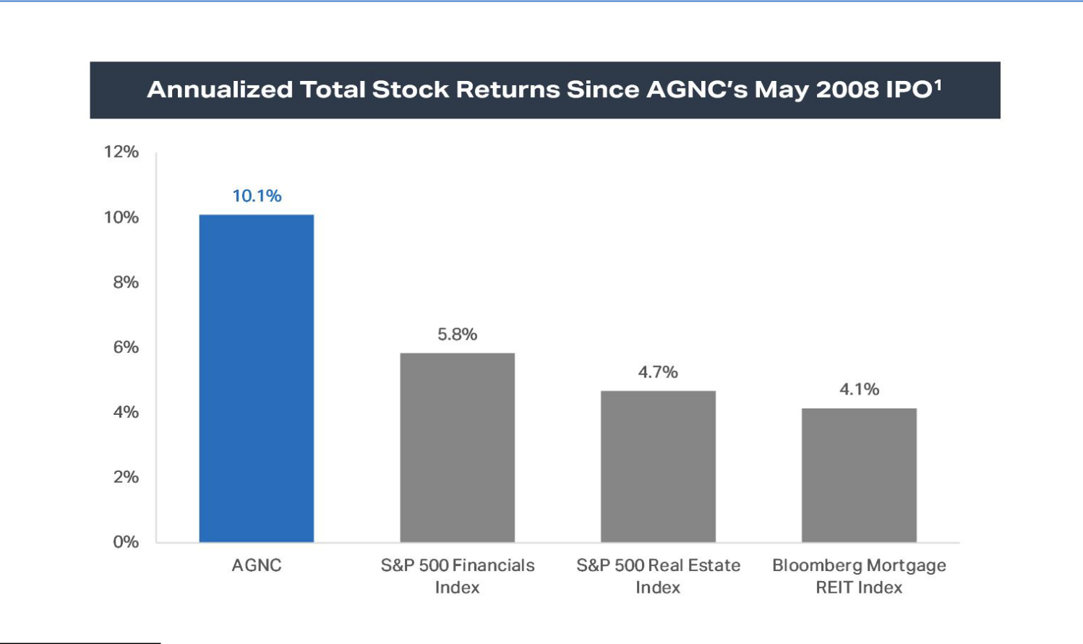

- Annualized total stock return is measured from AGNC’s May 2008 IPO through December 31, 2023. Total stock return over a period includes price appreciation and dividend reinvestment; dividends are assumed to be reinvested at the closing price of the security on the ex-dividend date. Source: Bloomberg.

Compensation Philosophy and Objectives

Compensation Program Objectives

The compensation programs for all of our employees, including our NEOs, are designed to focus on key strategic and financial objectives including:

Pay-for-Performance |  | Link compensation to achievement of short- and long-term financial and strategic goals
Attraction and Retention |  | Attract and retain a high-quality team with skills necessary to outperform industry peers and achieve AGNC’s
 |  | strategic objectives
Alignment with Stockholders |  | Align the interests of executive officers, employees, and stockholders by tying elements of realized compensation to
 |  | stockholder value
Financial Efficiency |  | Maintain a low-cost operating structure that maximizes financial efficiency from a tax, accounting, and cash flow
 |  | perspective
Strong Compensation |  | Employ high quality practices in governance of executive compensation
Governance
24 | AGNC INVESTMENT CORP. - Proxy Statement

Table of Contents

EXECUTIVE COMPENSATION

In support of these objectives, AGNC provides all of its employees total compensation in the form of base salary, annual performance-based incentives, and long-term incentive awards. The following describes the components of our NEO compensation program:
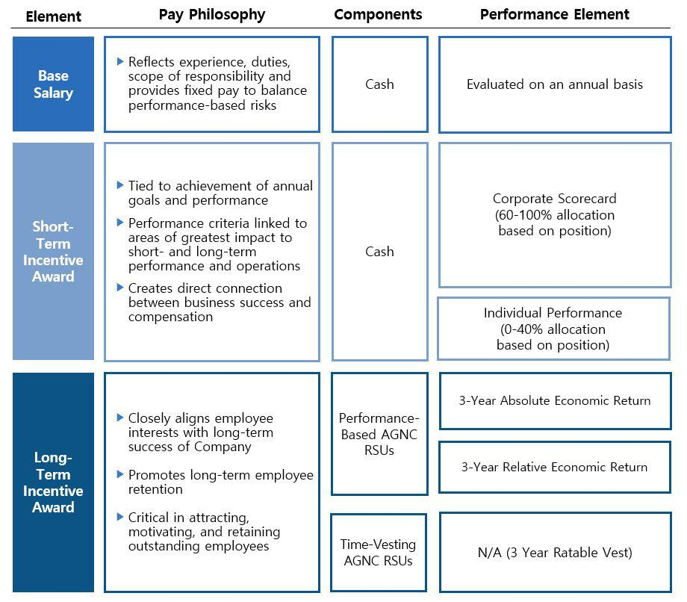

Stockholder Engagement

In 2023, 94% of our stockholders present or represented at the annual meeting and entitled to vote on the matter supported our advisory resolution

on executive compensation, which we believe reflects the positive support for the construction of our executive compensation program after taking into account stockholder feedback.

We value regular engagement with our stockholders, including through our quarterly earnings calls, investor conferences, fall and spring

engagement campaigns, and outreach through our Investor Relations department. We continued our robust program in 2023. Throughout the year, we held a successful equity-research-analyst event following the Nasdaq opening bell ringing ceremony celebrating AGNC’s fifteenth anniversary as a public company, participated in seven investor conferences, held over 160 meetings and calls with institutional investors, and responded to over 500 letters,

emails, and calls from retail investors. We engaged with our retail investors through our Investor Relations Department and as facilitated through collaboration with our proxy solicitor. In the fall of 2023, we sought meetings with our top 50 institutional stockholders by share count, who collectively hold 89% of our institutionally held common stock, and the two major proxy advisory firms to engage on governance related topics, including executive

compensation. We met with a number of institutional investors and the two proxy advisory firms and discussed our efforts to eliminate supermajority voting provisions from our Certificate of Incorporation and other governance and sustainability topics. Many institutional investors responded to our inquiry that there was no need to engage this year. The stockholders with whom we

AGNC INVESTMENT CORP. - Proxy Statement 25

Table of Contents

EXECUTIVE COMPENSATION

engaged did not voice concerns about our executive compensation program and many recognized our emphasis on linking our executives’ compensation to Company performance.

We continuously work to improve our stockholder engagement efforts and value the feedback provided to us during this process. Engagement with our stockholders regarding our compensation policies and practices has played a significant role in the evolution of our compensation program.

Summary of Recent Compensation Changes

The Compensation Committee continually evaluates our compensation program and considers stockholder feedback, industry compensation trends, historical and anticipated market conditions for the Company’s business, and comparative pay analysis. In these evaluations, the Compensation

Committee strives to maintain consistency with the overall compensation framework that has been well-accepted by investors and the Company’s employees. In 2021, the compensation packages for Messrs. Kain, Federico, and Kuehl were adjusted as a result of the promotion of Messrs. Federico and Kuehl to the roles of Chief Executive Officer and Chief Investment Officer, respectively, and Mr. Kain’s transition to the role of Executive Chair. Although

no changes were made to the target compensation of Messrs. Kain, Federico, and Kuehl in 2022, their annual target compensation changed relative to 2021 as 2022 compensation levels reflected a full-year of service in their new roles and with corresponding pay adjustments.

As part of its annual review of our compensation program for 2023, the Compensation Committee reexamined our compensation practices after

considering a number of factors, including the impact of changes in overall markets for Agency MBS on the Company’s compensation program following the Pandemic, compensation practices at comparable companies in consultation with FW Cook, and the evolving roles and functions of our NEOs. In examining the compensation practices at other mortgage REITs and asset managers considered comparable, the Compensation Committee noted that our

NEOs have a higher proportion of their target compensation allocated to performance-based equity compensation than executives at such companies. The Compensation Committee also determined as a result of this review that an increase in the aggregate compensation of Messrs. Federico, Kuehl and Pollack and Ms. Bell was appropriate considering their respective roles, market compensation conditions, and AGNC’s scale and performance relative to such

comparable companies.

The Compensation Committee remains committed to maintaining a program that incentivizes long-term performance, links pay with performance,

aligns executive objectives and incentives with our stockholders’ interests, and promotes retention of our NEOs. As discussed in greater detail below, a significant portion of NEO short and long-term compensation remains directly linked to absolute and relative economic returns. The Compensation Committee recognizes that both measures perform an important role in directly linking NEO pay to the interest of common stockholders and that economic

return relative to the Agency REIT Peer Group is the best measure of outperformance by the management team given the specialized asset class focus of the Company. Variability in these measures can lead to significant fluctuation in year-over-year pay outcomes.

The Compensation Committee took these factors into account in setting 2023 pay opportunities for our NEOs, which are discussed in detail below.

After completing its annual review and considering Messrs. Federico’s and Kuehl’s strong performance following their transition in 2021 to the role of CEO and Chief Investment Officer, respectively, during a period of historic market volatility, the Compensation Committee determined to increase Messrs. Federico’s and Kuehl’s target incentive compensation opportunities. Mr. Federico’s target incentive compensation opportunity was increased by a total of

$1.4 million, following which he continues to receive over 90% of his target compensation in the form of incentive-based compensation, a majority of this incentive-based compensation in the form of LTI equity awards, and 67% of LTI awards in the form of performance-based awards. Mr. Kuehl’s target incentive compensation opportunity was increased by $530,000, following which he receives 85% of his target compensation in the form of incentive-

based compensation and 50% of his LTI in the form of performance-based equity awards. After considering the compensation of NEOs performing similar functions at comparable companies and their evolving roles and responsibilities at the Company, the Compensation Committee increased the base pay and incentive compensation opportunities for Ms. Bell and Mr. Pollack such that 81% and 78%, respectively, of their target compensation is in the form of
incentive-based compensation, with 50% of their LTI allocated to performance-based equity. No changes were made to Mr. Kain’s target compensation. Mr.
Reid was not an NEO in 2022, and thus no comparative data for his 2022 compensation is provided.

26 AGNC INVESTMENT CORP. - Proxy Statement

Table of Contents

EXECUTIVE COMPENSATION

Composition of NEO Compensation

The Compensation Committee believes that incentive compensation should be a substantial component of each executive’s total compensation package. In 2023, all executives received at least 35% of their total compensation in the form of LTI, and at least 50% of LTI awards are performance-
vesting shares at target performance levels. The charts demonstrate the pay mix for our NEOs in 2023 based on target compensation:
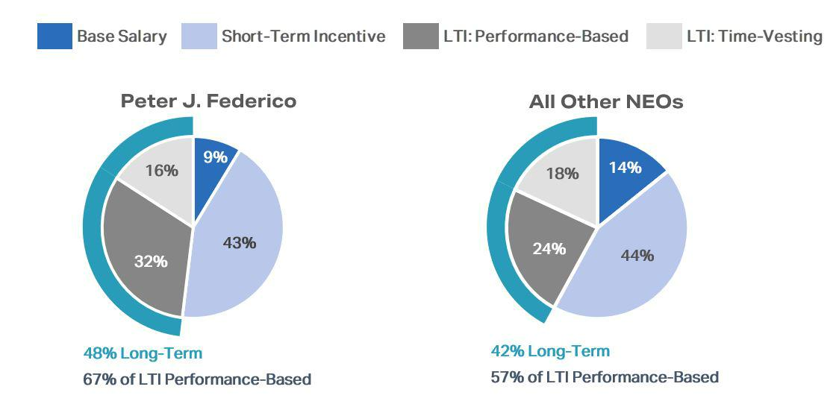

Compensation Governance Practices

To support our compensation philosophy and objectives, we are committed to the following compensation governance practices:

What we do:

- Focus on retention of high-performing employees
- Pay for performance
- Align executive and stockholder interests
- Impose stock ownership guidelines for our executive officers
- Prohibit our directors and executive officers from hedging, pledging, and short selling Company stock
- Engage an independent compensation consultant
- Provide long-term equity incentive compensation to all of our employees
- Conduct an annual review of our compensation program based on market conditions, performance, and stockholder feedback

What we don’t do:

- Pay based on a percentage of assets under management
- Provide tax gross-ups
- Provide special perquisites for executives
- Maintain supplemental retirement benefit plans
- Make option grants below fair market value
- Reprice stock options
- Provide for “single-trigger” severance or vesting acceleration

AGNC INVESTMENT CORP. - Proxy Statement 27

Table of Contents

EXECUTIVE COMPENSATION

Compensation Program in Detail

Compensation Program Elements

The Compensation Committee believes it is important to pay our NEOs in a manner that balances short- and long-term compensation and cash and

equity-based compensation. Our NEOs’ compensation program includes three primary elements: base salary, short-term incentives in the form of an annual cash bonus, and long-term equity incentives, with a significant portion subject to multi-year performance-based vesting.

The Compensation Committee’s philosophy on pay mix applies throughout the entire organization, with all AGNC employees receiving a portion

of their compensation in the form of short-term and long-term incentives. The proportion of an individual’s target total direct compensation opportunity in the form of variable incentive-based elements relative to fixed elements is directly correlated to the individual’s level of responsibility and role in the organization. Employees with greater seniority and greater responsibility have higher proportions of incentive-based compensation in their target mix.

Similarly, within the incentive-based elements, the proportion of LTI generally corresponds with the individual’s level of responsibility in the organization.

Base Salary

Base salary provides a baseline level of cash compensation to our NEOs and is a fixed expense for the Company. The Compensation Committee established base salaries for our NEOs considering a variety of factors, including:

- the competitive market for executive officers
- the scope of each executive officer’s responsibilities
- the highly complex and unique services provided by our NEOs
- the desire to retain our NEOs
- the duties and responsibilities of the NEOs
- internal and external pay equity

The Compensation Committee reviews the base salaries for our NEOs annually and at the time of a promotion or other change in responsibilities, and salaries may be adjusted after considering the above factors. The annual base salaries set forth in the table below are the minimum levels required in
each executive’s respective employment agreement. As part of its annual review in consultation with FW Cook and considering other relevant factors, the Compensation Committee increased the base salary levels for Ms. Bell and Mr. Pollack relative to their respective 2022 levels. Mr. Reid was not an NEO of the Company in 2022, and therefore only his 2023 compensation data is provided in this proxy statement.

NEO | 2022 Base Salary | 2023 Base Salary
Peter J. Federico | $900,000 | $900,000
Gary D. Kain | $500,000 | $500,000
Christopher J. Kuehl | $900,000 | $900,000
Bernice E. Bell | $500,000 | $750,000
Kenneth L. Pollack | $500,000 | $650,000
Sean P. Reid | — | $650,000

Annual Bonus

The Compensation Committee has established performance criteria for short-term incentives that directly correspond to the areas of greatest impact to our short- and long-term performance and operations, creating a direct connection between business success and our NEOs’ compensation. Each

NEO’s target for short-term incentive compensation, set forth in the table below, is determined based on an evaluation of the same factors used in setting base salaries.

NEO | 2022 Target Annual Bonus | 2023 Target Annual Bonus
Peter J. Federico | $3,600,000 | $4,500,000
Gary D. Kain | $3,600,000 | $3,600,000
Christopher J. Kuehl | $2,000,000 | $2,700,000
Bernice E. Bell | $1,250,000 | $1,725,000
Kenneth L. Pollack | $1,000,000 | $1,300,000
Sean P. Reid | — | $1,300,000

As part of its annual evaluation of the compensation package provided to our NEOs in consultation with FW Cook, the Compensation Committee, among other things, examined compensation practices at comparable companies and considered the scope of each NEO’s responsibilities and their performance. After considering these factors, the Compensation Committee determined it was appropriate to increase the annual target bonus for each of our NEOs other than Mr. Kain. Messrs. Federico’s and Kuehl’s annual

28 AGNC INVESTMENT CORP. - Proxy Statement

Table of Contents

EXECUTIVE COMPENSATION

target bonuses were increased to 500% and 300% of their base salaries, respectively, which represents the first adjustment to their target compensation since adjustments made at the time of their transition in 2021 to the roles of President and Chief Executive Officer and Chief Investment Officer, respectively. Following increases to each of their respective base salaries, Ms. Bell’s bonus target was reduced to 230% of her base salary, and Mr. Pollack’s bonus target remained at 200% of his base salary for 2023.

Corporate Scorecard for Calculating Annual Bonus

The Compensation Committee uses a Corporate Scorecard to assist in its evaluation of NEO performance and awards of annual cash bonuses. The Corporate Scorecard utilizes a framework that incentivizes and rewards performance over a broad range of circumstances, and, as described in greater detail below, the 2023 Corporate Scorecard was based upon a mix of financial and strategic measures that corresponded to the core elements of our value

proposition for stockholders. We believe the goals and measures included in the Corporate Scorecard effectively align NEO short-term incentives with financial, strategic, and operational performance of greatest importance to our business. Under the 2023 Corporate Scorecard, actual payouts can range from 0% to 200% of target for each metric, with category and metric weights as assigned by the Compensation Committee, and payouts for performance

between the threshold and maximum level of each measure are determined through linear interpolation. The cash bonuses for Messrs. Federico and Kain continue to be based solely on achievement of the Corporate Scorecard measures. The other NEOs’ short-term cash incentives were based predominantly on the Corporate Scorecard measures and to a lesser extent on individual performance.

2023 Corporate Scorecard

The Compensation Committee annually reviews the appropriateness of the Corporate Scorecard and considers feedback from stockholders as part of their deliberations. In response to feedback received during investor outreach in prior years, we revised the Corporate Scorecard in 2019 to increase the

weighting of financial performance and realign the strategic and operational objectives more directly with the Company’s value proposition to stockholders.

In conducting its annual review in January 2023, the Compensation Committee determined that it was appropriate to maintain the weightings

among the three financial performance metrics, with absolute annual economic return weighted at 25%, relative annual economic return weighted at 35%, and relative price-to-tangible book ratio weighted at 15%. The Compensation Committee previously adjusted these weightings in 2022 to increase the weighting of relative annual economic return and decrease the weighting of relative price-to-tangible book ratio after concluding that revising the allocation

among the relative measures better aligns the scorecard with the performance metrics prioritized by investors. In addition, the Compensation Committee determined at that time that market conditions and stock price volatility among the Agency REIT Peer Group made the relative price-to-tangible book ratio a less reliable indicator of performance. In its review in January 2023, the Compensation Committee determined it would be appropriate to allow for

payouts of up to 200% (from 150% under the prior Corporate Scorecards), with a corresponding increase in the performance levels required to achieve maximum payout. This adjustment in the performance continuum allows for greater reciprocity of outcomes under the Corporate Scorecard by providing a parallel to the 0% payout for below threshold performance. The Compensation Committee also considered the level of rigor of the goals and objectives in
light of market conditions and elected to reduce the target performance level for the relative price-to-tangible book ratio from 3.5 percentage points greater
than the Agency REIT Peer Group average to 1.0 percentage point and extended the performance bands of this measure consistent with this adjustment. In
making the adjustment to this relative metric, the Compensation Committee noted that evolutions in equity market conditions for mortgage REITs since the

prior target was set in 2019 had resulted in less differentiation among price-to-tangible book ratios of Agency-focused mortgage REITs. The Compensation Committee also considered the continued alignment of the Corporate Scorecard with the Compensation Committee’s overall compensation philosophy and relevant feedback from stockholders. As in prior years, the Compensation Committee set the financial measures for the Corporate Scorecard in January
2023 following an evaluation of historical performance over a five-year period, back-testing financial measures over this period to evaluate hypothetical
payout levels when applying the Corporate Scorecard to those periods, and our high-level forecast. Following this review, the Compensation Committee
concluded that the threshold, target, and outperformance levels for the Corporate Scorecard financial measures, weighted at 75% of the overall Corporate

Scorecard, remained challenging for 2023 in a market environment marked by extreme interest rate volatility, rapidly changing monetary policy, and continued economic uncertainty. The Compensation Committee also determined that it remained appropriate to continue including non-financial strategic and operational objectives weighted at 25% of the overall Corporate Scorecard.

Our Corporate Scorecard was designed to incentivize and reward results over a broad range of circumstances through balanced weightings of absolute and relative financial performance and strategic and operational objectives.

AGNC INVESTMENT CORP. - Proxy Statement 29

Table of Contents

EXECUTIVE COMPENSATION

Financial Metrics (75% of Total Corporate Scorecard)

Performance Continuum³
Category | Metric | Performance | Below |  |  | Out-
Weight | Weight | Metric | Threshold | Threshold | Target | performance
 | 25% | Absolute Annual Economic Return1 | < 0.0% | 0.0% | 10.0% | ≥ 24.0%
75% | 35% | Relative Annual Economic Return1,2 | < (5.0) | (5.0) | 1.0 | ≥ 10.0
 | 15% | Relative Price-to-Tangible Book Ratio2 | < (5.0) | (5.0) | 1.0 | ≥ 10.0
 |  |  |  | Payout Continuum (% of Metric Weight)
 |  |  | 0% | 50% | 100% | 200%

- Economic return is calculated on tangible common equity per share.

- Reflects AGNC’s relative performance to the unweighted, simple average of the Agency REIT Peer Group. Our Relative Annual Economic Return measure is calculated on an October 1 – September 30 year basis due to the timing of availability of comparative data.
- Relative Annual Economic Return and Relative Price-to-Tangible Book Ratio calculations are based on percentage points.

The financial measures emphasized our focus on generating strong absolute and relative economic returns and maintaining a strong common stock trading price to tangible book value relative to our peers.

Our economic return reflects the overall return we generate on our tangible common equity capital and is comprised of our dividends declared and the change in the tangible net book value per share of common stock over the relevant period. As such, it incorporates all aspects of our investment activity, including interest received on our investments, net of borrowing costs, and realized and unrealized gains and losses on our investments, hedging

instruments, and other assets and liabilities. We believe this measure best reflects a composite view of AGNC’s financial performance over any time period. Most investors and research analysts active in the residential mortgage REIT sector utilize this metric as a primary factor in analyzing residential mortgage REIT performance.

Our Compensation Committee has included both absolute and relative annual economic return as separate financial performance measures. Our inclusion of absolute annual economic return is reflective of our focus on generating positive economic returns for our stockholders and supporting our dividend, regardless of overall macroeconomic conditions. Relative annual economic return has been included to provide a comparison of our performance

against our peers and to reward our management team and employees for outperformance. While a favorable macroeconomic climate may drive a strong absolute annual economic return, relative annual economic return requires outperformance relative to peers, all of which are subject to the same prevailing macroeconomic conditions. For 2023, our Compensation Committee retained our target goals of absolute annual economic return at 10.0% and relative

annual economic return at 1.0 percentage point greater than the Agency REIT Peer Group average. These goals reflect the Compensation Committee’s view that an absolute annual economic return target of 10.0% would be appropriately challenging and that outperformance of the peer average by 1.0 percentage point should be the target goal for relative annual economic return.

Our third financial measure is our stock price to tangible net book value per share, or “price-to-tangible book ratio,” relative to peers. As discussed herein, in January 2023 our Compensation Committee adjusted our target relative price-to-tangible book ratio to a 1.0 percentage point premium to the Agency REIT Peer Group average. Price-to-tangible book ratio is a valuation metric utilized by many investors and research analysts and reflects the

premium (or discount) to tangible net book value of a company implied by the company’s stock price. As such, the price-to-tangible book ratio for AGNC relative to peers may in certain market environments imply the relative perception by the market of, or outlook for, AGNC as compared to its peer group. We believe that our track record of favorable long-term financial performance, operating efficiency, disciplined risk management, stockholder focus, and

significant scale and liquidity should position AGNC for a premium valuation relative to our peer group in most market environments.

Collectively, our three financial measures incentivize our management team to drive favorable returns – on both an absolute and relative basis – for our stockholders. Our success in generating economic returns at or above target levels while maintaining targeted premium valuation levels on a price-
to-tangible book value basis should translate into favorable total stock returns for our stockholders. As such, we believe these metrics appropriately align our short-term incentive plan with our stockholders.

Strategic and Operational Objectives (25% of Total Corporate Scorecard)

As noted above, our Compensation Committee believes our value proposition should position AGNC for a premium valuation. Our Compensation Committee seeks to drive management performance in these areas and focuses our strategic and operational efforts on the following components:

- Operating Efficiency: maintain low operating cost structure relative to peers and continually identify opportunities to improve operations across functional groups where practicable
- Disciplined Risk Management: mitigate business and operational risk based on the Company’s comprehensive risk management framework
- Stockholder Focus and Capital Management: provide detailed and transparent financial disclosure, actively engage with stockholders, and maintain an active stockholder-friendly approach to capital management consistent with broader market considerations

30 AGNC INVESTMENT CORP. - Proxy Statement

Table of Contents

EXECUTIVE COMPENSATION

- ESG Framework and Practices: incorporate material ESG and sustainability factors into our strategy, business, and operations and provide disclosure regarding ESG and corporate sustainability philosophy and practices

Annual 2023 Corporate Scorecard Incentive Compensation Determination

Following a review of each of the components of the 2023 Corporate Scorecard, the Compensation Committee calculated a total scorecard payout for 2023 of 142.2% of target. A more detailed discussion regarding each of the elements included in the Corporate Scorecard is provided below.

Component | Component | Component | Weighted
Component | Weight | Payout | Payout
Financial Metrics | 75% | 139.6% | 104.7%
Strategic and Operational Objectives | 25% | 150.0% | 37.5%
Corporate Scorecard Payout |  |  | 142.2%

2023 Financial Metric Results

Based on our 2023 Corporate Scorecard, our 2023 financial metric performance indicated a 139.6% payout for the financial metric component, as

significant outperformance compared to our peer group under both relative measures drove a favorable above-plan outcome. Despite significant fixed income market volatility in 2023, AGNC generated a positive absolute annual economic return of 3.0% for the year, above the threshold but below the base target. On a relative annual economic return basis, AGNC meaningfully outperformed the Agency REIT Peer Group average by 7.0 percentage points, materially exceeding the 1.0 percentage point outperformance base target. AGNC posted the highest price-to-tangible book ratio in our peer group by a wide margin, significantly outperforming the Agency REIT Peer Group average by 15.6 percentage points and exceeding the 10.0 percentage points outperformance level.
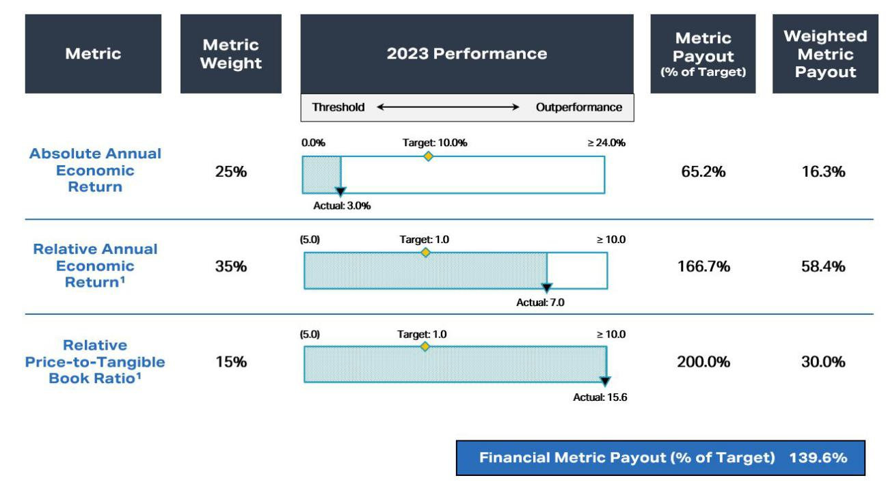

1. Relative Annual Economic Return and Relative Price-to-Tangible Book Ratio calculations are based on percentage points.

AGNC INVESTMENT CORP. - Proxy Statement 31

Table of Contents

EXECUTIVE COMPENSATION

2023 Strategic and Operational Review

In evaluating our performance under the strategic and operational objectives portion of the Corporate Scorecard, the Compensation Committee determined that Company personnel significantly exceeded target expectations for the year in all categories, meriting a 150% performance rating on these
measures. In reaching these conclusions, the Compensation Committee noted the following accomplishments:

Strategic Component Objective / Focus
Operating Efficiency ü Maintain low operating cost structure
relative to the residential mortgage REIT
and broader asset management industries

Disciplined Risk Management ü Utilize comprehensive risk management framework predicated on careful asset

selection, disciplined hedging, and diversified funding to preserve tangible net book value across a wide range of market

scenarios

- Maintain business continuity through operational and cybersecurity risk management

Stockholder Focus and ü Provide detailed and transparent public
Capital Management financial disclosure, actively engage with
investors, and provide clear and effective stockholder communications

ü Maintain an active, stockholder-friendly
capital management approach that is
consistent with broader market
considerations

ESG Framework and ü Expand and improve high-quality ESG and
Practices corporate sustainability practices, and
incorporate material ESG and sustainability
factors into AGNC’s strategy, business, and
operations

Highlights

- Continued to outperform mREIT industry on an operating cost basis by a wide margin
- Enhanced efficiencies through expansion of business intelligence reporting in accounting and portfolio management functions
- Expanded futures clearing capabilities and reduced haircuts
- Recovered $12 million in disputed claims from counterparties

- Automated, centralized, and significantly strengthened liquidity management function, translating to a safer operating position
- Transitioned all custodial functions to Bethesda Securities, providing cost savings and superior risk controls
- Created and implemented automated reconciliation tool that verifies internal positions to custodian positions
- Migrated AGNC network infrastructure onto the cloud and completed meaningful system-wide upgrades, enhancing scalability, security, and reliability

- Adopted and enhanced compliance policies and procedures in response to new SEC rules and the evolving enforcement landscape

- Operated in compliance with risk reporting framework throughout 2023 and maintained funding diversification with ample capacity
- Refined external messaging, which has been highly effective, as evidenced by our significant and sustained price-to-book value premium that provides access to accretive new capital

- Highly successful Agency-focused brand repositioning with launch of new website and redesign of corporate marketing materials

- Significantly increased investor outreach and hosted successful equity-research-analyst event
- Participated in seven sell-side hosted events, held over 160 meetings and calls with institutional investors, and responded to over 500 letters, emails, and calls from retail investors throughout the year

- Implemented new ATM program and enhanced liquidity and earnings capacity through accretive ATM offerings of common stock

- Greatly expanded employee engagement and community outreach initiatives and redesigned charitable giving program

- Received second Great Place to Work certification with high levels of employee satisfaction
- Successfully completed relocation to brand new LEED Platinum HQ built around sustainability and wellness
- Maintained high quality governance oversight and structure, including compliance with governance, reporting, listing and REIT regulatory requirements

- Published third annual ESG report and disclosures consistent with SASB and TCFD reporting framework
- Achieved meaningful improvement in AGNC’s ESG scores with multiple ratings upgrades

32 AGNC INVESTMENT CORP. - Proxy Statement

Table of Contents

EXECUTIVE COMPENSATION

Individual Bonus Decisions

The 2023 bonus payments for our NEOs are reflected in the following table:

NEO | Short-Term Incentive Award | Percentage of 2023 Target
Peter J. Federico | $6,399,000 | 142.2%
Gary D. Kain | $5,119,200 | 142.2%
Christopher J. Kuehl | $3,496,500 | 129.5%
Bernice E. Bell | $2,161,425 | 125.3%
Kenneth L. Pollack | $1,628,900 | 125.3%
Sean P. Reid | $1,628,900 | 125.3%

Short-term incentives for Messrs. Kain and Federico in 2023 were based solely on achievement of the Corporate Scorecard measures. Based on the Compensation Committee’s assessment of the 2023 Corporate Scorecard, this resulted in a payout of 142.2% of target for Messrs. Kain and Federico.
Short-term cash incentives for our NEOs other than Messrs. Federico and Kain were based predominantly on the Corporate Scorecard measures (70% for Mr. Kuehl and 60% for Ms. Bell and Messrs. Pollack and Reid) and to a lesser extent on individual performance. After considering the contributions of Messrs. Kuehl, Pollack, and Reid and Ms. Bell, as discussed below, and management’s collective achievements throughout the year, the Compensation

Committee determined that a rating of 100.0% was appropriate for each of Messrs. Kuehl, Pollack, and Reid and Ms. Bell for the individual component element of their bonus. The Compensation Committee recognized the efforts of Ms. Bell and Messrs. Kuehl, Pollack, and Reid in a number of operational accomplishments throughout the organization that contributed to increased efficiency and resiliency as discussed in further detail below. Our Corporate

Scorecard results reflect our strong absolute and relative performance in 2023 despite volatile market conditions and demonstrate our improved performance relative to 2022 when payouts among our NEOs ranged from 61.9% to 80.1%.

Mr. Kuehl was awarded a cash bonus at 129.5% of his target based on a relative weighting of the Corporate Scorecard at 70% and his personal

performance at 30%. In evaluating his personal performance, the Compensation Committee noted his management of the Company’s investment portfolio during a year of challenging market conditions resulting from historic levels of interest rate and spread volatility. The Compensation Committee also recognized his work to enhance the Company’s analytics and modeling capabilities in addition to his participation in industry-wide responses to regulatory

proposals with a potential to impact the Agency MBS market and our business and operations. Ms. Bell and Messrs. Pollack and Reid each were awarded 125.3% of their target bonus, which reflects a relative weighting of the Corporate Scorecard at 60% and their individual personal performance at 40%. For Ms. Bell, the Compensation Committee considered her leadership in expanding the Company’s business intelligence and data analytics capabilities. The

Compensation Committee also recognized her contributions towards improving the Company’s cash and liquidity management systems. For Mr. Pollack, the Compensation Committee considered his leadership in enhancing the Company's compliance policies and procedures in response to new regulations and business initiatives and his participation in industry-wide responses to regulatory and legislative proposals with a potential to impact the Agency MBS

market and our business and operations. The Compensation Committee also recognized his continued attention to the Board’s reporting and oversight process and to the provision of legal services to support the Company’s capital markets and business activities. For Mr. Reid, the Compensation Committee considered his leadership in our investor relations efforts, including the development and launch of the Company’s new website and the refinements to our

corporate messaging. The Compensation Committee also recognized his leadership in the Company’s capital market activities, including the issuance of over $1.1 billion of accretive common stock through the Company’s at-the-market program.

Equity Incentive Compensation

The Compensation Committee believes that equity incentive compensation is an important component of our NEO compensation package and is critical in attracting, motivating, and retaining outstanding employees. Equity incentive compensation is intended to closely align our NEOs’ and other employees’ interests with our long-term success and promote long-term employee retention. Our long-term incentive program consists of a combination of

performance-based RSUs and time-vesting RSUs.

Performance-based RSUs are designed to reward the generation of long-term economic returns for our stockholders both on an absolute and relative basis. To establish challenging economic thresholds and motivate long-term performance, the awards vest at the end of a three-year performance
period based 50% on our absolute economic return and 50% on our economic return relative to the unweighted average of economic returns of the Agency REIT Peer Group. In establishing vesting criteria for these awards, the Compensation Committee considers historical returns for us and our peers and our forecast. Absolute and relative economic returns are calculated on a cumulative basis over the three-year performance period. Achievement of these goals
will be determined in the same manner, including the same peer group, as described above with respect to the short-term incentive awards for such year.
For performance between the threshold, target, and outperformance goals, the number of shares vested will be determined through linear interpolation.

AGNC INVESTMENT CORP. - Proxy Statement 33

Table of Contents

EXECUTIVE COMPENSATION

2023 Long-Term Incentive Awards

The 2023 long-term incentive awards made by the Compensation Committee in February 2023 were at each NEO’s target levels as specified in their respective employment agreements and are reflected in the following table:

Mix of Long-Term Incentive Awards

NEO | Time-Vested | Performance-Vested | Total Value
NEO | RSUs ($) 1 | RSUs ($) 2 | of Awards ($) 3
Peter J. Federico | 1,650,000 | 3,350,000 | 5,000,000
Gary D. Kain | 1,386,000 | 2,814,000 | 4,200,000
Christopher J. Kuehl | 1,215,000 | 1,215,000 | 2,430,000
Bernice E. Bell | 750,000 | 750,000 | 1,500,000
Kenneth L. Pollack | 520,000 | 520,000 | 1,040,000
Sean P. Reid | 520,000 | 520,000 | 1,040,000

- Awards vest ratably over a three-year and one-half month period in equal annual installments.

- Represents grant-date fair value assuming performance achievement at 100% of target. Performance payouts may range from 0% to 200% of target shares based on actual performance. Awards are subject to cliff vesting two years and eleven and one-half months after the grant date, subject to a three-year performance period.
- Awards were granted on March 1, 2023 based on a $10.59 stock price.

The fair value of these awards as of their March 1, 2023 grant date is included in the Summary Compensation Table and Grants of Plan-Based Awards Table. The ultimate value of the RSUs will depend on AGNC’s total stock return over the vesting period, and in the case of the performance-based RSUs, AGNC’s absolute and relative economic return over the three-year performance period.

In setting the level of awards to our NEOs, the Compensation Committee considered a number of factors, including the compensation practices at comparable companies, and our ongoing commitment to link NEO compensation to our long-term performance. The Compensation Committee also considered the roles and ongoing responsibilities of each of our NEOs and relevant market data.

- Mr. Federico’s long-term incentive target was increased from $4,500,000 to $5,000,000 in 2023 and continued to be allocated, at target, 67% performance-based and 33% time-based.
- Mr. Kain’s long-term incentive target was unchanged in 2023 and continued to be $4,200,000, allocated, at target, 67% performance-based and 33% time-based.

- Mr. Kuehl’s long-term incentive target was decreased from $2,600,000 to $2,430,000 in 2023, allocated, at target, 50% performance-based and 50% time-based.

- Ms. Bell’s long-term incentive target was increased from $1,250,000 to $1,500,000 in 2023, allocated, at target, 50% performance-based and 50% time-based.

- Mr. Pollack’s long-term incentive target was increased from $1,000,000 to $1,040,000 in 2023, allocated, at target, 50% performance-based and 50% time-based.

- Mr. Reid’s long-term incentive target was $1,040,000 in 2023, allocated, at target, 50% performance-based and 50% time-based.

In granting awards in 2023, the Compensation Committee also reviewed the measures used for performance-based RSUs and determined that it was appropriate to retain the measures established in 2022 without adjustment. Although the outlook for financial markets continued to be uncertain at the outset of 2023, the Compensation Committee considered the value of consistency year-over-year in considering adjustments to the scorecard and concluded that these measures remained challenging in the current market environment for awards made in 2023. The table below sets forth the below threshold, threshold, target, and outperformance levels established by the Compensation Committee for performance-based RSU awards made in 2023.

Metric | Performance | Below |  | Base Performance
Weight | Variable | Threshold | Threshold | Target | Outperformance
50% | Absolute Three-Year Economic Return | < 0.0% | 0.0% | 30.0% | ≥ 60.0%
50% | Relative Three-Year Economic Return¹ | < (4.5) | (4.5) | 3.0 | ≥ 10.5
 | Payout Factor (% of Target Shares) | 0% | 0% | 100% | 200%

- Relative Three-Year Economic Return calculations reflect the difference between AGNC’s cumulative economic return for the period ending September 30, 2025 and the unweighted average cumulative economic return of the Agency REIT Peer Group over such period.

34 AGNC INVESTMENT CORP. - Proxy Statement

Table of Contents

EXECUTIVE COMPENSATION

2021 Performance-Based Restricted Stock Unit Awards

The three-year performance period for the performance-based RSU awards made to our employees in March 2021 was completed on
December 31, 2023. The performance calculations included absolute economic return measured from December 31, 2020 through December 31, 2023 and
relative economic return as compared to an Agency mortgage REIT peer group determined at the time of the grant and measured from September 30, 2020 through September 30, 2023. AGNC generated an absolute economic return of -22.1% and relative economic return of +5.5 percentage points of outperformance for the applicable measurement period, resulting in a vesting factor of 66.4% of the target number of shares for the 2021 performance-

based RSUs, as validated by the Compensation Committee. Distribution of shares in settlement of these awards occurred on February 15, 2024, provided that the recipient remained employed by the Company on that date. The diagram below includes the performance targets and details the performance calculations for these awards. Additional details regarding these RSUs are provided in the Outstanding Equity Awards table on page 42 of this proxy

statement. These measures were established in 2021 based on then anticipated ranges of performance deemed to be appropriately challenging based on the Compensation Committee’s analyses, including back-testing.
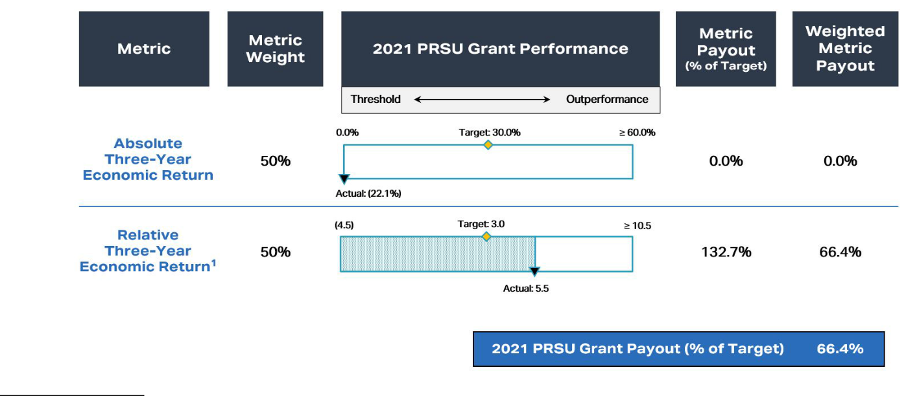

- Reflects AGNC’s performance relative to the unweighted, simple average of the peer group constituents: Anworth Mortgage Asset Corporation (“ANH”), ARR, Capstead Mortgage Corporation (“CMO”), DX, IVR, NLY, and TWO. Under pre-established peer group criteria, if a peer undergoes a merger or acquisition, its economic return is included through the quarter ended just prior to completion of the transaction. As a result of the acquisition of ANH announced in December 2020 (closed in March 2021) and the acquisition of CMO announced in July 2021 (closed in October 2021), ANH has been included through December 31, 2020, and CMO has been included through September 30, 2021. Relative Three-Year Economic Return calculations are based on percentage points.

Savings and Health and Welfare Benefits

Our executive officers participate in a broad-based 401(k) retirement savings plan generally applicable to all our employees, which includes an

opportunity to receive employer matching contributions. We do not currently provide for pension plans, supplemental retirement plans, or deferred compensation plans for our executive officers. We previously provided our executive officers the option to elect to defer payments of long-term incentive awards. In addition, all of our executive officers also participate in medical, dental, vision, disability, life and long-term care insurance, and qualified

transportation benefits that are provided generally to all our employees.

Perquisites and Other Personal Benefits

We do not believe our executive officers should receive special perquisites and benefits and do not currently provide our executive officers with any perquisites or other personal benefits that are not available on a non-discriminatory basis to all employees.

Compensation Decision Process

Compensation Comparator Group

AGNC’s internal management structure, size, and scale relative to other residential mortgage REITs and our Agency mortgage-backed securities investment focus are significant differentiators relative to other potential comparative public companies and have made identifying a peer group for AGNC challenging. As a result, the Compensation Committee has not adopted a policy to benchmark compensation levels against comparative companies.

AGNC INVESTMENT CORP. - Proxy Statement 35

Table of Contents

EXECUTIVE COMPENSATION

We are the second largest residential mortgage REIT overall by market capitalization, total assets, and total equity when compared with the 15 other residential-focused mortgage REITs included in The Bloomberg Mortgage REIT Index (BBREMTG) as of December 31, 2023, and we refer to these other 15 REITs individually as residential mREITs and collectively as the “Resi mREIT Universe.”¹ Some of these 15 REITs have an investment focus similar to AGNC, but most of these REITs employ investment strategies that place a greater emphasis on credit-sensitive assets than our portfolio. Residential mREITs that primarily invest in non-Agency mortgage-backed securities involve different risk and return profiles and will have performance that is not well-correlated to our performance. Many of the mortgage REITs in the Resi mREIT Universe are externally managed by a third party and pay the third party a management fee as a set percentage of equity (plus, in some cases, a performance incentive fee) in lieu of compensating employees directly. In an external management structure, the third-party manager, rather than the REIT, is responsible for the compensation and benefits of its executives and other employees, which are paid out of the management fee. Moreover, only one other internally managed mREIT in the Resi mREIT Universe had a market capitalization above $1.5 billion as of December 31, 2023, and its investment portfolio was not nearly as concentrated in Agency MBS as AGNC.

Although we are an internally managed REIT, our business of investing primarily in Agency mortgage-backed securities makes our operations somewhat comparable to asset management firms. However, asset management firms employ a different business model: they primarily generate income from management fees charged to clients based on, among other things, the level of assets under management or financial returns that clients earn on their investments. By comparison, AGNC generates income primarily from its investments in Agency securities. As a result, AGNC’s performance may vary materially from asset management firms given the vastly different asset base and significant leverage and hedging activities inherent in our business model.

Although we have few close peers considering our internal management structure, size, and scale relative to other mortgage REITs and investment focus on Agency mortgage-backed securities, the Compensation Committee, with the assistance of FW Cook, reviews compensation levels and practices at various financial services companies as part of its consideration of our compensation structure, programs, and practices. In 2023, the Compensation Committee reviewed the compensation practices at 18 companies, including eight internally managed publicly traded mortgage REITs and 10 publicly traded asset management companies and non-bank financial services companies. The Compensation Committee added one company, a mortgage REIT that recently internalized its management. The Compensation Committee determined the highly specialized and unique skill sets required of executives in these industries are most comparable to those required of AGNC’s NEOs, although very few would be an exact match for our Company. However, in considering this analysis, the Compensation Committee believes that, due to their vastly different business models, capital allocations, and assets, these companies collectively will have performance that is not well-correlated to AGNC’s performance, and accordingly they are not a suitable peer set for purposes of evaluating management’s relative performance or the alignment of our compensation program to our performance.

Mortgage REITs: | Asset Management and Financial Services Companies:
Annaly Capital Management, Inc. | Affiliated Managers Group, Inc.
Arbor Realty Trust, Inc. | AllianceBernstein Holding L.P.
Chimera Investment Corporation | Ameriprise Financial, Inc.
Ladder Capital Corp. | Apollo Global Management LLC
MFA Financial, Inc. | Ares Management LP
Redwood Trust, Inc. | DigitalBridge Group, Inc.
Rithm Capital Corp. | Invesco Ltd.
Two Harbors Investment Corp. | KKR & Co. L.P.
 | The Blackstone Group L.P.
 | The Carlyle Group L.P.

- The “Resi mREIT Universe” includes AG Mortgage Investment Trust, Inc. (“MITT”), NLY, ARR, Cherry Hill Mortgage Investment Corporation (“CHMI”), Chimera Investment Corporation (“CIM”), DX, Ellington Financial, Inc. (“EFC”), Great Ajax Corp. (“AJX”), IVR, MFA Financial, Inc. (“MFA”), New York Mortgage Trust, Inc. (“NYMT”), ORC, PennyMac Mortgage Investment Trust (“PMT”), Redwood Trust, Inc. (“RWT”), and TWO.

Performance Comparator Group

The Compensation Committee has determined that a subset of the Resi mREIT Universe, which we refer to as the “Agency REIT Peer Group,” provides a better basis for comparison to evaluate our performance and operations under our Corporate Scorecard and performance-based LTI awards. For
purposes of 2023 incentive awards, these REITs were:

- Annaly Capital Management, Inc.

- ARMOUR Residential REIT, Inc.

- Dynex Capital, Inc.

- Invesco Mortgage Capital, Inc.

36 AGNC INVESTMENT CORP. - Proxy Statement

Table of Contents

EXECUTIVE COMPENSATION

- Orchid Island Capital, Inc.

- Two Harbors Investment Corp.

The Agency REIT Peer Group companies have at least 50% of their capital allocated to portfolios that most closely resemble our own focus on Agency securities. Non-agency REITs in the Resi mREIT Universe have strategies that place a greater emphasis on credit-sensitive assets than our portfolio and those of our Agency REIT Peer Group. As such, these REITs would be expected to achieve divergent returns from our own Agency securities-focused
portfolio through various economic cycles and conditions. The Compensation Committee thus determined that our economic returns and stock price relative to tangible book value are appropriately measured against a simple, unweighted average of the Agency REIT Peer Group for purposes of determining our relative performance. Only two of the six REITs in the Agency REIT Peer Group were included in the group of companies for which

executive compensation practices were reviewed by the Compensation Committee, Annaly Capital Management, Inc. and Two Harbors Investment Corp. The other four companies included in the Agency REIT Peer Group were excluded from our compensation comparator group because these four REITs either are significantly smaller than AGNC or are externally managed.

The Compensation Committee continues to evaluate our peer group construction in response to changes in market conditions and the mortgage REIT sector. The Compensation Committee desires to limit the number of year-over-year changes to this peer group in order to provide meaningful ongoing comparative analyses for its work. The Compensation Committee added Orchid Island Capital, Inc. to the Agency REIT Peer Group in 2022 based

on guiding parameters, including a minimum of $500 million in total stockholders’ equity and approximately 50% or greater allocation of capital to Agency residential mortgage-backed securities at the time of inclusion.

Role of the Compensation and Corporate Governance Committee

Our Compensation Committee, which is comprised solely of independent directors, is responsible for establishing and overseeing our philosophy regarding executive compensation and for making decisions relating to the compensation of our NEOs. The Compensation Committee is also responsible for ensuring that the total compensation offered to our executive officers is fair and competitive and motivates high performance. The terms of any

employment agreements with our NEOs and actions on compensation under the employment agreements are also under the primary direction of the Compensation Committee. Decisions that set the compensation of our CEO or Executive Chair are subject to the review and approval of the Company’s independent directors based on the Compensation Committee’s evaluation of goals and objectives.

The Compensation Committee periodically reviews the Company’s compensation policies and programs and makes any modifications that the

Committee deems necessary or advisable, subject to the terms of such policies or programs. The Compensation Committee annually reviews and approves the Company’s goals and objectives relevant to the compensation of the NEOs and other employees of the Company.

Role of Management

All compensation decisions related to our executive officers are at the discretion of the Compensation Committee or independent directors of our Board. The Compensation Committee considers the advice and counsel of the CEO when evaluating compensation of the other NEOs given his direct day-to-day working relationship with those executives. Taking this feedback into consideration, the Compensation Committee engages in discussions and either
determines the compensation of our NEOs or makes a final recommendation to the Board related to compensation paid to NEOs. Neither our CEO nor our Executive Chair is present or a participant in the portions of meetings of the Compensation Committee or of the Board at which his performance is evaluated and his compensation is deliberated and determined; only independent directors participate in such matters.

Role of the Independent Compensation Consultant

Under its charter, the Compensation Committee has the authority to select, retain, and terminate compensation consultants. The Compensation Committee has retained FW Cook to provide advice and counsel on executive compensation opportunities and program design and structure.
Representatives of FW Cook attended certain meetings of the Compensation Committee, including meeting with members of the Compensation Committee without members of management present. FW Cook assists the Compensation Committee in its analysis and evaluation of our executive compensation program, practices, and communications and provides the Compensation Committee with market data and analysis of certain comparator companies that

hire personnel and executives with similar skills and experience as our executive management team. FW Cook also provides advice with respect to our Corporate Scorecard, our long-term incentive awards, the setting of measures for performance-based incentive compensation, and other work that informs executive compensation decisions. During 2023, the Compensation Committee reviewed the independence of FW Cook using assessment criteria under

applicable Nasdaq and SEC rules and concluded FW Cook was independent and had no conflicts of interest.

Risk Assessment and Compensation

The Compensation Committee regularly monitors the risks and rewards associated with our compensation program. The Compensation

Committee established our compensation program with the intent to align our interests with stockholders and prevent unnecessary or excessive risk-taking. We believe that our compensation policies and practices are well-balanced and designed to avoid creating incentives that encourage unnecessary or excessive risks that could potentially have a material adverse effect on the Company. We use variable compensation for all of our NEOs, with a focus on

performance-based compensation. We have designed a compensation program with a mix of short- and long-term incentives to ensure management focuses on the long-term impact of short-

AGNC INVESTMENT CORP. - Proxy Statement 37

Table of Contents

EXECUTIVE COMPENSATION

term decisions and that management’s interests are aligned with stockholders. At least 50% and up to 67% of our NEOs’ long-term incentive awards vest based on performance over a three-year period. Compliance with the risk management framework designed to address excessive risk taking and approved by our Board is an integral part of the strategic and operational objectives of the Corporate Scorecard used for short-term incentive compensation decisions.
The Compensation Committee continually assesses our executive compensation programs and has implemented additional policies and practices that we believe have further mitigated compensation driven risk, including the adoption of a clawback policy and executive officer stock ownership guidelines.

Other Compensation Policies and Practices

Stock Ownership Guidelines

We have adopted stock ownership guidelines for our executive officers establishing share ownership targets based on a multiple of base salary. The minimum objective is 6x for our Executive Chair and our CEO, 4x for our Chief Investment Officer, and 3x for all other executive officers. Until the
foregoing ownership requirements are met, each individual is required to retain at least 50% of the shares of common stock received upon vesting of stock-based compensation, net of any shares withheld or sold to pay or reimburse taxes on such income. The retention obligations also apply in the event ownership levels fall below applicable guideline levels due to a decline in stock price. Shares of time-vested RSUs granted under the 2016 Equity Plan

(whether vested, unvested, or subject to a deferral election) are included in determining the number of shares held for this purpose, net of anticipated tax withholdings. Shares of unvested performance-based RSUs are not included for this purpose prior to completion of the applicable performance period. As of February 23, 2024, all of our NEOs had complied with their obligations under our stock ownership guidelines.

The following table sets forth the total stock ownership of all our NEOs, including beneficially owned, unvested, and deferred shares, as calculated pursuant to our stock ownership guidelines as of February 23, 2024:

 | Beneficially | Unvested Shares | Vested/Deferred | Total
Name | Owned | Unvested Shares | Vested/Deferred | Total
Name | Shares (#) | (#) ² | Shares (#) ^{2,3} | (#)
Peter J. Federico | 680,910 | 189,441 | 159,864 | 1,030,215
Gary D. Kain | 1,495,063 | 191,660 | 499,473 | 2,186,196
Christopher J. Kuehl | 442,885 | 115,516 | — | 558,401
Bernice E. Bell | 82,670 | 67,845 | 37,702 | 188,217
Kenneth L. Pollack | 48,137 | 47,967 | 89,068 | 185,172
Sean P. Reid | 104,524 | 46,538 | — | 151,062

- Includes 517,920 shares held in a family trust over which shares Mr. Kain has voting and dispositive power.

- Share amounts are net of anticipated tax withholdings.
- Deferred shares are vested and non-forfeitable, subject to AGNC’s clawback policy.

Anti-Hedging and Pledging Policy

Our Board has adopted a policy prohibiting our employees (including our executive officers) and directors from any hedging, pledging, or entering

into margin loans with respect to any shares of our common stock or from engaging in short sales of our common stock or entering into any other transaction or derivative agreement where he or she would earn a profit or offset losses due to a decline of our stock price. By way of example, transactions prohibited under the policy may include options, short sales, puts, calls, or derivative actions such as forwards, futures, or swaps.

Clawback Policy

In October 2023, the Company adopted a new clawback policy to comply with the SEC requirements and Nasdaq listing standards, superseding the Company’s pre-existing policy. The policy applies to performance-based compensation received (as such term is defined in the policy) after October 2,
2023. The clawback policy provides for the recovery of certain performance-based compensation in the event of any accounting restatement by the Company due to material noncompliance with any financial reporting requirement under U.S. federal securities laws. Under this policy, the Company must seek to recover the portion of performance-based compensation paid to our current or former executive officers that would not have been earned had the

Company’s restated financial statements been used in the determination of the amount of performance-based compensation originally awarded. This policy includes a three-year look back period.

Employment Agreements

The Company has entered into employment agreements with each of our NEOs. The Compensation Committee has consulted with FW Cook on each of the agreements and believes that they provide appropriate and balanced incentives toward achieving the annual and long-term strategic objectives

set by the Compensation Committee and create a stronger alignment of interests between our executives and our stockholders.

The Compensation Committee reviews the compensation of our executive officers on an annual basis and will make adjustments when warranted by personal performance, internal and external pay equity, and other considerations. The employment agreements for each NEO include certain severance
payments and benefits if a NEO that is party to an employment agreement is

38 AGNC INVESTMENT CORP. - Proxy Statement

Table of Contents

EXECUTIVE COMPENSATION

terminated by the Company, including without “cause” or by the NEO for “good reason,” as each term is defined in each respective employment agreement and were the result of arms-length negotiations with these NEOs. The severance provisions included in the employment agreements related to a change of control include a “double trigger” requirement, which we determined was appropriate and in the best interest of our stockholders. See “Severance and
Change of Control Payments” on page 43. The employment agreements with these NEOs also include covenants related to post-employment obligations in areas such as competition with us, solicitation of our employees, and the confidentiality of certain information.

Retirement Vesting Policy

The Company has adopted a retirement vesting policy to provide all employees of the Company commencing January 1, 2026 with vesting of certain incentive compensation awards upon their qualifying retirement. To be eligible, an employee must have (i) attained a minimum age of 55 and the sum of the employee’s age and years of continuous service are equal to or greater than 70 with a minimum service of at least three years, (ii) attained the
minimum age of 65 with a minimum service of at least three years, or (iii) completed at least 20 years of continuous service. At their retirement date, eligible employees would vest in stock-based awards granted in the years preceding their retirement, and awards granted during the year of retirement would be reduced on a pro-rata basis reflecting the portion of the year they remained employed by the Company. Time-based awards would fully vest at the

time of retirement, and performance-based awards would continue to vest according to the terms of the awards as if the employee had remained with the Company throughout the applicable vesting period. Eligible employees would also be entitled to receive a pro-rata portion of their short-term incentive compensation for the year of their retirement based on the Company’s actual year-end performance. The Compensation Committee believes that this policy

creates a strong retention incentive by rewarding long-tenured employees, helps facilitate orderly succession, is consistent with the practices of a number of other companies, and provides an important recruitment incentive for future executives.

Report of the Compensation and Corporate Governance Committee

Our Compensation and Corporate Governance Committee reviewed and discussed with our management the “Compensation Discussion and Analysis” contained in this proxy statement. Based on that review and discussions, our Compensation and Corporate Governance Committee recommends to the Board of Directors that the “Compensation Discussion and Analysis” be included in this proxy statement.

By the Compensation and Corporate
Governance Committee:
Morris A. Davis, Chair
John D. Fisk
Prue B. Larocca

Paul E. Mullings

AGNC INVESTMENT CORP. - Proxy Statement 39

Table of Contents

EXECUTIVE COMPENSATION

2023 Summary Compensation Table

The following table provides information concerning the compensation of our NEOs earned during our fiscal years ended December 31, 2023, 2022, and 2021.

In the column “Salary,” we disclose the amount of base salary paid to the NEO during the fiscal year. See “Base Salary” under “Compensation Program in Detail” above, for a description of the base salaries payable under each NEO’s employment agreement. In the column “Bonus,” we disclose the amount of short-term cash incentive payments earned by the NEO during the fiscal year. See “2023 Corporate Scorecard” for a description of the annual
scorecard for calculating the cash component of our incentive compensation awards for 2023 that were paid in 2024, and which are included in the Summary Compensation Table for 2023. In the column “Stock Awards,” we disclose awards of RSUs under the 2016 Equity Plan, which includes both performance-based vesting and time-based vesting awards. The grant date fair value of the performance-based vesting RSU awards assumes performance
achievement at 100% of the target amount. Performance payouts may range from 0% to 200% of the target amount based on actual performance achieved.
See “Equity Incentive Compensation” under “Compensation Discussion and Analysis,” above.

The amounts in the column “All Other Compensation” represent employer matches for employee contributions to our 401(k) plan. The NEOs did not have any perquisites or other personal benefits in excess of the reporting thresholds during the fiscal year.

 |  | Salary | Bonus | Stock | All Other | Total
Name and Principal Position |  | Salary | Bonus | Awards ¹ | Compensation | Total
Name and Principal Position | Year | ($) | ($) | ($) | ($) | ($)
Peter J. Federico | 2023 | 900,000 | 6,399,000 | 5,000,000 | 19,800 | 12,318,800
President and Chief Executive Officer² | 2022 | 900,000 | 2,228,400 | 4,500,000 | 18,300 | 7,646,700
 | 2021 | 900,000 | 2,632,500 | 3,400,000 | 17,400 | 6,949,900
Gary D. Kain | 2023 | 500,000 | 5,119,200 | 4,200,000 | 19,800 | 9,839,000
Executive Chair³ | 2022 | 500,000 | 2,228,400 | 4,200,000 | 18,300 | 6,946,700
 | 2021 | 700,000 | 4,387,500 | 6,150,000 | 17,400 | 11,254,900
Christopher J. Kuehl | 2023 | 900,000 | 3,496,500 | 2,430,000 | 19,800 | 6,846,300
Executive Vice President and Chief Investment Officer⁴ | 2022 | 900,000 | 1,512,000 | 2,600,000 | 18,300 | 5,030,300
 | 2021 | 900,000 | 1,764,000 | 2,125,000 | 17,400 | 4,806,400
Bernice E. Bell | 2023 | 750,000 | 2,161,425 | 1,500,000 | 19,800 | 4,431,225
Executive Vice President and Chief Financial Officer | 2022 | 500,000 | 1,001,250 | 1,250,000 | 18,300 | 2,769,550
 | 2021 | 500,000 | 985,000 | 1,100,000 | 17,400 | 2,602,400
Kenneth L. Pollack | 2023 | 650,000 | 1,628,900 | 1,040,000 | 19,800 | 3,338,700
Executive Vice President, General Counsel, Chief | 2022 | 500,000 | 801,000 | 1,000,000 | 18,300 | 2,319,300
Compliance Officer and Secretary | 2021 | 500,000 | 837,250 | 950,000 | 17,400 | 2,304,650
Sean P. Reid | 2023 | 650,000 | 1,628,900 | 1,040,000 | 19,800 | 3,338,700
Executive Vice President, Strategy and Corporate Development

- The amounts reported in the “Stock Awards” column represent the aggregate grant date fair value of each NEO’s awards calculated in accordance with FASB ASC Topic 718, as required by SEC regulations. The fair market value of a stock award is based on the fair market value of our stock on the date of grant with the value of the performance-based RSUs based on the probable outcome of the performance conditions as of the grant date and is set at 100% of the target amount. For fiscal year 2023, the grant date fair value of performance-based RSUs at 100% of the target amount was $3,350,000 for Mr. Federico, $2,814,000 for Mr. Kain, $1,215,000 for Mr. Kuehl, $750,000 for Ms. Bell, and $520,000 for each of Messrs. Pollack and Reid. The grant date fair value of the performance-based RSUs assuming the highest level of performance conditions is met, was $6,700,000 for Mr. Federico, $5,628,000 for Mr. Kain, $2,430,000 for Mr. Kuehl, $1,500,000 for Ms. Bell, and $1,040,000 for each of Messrs. Pollack and Reid. See below in the “Grants of Plan Based Awards in Fiscal Year 2023” table for further details regarding the allocation of grants between time-vesting and performance-based RSUs.

- Mr. Federico assumed the role of Chief Executive Officer on July 1, 2021. His 2021 compensation reflects blended compensation for his services for six months as our President and Chief Operating Officer and six months as our President and Chief Executive Officer. His total compensation in 2022 reflects full year compensation as our CEO.
- Mr. Kain transitioned from the role of Chief Executive Officer and Chief Investment Officer to Executive Chair on July 1, 2021.
- Mr. Kuehl assumed the role of Chief Investment Officer on July 1, 2021. His 2021 compensation reflects blended compensation for his services for six months as our Executive Vice President, Agency Portfolio Investments and six months as our Executive Vice President and Chief Investment Officer. His total compensation in 2022 reflects full year compensation as our CIO.

40 AGNC INVESTMENT CORP. - Proxy Statement

Table of Contents

EXECUTIVE COMPENSATION

Grants of Plan-Based Awards in Fiscal Year 2023

In the following table we provide information about each grant of an award made to an NEO during our fiscal year ended December 31, 2023 under the 2016 Equity Plan. See “Equity Incentive Compensation” in “Compensation Discussion and Analysis” above for a description of the plan and

awards. Amounts included in the “Grant date fair value of stock awards” column are valued in accordance with ASC 718 without reduction of any assumed forfeitures.

 |  |  | Estimated Future Payouts Under |  |  | All Other
 |  |  | Equity Incentive Plan Awards ³ |  |  | All Other
 |  |  |  |  |  | Stock
 |  |  |  |  |  | Awards: | Grant date fair
Name | Award Type ¹ | Grant Date ² | Threshold | Target | Maximum | Number | value of stock
Name | Award Type ¹ | Grant Date ² | (#) | (#) | (#) | of Units | awards ⁴
Peter J. Federico
 | Time-Based Vesting RSUs | 3/1/23 |  |  |  | 155,807 | $1,650,000
 | Performance-Based Vesting RSUs | 3/1/23 | 0 | 316,336 | 632,672 |  | $3,350,000
Gary D. Kain
 | Time-Based Vesting RSUs | 3/1/23 |  |  |  | 130,878 | $1,386,000
 | Performance-Based Vesting RSUs | 3/1/23 | 0 | 265,722 | 531,444 |  | $2,814,000
Christopher J. Kuehl
 | Time-Based Vesting RSUs | 3/1/23 |  |  |  | 114,730 | $1,215,000
 | Performance-Based Vesting RSUs | 3/1/23 | 0 | 114,730 | 229,460 |  | $1,215,000
Bernice E. Bell
 | Time-Based Vesting RSUs | 3/1/23 |  |  |  | 70,821 | $750,000
 | Performance-Based Vesting RSUs | 3/1/23 | 0 | 70,821 | 141,642 |  | $750,000
Kenneth L. Pollack
 | Time-Based Vesting RSUs | 3/1/23 |  |  |  | 49,102 | $520,000
 | Performance-Based Vesting RSUs | 3/1/23 | 0 | 49,102 | 98,204 |  | $520,000
Sean P Reid
 | Time-Based Vesting RSUs | 3/1/23 |  |  |  | 49,102 | $520,000
 | Performance-Based Vesting RSUs | 3/1/23 | 0 | 49,102 | 98,204 |  | $520,000

- AGNC time-based vesting RSU awards vest ratably over a three-year and one-half month period in three equal annual installments. AGNC performance-based vesting RSU awards are subject to cliff vesting two years and eleven and one-half months after the grant date after a three-year performance period and meeting performance conditions. Awards were granted to each NEO pursuant to the terms of his or her respective employment agreement.

- The Compensation Committee approved all grants of plan-based awards in fiscal year 2023 at a meeting held on February 17, 2023.

- Excludes accrued dividend equivalent units.

- AGNC performance-based vesting RSUs’ grant date fair value assumes performance achievement at 100% of target. Performance payouts may range from 0% to 200% of target based on actual performance achieved.

AGNC INVESTMENT CORP. - Proxy Statement 41

Table of Contents

EXECUTIVE COMPENSATION

Outstanding Equity Awards at 2023 Fiscal Year-End

In the table below we provide information about stock awards under the 2016 Equity Plan that have not vested and were outstanding as of December 31, 2023, for each NEO.

 |  |  | Stock awards
 |  |  | Market value of | Equity incentive plan | Equity incentive plan
 |  | Number of shares or | Market value of | Equity incentive plan | awards: market or
 |  | Number of shares or | shares or units of | awards: number of | payout value
 |  | units of stock that | stock that | unearned units that | of unearned
Name | Grant Date | have not vested ¹ | have not vested ² | have not vested ¹ | units 2
Name | Grant Date | (#) | ($) | (#) | ($)
Peter J. Federico | 3/1/2021 ³ | 33,150 | 325,202
 | 3/1/2021 ⁴ |  |  | 134,123 | 1,315,747
 | 3/1/2022 ³ | 98,646 | 967,717
 | 3/1/2022 ⁵ |  |  | 150,208 | 1,473,540
 | 3/1/2023 ³ | 176,635 | 1,732,789
Gary D. Kain | 3/1/2023 ⁶ |  |  | 358,626 | 3,518,121
Gary D. Kain | 3/1/2021 ³ | 59,959 | 588,198
 | 3/1/2021 ⁴ |  |  | 242,597 | 2,379,877
 | 3/1/2022 ³ | 92,071 | 903,217
 | 3/1/2022 ⁵ |  |  | 140,196 | 1,375,323
 | 3/1/2023 ³ | 148,374 | 1,455,549
Christopher J. Kuehl | 3/1/2023 ⁶ |  |  | 301,244 | 2,955,204
Christopher J. Kuehl | 3/1/2021 ³ | 20,705 | 203,116
 | 3/1/2021 ⁴ |  |  | 83,824 | 822,313
 | 3/1/2022 ³ | 56,999 | 559,160
 | 3/1/2022 ⁵ |  |  | 86,787 | 851,380
 | 3/1/2023 ³ | 130,067 | 1,275,957
Bernice E. Bell | 3/1/2023 ⁶ |  |  | 130,067 | 1,275,957
Bernice E. Bell | 3/1/2021 ³ | 16,254 | 159,452
 | 3/1/2021 ⁴ |  |  | 32,381 | 317,658
 | 3/1/2022 ³ | 27,402 | 268,814
 | 3/1/2022 ⁵ |  |  | 41,725 | 409,322
 | 3/1/2023 ³ | 80,290 | 787,645
Kenneth L. Pollack | 3/1/2023 ⁶ |  |  | 80,290 | 787,645
Kenneth L. Pollack | 3/1/2021 ³ | 14,029 | 137,624
 | 3/1/2021 ⁴ |  |  | 27,966 | 274,346
 | 3/1/2022 ³ | 21,919 | 215,025
 | 3/1/2022 ⁵ |  |  | 33,381 | 327,468
 | 3/1/2023 ³ | 55,666 | 546,083
Sean P. Reid | 3/1/2023 ⁶ |  |  | 55,666 | 546,083
Sean P. Reid | 3/1/2021 ³ | 8,308 | 81,501
 | 3/1/2021 ⁴ |  |  | 16,558 | 162,434
 | 3/1/2022 ³ | 19,729 | 193,541
 | 3/1/2022 ⁵ |  |  | 30,042 | 294,712
 | 3/1/2023 ³ | 55,666 | 546,083
 | 3/1/2023 ⁶ |  |  | 55,666 | 546,083

- Includes accrued dividend equivalent units.

- Market value computed by multiplying the closing market price of our stock on December 30, 2023, or $9.81, by the number of units.

42 AGNC INVESTMENT CORP. - Proxy Statement

Table of Contents

EXECUTIVE COMPENSATION

- Time-based vesting RSUs vest ratably over a three-year and one-half month period that commenced on the Grant Date with the next vesting date on March 15, 2024.

- Performance-based vesting RSUs which, subject to meeting the performance conditions calculated over a three-year period, cliff vest two years and eleven and one-half months from the Grant Date. Reflects performance achievement of 66.4% of target.
- Performance-based vesting RSUs which, subject to meeting the performance conditions calculated over a three-year period, cliff vest two years and eleven and one-half months from the Grant Date. Assumes performance achievement at 50% of target.
- Performance-based vesting RSUs which, subject to meeting the performance conditions calculated over a three-year period, cliff vest two years and eleven and one-half months from the Grant Date. Assumes performance achievement at 100% of target.

Option Exercises and Stock Vested for Fiscal Year 2023

The following table provides information about stock awards under the 2016 Equity Plan that vested in 2023 for each NEO:

 |  | Stock Awards
Name | Number of shares | Value realized on vesting ($)
Name | acquired on vesting (#) | Value realized on vesting ($)
Peter J. Federico | 199,505 | 2,145,944
Gary D. Kain | 538,669 | 5,933,123
Christopher J. Kuehl | 134,332 | 1,452,536
Bernice E. Bell | 67,662 | 718,246
Kenneth L. Pollack | 59,756 | 635,853
Sean P. Reid | 41,062 | 435,898

Severance and Change of Control Payments

Employment Agreements

Each of the employment agreements with Ms. Bell and Messrs. Kain, Federico, Kuehl, Pollack, and Reid contains provisions for payments upon

certain events as set forth below. In the event of a termination by the Company of any of our NEOs for Cause (as defined in their respective employment agreements), our NEOs are not entitled to receive any supplemental payments or incremental benefits.

Termination by the Board Without Cause or Termination by the Executive for Good Reason

If the employment of Ms. Bell or Messrs. Federico, Kuehl, Pollack, or Reid terminates by reason of a Termination Without Cause or Termination For Good Reason, each as defined in their employment agreements, and such termination does not occur during the 21-month period (24 months in the case of Ms. Bell or Messrs. Pollack or Reid) following a Change of Control, each such executive would be entitled to the following payments from the
Company, as applicable, in addition to the payments listed below under “All Terminations” (a) an amount equal to the product of (i) 1.5 for

Messrs. Federico or Kuehl or 1.0 for Ms. Bell or Messrs. Pollack or Reid, multiplied by (ii) the sum of (A) the executive’s annual base salary at the time of such termination, plus (B) the target value of the executive’s annual cash bonus for the year in which such termination occurs (the “Severance Amount”),
paid over 18 months for Messrs. Federico and Kuehl, and 12 months to Ms. Bell and Messrs. Pollack and Reid, respectively; (b) a pro rata portion of the
annual cash bonus the executive would have been entitled to receive if he or she had remained employed through December 31 of the year in which such
termination occurs (as determined by the Compensation Committee but assuming that all qualitative and subjective performance metrics were achieved at
their target level); (c) reimbursements under COBRA, or substitute payments, for the executive and his or her eligible dependents for up to 18 months in the case of Messrs. Federico and Kuehl and 12 months in the case of Ms. Bell and Messrs. Pollack and Reid; and (d) acceleration of any outstanding unvested equity awards. Under the terms of Mr. Kain’s employment agreement, he would be entitled only to a pro rata portion of the annual cash bonus he

would have been entitled to receive if he had remained employed through December 31 and acceleration of any outstanding equity awards.

Termination by the Board Without Cause or Termination by the Executive For Good Reason Following a Change of Control

If the employment of Ms. Bell or Messrs. Federico, Kuehl, Pollack, or Reid terminates by reason of a Termination Without Cause or Termination

For Good Reason, and such termination occurs during the 21-month period following a Change of Control (24 months in the case of Ms. Bell and Messrs. Pollack and Reid), as defined in their employment agreements, each such executive would be entitled to the following (as applicable), in addition to the payments listed below under “All Terminations”: (a) an amount equal to the product of (i) 2.0 (for Messrs. Federico or Kuehl) or 1.5 (for Ms. Bell

and Messrs. Pollack or Reid), multiplied by (ii) the sum of (A) the executive’s annual base salary at the time of such termination, plus (B) the target value of the executive’s annual cash bonus for the year in which such termination occurs, paid in a lump sum; (b) a pro rata portion of the target value of his or her annual cash bonus for the year in which such termination occurs; (c) COBRA reimbursements (or substitute payments) for the executive and his or her

eligible dependents for up to 18 months; and (d) acceleration of any outstanding unvested equity awards. Under the terms of Mr. Kain’s employment agreement, he would be entitled only to a pro rata portion of the annual cash bonus he would have been entitled to receive if he had remained employed through December 31 and acceleration of any outstanding equity awards.

AGNC INVESTMENT CORP. - Proxy Statement 43

Table of Contents

EXECUTIVE COMPENSATION

Death or Disability

If the employment period of Ms. Bell or Messrs. Federico, Kuehl, Pollack, or Reid terminates early by reason of death or disability, each executive

(or his or her estate or eligible dependents, if applicable) is entitled to receive, in addition to the payments listed below under “All Terminations”: (i) a pro rata portion of the annual cash bonus the executive would have been entitled to receive if he or she had remained employed through December 31 of the year in which such termination occurs (as determined by the Compensation Committee but assuming that the executive achieved all qualitative and

subjective performance metrics at their target level), payable in a lump sum; (ii) COBRA reimbursements (or substitute payments) for the executive and his or her eligible dependents for up to 18 months (12 months in the case of Ms. Bell and Messrs. Pollack and Reid); and (iii) acceleration of any outstanding unvested equity awards. Under the terms of Mr. Kain’s employment agreement, he would be entitled only to a pro rata portion of the annual cash bonus he

would have been entitled to receive if he had remained employed through December 31 and acceleration of any outstanding equity awards.

Voluntary Termination

Pursuant to the terms of his amended and restated employment agreement, Mr. Kain’s outstanding equity awards will be subject to accelerated vesting described above, except that, for such LTI awards granted in the year of the voluntary termination, such terms would only apply to a pro rata portion of the awards based on the number of full calendar months Mr. Kain was employed in such year. The continued vesting of any performance-based
vesting described in this section shall only occur if Mr. Kain continues to comply with certain restrictive covenants contained in the agreement during such time. Mr. Kain must provide the Company with at least 90 days’ prior written notice to qualify as a voluntary termination under the terms of his employment agreement.

All Terminations

If the employment period of Ms. Bell and Messrs. Kain, Federico, Kuehl, Pollack, or Reid terminates early for any reason, each executive is entitled to receive (i) any earned but unpaid base salary; (ii) any annual cash bonus that has been earned for a calendar year prior to termination but is
unpaid (but only if not a Termination For Cause or (other than Mr. Kain) a voluntary termination by the executive for any reason other than Good Reason);
- any unpaid reimbursable expenses that have been incurred by the executive; (iv) any plan benefits which by their terms extend beyond termination of employment; and (v) any COBRA benefits generally available to employees.

In addition, each of the employment agreements contains a non-competition provision that prevents the officer from participating as an officer, employee, director, partner, stockholder, consultant or otherwise, in any type of business that engages in the Company’s business for a certain restricted period. Each of the employment agreements also contains a provision preventing the executive from soliciting any of our employees or interfering in a
similar manner with our business during such restricted period.

Equity Plans

The 2016 Equity Plan includes “double-trigger” acceleration provisions with respect to the vesting of awards in connection with a Change of

Control of the Company (as defined in the 2016 Equity Plan). Under the 2016 Equity Plan, the vesting of awards may accelerate in connection with a Change of Control where either (1) within a specified period the participant experiences a qualifying termination of employment or service, as applicable, in a manner described in the award agreement or (2) the award is not continued, assumed, or converted into a replacement award in a manner described in the applicable award agreement.

The following table summarizes the estimated payments to be made under the employment agreement for each NEO at, following, or in connection with any termination of employment, including by the Company without cause or by the executive for good reason, death or disability and upon a change of control. In accordance with SEC regulations, the following table does not include any amount to be provided to an NEO under any arrangement

that does not discriminate in scope, terms or operation in favor of the NEO and that are available generally to all salaried employees. Also, the following table does not duplicate information already provided in the outstanding equity awards at fiscal year-end table, except to the extent that the amount payable to the NEO would be enhanced by the termination event. The amounts in the following table are hypothetical and based on SEC regulations. Actual

payments will depend on the circumstances and timing of any termination.

44 AGNC INVESTMENT CORP. - Proxy Statement

Table of Contents

EXECUTIVE COMPENSATION

In accordance with SEC regulations, for purposes of the quantitative disclosure in the following table, we have assumed that the termination took place on December 31, 2023, and that the price per share of our common stock is the closing market price as of December 29, 2023, which was $9.81.

The information below constitutes forward-looking statements for purposes of the Private Litigation Securities Reform Act of 1995.

Termination by
Company Without
 | Termination by | Cause or
 | Termination by | Termination by |  | Voluntary
 | Company Without | Executive for |  | Voluntary
 | Cause or Termination | Good Reason, each in |  | Termination by
NEO Benefits and Payments | by Executive for | connection with a | Death or Disability | Executive without
NEO Benefits and Payments | Good Reason ¹ | Change in Control ² | Death or Disability | Good Reason
upon Termination | ($) | ($) | ($) | ($)
Peter J. Federico
Severance Amount | 8,100,000 | 10,800,000 | — | —
Base Salary | — | — | — | —
Cash Bonus ³ | 6,399,000 | 6,399,000 | 6,399,000 | —
Accelerated Equity Awards ⁴ | 9,333,116 | 9,333,116 | 9,333,116 | —
Insurance Benefits ⁵ | 51,840 | 51,840 | 51,840 | —
TOTAL: | 23,883,956 | 26,583,956 | 15,783,956 | —
Gary D. Kain
Severance Amount | — | — | — | —
Base Salary | — | — | — | —
Cash Bonus ³ | 5,119,200 | 5,119,200 | 5,119,200 | 5,119,200 ⁶
Accelerated Equity Awards ⁴ | 9,657,366 | 9,657,366 | 9,657,366 | 9,657,366 ⁶
Insurance Benefits ⁵ | — | — | — | —
TOTAL: | 14,776,566 | 14,776,566 | 14,776,566 | 14,776,566
Christopher J. Kuehl
Severance Amount | 5,400,000 | 7,200,000 | — | —
Base Salary | — | — | — | —
Cash Bonus ³ | 3,496,500 | 3,496,500 | 3,496,500 | —
Accelerated Equity Awards ⁴ | 4,987,885 | 4,987,885 | 4,987,885 | —
Insurance Benefits ⁵ | 51,840 | 51,840 | 51,840 | —
TOTAL: | 13,936,225 | 15,736,225 | 8,536,225 | —
Bernice E. Bell
Severance Amount | 2,475,000 | 3,712,500 | — | —
Base Salary | — | — | — | —
Cash Bonus ³ | 2,161,425 | 2,161,425 | 2,161,425 | —
Accelerated Equity Awards ⁴ | 2,730,535 | 2,730,535 | 2,730,535 | —
Insurance Benefits ⁵ | 34,560 | 51,840 | 34,560 | —
TOTAL: | 7,401,520 | 8,656,300 | 4,926,520 | —
Kenneth L. Pollack
Severance Amount | 1,950,000 | 2,925,000 | — | —
Base Salary | — | — | — | —
Cash Bonus ³ | 1,628,900 | 1,628,900 | 1,628,900 | —
Accelerated Equity Awards ⁴ | 2,046,631 | 2,046,631 | 2,046,631 | —
Insurance Benefits ⁵ | 34,560 | 51,840 | 34,560 | —
TOTAL: | 5,660,091 | 6,652,371 | 3,710,091 | —
Sean P. Reid
Severance Amount | 1,950,000 | 2,925,000 | — | —
Base Salary | — | — | — | —
Cash Bonus ³ | 1,628,900 | 1,628,900 | 1,628,900 | —
Accelerated Equity Awards ⁴ | 1,824,356 | 1,824,356 | 1,824,356 | —
Insurance Benefits ⁵ | 34,560 | 51,840 | 34,560 | —
TOTAL: | 5,437,816 | 6,430,096 | 3,487,816 | —
 |  |  | AGNC INVESTMENT CORP. - Proxy Statement |  | 45

Table of Contents

EXECUTIVE COMPENSATION

- Severance amounts are payable over a period of 18 months for Messrs. Federico and Kuehl and over a period of 12 months for each of Messrs. Kain, Pollack, and Reid and Ms. Bell.

- Severance amounts are payable in a lump sum on the first payroll date 60 days after termination.
- Payable in a lump sum by March 15 of the calendar year following the calendar year in which termination occurs. Reflects cash bonus NEO is entitled to receive for fiscal year 2023 based on achievement of Corporate Scorecard measures and personal performance, as applicable.
- Reflects performance achievement of 66.4% of target for March 1, 2021 performance-based vesting RSUs award. Assumes performance achievement at 50% of target for March 1, 2022 and 100% of target for March 1, 2023 performance-based vesting RSUs awards.
- Insurance Benefits are based on the December 2023 monthly payment for Health, Dental and Vision coverage for each NEO.
- Mr. Kain must provide the Company with at least 90 days’ prior written notice to qualify as a voluntary termination under the terms of his employment agreement.

Pay Versus Performance

As required by Section 953(a) of the Dodd-Frank Wall Street Reform and Consumer Protection Act and Item 402(v) of Regulation S-K, we have prepared this pay versus performance disclosure, which serves to further demonstrate the alignment of our executive compensation program with

stockholder interests.

 |  |  |  |  |  |  | Value of Initial Fixed
 |  |  |  |  |  |  | $100 Investment Based
 |  |  |  |  |  |  |  | on:
 | Summary | Summary |  |  | Average | Average | Total | Peer Group |  | Relative
 | Summary | Summary | Compensation | Compensation | Summary | Average | Total | Peer Group | Net Income | Relative
 | Compensation | Compensation | Compensation | Compensation | Compensation | Compensation | Stock- | Total Stock- | Net Income | Annual
Year | Table Total for | Table Total for | Actually Paid to | Actually Paid to | Table Total for | Actually Paid to | holder | holder | ($ in | Economic
Year | Current CEO¹ | Prior CEO¹ | Current CEO¹ | Prior CEO¹ | Non-CEO NEOs² | Non-CEO NEOs² | Return³ | Return^{3,4} | Millions)⁵ | Return⁶
2023 | $12,318,800 | N/A | $13,343,838 | N/A | $5,558,785 | $6,145,933 | $89.13 | $79.21 | $155 | 6.4
2022 | $7,646,700 | N/A | $3,653,990 | N/A | $4,266,463 | $1,425,320 | $81.01 | $69.20 | $(1,190) | (2.1)
2021 | $6,949,900 | $11,254,900 | $7,745,878 | $15,106,695 | $2,952,885 | $3,317,861 | $103.51 | $91.50 | $749 | 9.9
2020 | N/A | $15,826,500 | N/A | $13,076,972 | $3,623,342 | $3,153,609 | $98.36 | $77.80 | $(266) | 28.8

- During 2022 and 2023, our CEO was Peter Federico (“Current CEO”). During 2021, each of Peter Federico and Gary Kain (“Prior CEO”) served as CEO of the Company for a six month period. Compensation totals during 2021 reflect the full-year compensation received by each of Messrs. Kain and Federico and do not reflect pro-rated payment for the period that each individual served as CEO. During 2020, our CEO was Gary Kain.
- During 2023, our remaining NEOs consisted of Messrs. Kain, Kuehl, Pollack, and Reid and Ms. Bell. During 2022, remaining NEOs included Messrs. Kain, Kuehl and Pollack and Ms. Bell. During 2021, our remaining NEOs consisted of Messrs. Kuehl, Pas, and Pollack and Ms. Bell. During 2020, our remaining NEOs consisted of Messrs. Federico, Kuehl, and Pollack and Ms. Bell. For more details regarding how the amounts in this column are calculated, refer to the “Adjustments to Summary Compensation Tables to Determine Compensation Actually Paid” tables immediately below.
- Total Stockholder Return and Peer Group Total Stockholder Return assumes $100 invested at December 31, 2019.

- As permitted by SEC rules, the Peer Group referenced for purpose of the Total Stockholder Return comparison consists of the Bloomberg Mortgage REIT Index.

- Reflects after-tax net income attributable to stockholders prepared in accordance with GAAP for each of the years shown.

- The Company has designated “Relative Annual Economic Return” as its Company Selected Measure, as this is the largest financial component of our 2023 Corporate Scorecard and our most important financial measure (that is not otherwise required to be disclosed in this table) used by us to link compensation actually paid to our NEOs to Company performance. Relative Annual Economic Return compares the economic return of AGNC to that of the average of the Agency REIT Peer Group and is calculated based on percentage points. For purposes of AGNC’s Corporate Scorecard, relative annual economic return is calculated on an October 1 - September 30 year, but consistent with the requirements of Regulation S-K, it is calculated for purposes of this table on a calendar year basis. Additional details regarding the calculation of Relative Annual Economic Return and the companies included in the Agency REIT Peer Group for 2023 are included in the discussion of our 2023 Corporate Scorecard on page 29. For 2020, the peer group consisted of ANH, ARR, CMO, DX, IVR, NLY, and TWO. For 2021, the component companies were ARR, CMO, DX, IVR, NLY, and TWO, although CMO was included only through September 30, 2021 as a result of its acquisition. ANH was not included in 2021 as a result of its acquisition. For 2022, the peer group included ARR, DX, IVR, NLY, ORC, and TWO.

Compensation Actually Paid represents the Summary Compensation Table Totals adjusted for the following items:

 |  |  |  | Year 2023
Adjustments to Summary Compensation Table Totals to Determine Compensation Actually Paid |  |  | Current CEO | Prior CEO | Average for Non-
 |  |  | Current CEO | Prior CEO |  | CEO-NEOs
Deduction for amounts reported under the Stock Awards Column in the Summary Compensation Table $ |  |  | (5,000,000) | N/A | $ | (2,042,000)
Increase for fair value at year-end of awards granted during year that remain unvested as of year-end |  | $ | 5,250,910 | N/A | $ | 2,144,458
Increase/(Deduction) for change in fair value from prior year-end to current year-end of awards
granted prior to year that were outstanding and unvested as of year-end |  | $ | 643,902 | N/A | $ | 356,759
Increase/(Deduction) for change in fair value from prior year-end to vesting date of awards granted prior to year |  | $ | 130,226 | N/A | $ | 127,931
that vested during year
Total adjustments |  | $ | 1,025,038 | N/A | $ | 587,148
46 | AGNC INVESTMENT CORP. - Proxy Statement

Table of Contents

EXECUTIVE COMPENSATION

 |  |  |  | Year 2022
Adjustments to Summary Compensation Table Totals to Determine Compensation Actually Paid |  | Current CEO |  | Prior CEO | Average for Non-
 |  | Current CEO |  | Prior CEO |  | CEO-NEOs
Deduction for amounts reported under the Stock Awards Column in the Summary Compensation Table $ |  | (4,500,000) |  | N/A | $ | (2,262,500)
Increase for fair value at year-end of awards granted during year that remain unvested as of year-end | $ | 2,663,407 |  | N/A | $ | 1,339,108
Increase/(Deduction) for change in fair value from prior year-end to current year-end of awards
granted prior to year that were outstanding and unvested as of year-end | $ | (2,009,058) |  | N/A | $ | (1,669,332)
Increase/(Deduction) for change in fair value from prior year-end to vesting date of awards granted prior to year | $ | (147,059) |  | N/A | $ | (248,419)
that vested during year | $ | (147,059) |  | N/A | $ | (248,419)
Total adjustments | $ | (3,992,710) |  | N/A | $ | (2,841,143)
 |  |  |  | Year 2021
Adjustments to Summary Compensation Table Totals to Determine Compensation Actually Paid |  | Current CEO |  | Prior CEO | Average for Non-
 |  | Current CEO |  | Prior CEO |  | CEO-NEOs
Deduction for amounts reported under the Stock Awards Column in the Summary Compensation Table $ |  | (3,400,000) | $ | (6,150,000) | $ | (1,257,500)
Increase for fair value at year-end of awards granted during year that remain unvested as of year-end | $ | 3,443,197 | $ | 6,228,139 | $ | 1,273,459
Increase/(Deduction) for change in fair value from prior year-end to current year-end of awards
granted prior to year that were outstanding and unvested as of year-end | $ | 635,848 | $ | 3,420,757 | $ | 316,660
Increase/(Deduction) for change in fair value from prior year-end to vesting date of awards granted prior to year | $ | 116,933 | $ | 352,899 | $ | 32,357
that vested during year
Total adjustments | $ | 795,978 | $ | 3,851,795 | $ | 364,976
 |  |  |  | Year 2020
Adjustments to Summary Compensation Table Totals to Determine Compensation Actually Paid |  | Current CEO |  | Prior CEO | Average for Non-
 |  | Current CEO |  | Prior CEO |  | CEO-NEOs
Deduction for amounts reported under the Stock Awards Column in the Summary Compensation Table |  | N/A | $ | (8,100,000) | $ | (1,406,250)
Increase for fair value at year-end of awards granted during year that remain unvested as of year-end |  | N/A | $ | 7,117,718 | $ | 1,235,711
Increase/(Deduction) for change in fair value from prior year-end to current year-end of awards
granted prior to year that were outstanding and unvested as of year-end |  | N/A | $ | (14,176) | $ | (19,510)
Increase/(Deduction) for change in fair value from prior year-end to vesting date of awards granted prior to year |  | N/A | $ | (1,753,070) | $ | (279,684)
that vested during year
Total adjustments |  | N/A | $ | (2,749,528) | $ | (469,733)

AGNC INVESTMENT CORP. - Proxy Statement 47

Table of Contents

EXECUTIVE COMPENSATION

The following graph illustrates the relationship between compensation actually paid to our NEOs and AGNC’s total stockholder return on a cumulative basis assuming investment of $100 on December 31, 2019:
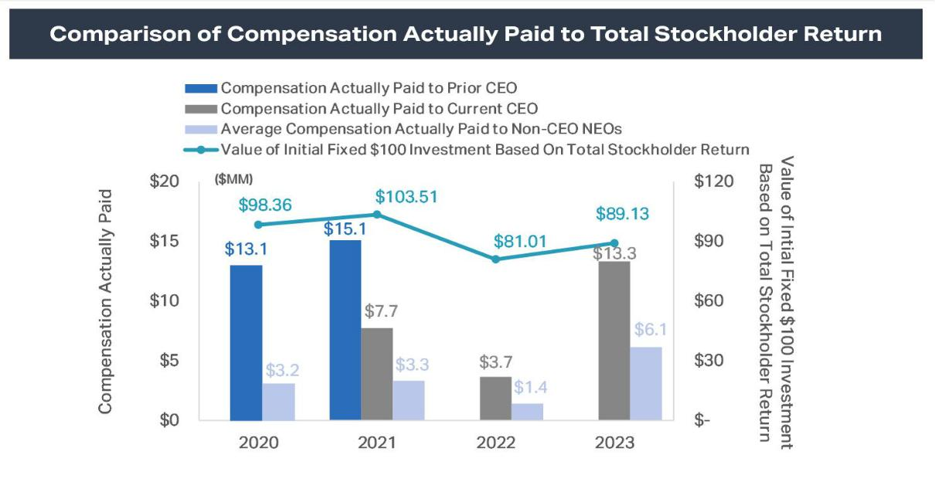

The following graph illustrates the relationship between compensation actually paid to our NEOs and AGNC’s net income on an annual basis:
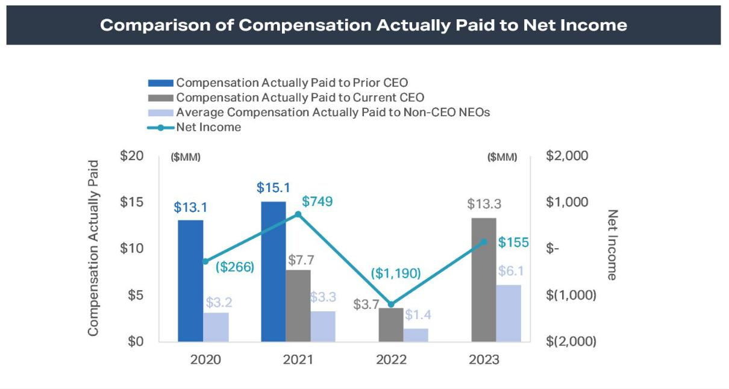

48 AGNC INVESTMENT CORP. - Proxy Statement

Table of Contents

EXECUTIVE COMPENSATION

The following graph illustrates the relationship between compensation actually paid to our NEOs and AGNC’s economic return relative to the
AGNC Peer Group on an annual basis:
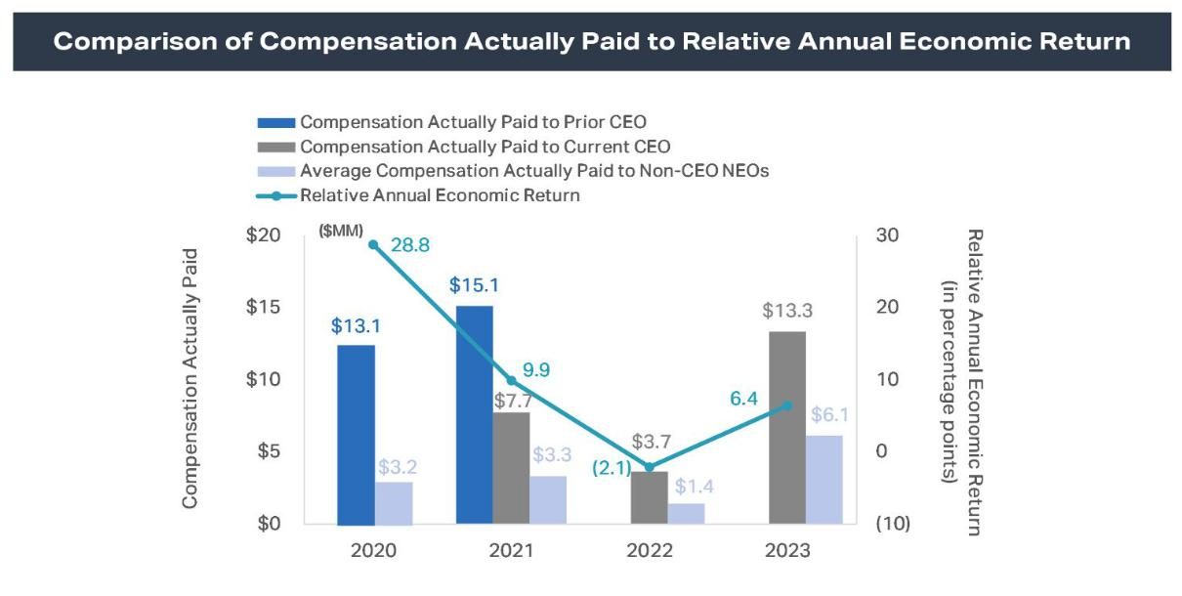

The relationship between AGNC’s total stockholder return and the total stockholder return of The Bloomberg Mortgage REIT Index on a cumulative basis is shown below:
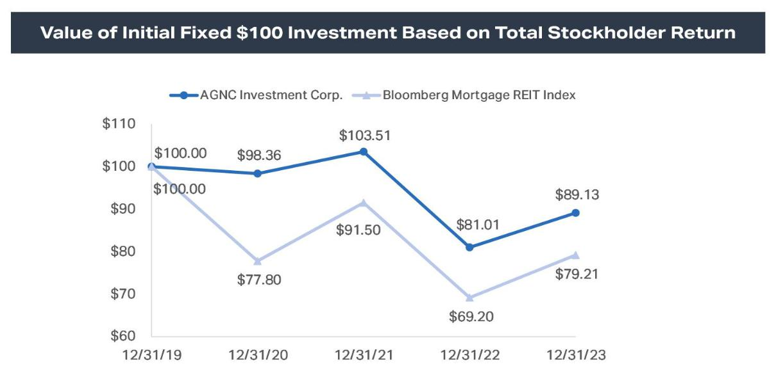

AGNC INVESTMENT CORP. - Proxy Statement 49

Table of Contents

EXECUTIVE COMPENSATION

Since its adoption in 2016, our current compensation program has linked the compensation of our NEOs to achievement of short- and long-term

financial and strategic goals. Our 2023 Corporate Scorecard consists 75% of financial metrics and 25% of strategic and operational objectives. A significant percentage of our NEOs’ compensation is in the form of equity awards that vest over three years, and in 2023, our CEO and our Executive Chair

each received 67% of their equity awards in the form of performance-based compensation. For our remaining NEOs, 50% of these awards were performance vesting. In 2023, incentive compensation served as a material element of each NEO’s compensation package and serves to further align compensation to Company performance. The most important financial performance measures utilized by the Compensation Committee to link

compensation paid to our NEOs to AGNC’s performance for 2023 were:

- Annual Economic Return Relative to the Agency REIT Peer Group

- Absolute Annual Economic Return

- Price-to-Tangible Book Value Ratio Relative to the Agency REIT Peer Group

CEO Compensation Pay Ratio

As required by Section 953(b) of the Dodd-Frank Wall Street Reform and Consumer Protection Act, and Item 402(u) of Regulation S-K, we

determined that the 2023 total compensation of Peter Federico, our President and Chief Executive Officer, of $12,318,800 was approximately 38 times the total compensation of a median employee in 2023 of $328,052.

We identified the median employee using the annual base salary and expected bonus, as of December 31, 2023, plus any long-term incentive stock

awards granted in 2023 for all individuals, excluding our Chief Executive Officer, who were employed by us on December 31, 2023, the last day of our payroll year (whether employed on a full-time, part-time, or seasonal basis). After identifying the median employee, we calculated annual total compensation for such employee using the same methodology we used for determining the CEO Compensation shown in the Summary Compensation

Table.

50 AGNC INVESTMENT CORP. - Proxy Statement

Table of Contents

INFORMATION REGARDING COMPANY VOTING SECURITIES

INFORMATION REGARDING COMPANY VOTING SECURITIES

Security Ownership of Management and Certain Beneficial Owners

The following table sets forth, as of February 23, 2024 (unless otherwise indicated), the beneficial ownership of common stock of each current director, each nominee for director, each of our named executive officers, our executive officers and directors as a group, and each stockholder known to
management to own beneficially more than 5% of the outstanding shares of our common stock. Unless otherwise indicated, we believe that the beneficial owners set forth in the table below have sole voting and investment power. As of February 23, 2024, there were 695,684,990 shares of our common stock outstanding.

Name and Address of Beneficial Owner

 | Percentage of
 | Common
Number of Shares of | Stock
Common Stock | Beneficially
Beneficially Owned ¹ | Owned

Beneficial Owners of more than 5%:
The Vanguard Group 2 | 63,366,808 | 9.11%
100 Vanguard Blvd.
Malvern, PA 19355
BlackRock, Inc.3 | 36,100,338 | 5.19%
55 East 52nd Street
New York, NY 10055
Directors and Named Executive Officers: 4
Peter J. Federico | 680,910 | *
Gary D. Kain ⁵ | 1,495,063 | *
Christopher J. Kuehl | 442,885 | *
Donna J. Blank⁶ | 7,223 | *
Bernice E. Bell | 82,670 | *
Morris A. Davis⁶ | 12,122 | *
John D. Fisk⁶ | 20,773 | *
Andrew A. Johnson, Jr.⁶ | — | *
Prue B. Larocca⁶ | 69,168 | *
Paul E. Mullings⁶ | 8,526 | *
Kenneth L. Pollack | 48,137 | *
Sean P. Reid | 104,524 | *
Frances R. Spark⁶ | 29,892 | *
Directors and Executive Officers as a group (13 persons) | 3,001,893 | *

* Less than one percent.

- The amounts shown reflect shares of our common stock. Mr. Kain also owns 10,900 shares of our 6.875% Series D Fixed-to-Floating Rate Cumulative Redeemable Preferred Stock (“Series D Preferred Stock”), representing less than one percent of the shares of Series D Preferred Stock issued and outstanding as of February 23, 2024. Holders of Series D Preferred Stock generally do not have any voting rights. Other than Mr. Kain’s ownership of Series D Preferred Stock, our Directors and executive officers do not own shares of our 7.00% Series C Fixed-to-Floating Rate Cumulative Redeemable Preferred Stock, 6.875%, Series D Fixed-to-Floating Rate Cumulative Redeemable Preferred Stock, 6.50% Series E Fixed-to-Floating Rate Cumulative Redeemable Preferred Stock, 6.125% Series F Fixed-to-Floating Rate Cumulative Redeemable Preferred Stock, or Series G Fixed-Rate-Reset Cumulative Redeemable Preferred Stock.

- This information is based on a Schedule 13G/A filed with the SEC on February 13, 2024 by The Vanguard Group, Inc. (“Vanguard”), as an investment adviser. Vanguard reports being the beneficial owner of 63,366,808 shares and has the sole power to dispose or direct the disposition of 62,474,071 of such shares, shared power to dispose or direct the disposition of 892,737 of such shares, and shared power to vote or direct the vote of 208,818 of such shares.

- This information is based on a Schedule 13G filed with the SEC on January 31, 2024 by BlackRock, Inc., as a parent holding company or control person of certain named funds (“BlackRock”). BlackRock reports being the beneficial owner of 36,100,338 shares and has the sole power to dispose or direct the disposition of 36,100,338 of such shares and sole power to vote or direct the vote of 34,749,463 of such shares.

- The address of each of the executive officers and directors listed above is c/o AGNC Investment Corp., 7373 Wisconsin Ave, 22nd Floor, Bethesda, MD 20814.
- Includes 517,920 shares held in a family trust over which shares Mr. Kain has voting and dispositive power.
- Under the 2016 Equity Plan, independent directors may elect to defer distribution of their equity awards for a period of up to ten years. Deferred awards are non-forfeitable following the vesting date. Please see the table on page 9 herein for a more complete breakdown of total ownership of common stock by our independent directors, including beneficially owned, unvested, and deferred shares.

AGNC INVESTMENT CORP. - Proxy Statement 51

Table of Contents

QUESTIONS AND ANSWERS ABOUT STOCKHOLDER COMMUNICATIONS AND PROPOSALS

QUESTIONS AND ANSWERS ABOUT STOCKHOLDER COMMUNICATIONS AND PROPOSALS

1. WHO IS RESPONSIBLE FOR STOCKHOLDER COMMUNICATIONS?

The Board is of the view that management is primarily responsible for all communications on behalf of AGNC with stockholders and the public at large. Thus, in addition to our executive officers, we employ a Vice President, Investor Relations, whose primary responsibilities include investor and stockholder relations.

2. HOW DO I COMMUNICATE WITH THE COMPANY’S BOARD?

Stockholders who wish to communicate with our Board or with a particular director may send a letter to our Secretary at AGNC Investment Corp., 7373 Wisconsin Avenue, 22nd Floor, Bethesda, MD 20814. Any communication should clearly specify that it is intended to be made to the entire Board or to one or more particular director(s).

Under this process, our Secretary reviews all such correspondence and will forward to the Board a summary of all such correspondence and copies of all correspondence that, in the opinion of the Secretary, deals with the functions of the Board or committees thereof or that he otherwise determines requires their attention. Directors may at any time review a log of all correspondence received by AGNC that is addressed to members of the Board and request
copies of any such correspondence. Concerns relating to accounting, internal controls, or auditing matters are promptly brought to the attention of the Chair of the Audit Committee and handled in accordance with procedures approved by the Board with respect to such matters.

A copy of such procedures for the submission and handling of complaints or concerns regarding accounting, internal accounting controls, or auditing matters is included in our Code of Ethics, which is published in the Investors section of our web site at ir.agnc.com/corporate-governance-documents.

3. HOW CAN A STOCKHOLDER NOMINATE A DIRECTOR OR SUBMIT A PROPOSAL FOR THE 2025 ANNUAL MEETING?

Stockholder proposals or nominees for election to the Board must be made in accordance with the procedures set forth in our Bylaws and described in the following question, and not the procedures set forth in the preceding question.

4. HOW CAN A STOCKHOLDER SUBMIT A PROPOSAL FOR THE 2025 ANNUAL MEETING OF STOCKHOLDERS?

Proposals received from common stockholders in accordance with Rule 14a-8 under the Exchange Act are given careful consideration by our

Compensation Committee and our Board. If a common stockholder intends to present a proposal at the 2025 annual meeting of stockholders pursuant to Rule 14a-8 under the Exchange Act, in order for such stockholder proposal to be included in our proxy statement and proxy card for that meeting, the stockholder proposal must be received by our Secretary at AGNC Investment Corp., 7373 Wisconsin Avenue, 22nd Floor, Bethesda, Maryland 20814, on

or before November 9, 2024, unless the date of the 2025 annual meeting of stockholders has been changed by more than 30 days from April 18, 2025, in which event the deadline is a reasonable time before we begin to print and send our proxy materials.

If such proposal is in compliance with all of the requirements of Rule 14a-8 under the Exchange Act, the proposal will be included in our proxy statement and proxy card relating to such meeting. Nothing in the response to this question shall be deemed to require us to include any stockholder proposal that does not meet all the requirements for such inclusion established by the SEC in effect at that time.

In order for a proposal by a common stockholder submitted outside of Rule 14a-8, including any nominations for election to the Board made by common stockholders, to be considered at the 2025 annual meeting of stockholders, such proposal must be made by written notice (setting forth the information required by our current Bylaws) and received by our Secretary not less than 90 and not more than 120 days in advance of the 2025 annual meeting.

Such proposals should be submitted by certified mail, return receipt requested.

5. HOW CAN I OBTAIN A COPY OF THE COMPANY’S 2024 ANNUAL REPORT ON FORM 10-K AND OTHER SEC FILINGS?

A copy of our 2023 annual report on Form 10-K containing audited financial statements was delivered or made available with this proxy statement. Additional copies of our 2023 annual report on Form 10-K (without exhibits, unless otherwise requested) are available in print, free of charge, to
stockholders requesting a copy by writing to: AGNC Investment Corp., Investor Relations, 7373 Wisconsin Avenue, 22nd Floor, Bethesda, Maryland 20814, or by calling (301) 968-9300. You may review our filings with the SEC by visiting the SEC’s home page on the internet at http://www.sec.gov or by visiting the Investors section of our web site at ir.agnc.com/financial-information/sec-filings.

52 AGNC INVESTMENT CORP. - Proxy Statement

Table of Contents

QUESTIONS AND ANSWERS ABOUT THE 2024 ANNUAL MEETING AND VOTING

QUESTIONS AND ANSWERS ABOUT THE 2024 ANNUAL MEETING AND VOTING

1. WHY DID I RECEIVE THESE PROXY MATERIALS?

Our Board is furnishing this proxy statement to you to solicit proxies on its behalf to be voted at the 2024 Annual Meeting on Thursday, April 18, 2024, at 9:00 a.m., Eastern Time. This year’s Annual Meeting will be held in a virtual format only through a live audio webcast. The proxies also may be voted at any postponement or adjournment of the meeting.

All properly executed written proxies, and all properly completed proxies submitted by telephone or by the internet, that are timely delivered pursuant to this solicitation, will be voted at the Annual Meeting in accordance with the directions given in the proxy unless the proxy is revoked before the completion of voting at the meeting.

2. WHAT ITEMS WILL BE CONSIDERED AND VOTED ON AT THE ANNUAL MEETING?

Proposal |  | Board
 |  | Recommendations
1) | Election of nine directors, each to serve a one-year term and until his or | FOR each of the nominees of the Board of
 | her successor is elected and qualified | Directors
2) | Approval of an advisory resolution on executive compensation | FOR the advisory resolution
3) | Ratification of the appointment of Ernst & Young LLP to serve as our | FOR the ratification of appointment
 | independent public accountant for the year ending December 31, 2024

The Board does not intend to bring other matters before the Annual Meeting except items incidental to the conduct of the meeting. However, on all other matters properly brought before the meeting, or any postponement or adjournment thereof, by the Board or others, the persons named as proxies in the
accompanying proxy card, or their substitutes, will vote in accordance with their discretion.

3. WHAT IS A PROXY?

It is your legal designation of another person to vote the stock you own. That other person is called a proxy. If you designate someone as your proxy in a written document, that document is also called a proxy or a proxy card. Peter J. Federico and Kenneth L. Pollack have been designated as proxies by the
Board for the Annual Meeting.

4. WHAT IS THE RECORD DATE AND WHAT DOES IT MEAN?

The record date for the Annual Meeting is February 23, 2024 (the “record date”). The record date is established by the Board and only common stockholders of record at the close of business on the record date are entitled to:

- receive notice of the meeting; and

- vote at the meeting and any postponement or adjournment of the meeting.

Each common stockholder of record on the record date is entitled to one vote for each share of common stock held. On the record date, there were 695,684,990 shares of common stock outstanding.

- WHAT IS THE DIFFERENCE BETWEEN A STOCKHOLDER OF RECORD AND A STOCKHOLDER WHO HOLDS STOCK IN STREET NAME?

If your shares of common stock are registered in your name on the books and records of our transfer agent, you are a common stockholder of record.

If your shares of common stock are held for you through an intermediary in the name of your broker, bank or other nominee, your shares are held in street name. The answer to Question 10 below describes brokers’ discretionary voting authority and when your broker, bank, or other nominee is permitted to vote your shares of common stock without instructions from you. For shares held through a benefit or compensation plan or a broker, bank, or other

nominee, you may vote by submitting voting instructions to your plan trustee, broker, bank, or nominee. If you attend the virtual Annual Meeting, you may withdraw your proxy and vote online during the meeting using your 16-digit control number included on your notice, proxy card, or the voting instruction form.

It is important that you vote your shares of common stock if you are a stockholder of record and, if you hold shares in street name, that you provide appropriate voting instructions to your broker, bank, or other nominee as discussed in the answer to Question 10 below.

AGNC INVESTMENT CORP. - Proxy Statement 53

Table of Contents

QUESTIONS AND ANSWERS ABOUT THE 2024 ANNUAL MEETING AND VOTING

6. WHAT ARE THE DIFFERENT METHODS THAT I CAN USE TO VOTE MY SHARES OF COMMON STOCK?

You may submit your proxy or vote your shares of our common stock by any of the following methods:

By Telephone or the Internet—Common stockholders can vote their shares via telephone or the internet as instructed in the proxy card or the voting instruction form. The telephone and internet procedures are designed to authenticate a stockholder’s identity, to allow common stockholders to vote their

shares, and to confirm that their instructions have been properly recorded.

By Mail—A common stockholder who receives a paper proxy card or voting instruction form or requests a paper proxy card or voting instruction form by telephone or internet may elect to vote by mail and should complete, sign, and date the proxy card or voting instruction form and mail it in the pre-
addressed envelope that accompanies the delivery of the proxy card or voting instruction form. For common stockholders of record, proxy cards submitted by mail must be received by the date and time of the Annual Meeting. For common stockholders who hold their shares through an intermediary, such as a broker, bank, or other nominee, the voting instruction form submitted by mail must be mailed by the deadline imposed by your broker, bank, or other

nominee for your shares to be voted.

Online during the Meeting—Shares of common stock may be voted online during the Annual Meeting using the 16-digit control number included on your notice, proxy card, or the voting instruction form.

7. WHO COUNTS THE VOTES?

A representative of Broadridge Investor Communication Solutions, Inc. will serve as the inspector of election and will receive and tabulate the proxies and certify the results.

8. WHAT IF A STOCKHOLDER DOES NOT SPECIFY A CHOICE FOR A MATTER WHEN RETURNING A PROXY?

Stockholders should specify their voting choice for each matter on the accompanying proxy. If no specification is made, such shares will be voted “FOR”

the election of the nine director nominees, “FOR” the advisory resolution on executive compensation, and “FOR” the ratification of the appointment of Ernst & Young LLP as our independent public accountant for the year ending December 31, 2024.

9. WHAT DOES IT MEAN IF I RECEIVE MORE THAN ONE PROXY CARD?

It means that you have multiple accounts with brokers and/or our transfer agent. Please vote all of these shares.

We recommend that you contact your broker and/or our transfer agent to consolidate as many accounts as possible under the same name and address. Our transfer agent is Computershare Investor Services. Computershare’s address is P.O. Box 43006; Providence, RI 02940-3006; you can reach Computershare at 1-800-733-5001 (from within the United States or Canada) or 781-575-3400 (from outside the United States or Canada) or via their Investor Centre™
portal at www.computershare.com/investor.

- WILL MY SHARES BE VOTED IF I DO NOT PROVIDE MY PROXY?

Stockholders of Record—If you are a stockholder of record (see Question 5 above), your shares of common stock will not be voted if you do not provide your proxy unless you vote online during the Annual Meeting. It is important that you vote your shares.

Street Name Holders—If your shares of common stock are held in street name (see Question 5 above) and you do not provide your signed and dated voting instruction form to your broker, bank, or other nominee, your shares may be voted by your broker, bank, or other nominee but only under certain circumstances. Specifically, under applicable rules, shares held in the name of your broker, bank, or other nominee may be voted by your broker, bank, or

other nominee on certain “routine” matters if you do not provide voting instructions.

The only proposals to be voted on at the Annual Meeting that are considered a “routine” matter for which brokers, banks or other nominees may vote uninstructed shares is the ratification of the appointment of Ernst & Young LLP as the Company’s independent public accountant. The other proposals
(specifically, the election of director nominees and the approval of the advisory resolution on executive compensation) are not considered “routine” under applicable rules, so the broker, bank, or other nominee cannot vote your shares on these proposals unless you provide to the broker, bank, or other nominee voting instructions for these matters. If you do not provide voting instructions on a non-routine matter, your shares of common stock will not be voted on

the matter, which is referred to as a “broker non-vote.” It is, therefore, important that you vote your shares.

11. ARE ABSTENTIONS AND BROKER NON-VOTES COUNTED?

Abstentions and broker non-votes will not be counted as votes cast and will not affect the outcome of the votes at the Annual Meeting. See Question 10 above for more information about broker non-votes.

12. HOW CAN I REVOKE A PROXY?

The enclosed proxy is solicited on behalf of the Board and is revocable at any time prior to the voting of the proxy, by the filing of an instrument revoking it, or a duly executed proxy bearing a later date, with our Secretary, addressed to our principal executive offices at

54 AGNC INVESTMENT CORP. - Proxy Statement

Table of Contents

QUESTIONS AND ANSWERS ABOUT THE 2024 ANNUAL MEETING AND VOTING

7373 Wisconsin Avenue, 22nd Floor, Bethesda, Maryland 20814. In the event that you attend the Annual Meeting, you may revoke your proxy and cast your vote personally online during the meeting.

- WHO WILL PAY THE COST OF THIS PROXY SOLICITATION?

We will bear the cost of soliciting proxies on the accompanying form. In addition to the use of mail, our officers and employees may solicit proxies by

telephone or email. Upon request, we will reimburse brokers, dealers, banks and trustees, or their nominees, for reasonable expenses incurred by them in forwarding our proxy materials to beneficial owners of our common stock. The Company has also retained D.F. King & Co., Inc. to assist in the solicitation of proxies in connection with the Annual Meeting and will pay D.F. King a fee of $10,000 for its services. In addition, the Company may pay D.F. King additional fees depending on the extent of additional services requested by the Company and will reimburse D.F. King for expenses incurred in connection

with its engagement by the Company.

- HOW DO I OBTAIN ADMISSION TO THE ANNUAL MEETING?

Attendance at the virtual Annual Meeting will be limited to common stockholders of record as of the close of business on the record date, February 23, 2024. To be admitted to the Annual Meeting at www.virtualshareholdermeeting.com/AGNC2024, you must enter the 16-digit control number which is

located on your notice, proxy card, voting instruction form, or in the email sending you the Proxy Statement. If you are a beneficial stockholder, you may contact the bank, broker, or other institution where you hold your account if you have questions about obtaining your control number. Participants will be able to access the virtual meeting site 15 minutes before the meeting begins on April 18, 2024. Stockholders experiencing technical difficulties when

logging into the virtual meeting platform may access technical assistance provided by Broadridge Financial Solutions, Inc., the hosting platform for the Annual Meeting, toll-free in the United States at 1-844-986-0822 or internationally at 303-562-9302 beginning 15 minutes in advance of the meeting.

- WILL STOCKHOLDERS BE ABLE TO ASK QUESTIONS AT THE MEETING?

The Annual Meeting will include a question and answer session and will address questions submitted in writing in advance of and during the virtual

meeting. Common stockholders of record on the record date may submit questions at www.proxyvote.com beginning up to 24 hours in advance of the meeting. We will endeavor to answer as many questions submitted by stockholders as time permits. We reserve the right to edit profanity or other inappropriate language and to exclude questions regarding topics that are not pertinent to meeting matters or Company business in accordance with our

rules of conduct for the meeting. If we receive substantially similar questions, we may group such questions together and provide a single response to avoid repetition. Additional information regarding the rules and procedures for participating in the virtual Annual Meeting will be provided in our meeting rules of conduct, which stockholders can view during the meeting at the virtual meeting website.

- HOW MANY VOTES MUST BE PRESENT TO HOLD THE ANNUAL MEETING?

In order for us to conduct the Annual Meeting, holders representing a majority of our outstanding shares of common stock entitled to vote as of the close of business on the record date must be present online or by proxy at the meeting. This is referred to as a quorum.

Your shares are counted as present at the Annual Meeting if you attend the virtual meeting online and vote in person or if you properly return a proxy by internet, telephone, or mail.

Abstentions and broker non-votes will be considered present for the purpose of determining whether a quorum is present.

OTHER MATTERS

The Board does not intend to bring other matters before the Annual Meeting except items incidental to the conduct of the meeting. However, on all other

matters properly brought before the meeting, or any postponement or adjournment thereof, by the Board or others, the persons named as proxies in the accompanying proxy card, or their substitutes, will vote in accordance with their discretion.

AGNC INVESTMENT CORP. - Proxy Statement 55

Table of Contents

QUESTIONS AND ANSWERS ABOUT THE 2024 ANNUAL MEETING AND VOTING
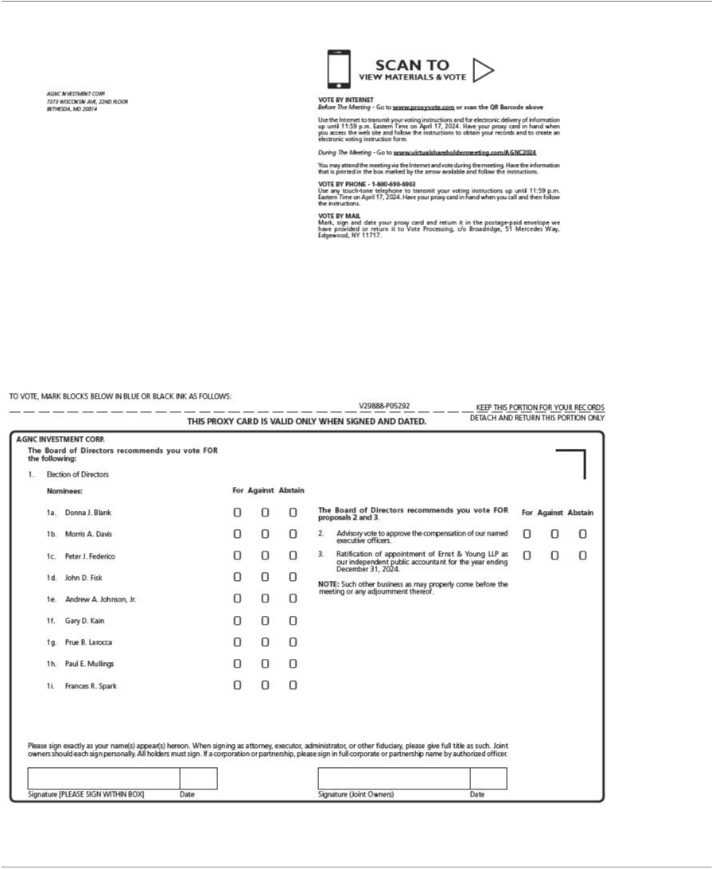

Table of Contents

QUESTIONS AND ANSWERS ABOUT THE 2024 ANNUAL MEETING AND VOTING


