SEC Form 4

FORM 4

Check this box if no longer subject to Section 16. Form 4 or Form 5 obligations may continue. See Instruction 1(b).

UNITED STATES SECURITIES AND EXCHANGE COMMISSION
Washington, D.C. 20549
 |  | OMB APPROVAL
STATEMENT OF CHANGES IN BENEFICIAL OWNERSHIP
 |  | OMB Number: | 3235-0287
 |  | Estimated average burden
Filed pursuant to Section 16(a) of the Securities Exchange Act of 1934 |  | hours per response: | 0.5
or Section 30(h) of the Investment Company Act of 1940
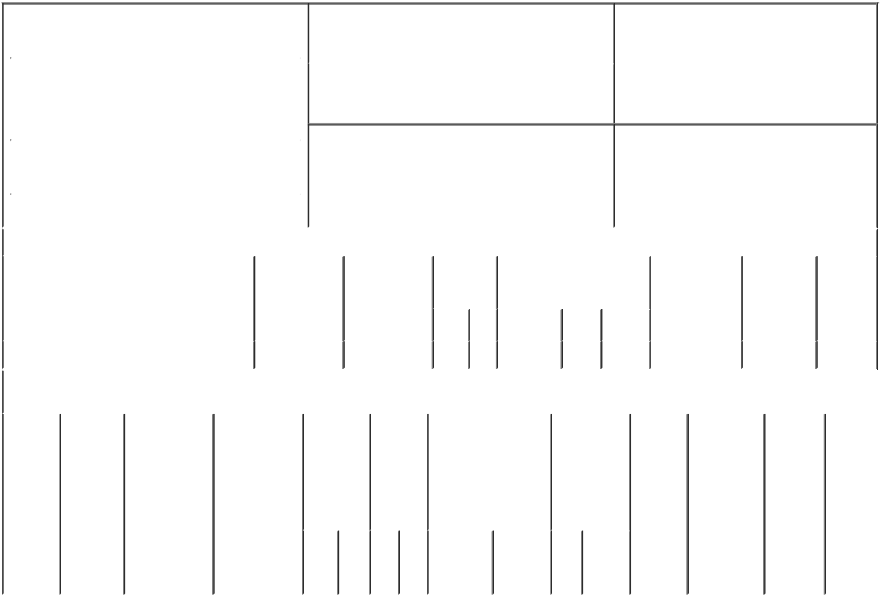

1. Name and Address of Reporting Person* |  |  |  |  |  |  | 2. Issuer Name and Ticker or Trading Symbol
 | Pollack Kenneth L. |  |  |  |  |  | AGNC Investment Corp. [ AGNC ]
 | (Last) | (First) |  | (Middle) |  |  | 3. Date of Earliest Transaction (Month/Day/Year)
 | AGNC INVESTMENT CORP. |  |  |  | 01/26/2023

2 BETHESDA METRO CENTER, 12TH FLOOR

- Relationship of Reporting Person(s) to Issuer (Check all applicable)

 | Director | 10% Owner
X | Officer (give title | Other (specify
 | below) | below)

EVP and General Counsel

 |  |  |  |  |  |  |  | 4. If Amendment, Date of Original Filed (Month/Day/Year) |  |  |  |  |  |  | 6. Individual or Joint/Group Filing (Check Applicable
 | (Street) |  |  |  |  |  |  |  |  |  |  |  |  |  | Line)
 |  |  |  |  |  |  |  |  |  |  |  |  |  |  |  |  | X Form filed by One Reporting Person
 |  | BETHESDA |  | MD |  | 20814
 |  |  |  |  |  |  |  |  |  |  |  |  |  |  |  |  |  | Form filed by More than One Reporting
 |  |  |  |  |  |  |  |  |  |  |  |  |  |  |  |  |  | Person
 |  | (City) |  | (State) |  | (Zip)
 |  |  |  |  | Table I - Non-Derivative Securities Acquired, Disposed of, or Beneficially Owned
 | 1. Title of Security (Instr. 3) |  |  |  |  | 2. Transaction |  |  | 2A. Deemed |  | 3. | 4. Securities Acquired (A) or |  |  |  |  |  | 5. Amount of |  | 6. Ownership | 7. Nature
 |  |  |  |  |  | Date |  |  | Execution Date, |  | Transaction | Disposed Of (D) (Instr. 3, 4 and Securities |  |  |  |  |  |  |  | Form: Direct | of Indirect
 |  |  |  |  |  | (Month/Day/Year) |  |  | if any |  | Code (Instr. | 5) |  |  |  |  |  | Beneficially |  | (D) or Indirect | Beneficial
 |  |  |  |  |  |  |  |  | (Month/Day/Year) |  | 8) |  |  |  |  |  |  | Owned Following |  | (I) (Instr. 4) | Ownership
 |  |  |  |  |  |  |  |  |  |  |  |  |  |  |  |  |  | Reported |  |  | (Instr. 4)
 |  |  |  |  |  |  |  |  |  |  | Code V | Amount | (A) or |  | Price |  |  | Transaction(s)
 |  |  |  |  |  |  |  |  |  |  |  |  | (D) |  |  |  |  | (Instr. 3 and 4)
 | Common Stock |  |  |  |  | 01/26/2023 |  |  |  |  | A | 27,926 | A |  | (1) |  | 248,165⁽²⁾ |  |  | D
 |  |  |  |  |  | Table II - Derivative Securities Acquired, Disposed of, or Beneficially Owned
 |  |  |  |  |  | (e.g., puts, calls, warrants, options, convertible securities)
 | 1. Title of |  | 2. |  | 3. Transaction | 3A. Deemed | 4. |  |  | 5. Number | 6. Date Exercisable and |  | 7. Title and |  |  |  | 8. Price of |  | 9. Number of 10. |  | 11. Nature
 | Derivative |  | Conversion |  | Date | Execution Date, |  | Transaction |  | of | Expiration Date |  | Amount of |  |  |  | Derivative |  | derivative | Ownership | of Indirect
 | Security |  | or Exercise |  | (Month/Day/Year) if any |  |  | Code (Instr. |  | Derivative | (Month/Day/Year) |  | Securities |  |  |  | Security |  | Securities | Form: | Beneficial
 | (Instr. 3) |  | Price of |  |  | (Month/Day/Year) | 8) |  |  | Securities |  |  | Underlying |  |  |  | (Instr. 5) |  | Beneficially | Direct (D) | Ownership
 |  |  | Derivative |  |  |  |  |  |  | Acquired |  |  | Derivative |  |  |  |  |  | Owned | or Indirect | (Instr. 4)
 |  |  | Security |  |  |  |  |  |  | (A) or |  |  | Security (Instr. |  |  |  |  |  | Following | (I) (Instr. 4)
 |  |  |  |  |  |  |  |  |  | Disposed |  |  | 3 and 4) |  |  |  |  |  | Reported
 |  |  |  |  |  |  |  |  |  | of (D) |  |  |  |  |  |  |  |  | Transaction(s)
 |  |  |  |  |  |  |  |  |  | (Instr. 3, 4 |  |  |  |  |  |  |  |  | (Instr. 4)
 |  |  |  |  |  |  |  |  |  | and 5)
 |  |  |  |  |  |  |  |  |  |  |  |  |  | Amount
 |  |  |  |  |  |  |  |  |  |  |  |  |  | or
 |  |  |  |  |  |  |  |  |  |  |  |  |  | Number
 |  |  |  |  |  |  |  |  |  |  | Date | Expiration |  | of
 |  |  |  |  |  |  |  | Code | V | (A) (D) | Exercisable | Date | Title | Shares

Explanation of Responses:

- Shares received for no consideration upon the satisfaction of performance criteria underlying performance based grants made under the Amended and Restated AGNC Investment Corp. 2016 Equity and Incentive Compensation Plan on February 20, 2020.

- Includes 21,199 dividend equivalent restricted stock units received on previously granted RSU awards since the Reporting Person's last Form 4 filing.

Kenneth L. Pollack |  |  | 01/27/2023
** Signature of Reporting Person |  | Date

Reminder: Report on a separate line for each class of securities beneficially owned directly or indirectly.

* If the form is filed by more than one reporting person, see Instruction 4 (b)(v).

- Intentional misstatements or omissions of facts constitute Federal Criminal Violations See 18 U.S.C. 1001 and 15 U.S.C. 78ff(a). Note: File three copies of this Form, one of which must be manually signed. If space is insufficient, see Instruction 6 for procedure.
Persons who respond to the collection of information contained in this form are not required to respond unless the form displays a currently valid OMB Number.

