SEC Form 3
FORM 3 | UNITED STATES SECURITIES AND EXCHANGE COMMISSION
 | Washington, D.C. 20549
 |  |  | OMB APPROVAL
 | INITIAL STATEMENT OF BENEFICIAL OWNERSHIP OF
 |  |  | OMB Number: | 3235-0104
 | SECURITIES |  | Estimated average burden
 |  |  | hours per response: | 0.5

Filed pursuant to Section 16(a) of the Securities Exchange Act of 1934
or Section 30(h) of the Investment Company Act of 1940
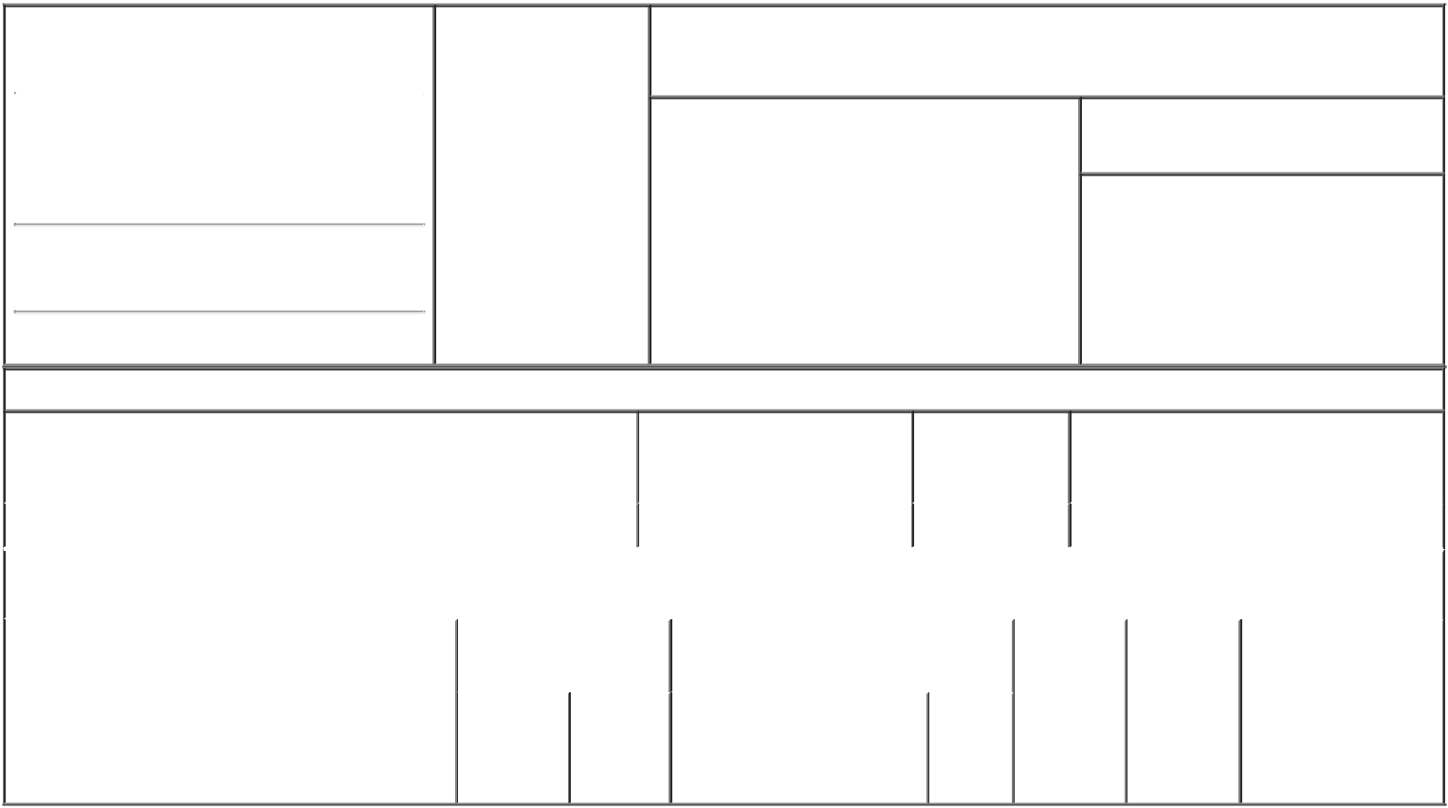

1. Name and Address of Reporting Person* |  |  |  | 2. Date of Event
 |  | WILKUS MALON |  | Requiring Statement
 |  |  |  | (Month/Day/Year)
 |  |  |  | 05/14/2008

3. Issuer Name and Ticker or Trading Symbol

American Capital Agency Corp [ AGNC ]

(Last) (First) (Middle)

2 BETHESDA METRO CENTER

14TH FLOOR

(Street)
BETHESDA MD | 20814

- Relationship of Reporting Person(s) to Issuer (Check all applicable)

X | Director | 10% Owner
X | Officer (give title | Other (specify
 | below) | below)

CEO, COB & President

- If Amendment, Date of Original Filed (Month/Day/Year)

- Individual or Joint/Group Filing (Check Applicable Line)

- Form filed by One Reporting Person

Form filed by More than One Reporting Person

(City) (State) (Zip)

Table I - Non-Derivative Securities Beneficially Owned

1. Title of Security (Instr. 4) | 2. Amount of Securities | 3. Ownership | 4. Nature of Indirect Beneficial Ownership
 | Beneficially Owned (Instr. 4) | Form: Direct (D) | (Instr. 5)
 |  | or Indirect (I)
 |  | (Instr. 5)

 | Common Stock, par value $0.01 per share |  |  |  | 0 | D
 |  |  | Table II - Derivative Securities Beneficially Owned
 |  | (e.g., puts, calls, warrants, options, convertible securities)
 | 1. Title of Derivative Security (Instr. 4) |  | 2. Date Exercisable and |  | 3. Title and Amount of Securities |  | 4. | 5. | 6. Nature of Indirect
 |  |  | Expiration Date |  | Underlying Derivative Security (Instr. 4) |  | Conversion | Ownership | Beneficial Ownership
 |  |  | (Month/Day/Year) |  |  |  | or Exercise | Form: | (Instr. 5)
 |  |  |  |  |  |  | Price of | Direct (D)
 |  |  |  |  |  | Amount
 |  |  |  |  |  |  | Derivative | or Indirect
 |  |  |  |  |  | or | Security | (I) (Instr. 5)
 |  |  |  |  |  | Number
 |  |  | Date | Expiration |  | of
 |  |  | Exercisable | Date | Title | Shares

Explanation of Responses:

Remarks:

/s/ Cydonii Fairfax, as
Attorney-in-Fact for the
Reporting Person pursuant to 05/14/2008
the Power of Attorney filed
hereto as Exhibit 24.1

** Signature of Reporting Person Date

Reminder: Report on a separate line for each class of securities beneficially owned directly or indirectly.

* If the form is filed by more than one reporting person, see Instruction 5 (b)(v).

- Intentional misstatements or omissions of facts constitute Federal Criminal Violations See 18 U.S.C. 1001 and 15 U.S.C. 78ff(a). Note: File three copies of this Form, one of which must be manually signed. If space is insufficient, see Instruction 6 for procedure.
Persons who respond to the collection of information contained in this form are not required to respond unless the form displays a currently valid OMB Number.

Exhibit 24.1

Power of Attorney

Know all by these presents, that the undersigned hereby constitutes and appoints each of John R. Erickson, Samuel A. Flax, and Cydonii V. Fairfax, as the undersigned's true and lawful attorney-in-fact to execute and file on behalf of the undersigned in the undersigned's capacity as a Director and/or Officer of American Capital Agency Corp. ("American Capital") all necessary and/or required applications, reports, registrations, information, documents and instruments filed or required to be filed by American Capital or the undersigned with the Securities and Exchange Commission ("SEC"), any stock exchanges or any governmental official or agency, including without limitation:

- execute and file Forms 3, 4 and 5 in accordance with Section 16(a) of the Securities Exchange Act of 1934 and the rules thereunder and a Form ID, Uniform Application for Access codes to file on EDGAR;

- do and perform any and all acts for and on behalf of the undersigned which may be necessary or desirable to complete and execute any such Form 3, 4, 5 or Form ID and timely file such Forms 3, 4, 5 or Form ID, including amendments thereto;

- execute and file Form 144 in accordance with Rule 144 of the Securities Act of 1933, as amended, and the rules thereunder;

- do and perform any and all acts for and on behalf of the undersigned which may be necessary or desirable to complete and execute any such Form 144 and timely file such Form 144;

- execute and file Schedules 13D and 13G in accordance with all applicable
laws;

- take any other action of any type whatsoever in connection with the foregoing, which, in the opinion of such attorney-in-fact, may be of benefit to, in the best interest of, or legally required by, the undersigned, it being understood that the documents executed by such attorney-in-fact on behalf of the undersigned pursuant to this Power of Attorney shall be in such form and shall contain such terms and conditions as such attorney-in-fact may approve in such attorney-in-fact's discretion.

[REMAINDER OF THIS PAGE LEFT INTENTIONALLY BLANK]

The undersigned hereby grants to such attorney-in-fact full power and authority to do and perform any and every act and thing whatsoever requisite, necessary,
or proper to be done in the exercise of any of the rights and powers herein granted, as fully to all intents and purposes as the undersigned might or could do if personally present, with full power of substitution or revocation, hereby ratifying and confirming all that such attorney-in-fact, or such attorney-in-fact's substitute or substitutes, shall lawfully do or cause to be done by virtue of this Power of Attorney and the rights and powers herein granted. Each of the attorneys-in-fact named herein shall have the power to act hereunder with or without the other. The undersigned acknowledges that the foregoing attorneys-in-fact, in serving in such capacity at the request of the undersigned, are not assuming, nor is American Capital assuming, any of the undersigned's responsibilities to comply with Section 16 of the Securities Exchange Act of 1934.

IN WITNESS WHEREOF, the undersigned has caused this Power of Attorney to be executed on the date set forth below.

Signature Date

/s/ Malon Wilkus
May 12, 2008

